CALL ALL
  MAP | 30
Henwood Road Papatoetoe | Printed 1/1/2014
Do not call Henwood 15/2 caution

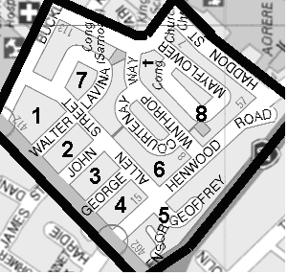

CALL ALL
  MAP | 30
Henwood Road Papatoetoe | Printed 1/1/2014
Do not call Henwood 15/2 caution

CALL ALL
  MAP | 30
Henwood Road Papatoetoe | Printed 1/1/2014
Do not call Henwood 15/2 caution

CALL ALL
  MAP | 30
Henwood Road Papatoetoe | Printed 1/1/2014
Do not call Henwood 15/2 caution

