CALL ALL
  MAP | 31
Hillcrest Road Papatoetoe | Printed 1/1/2014
Do not call
Ferndown 52 Hillcrest 11d and 25a and 29 and 84
Hillside 1 and 67 Hill Rd 19A

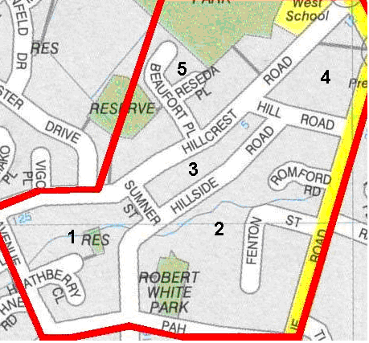

CALL ALL
  MAP | 31
Hillcrest Road Papatoetoe | Printed 1/1/2014
Do not call
Ferndown 52 Hillcrest 11d and 25a and 29 and 84
Hillside 1 and 67 Hill Rd 19A

CALL ALL
  MAP | 31
Hillcrest Road Papatoetoe | Printed 1/1/2014
Do not call
Ferndown 52 Hillcrest 11d and 25a and 29 and 84
Hillside 1 and 67 Hill Rd 19A

CALL ALL
  MAP | 31
Hillcrest Road Papatoetoe | Printed 1/1/2014
Do not call
Ferndown 52 Hillcrest 11d and 25a and 29 and 84
Hillside 1 and 67 Hill Rd 19A

