CALL ALL
  MAP | 3
Huia Road Otahuhu | Printed 1/1/2014
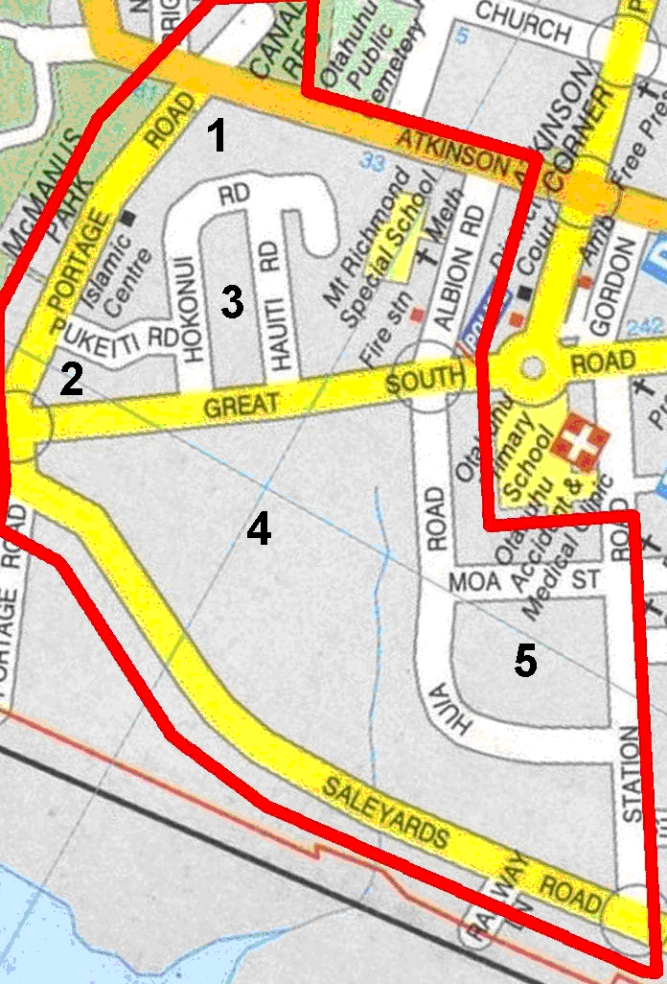
CALL ALL
  MAP | 3
Huia Road Otahuhu | Printed 1/1/2014
CALL ALL
  MAP | 3
Huia Road Otahuhu | Printed 1/1/2014
CALL ALL
  MAP | 3
Huia Road Otahuhu | Printed 1/1/2014

