CALL ALL
  MAP | 4
Avenue Road Otahuhu | Printed 1/1/2014

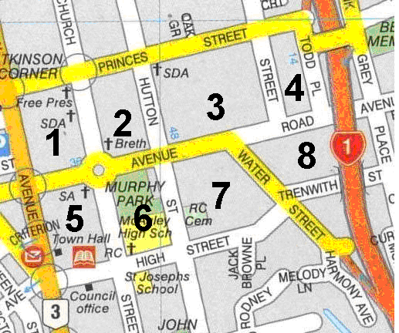

CALL ALL
  MAP | 4
Avenue Road Otahuhu | Printed 1/1/2014

CALL ALL
  MAP | 4
Avenue Road Otahuhu | Printed 1/1/2014

CALL ALL
  MAP | 4
Avenue Road Otahuhu | Printed 1/1/2014

