CALL ALL
  MAP | 5
Fairburn Road Otahuhu | Printed 1/1/2014
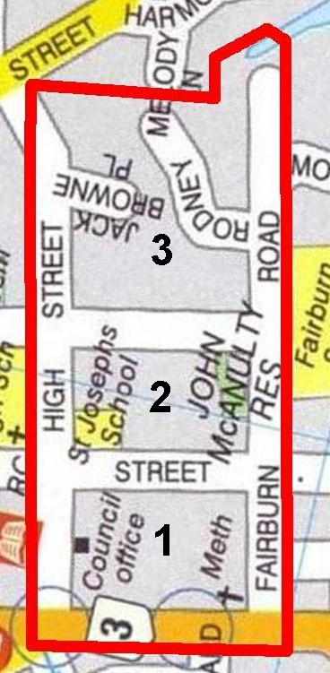

CALL ALL
  MAP | 5
Fairburn Road Otahuhu | Printed 1/1/2014

CALL ALL
  MAP | 5
Fairburn Road Otahuhu | Printed 1/1/2014

CALL ALL
  MAP | 5
Fairburn Road Otahuhu | Printed 1/1/2014

