CALL ALL
  MAP | 9
Otahuhu College | Printed 1/1/2014
Do not Call
Jane Cowie 51a and 57 Baldwin 17
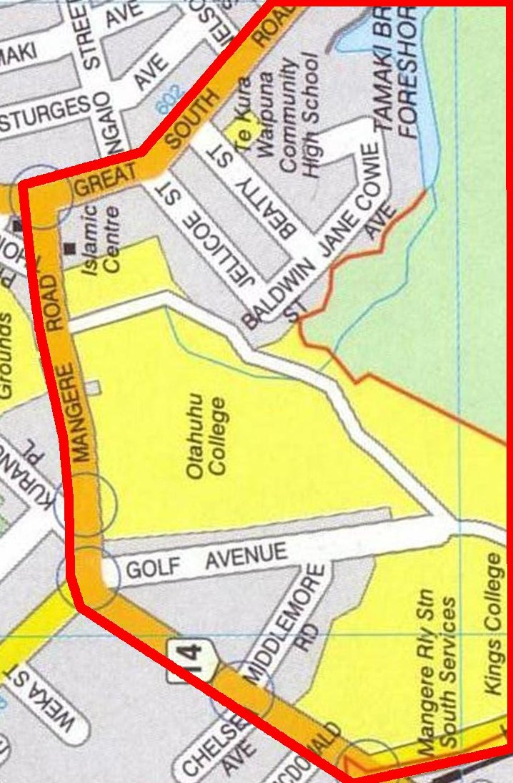
CALL ALL
  MAP | 9
Otahuhu College | Printed 1/1/2014
Do not Call
Jane Cowie 51a and 57 Baldwin 17
CALL ALL
  MAP | 9
Otahuhu College | Printed 1/1/2014
Do not Call
Jane Cowie 51a and 57 Baldwin 17
CALL ALL
  MAP | 9
Otahuhu College | Printed 1/1/2014
Do not Call
Jane Cowie 51a and 57 Baldwin 17

