1. Our Affiliates:

ADD with logo:

* DOT Department of Transportation
* DOB Department of Buildings
* LPC Landmark preservation Commission

1. Add Brownstone Restoration Specialist under Infinity Construction NYC

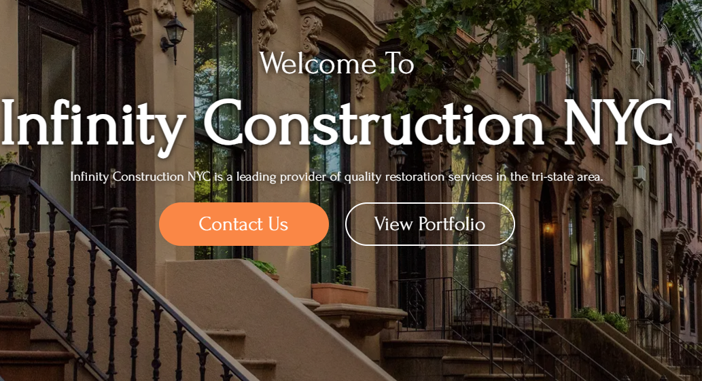

1. Instead of Our Specialty, Make it into Our Services. Then going to need all the services to show. you can make them into one column or put them into two columns. I prefer Two columns. The old information about the services will change. For all eight items I will send you all the detailed information. We will need a picture for each item. I will email them to you. If you don’t like it them, we can buy them then I guess.

|  |  |
| --- | --- |
| Column 1 | Column 2 |
| Historical Landmark Brownstone/Limestone Restoration | Stucco/Waterproofing of Exterior, Parapet, and Retaining Walls |
| Brick and CMU Block Layering | Roof Restoration and Weatherproofing |
| Brick Pointing and Waterproofing | Fire Escape, Metal Railings and Fence Restoration |
| Concrete/Stone/Brick Paving | Exterior and Interior Plastering and Painting |

1. Going to need the contact us tab to go at the bottom of the page.

1. Our Projects are good, just need to update some pictures. But I want the orientation to be like this below.

1. Finally, under affiliates: see you can provide links to our following social media page: I like it in horizontal orientation.

* Brownstoner.com
* Yelp.com
* Facebook.com
* Instagram
* Linked in.