DESIGN & FEATURE SPECIFICATION
BFT Selection Workspace
Transparent, high-control bundle composition for developers, writers, and mixed-content teams
Status: Draft for Ringo / George / John design review
Prepared by: Paul, Lead Analyst
Date: 25 August 2026
Current baseline: BFT v2.1.112 (Build 112)
Proposed target: BFT v2.2, delivered through governed work packages

Recommendation: Replace the flat checked-file list with one shared Selection Workspace and SelectionPlan engine. Planning must classify paths without reading content; every included or excluded result must expose its reason; previews must update incrementally from a cache; and UI and CLI must consume the same ordered rules, groups, detectors, and overrides.

1. Decision summary
The screenshot is evidence of a broader control and trust problem. BFT reports 4,084 source files and includes files under .venv312/Lib/site-packages because the current virtual-environment rule names .venv literally. The interface then presents thousands of files as one flat list, leaving the user to repair discovery one file at a time.
The second issue is architectural: selection changes and content generation are coupled. With auto-preview enabled, unchecking one item calls create_manifest() again for the entire remaining selection. The visible checkbox changes quickly, but the expensive read/encode/checksum work restarts even when all other files are unchanged.
The proposed design separates three jobs that are currently entangled: classify paths, express user intent, and read bundle content. That separation provides the control requested here without trading away BFT's established safety, determinism, cancellation, or governed-delivery model.

1.1 The decision in one view
Decision area | Proposed direction | Why it matters
Discovery | Metadata-first scan plus typed detectors | Find .venv312 by signature and prune before descent
Selection | Ordered rules plus explicit path/folder overrides | Fast bulk control with deterministic precedence
Transparency | Decision reason and rule chain for every path | No silent exclusion or unexplained inclusion
Organization | User-defined groups independent of include/exclude | Developers and authors can impose different bundle order
Preview | Incremental manifest cache with 250 ms debounce | One checkbox never rereads every unchanged file
Surfaces | One SelectionPlan in core, consumed by UI and CLI | Eliminates policy drift between adapters

2. Evidence and problem definition

2.1 What the current implementation does
Observed behavior | Evidence in current baseline | Consequence
GUI bypasses configured selection policy | bundle_frame.py:72 constructs BundleCreator() directly | GUI and CLI can classify the same tree differently
Environment names are literal | writer.py:618 defaults include **/.venv/**, not .venv312 | Named environments leak into the candidate set
CLI flags replace defaults | cli.py:309-310 selects command-line lists instead of configured lists | One custom exclusion can discard baseline safety rules
Every change rebuilds preview | bundle_frame.py:522-570 calls _update_preview() then create_manifest(selected_files) | All selected files are reread after a single toggle
Directory pruning is literal-name based | writer.py:88 and :761 derive a set of exact directory names | A naive .venv* glob filters late and loses the performance benefit

A one-line deny glob would treat the symptom but not the design. **/.venv*/** would match more names, yet the current prunable_dir_names() contract deliberately rejects wildcard directory segments. BFT would still descend through the environment and discard its files later. The proper fix is a cheap directory classifier that can prove a Python environment at the directory boundary (for example, pyvenv.cfg plus the expected interpreter layout) and prune it before walking site-packages.

2.2 User costs
- High noise: users cannot tell whether a folder is included because of a default, a rule, or a manual checkbox.
- Slow correction: excluding a category means locating and toggling many individual files or editing governed configuration outside the GUI.
- Low confidence: the interface emphasizes what will be bundled but does not make excluded content, reasons, or conflicts equally inspectable.
- Preview churn: repeated full reads make safe exploration feel expensive, discouraging users from refining the selection.
- Surface inconsistency: the CLI has include/exclude switches, the GUI has file toggles, and neither presents the same explainable plan.

3. Users, jobs, and design range
The feature must not encode “software project” as the universal model. The common job is to assemble a purposeful, reviewable set of files; the categories and ordering differ by user.
User type | Primary material | Typical intent | Needed control
Application developer | Source, tests, configs, technical docs | Include authored code; exclude environments, caches, generated output | Detectors, extensions, folders, source/test groups
Writer / marketer | Chapters, research, copy, images, exports | Bundle manuscript and campaign inputs in a chosen narrative order | Named groups, ordered sections, media-size rules
Analyst / researcher | Notebooks, data dictionaries, reports, datasets | Include reproducible inputs; exclude derived outputs or sensitive raw data | Size/type rules, explicit blocked paths, selection report
Release / support operator | Logs, configs, diagnostics, selected artifacts | Assemble a precise troubleshooting packet | Time-bounded session overrides and machine-readable plan

3.1 Core jobs to be done
- Show me the whole selection outcome, not only the files that survived filtering.
- Let me include or exclude a folder, category, file type, named group, or individual path in one action.
- Tell me exactly why a path is included, excluded, blocked, skipped, or overridden.
- Let me reuse a useful selection pattern without changing the governed installation file.
- Let me reorganize bundle order without duplicating content or changing inclusion accidentally.
- Let me experiment rapidly; do not reread unchanged content after every checkbox.
- Give scripts the same power and the same decision report as the desktop interface.

4. Product principles
Intent before inventory. Users begin with a preset or purpose, then refine; they do not begin by repairing a raw filesystem dump.
Explain every decision. Every path exposes a winning rule, its layer, and any overridden rules.
Safe, not silent. Hard safety blocks remain explicit; ordinary exclusions can be overridden deliberately.
One engine, many adapters. Core produces a SelectionPlan; Tkinter and CLI render it without reimplementing precedence.
Grouping is not filtering. Groups control comprehension and order. Include/exclude controls membership in the bundle.
Metadata is cheap; content is expensive. Scanning and selection use metadata. Content reads happen lazily and incrementally.
Determinism over magic. Typed detectors are inspectable and testable. No AI classification is required for v1.

5. Functional model

5.1 SelectionPlan: the single source of truth
A SelectionPlan is an immutable result for a source snapshot and a rule stack. It records candidates, groups, the final decision for each candidate, the full decision chain, aggregate counts, estimated bytes, warnings, pruned roots, and the deterministic output order. Creating a bundle consumes a plan; it does not rediscover policy independently.
Model | Required fields | Purpose
SelectionRule | id, label, action, matcher, layer, order, enabled | Express an include, exclude, group, or block condition
SelectionDecision | path, state, winning_rule, chain, override, group | Explain one path completely
SelectionGroup | id, label, order, matchers, output_policy | Create user-defined organization without duplicates
SelectionPlan | source_snapshot, decisions, groups, counts, warnings | Authoritative handoff to preview and bundle creation
ContentCacheEntry | path, size, mtime_ns, optional fingerprint, BundleEntry | Reuse unchanged reads inside the current session

5.2 Decision states
State | Meaning | User action
Included | Will be read and emitted in the bundle | May exclude or move to a group
Excluded | Matched an ordinary rule or inherited folder action | May override for session or preset
Blocked | Violates a non-overridable safety boundary | Inspect reason; change source/output design
Skipped | Selected but could not be emitted, such as size policy | Change size policy or selection
Unknown | Metadata or detector failed | Resolve warning before final bundle

5.3 Typed matchers
Rules use typed matchers rather than treating every decision as an opaque glob. Globs remain supported, but common high-value cases are first-class and explainable.
- Path glob: **/*.py, chapters/**/*.md, exports/**.
- Exact path or folder: one user-picked file or subtree.
- Extension / content family: source, document, image, archive, binary.
- Directory detector: Python environment, Node dependency tree, VCS metadata, tool cache.
- Size band: include images below a threshold; exclude large video masters.
- Group assignment: first matching group is primary; later matches remain secondary labels only.

5.4 Python environment detection
Design requirement: Recognize a Python environment regardless of whether the directory is named .venv, .venv312, env-app, or another user-defined name. The classifier must be explainable and cheap enough to run before directory descent.
The detector should classify a directory as a Python environment when pyvenv.cfg exists and at least one expected interpreter layout is present (Scripts/python*.exe on Windows or bin/python* on POSIX). A well-known-name hint may reduce checks, but the signature is authoritative. The selection report records the detector result and the evidence used. A session-level force include may override the ordinary environment exclusion; hard safety checks still apply.

6. Rule layers and precedence
Precedence must be visible and stable. The rule editor displays these layers in the order below, and the inspector shows the complete chain for a selected path.
Priority | Layer | Behavior
0 (highest) | Hard safety | Non-overridable: outside base, traversal target, output self-ingestion, invalid/unreadable path
1 | Session overrides | Explicit include/exclude on files or folders; reversible and not persisted by default
2 | Project rule file | Opt-in shared rules from .bft-selection.json or --rules
3 | User preset | Reusable personal rules and groups stored outside governed configuration
4 | Shipped preset / detectors | Application development, manuscript, diagnostics, or minimal defaults
5 | Governed baseline | Mandatory installed safety defaults and policy invariants
6 | Preset base action | Include by default or exclude by default when no rule matches

Within one layer, rules are ordered and the last matching include/exclude action wins. Across layers, the higher-priority layer wins. Group assignment is evaluated separately after the final inclusion decision. This gives power users maximum control without hiding what happened.

6.1 Conflict example
Path: .venv312/Lib/site-packages/pytest/__init__.py
Governed baseline include (base action)
Python env detector exclude (pyvenv.cfg + Scripts/python.exe)
User preset no match
Session override include
FINAL INCLUDED — manual override of Python env detector

7. Desktop UI specification

7.1 Window structure
Bundle mode becomes a Selection Workspace. The existing source and create actions remain recognizable, but the center of gravity moves from a flat checklist to a plan with four continuously visible questions: what is included, what is excluded, why, and what will change if I act.
Region | Contents | Interaction
Action bar | Source, preset, Rescan, Create Bundle | Changing preset recomputes the plan without reading content
Summary band | Included/excluded/blocked counts, estimated bytes, overrides | Counts update immediately and announce accessibly
Folders & groups | Tri-state folder tree plus user-defined groups | Folder actions create one inherited override, not thousands of toggles
Rules in effect | Ordered active rules with layer and matcher | Edit, enable, reorder, save as preset
Decision list | All / Included / Excluded filters, path search, bulk actions | Selection of a row opens its explanation; checkbox changes inclusion
Inspector | Winning rule, full chain, group, override action | No decision is unexplained
Footer | Cache reuse and pending preview work | Makes performance behavior visible without modal interruption

7.2 Selection behavior
- Folder checkboxes are tri-state. Checking or unchecking a folder creates one scoped override; descendants remain explainable and reversible.
- Tree selection and inclusion state are separate. Arrow keys move focus; Space toggles the focused checkbox; Ctrl+Z / Ctrl+Y operate on the override history.
- Bulk actions apply to the current visible result set, with the scope stated before execution (for example, “Exclude 94 visible files”).
- A rule badge beside a folder explains why it is excluded (Python env, Rule, Large media, Blocked). Color never carries meaning alone.
- Clearing an override restores the underlying rule result; it does not invert the prior action blindly.
- Create Bundle opens a final selection review if warnings, blocked candidates, stale files, or manual safety overrides remain.

7.3 Rule editor
The rule editor is a focused dialog, not a second application. Each row contains enabled state, action, label, matcher summary, group, and drag/order controls. A live “matches N paths / changes M decisions” preview appears before Apply. Invalid patterns are rejected inline. Saving offers Session only, Update preset, Save as new preset, or Export project rule file.
The editor must never write bundle_config.json. Governed policy is rendered as a locked layer. Personal presets and UI state live outside the installation root; a shared project rule file is written only through an explicit export action.

7.4 Review selection report
The review surface is the transparency contract. It lists aggregate counts by state, rule, group, and file family; pruned directories; manual overrides; skipped/oversized files; and conflicts. Users can export the same report as JSON or text. A pruned environment may be reported as one excluded root with an exact or “not enumerated” descendant count; BFT must not imply it inspected files it intentionally did not walk.

8. Rendering A — application developer
The developer view begins with the Application development preset. The folder pane shows authored source and tests as included while .venv312 and .venv are excluded by a signature-based Python environment detector. The selected file's inspector explains the evidence and offers a session override. The footer states that planning did not read file content and shows preview-cache reuse.
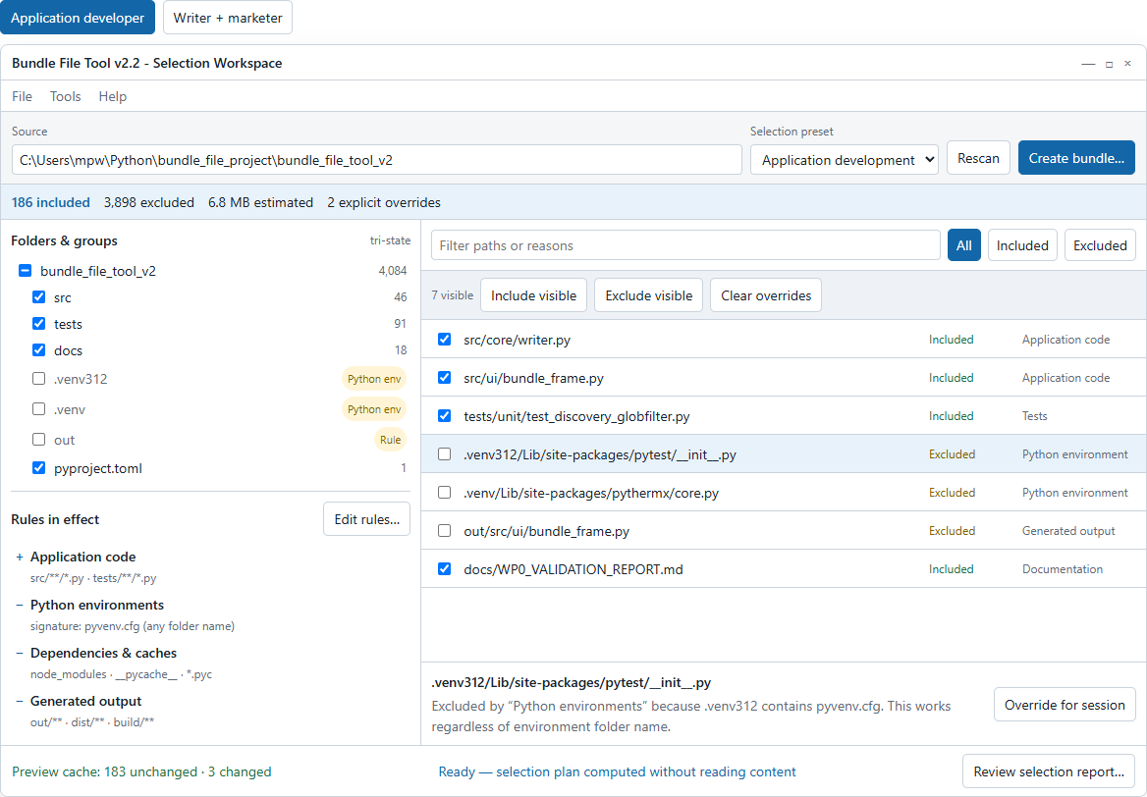
Figure 1. Application developer selection workspace: environment roots are visible, excluded, and explainable without expanding site-packages.
This directly addresses the supplied screenshot. The user sees .venv312 as an excluded root instead of thousands of selected site-package files. If the environment genuinely contains material they need, Override for session is available and the resulting exception remains visible in the summary and report.

9. Rendering B — writer and marketer
The same interface supports a different mental model without becoming a different product. The Book + campaign preset organizes content into Manuscript, Research, Marketing campaign, and Reference images. Exports, archives, and large video masters are excluded. Group order controls bundle order while inclusion remains independently inspectable.
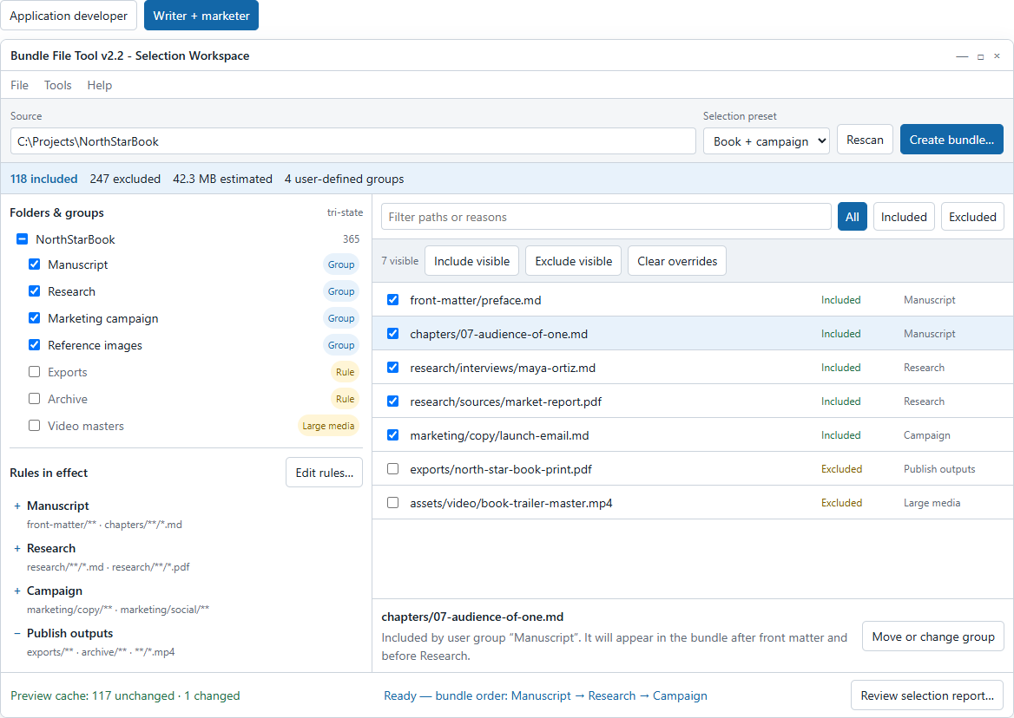
Figure 2. Writer and marketer selection workspace: user-defined groups make bundle composition and narrative order explicit.
A chapter can be moved within the manuscript group or assigned to another group without rereading its contents. The group arrangement supplies a deterministic presentation order: front matter, chapters, research, then campaign material. Existing bundle profiles may keep their transport grammar; ordering is supplied by the manifest sequence and duplicate paths remain prohibited.

10. Preview and performance contract

10.1 Separate planning from reading
- Scan metadata: normalized relative path, directory identity, size, mtime_ns, file family, and detector evidence.
- Compute SelectionPlan: evaluate rules, overrides, groups, counts, and deterministic order without opening file content.
- Build preview incrementally: reuse cached BundleEntry objects for unchanged included files; read only newly included or changed files.
- Finalize bundle: re-stat candidates, invalidate stale cache entries, read remaining changes, run integrity gates, then format once.

10.2 Cache and invalidation
The preview cache is in memory by default; file content is not persisted to user state. Each cache entry is keyed by normalized path and validated by size plus mtime_ns. When timestamp reliability is uncertain, BFT may retain a lightweight leading/trailing fingerprint. The final bundle path always revalidates metadata and rereads anything stale before the existing integrity gate.
User change | Planning work | Content reads
Uncheck one included file | Update one decision; remove from ordered view | 0
Check one previously excluded file | Update one decision and group | 1 file
Exclude a folder | Re-evaluate descendants from metadata index | 0
Change group order | Reorder selected paths | 0
Edit an include glob | Re-evaluate matcher against metadata index | Newly included or externally changed only
Create bundle | Revalidate plan snapshot | Stale / uncached included files only

10.3 Responsiveness rules
- Apply inclusion state immediately in the UI; debounce preview formatting for 250 ms so rapid checkbox changes coalesce.
- Tag each preview job with a generation number. A later selection invalidates stale results; cooperative cancellation stops obsolete reads between files.
- Virtualize the decision list beyond 5,000 rows; never create one Tk widget per file.
- Keep scan, plan, read, format, and complete as distinct progress phases so the operator can tell classification from content work.
- Report cache reuse in the footer and selection report; do not use a modal progress dialog for a cache-only selection change.

10.4 Performance acceptance gates
Gate | Target
SEL-PERF-001 | Unchecking one file in a 4,000-path plan performs zero file-content reads and updates visible counts within 50 ms p95 on the reference tree.
SEL-PERF-002 | Rapid changes within 250 ms produce one preview generation, not one generation per click.
SEL-PERF-003 | Including one uncached file reads exactly that file; unchanged selected files are cache hits.
SEL-PERF-004 | A detected Python environment is pruned before site-packages descent and appears as an excluded root in the report.
SEL-PERF-005 | Final bundle output is byte-identical to a cold rebuild for the same ordered plan and profile.

11. CLI specification
The CLI gains a read-only plan command and explicit rule-layer switches. Existing bundle invocations remain valid. The key compatibility correction is that command-line exclusions append to baseline safety rules; replacing defaults requires an explicit --no-default-rules switch. Existing --include retains allow-list behavior when present so automation does not silently broaden output.

11.1 New command and bundle options
Syntax | Meaning
bundle-tool plan SOURCE… | Compute and display a SelectionPlan without reading file content
--preset NAME | Apply a shipped or user preset
--rules PATH | Opt in to a project/shared rule file
--include GLOB | Legacy-compatible allow-list rule; repeatable
--exclude GLOB | Append an exclusion rule; repeatable; does not discard baseline rules
--force-include PATH_OR_GLOB | Session override of ordinary exclusions; hard safety remains
--force-exclude PATH_OR_GLOB | Highest-priority session exclusion
--group NAME=GLOB | Assign primary group and output order; repeatable
--list included|excluded|blocked|all | Choose decision rows printed in a human report
--explain PATH | Print the complete decision chain for one path
--report PATH --report-format text|json | Write a deterministic selection report
--no-default-rules | Disable ordinary shipped defaults; requires explicit intent and emits a warning

11.2 Developer examples
bundle-tool plan . --preset application-dev --list excluded
bundle-tool plan . --preset application-dev --explain .venv312/pyvenv.cfg
bundle-tool bundle . -o bft_source.txt --preset application-dev --report selection.json --report-format json
bundle-tool bundle . -o debug.txt --preset application-dev --force-include logs/latest.log

11.3 Writer and marketer examples
bundle-tool plan . --preset book-campaign --group "Manuscript=chapters/**/*.md"
bundle-tool bundle . -o review.txt --preset book-campaign --exclude "exports/**"
bundle-tool plan . --rules .bft-selection.json --list all --report selection.txt

11.4 Output purity
The established stdout contract remains: bundle content alone goes to stdout when --output is omitted. Human plan output goes to stdout only for the plan command. Bundle diagnostics, warnings, cache statistics, and selection-report paths go to stderr. JSON reports are deterministic, UTF-8, and contain no timestamps unless --include-runtime-metadata is requested.

12. Presets, grouping, and persistence

12.1 Ownership boundaries
Data | Location | Write policy
Governed baseline rules and detectors | bundle_config.json / packaged defaults | Read-only at runtime; delivery-kit controlled
Personal selection presets | %LOCALAPPDATA%/BundleFileTool/selection_presets/*.json | Explicit save/update from UI or CLI
Active preset and last UI view | user_state.json | Convenience state; non-fatal persistence
Shared project rules | .bft-selection.json | Explicit export/import or --rules; never silently authored
Preview content cache | Process memory | Not persisted by default
Selection report | User-chosen path or stdout for plan | Explicit export

12.2 Proposed rule-file schema
{
"schema_version": "1.0",
"name": "Book + campaign",
"base_action": "exclude",
"rules": [
{"id": "manuscript", "action": "include", "glob": "chapters/**/*.md", "group": "Manuscript"},
{"id": "research", "action": "include", "glob": "research/**/*", "group": "Research"},
{"id": "exports", "action": "exclude", "glob": "exports/**"}
],
"groups": ["Manuscript", "Research", "Campaign"]
}
Unknown fields are preserved for forward compatibility. Invalid rules fail loud with the rule id and field. Loading a project rule file from an untrusted source requires explicit opt-in because it can change which local files enter a bundle.

12.3 Group semantics
- A file is emitted once. The first matching group by configured group order becomes its primary group.
- Secondary group matches are visible in the inspector and report but do not duplicate bundle entries.
- Group order determines manifest order, followed by normalized path order within each group unless a user-defined path order is supplied.
- Existing transport profiles remain parse-compatible because grouping can be implemented as entry order first; serialized group metadata is a later, separately governed extension.
- Changing only group membership or order never rereads content.

13. Core and adapter architecture
Component | Responsibility
core/selection.py | Rule validation, precedence, decision chains, group assignment, deterministic SelectionPlan
core/detectors.py | Typed directory and file-family detectors; no Tkinter or CLI imports
core/selection_cache.py | Session metadata index and incremental BundleEntry cache
core/service.py | plan_bundle(), preview_bundle(), create_bundle(plan=…); owns integrity gates
ui/bundle_frame.py | Render the plan, collect overrides, debounce preview; never call BundleCreator directly
cli.py | Parse switches, call service, render text/JSON plan; preserve stdout purity

This feature should complete, not work around, the outstanding shared-facade direction. Both adapters submit source plus rule layers to BundleToolService. Core emits plan/read/format progress events and accepts the existing cancellation predicate. No UI model, CLI formatter, PyThermX class, or Tk object enters core.

13.1 Proposed service surface
plan = service.plan_bundle(sources, base_path, preset, rules, overrides, progress, cancel)
preview = service.preview_bundle(plan, cache, profile, progress, cancel)
result = service.create_bundle(plan, cache, profile, output_path, progress, cancel)
report = service.explain_selection(plan, path=None, format="json")

14. Accessibility and usability requirements
- Use native checkbox semantics, including mixed state for folders; expose labels and state to assistive technology.
- Support full keyboard operation without requiring multi-selection or pointer-only drag behavior.
- Pair every color state with text (Included, Excluded, Blocked, Override, Detector).
- Announce summary-count changes and completed plan refreshes politely; do not announce every scan tick.
- Retain focus after plan recomputation and restore the nearest surviving row after filtering.
- Allow interface scaling and high-contrast themes; paths and rule reasons must wrap or elide with an accessible full value.
- Confirm destructive-looking bulk actions with exact scope only when they create more than a configurable threshold of overrides; do not interrupt ordinary single changes.

15. Error, warning, and cancellation behavior
Condition | Required behavior
Invalid glob or matcher | Reject Apply; identify rule and validation reason; keep prior valid plan active
Unreadable directory | Show Unknown/Blocked root with error detail; do not claim it is empty
File changes after plan | Mark stale, invalidate one cache entry, reread on preview/finalize
Cancelled scan | Keep last complete plan visible; mark new plan cancelled; no partial plan becomes authoritative
Cancelled preview | Keep last complete preview; discard partial generation
Cancelled bundle | Retain existing Build 112 cancellation semantics and report any completed output as applicable
Rule-file schema newer than supported | Fail loud or open read-only after explicit confirmation; never reinterpret silently

16. Non-goals for the first release
- No AI-generated file classification or natural-language rules. Typed deterministic matchers are sufficient for v1.
- No automatic edits to .gitignore, .dockerignore, or project source files.
- No persistent cache of file contents by default.
- No regular-expression matcher until glob, exact path, detector, type, and size matchers prove insufficient.
- No duplicate bundle entries for multi-group membership.
- No breaking change to plain_marker or markdown_fence transport grammar in the selection release.
- No silent trust of a project rule file discovered in an arbitrary source tree.

17. Delivery plan
The work should ship in independently testable governed increments. UI polish must not precede the core selection contract; otherwise the GUI will become another source of policy logic.
Work package | Scope | Exit gate
WP1 — Selection core | Models, rule evaluation, decision chains, report | Deterministic plans and precedence tests
WP2 — Detectors & pruning | Python environment detector and typed directory classifiers | .venv312 pruned before descent with explainable evidence
WP3 — Service & CLI | Facade methods, plan command, flags, JSON report | CLI/UI-ready contract; stdout purity and cancellation proven
WP4 — Desktop workspace | Tri-state tree, result list, inspector, rule editor | 4,000-path UX and accessibility gates pass
WP5 — Incremental preview | Metadata index, cache, debounce, generation cancellation | Single toggle causes zero unchanged reads
WP6 — Presets & groups | Personal storage, opt-in project files, output order | Developer and writer scenarios round-trip deterministically

18. Acceptance criteria

18.1 Functional and transparency
- SEL-F-001: A source tree containing .venv312 is classified as a Python environment by signature and excluded by the application-development preset.
- SEL-F-002: Every visible decision exposes final state, winning rule label, layer, and override status.
- SEL-F-003: Folder include/exclude creates a scoped override and updates descendant outcomes without creating per-file persisted mutations.
- SEL-F-004: All, Included, Excluded, Blocked, and search views report counts consistent with the SelectionPlan.
- SEL-F-005: User-defined groups produce deterministic manifest order with no duplicate paths.
- SEL-F-006: The text and JSON selection reports reconcile exactly with the final manifest and skipped-entry report.

18.2 Cross-surface and governance
- SEL-X-001: The same sources, preset, rule file, and overrides produce the same ordered decisions in service, CLI, and Tkinter adapter tests.
- SEL-X-002: Neither UI nor CLI reimplements precedence or detector logic.
- SEL-GOV-001: Runtime operations never write bundle_config.json or another governed payload.
- SEL-GOV-002: Personal presets persist outside the installation root and corrupt preset files fail non-destructively.
- SEL-GOV-003: A project rule file is inactive until the user or command explicitly opts in.
- SEL-GOV-004: Existing integrity, oversized-file, cancellation, and output-purity gates remain live.

18.3 Regression and quality
- All existing bundle/unbundle profile round-trip tests pass unchanged unless a test intentionally targets corrected selection semantics.
- Cold and cache-assisted bundle generation are byte-identical for the same ordered plan.
- No skipped Tk tests are counted as UI acceptance; the established session-scoped Tk root remains in use.
- Reference trees cover Windows and POSIX environment layouts, environment names with versions, spaces, Unicode, nested source roots, and multiple source paths.
- The two persona scenarios shown in this document are executable acceptance fixtures, not screenshot-only demonstrations.

19. Decisions requested
For Ringo: Approve the Selection Workspace as the bundle-mode interaction model and confirm that personal presets plus opt-in project rule files are the intended control range.
For George: Ratify the precedence ladder, especially whether a session force-include may override ordinary environment detectors while hard safety remains non-overridable. Confirm that group metadata stays out of transport grammar for the first release.
For John: Validate the work-package boundaries and the requirement that UI and CLI migrate through BundleToolService rather than adding new direct BundleCreator paths. Confirm the cache-generation and directory-detector seams before implementation begins.

20. Analyst recommendation
Proceed with a design round and ratify WP1-WP2 before UI implementation. The immediate .venv312 symptom is real, but patching only a glob would leave the user with the same flat, opaque, reread-heavy workflow and would lose the pruning benefit that Build 110 deliberately established. The shared SelectionPlan is the smallest architectural move that solves the screenshot, the performance complaint, the UI/CLI divergence, and the broader cross-user requirement together.

