**SonarQube**

Login: https://sonarqube-https-dso-tooling-sonar.apps.ocp1.azure.dso.digital.mod.uk/

Assumption is Google id is created or supply login credentials

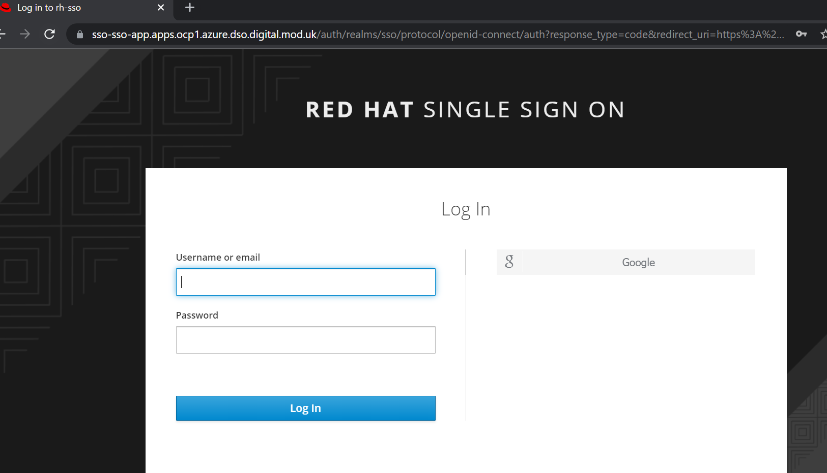

Users need to be in right group or get added by administrator.

Click on my account -> profile

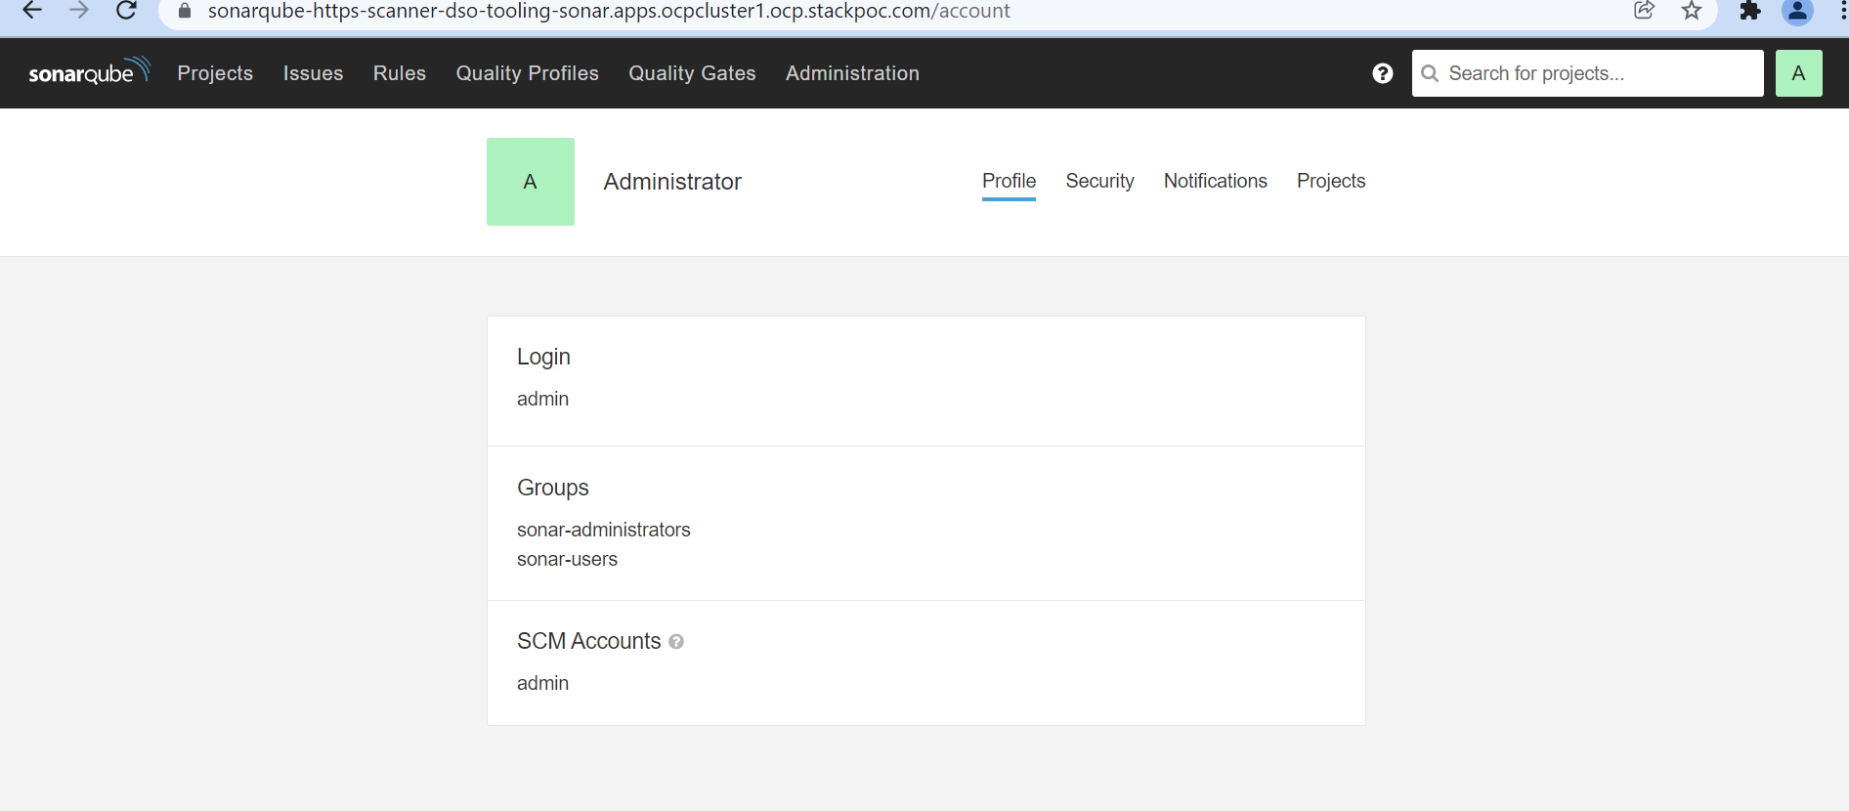

Create new project if the project is not already present on SonarQube dashboard.

Click on project -> new project

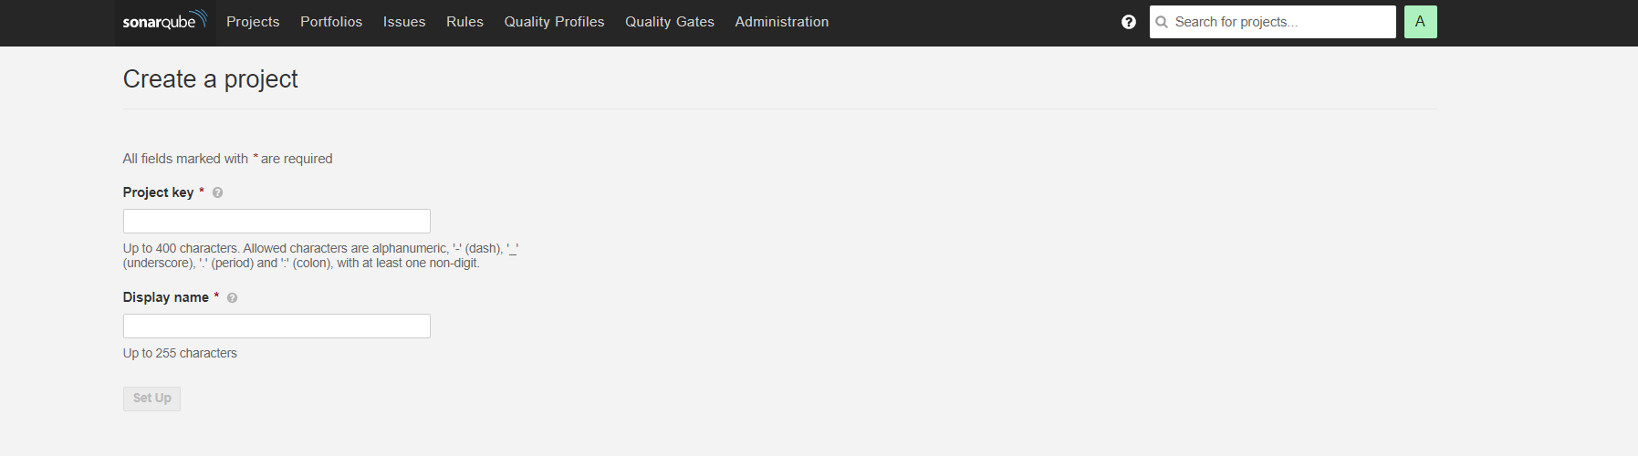

Example screenshot for new project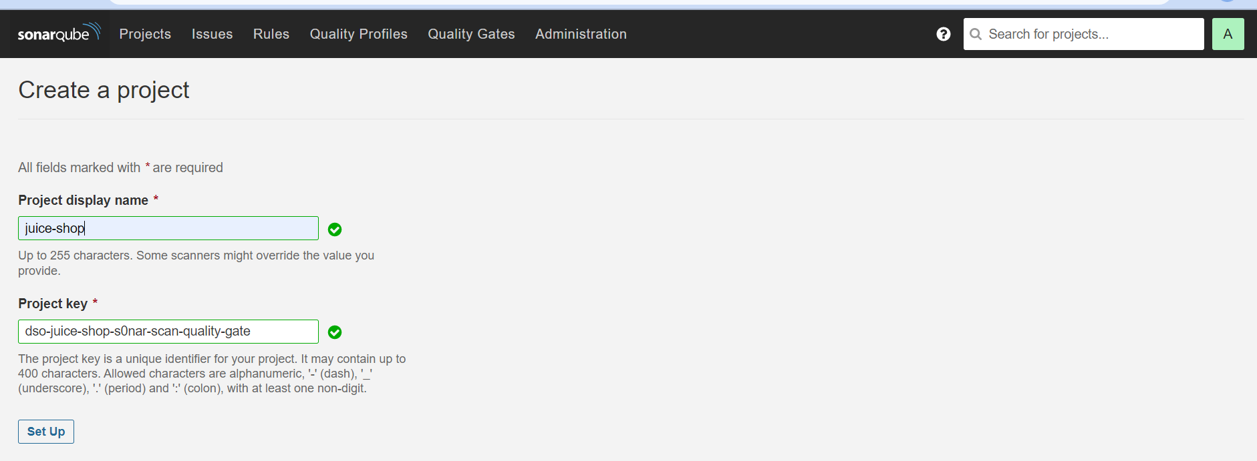

Generate token if not available, Click on my account -> security

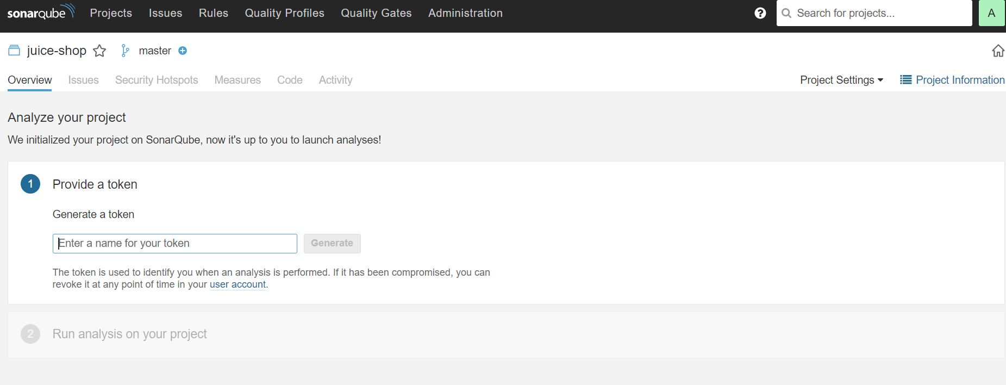

Example generating token

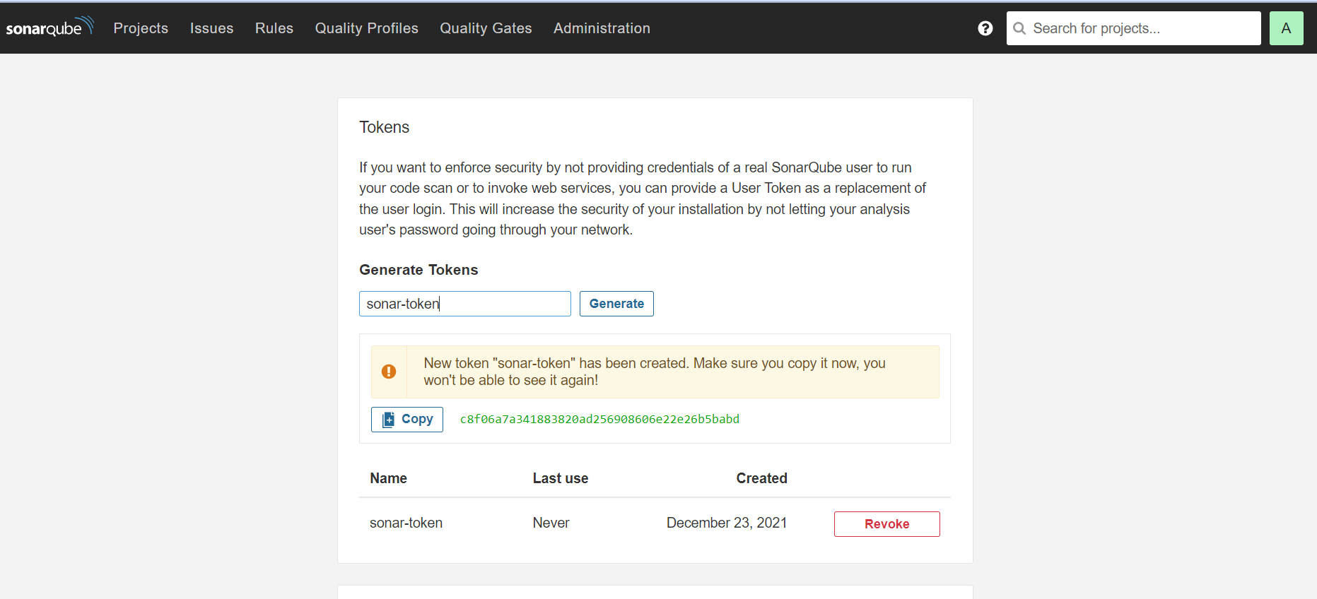

Add **sonar-project. properties** file in the project, that level in the project hierarchy.

Following info which we have created in previous steps:

*sonar.projectKey=dso-juice-shop-s0nar-scan-quality-gate*

*sonar.projectname=juice-shop*

*sonar.login=###############################<token>*

*sonar.host.url=https://sonarqube-https-dso-tooling-sonar.apps.ocp1.azure.dso.digital.mod.uk/*

Update following content for sonar scanner in pipeline if not exist.

*- name: sonarqube-scanner*

*params:*

*- name: SONAR_HOST_URL*

*value: https://sonarqube-https-scanner-dso-tooling-sonar.apps.ocp1.azure.dso.digital.mod.uk*

*- name: SONAR_PROJECT_KEY*

*value: juice-shop*

*- name: REPO_NAME*

*value: "$(params.REPO_NAME)"*

*taskRef:*

*name: sonarqube-scanner*

*workspaces:*

*- name: source-dir*

*workspace: shared-data*

*- name: sonar-settings*

*workspace: shared-data*

*runAfter:*

*- fetch-repo*

Refer Example: <https://github.com/defencedigital/dso-pipeline-integration/blob/master/juice-shop/Pipeline/PipelineRun.yaml>

**Sonar Dashboard**

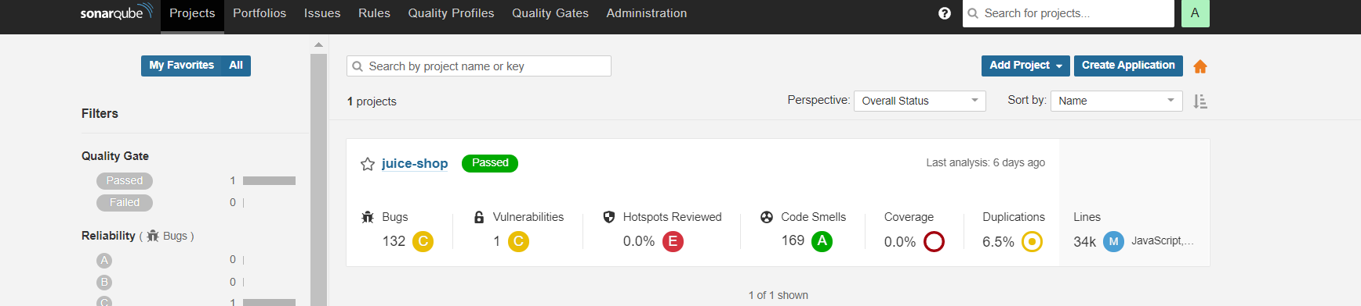

**Adding Quality Gate:**

