**Somadores de 1 e 8 bits**

(junho de 2018)

Mateus Felipe Da Silva Junges

**Abstract**—These instructions give you guidelines for preparing papers for IEEE Computer Society Transactions. Use this document as a template if you are using Microsoft Word 6.0 or later. Otherwise, use this document as an instruction set. Please note that use of IEEE Computer Society templates is meant to assist authors in correctly formatting manuscripts for final submission and does not guarantee how the final paper will be formatted by IEEE Computer Society staff. This template may be used for initial submissions; however, please consult the author submission guidelines for formatting instructions as most journals prefer single column format for peer review. An abstract should be 100 to 200 words for regular papers, no more than 50 words for short papers and comments, and should clearly state the nature and significance of the paper. Abstracts *must not* include mathematical expressions or bibliographic references. Please note that abstracts are formatted as left justified in our editing template (as shown here).

**Index Terms**—Keywords should be taken from the taxonomy (http://www.computer.org/mc/keywords/keywords.htm). Keywords should closely reflect the topic and should optimally characterize the paper. Use about four key words or phrases in alphabetical order, separated by commas (there should not be a period at the end of the index terms)

xxxx-xxxx/0x/$xx.00 © 200x IEEE Published by the IEEE Computer Society

————————————————

1. F.A. Author is with the National Institute of Standards and Technology, Boulder, CO 80305. E-mail: author@ boulder.nist.gov.
2. S.B. Author Jr. is with the Department of Physics, Colorado State University, Fort Collins, CO 80523. E-mail: author@colostate.edu.
3. T.C. Author is with the Electrical Engineering Department, University of Colorado, Boulder, CO 80309. On leave from the National Research Institute for Metals, Tsukuba, Japan E-mail: [author@nrim.go.jp](mailto:author@nrim.go.jp).

**\*\*\*Please provide a complete mailing address for each author, as this is the address the 10 complimentary reprints of your paper will be sent**

*Please note that all acknowledgments should be placed at the end of the paper, before the bibliography (****note that corresponding authorship is not noted in affiliation box, but in acknowledgment section****).*

—————————— ◆ ——————————

# 1 Introdução

T

HIS document is a template for Microsoft Word versions 6.0 or later. If you are reading a paper version of this document, please download the electronic file from the [template download page](http://www.computer.org/portal/web/peerreviewjournals/author#templates) so you can use it to prepare your manuscript.

When you open the document, select “Page Layout” from the “View” menu in the menu bar (View | Page Layout), which allows you to see the footnotes. Then type over sections of the document or cut and paste from another document and then use markup styles. Please keep the template at 8.5” x 11”—do not set the template for A4 paper. The pull-down style menu is at the left of the Formatting Toolbar at the top of your Word window (for example, the style at this point in the document is “Text”). Highlight a section that you want to designate with a certain style, and then select the appropriate name on the style menu. The style will adjust your fonts and line spacing. Use italics for emphasis; do not underline. **Do not change the font sizes or line spacing to squeeze more text into a limited number of pages. Please be certain to follow all submission guidelines when formatting an article or it will be returned for reformatting.**

To modify the running headings, select View | Header and Footer. Click inside the text box to type the name of the journal the article is being submitted to and the manuscript identification number. Click the forward arrow in the pop-up tool bar to modify the header or footer on subsequent pages.

To insert images in Word*,* position the cursor at the insertion point and either use Insert | Picture | From File or copy the image to the Windows clipboard and then Edit | Paste Special | Picture (with “Float over text” unchecked).

IEEE Computer Society staff will edit and complete the final formatting of your paper.

# 2 Sínteses de um somador de 1 bit

## 2.1 Review Stage

Detailed submission guidelines can be found on the author resources Web pages. Author resource guidelines are specific to each journal, so please be sure to refer to the correct journal when seeking information. All authors are responsible for understanding these guidelines before submitting their manuscript. For further information on both submission guidelines, authors are strongly encouraged to refer to <http://www.computer.org/portal/web/peerreviewjournals/author>.

## 2.2 Final Stage

For papers accepted for publication, it is essential that the electronic version of the manuscript and artwork match the hardcopy exactly! The quality and accuracy of the content of the electronic material submitted is crucial since the content is not recreated, but rather converted into the final published version.

All papers in IEEE Computer Society Transactions are edited electronically. A final submission materials check list, transmission and compression information, and general publication materials can be found at: <http://www.computer.org/portal/web/peerreviewjournals/author>.

## 2.3 Figures

All tables and figures will be processed as images. You will have the greatest control over the appearance of your figures if you are able to prepare electronic image files. Save them to a file in PostScript (PS) or Encapsulated PostScript (EPS) formats. Use a separate file for each image. File names should be of the form “fig1.ps” or “fig2.eps.”

For more information on how to format your figure or table files for final submission, please go to <http://www.computer.org/portal/web/peerreviewjournals/author#figures> and [View transactions art_guide.pdf (PDF, 4.69MB)](http://www.computer.org/cms/Computer.org/Journal%20templates/transactions_art_guide.pdf).

## Copyright Form

An IEEE Computer Society copyright form must accompany your final submission. You can get a .pdf, .html, or .doc version at <http://computer.org/copyright.htm>. Authors are responsible for obtaining any security clearances.

For any questions about initial or final submission requirements, please contact one of our staff members. Contact information can be found at: <http://www.computer.org/portal/web/volunteercenter/staff>.

# 3 síntese de um somador de 8 bits

As demonstrated in this document, the numbering of sections is upper case Arabic numerals, then upper case Arabic numerals, separated by periods. Initial paragraphs after the section title are not indented. Only the initial, introductory paragraph has a drop cap.

IEEE Computer Society style is to note citations in individual brackets, followed by a comma, e.g. “[1], [5]” (as opposed to the more common “[1, 5]” form.) Citation ranges should be formatted as follows: [1], [2], [3], [4] (as opposed to [1]-[4], which is not IEEE Computer Society style). When citing a section in a book, please give the relevant page numbers [2]. In sentences, refer simply to the reference number, as in [3]. Do not use “Ref. [3]” or “reference [3]” At the beginning of a sentence use the author names instead of “Reference [3],” e.g., “Smith and Smith [3] show ... .” Please note that references will be formatted by IEEE Computer Society production staff in the same order provided by the author.

If you are using Word, use the MathType add-on (<http://www.mathtype.com>) for equations in your paper (Insert | Object | Create New | Microsoft Equation or MathType Equation). “Float over text” should not be selected.

For display equations as seen below, number equations consecutively with equation numbers in parentheses flush with the right margin, as in (1). First, use the equation editor to create the equation. Then, select the “Equation” markup style. Press the tab key and write the equation number in parentheses. To make your equations more compact, you may use the solidus ( / ), the exp function, or appropriate exponents. Use parentheses to avoid ambiguities in denominators. Punctuate equations when they are part of a sentence, as in

 (1)

Be sure that the symbols in your equation have been defined before the equation appears or immediately following. Italicize symbols (*T* might refer to temperature, but T is the unit tesla). Per IEEE Computer Society, please refer to “(1),” not “Eq. (1)” or “equation (1),” except at the beginning of a sentence: “Equation (1) shows ... .” Also see *The Handbook of Writing for the Mathematical Sciences*, 1993. Published by the Society for Industrial and Applied Mathematics, this handbook provides some helpful information about math typography and other stylistic matters. For further information about typesetting mathematical equations, please visit the IEEE Computer Society style guide: <http://www.computer.org/portal/web/publications/style_math>.

Please note that math equations might need to be reformatted from the original submission for page layout reasons. This includes the possibility that some in-line equations will be made display equations to create better flow in a paragraph. If display equations do not fit in the two-column format, they will also be reformatted. Authors are strongly encouraged to ensure that equations fit in the given column width.

# 4 portas lógicas cmos

## 4.1 Figures and Tables

Because IEEE Computer Society staff will do the final formatting of your paper, some figures may have to be moved from where they appeared in the original submission. Figures and tables should be sized as they are to appear in print. Figures or tables not correctly sized will be returned to the author for reformatting.

Detailed information about the creation and submission of images for articles can be found at <http://www.computer.org/portal/web/peerreviewjournals/author#figures> where you can [View transactions art_guide.pdf (PDF, 4.69MB)](http://www.computer.org/cms/Computer.org/Journal%20templates/transactions_art_guide.pdf) . We strongly encourage authors to carefully review the material posted here to avoid problems with incorrect files or poorly formatted graphics.

Place figure captions below the figures; place table titles above the tables. Figure captions appear as left justified. Table captions are restricted to one sentence and are formatted as title case. Any additional sentence in a table caption will be formatted as a footnote below the table (see Table 1 in this document). If your figure has two parts, include the labels “(a)” and “(b)” as part of the artwork. Please verify that the figures and tables you mention in the text actually exist. Figures and tables should be called out in sequential order, as this is how they will be placed in your paper. For example, avoid referring to figure “8” in the first paragraph of the article unless figure 8 will again be referred to after the reference to figure 7. **Please do not include figure captions as part of the figure. Do not put captions in “text boxes” linked to the figures. Do not put borders around the outside of your figures.** Per IEEE Computer Society, please use the abbreviation “Fig.” even at the beginning of a sentence. Do not abbreviate “Table.” Tables are numbered numerically.

For journals that use print for publication, please verify with IEEE Computer Society that the journal you are submitting to does indeed accept color before submitting final materials. **Do not use color unless it is necessary for the proper interpretation of your figures.**

Figures (graphs, charts, drawing or tables) should be named fig1.eps, fig2.ps, etc. If your figure has multiple parts, please submit as a single figure. Please do not give them descriptive names. Author photograph files should be named after the author’s LAST name. Please avoid naming files with the author’s first name or an abbreviated version of either name to avoid confusion. If a graphic is to appear in print as black and white, it should be saved and submitted as a black and white file (grayscale or bitmap.) If a graphic is to appear in color, it should be submitted as an RGB color file.

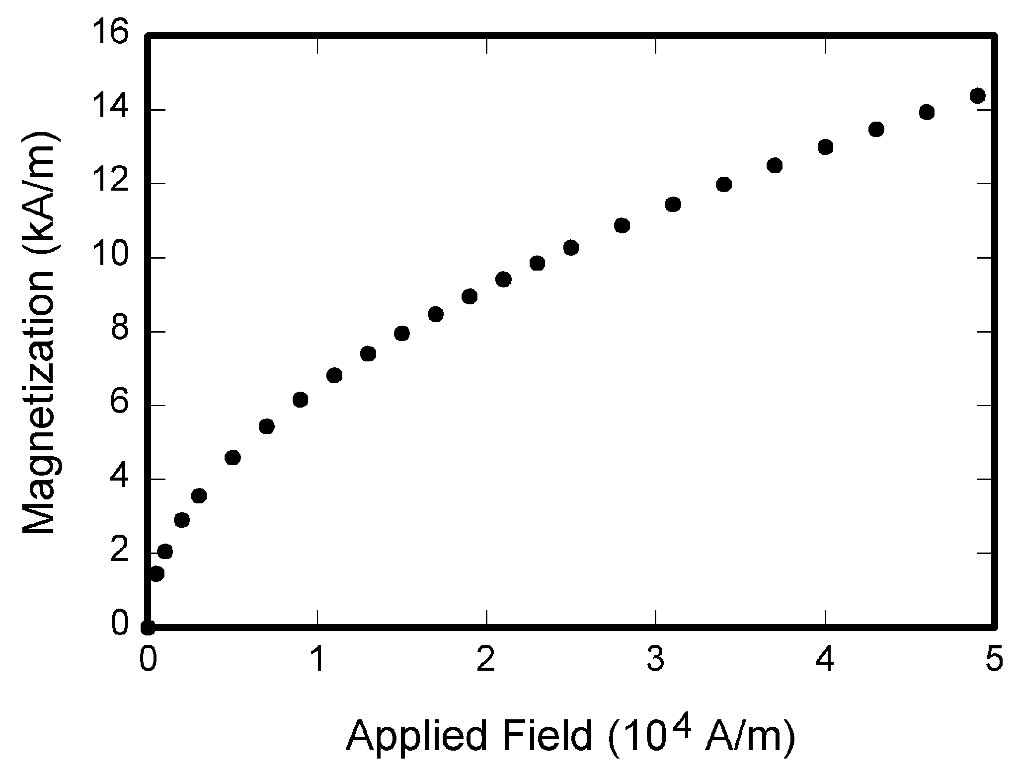

Fig. 1. Magnetization as a function of applied field. Note that “Fig.” is abbreviated. There is a period after the figure number, followed by one space. It is good practice to briefly explain the significance of the figure in the caption.

Figure axis labels are often a source of confusion. Use words rather than symbols. As an example, write the quantity “Magnetization,” or “Magnetization *M*,” not just “*M*.” Put units in parentheses. Do not label axes only with units. As in Fig. 1, for example, write “Magnetization (A/m)” or “Magnetization (Am−1),” not just “A/m.” Do not label axes with a ratio of quantities and units. For example, write “Temperature (K),” not “Temperature/K.” Table 1 shows some examples of units of measure.

Multipliers can be especially confusing. Write “Magnetization (kA/m)” or “Magnetization (103 A/m).” Do not write “Magnetization (A/m) × 1,000” because the reader would not know whether the top axis label in Fig. 1 meant 16,000 A/m or 0.016 A/m. Figure labels should be legible, approximately 8 to 12 point type. When creating your graphics, especially in complex graphs and charts, please ensure that line weights are thick enough that when reproduced at print size, they will still be legible. We suggest at least 1 point.

## 4.2 Footnotes

Number footnotes separately in superscripts (Insert | Footnote)[1]. Place the actual footnote at the bottom of the column in which it is cited; do not put footnotes in the reference list (endnotes). Use letters for table footnotes (see Table 1). Please do not include footnotes in the abstract and avoid using a footnote in the first column of the article. This will cause it to appear above the affiliation box, making the layout look confusing.

TABLE 1  
Units for Magnetic Properties

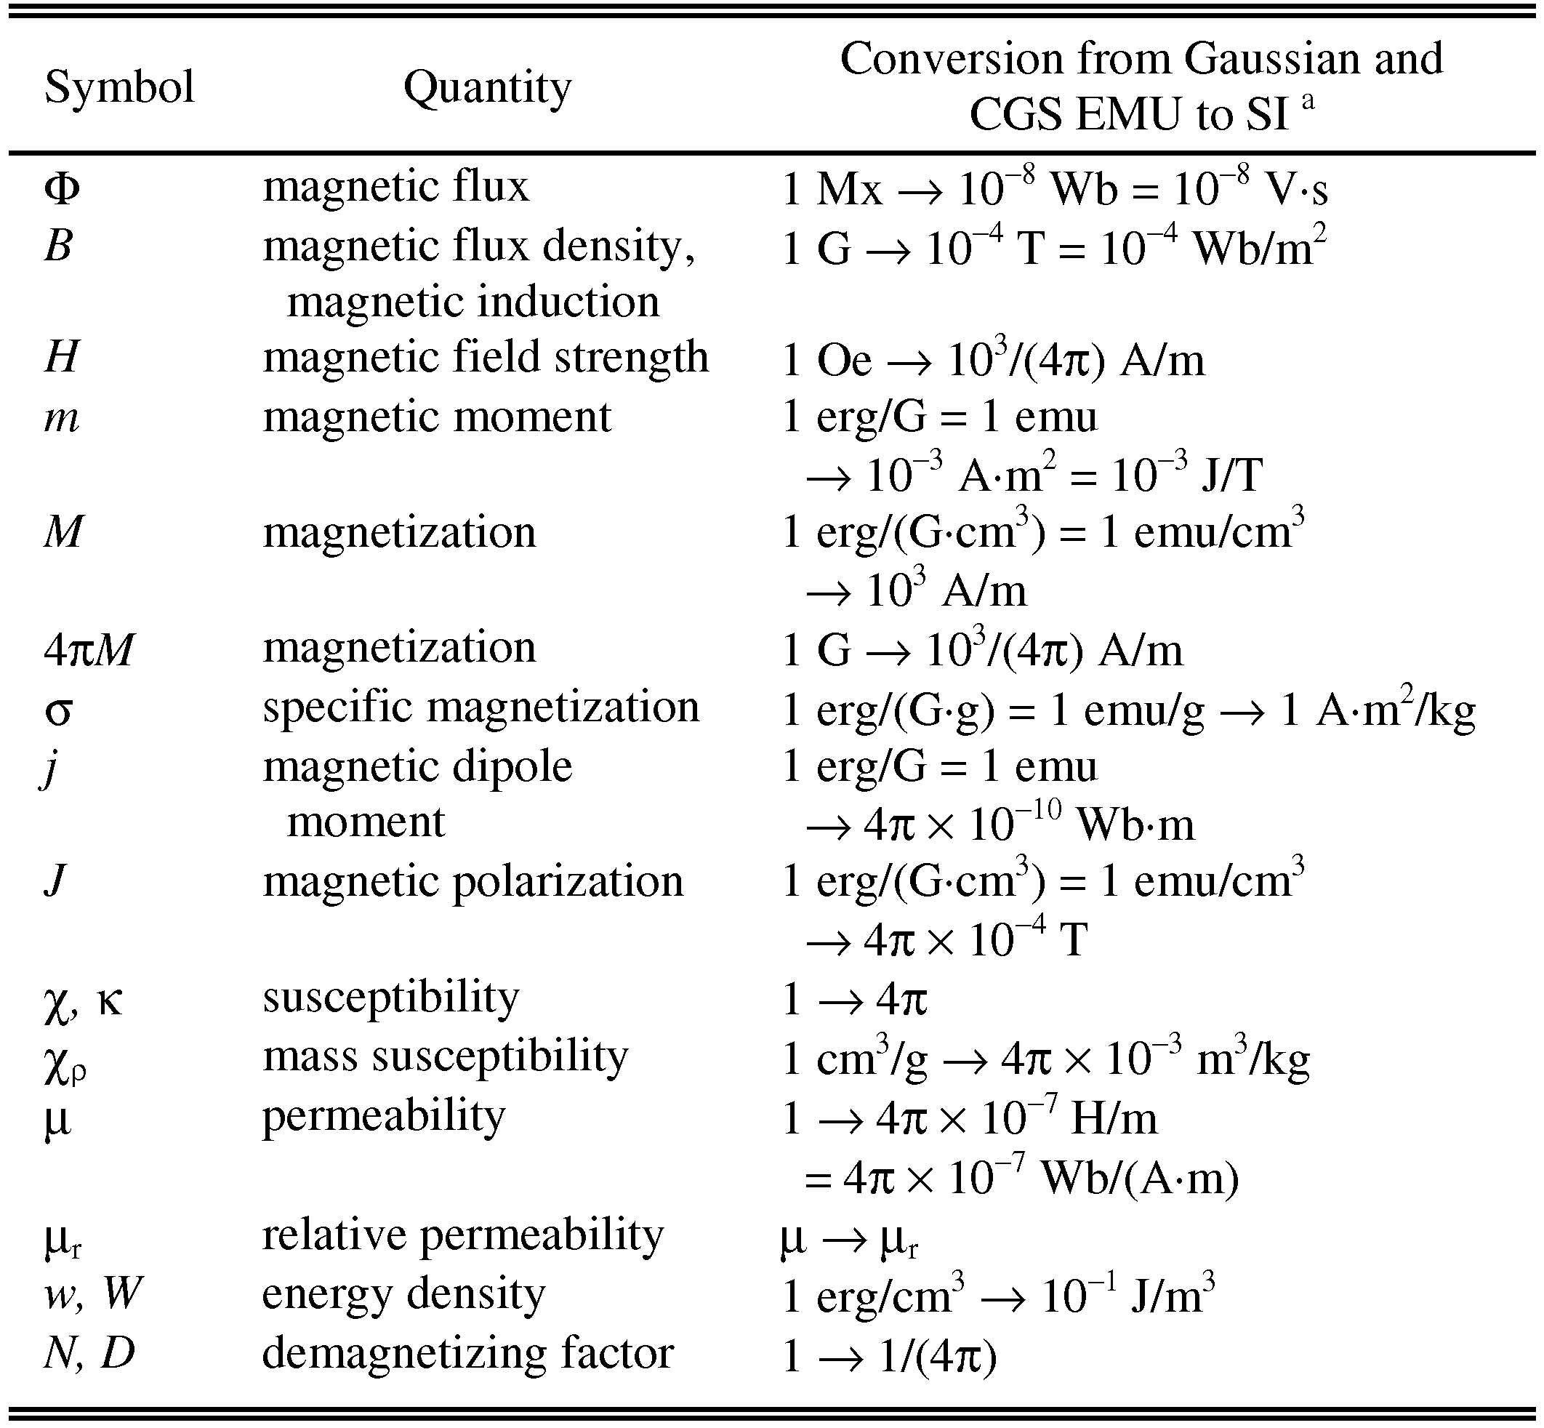

Statements that serve as captions for the entire table do not need footnote letters.

aGaussian units are the same as cgs emu for magnetostatics; Mx = maxwell, G = gauss, Oe = oersted; Wb = weber, V = volt, s = second, T = tesla, m = meter, A = ampere, J = joule, kg = kilogram, H = henry.

## 4.3 Lists

The IEEE Computer Society style is to create displayed lists if the number of items in the list is longer than three. For example, within the text lists would appear 1) using a number, 2) followed by a close parenthesis. However, longer lists will be formatted so that:

1. Items will be set outside of the paragraphs.
2. Items will be punctuated as sentences where it is appropriate.
3. Items will be numbered, followed by a period.

## 4.4 Theorems and Proofs

Theorems and related structures, such as axioms corollaries, and lemmas, are formatted using a hanging indent paragraph. They begin with a title and are followed by the text, in italics.

**Theorem 1.** *Theorems, corollaries, lemmas, and related structures follow this format. They do not need to be numbered, but are generally numbered sequentially.*

Proofs are formatted using the same hanging indent format. However, they are not italicized.

**Proof.** The same format should be used for structures such as remarks, examples, and solutions (though these would not have a Q.E.D. box at the end as a proof does). □

# 5 Implementação física de um somador de 1 bit

## 5.1 Appendices

Appendices, if present, appear online as supplemental material. In the event multiple appendices are required, they will be labeled “Appendix A,” “Appendix B, “ etc.

IEEE Computer Society Transactions accepts supplemental materials for review with regular paper submissions. These materials may be published on our Digital Library with the electronic version of the paper and are available for free to Digital Library visitors. Please see our guidelines below for file specifications and information. Any submitted materials that do not follow these specifications will not be accepted. All materials must follow US copyright guidelines and may not include material previously copyrighted by another author, organization or company. More information can be found at <http://www.computer.org/portal/web/peerreviewjournals/author#supplemental>.

## 5.2 Acknowledgments

The preferred spelling of the word “acknowledgment” in American English is without an “e” after the “g.” Use the singular heading even if you have many acknowledgments. Avoid expressions such as “One of us (S.B.A.) would like to thank ... .” Instead, write “F. A. Author thanks ... .” Sponsor and financial support acknowledgments are included in the acknowledgment section. For example: This work was supported in part by the US Department of Commerce under Grant BS123456 (sponsor and financial support acknowledgment goes here). Researchers that contributed information or assistance to the article should also be acknowledged in this section. Also, if corresponding authorship is noted in your paper it will be placed in the acknowledgment section. Note that the acknowledgment section is placed at the end of the paper before the reference section.

## 5.3 References

Unfortunately, the Computer Society document translator cannot handle automatic endnotes in Word; therefore, type the reference list at the end of the paper using the “References” style. See the IEEE Computer Society’s style for reference formatting at: <http://www.computer.org/portal/web/publications/style_refs>. The order in which the references are submitted in the manuscript is the order they will appear in the final paper, i.e., references submitted nonalphabetized will remain that way.

Please note that the references at the end of this document are in the preferred referencing style. Within the text, use “et al.” when referencing a source with more than three authors. In the reference section, give all authors’ names; do not use “et al.” Do not place a space between an authors' initials. Papers that have not been published should be cited as “unpublished” [4]. Papers that have been submitted or accepted for publication should be cited as “submitted for publication” [5]. Please give affiliations and addresses for personal communications [6].

Capitalize all the words in a paper title. For papers published in journals not published in English, please give the English citation first, followed by the original foreign-language citation [7].

Additional information on formatting and style issues can be obtained in the IEEE Computer Society Style Guide, which is posted online at: <http://www.computer.org/portal/web/publications/styleguide>. Click on the appropriate topic under the Special Sections link.

# 6 Implementação física de um somador de 8 bit

## 6.1 Appendices

Appendices, if present, appear online as supplemental material. In the event multiple appendices are required, they will be labeled “Appendix A,” “Appendix B, “ etc.

IEEE Computer Society Transactions accepts supplemental materials for review with regular paper submissions. These materials may be published on our Digital Library with the electronic version of the paper and are available for free to Digital Library visitors. Please see our guidelines below for file specifications and information. Any submitted materials that do not follow these specifications will not be accepted. All materials must follow US copyright guidelines and may not include material previously copyrighted by another author, organization or company. More information can be found at <http://www.computer.org/portal/web/peerreviewjournals/author#supplemental>.

## 6.2 Acknowledgments

The preferred spelling of the word “acknowledgment” in American English is without an “e” after the “g.” Use the singular heading even if you have many acknowledgments. Avoid expressions such as “One of us (S.B.A.) would like to thank ... .” Instead, write “F. A. Author thanks ... .” Sponsor and financial support acknowledgments are included in the acknowledgment section. For example: This work was supported in part by the US Department of Commerce under Grant BS123456 (sponsor and financial support acknowledgment goes here). Researchers that contributed information or assistance to the article should also be acknowledged in this section. Also, if corresponding authorship is noted in your paper it will be placed in the acknowledgment section. Note that the acknowledgment section is placed at the end of the paper before the reference section.

## 6.3 References

Unfortunately, the Computer Society document translator cannot handle automatic endnotes in Word; therefore, type the reference list at the end of the paper using the “References” style. See the IEEE Computer Society’s style for reference formatting at: <http://www.computer.org/portal/web/publications/style_refs>. The order in which the references are submitted in the manuscript is the order they will appear in the final paper, i.e., references submitted nonalphabetized will remain that way.

Please note that the references at the end of this document are in the preferred referencing style. Within the text, use “et al.” when referencing a source with more than three authors. In the reference section, give all authors’ names; do not use “et al.” Do not place a space between an authors' initials. Papers that have not been published should be cited as “unpublished” [4]. Papers that have been submitted or accepted for publication should be cited as “submitted for publication” [5]. Please give affiliations and addresses for personal communications [6].

Capitalize all the words in a paper title. For papers published in journals not published in English, please give the English citation first, followed by the original foreign-language citation [7].

Additional information on formatting and style issues can be obtained in the IEEE Computer Society Style Guide, which is posted online at: <http://www.computer.org/portal/web/publications/styleguide>. Click on the appropriate topic under the Special Sections link.

# 7 conclusão

Although a conclusion may review the main points of the paper, do not replicate the abstract as the conclusion. A conclusion might elaborate on the importance of the work or suggest applications and extensions. Authors are strongly encouraged not to reference multiple figures or tables in the conclusion—these should be referenced in the body of the paper.

**bibliografia**

1. J.S. Bridle, “Probabilistic Interpretation of Feedforward Classification Network Outputs, with Relationships to Statistical Pattern Recognition,” *Neurocomputing—Algorithms, Architectures and Applications,* F. Fogelman-Soulie and J. Herault, eds., NATO ASI Series F68, Berlin: Springer-Verlag, pp. 227-236, 1989. (Book style with paper title and editor)
2. W.-K. Chen, *Linear Networks and Systems.* Belmont, Calif.: Wadsworth, pp. 123-135, 1993. (Book style)
3. H. Poor, “A Hypertext History of Multiuser Dimensions,” *MUD History,* http://www.ccs.neu.edu/home/pb/mud-history.html. 1986. (URL link *include year)
4. K. Elissa, “An Overview of Decision Theory,"unpublished. (Unpublished manuscript)
5. R. Nicole, "The Last Word on Decision Theory," *J. Computer Vision,* submitted for publication. (Pending publication)
6. C. J. Kaufman, Rocky Mountain Research Laboratories, Boulder, Colo., personal communication, 1992. (Personal communication)
7. D.S. Coming and O.G. Staadt, "Velocity-Aligned Discrete Oriented Polytopes for Dynamic Collision Detection," *IEEE Trans. Visualization and Computer Graphics*, vol. 14,  no. 1,  pp. 1-12,  Jan/Feb  2008, doi:10.1109/TVCG.2007.70405. (IEEE Transactions )
8. S.P. Bingulac, “On the Compatibility of Adaptive Controllers,” *Proc. Fourth Ann. Allerton Conf. Circuits and Systems Theory*, pp. 8-16, 1994. (Conference proceedings)
9. H. Goto, Y. Hasegawa, and M. Tanaka, “Efficient Scheduling Focusing on the Duality of MPL Representation,” *Proc. IEEE Symp. Computational Intelligence in Scheduling* *(SCIS ’07)*, pp. 57-64, Apr. 2007, doi:10.1109/SCIS.2007.367670. (Conference proceedings)
10. J. Williams, “Narrow-Band Analyzer,” PhD dissertation, Dept. of Electrical Eng., Harvard Univ., Cambridge, Mass., 1993. (Thesis or dissertation)
11. E.E. Reber, R.L. Michell, and C.J. Carter, “Oxygen Absorption in the Earth’s Atmosphere,” Technical Report TR-0200 (420-46)-3, Aerospace Corp., Los Angeles, Calif., Nov. 1988. (Technical report with report number)
12. L. Hubert and P. Arabie, “Comparing Partitions,” *J. Classification,* vol. 2, no. 4, pp. 193-218, Apr. 1985. (Journal or magazine citation)
13. R.J. Vidmar, “On the Use of Atmospheric Plasmas as Electromagnetic Reflectors,” *IEEE Trans. Plasma Science*, vol. 21, no. 3, pp. 876-880, available at http://www.halcyon.com/pub/journals/21ps03-vidmar, Aug. 1992. (URL for Transaction, journal, or magzine)
14. J.M.P. Martinez, R.B. Llavori, M.J.A. Cabo, and T.B. Pedersen, "Integrating Data Warehouses with Web Data: A Survey," *IEEE Trans. Knowledge and Data Eng.*, preprint, 21 Dec. 2007, doi:10.1109/TKDE.2007.190746.(PrePrint)

**First A. Author** Allbiographies should be limited to one paragraph consisting of the following: sequentially ordered list of degrees, including years achieved; sequentially ordered places of employ concluding with current employment; association with any official journals or conferences; major professional and/or academic achievements, i.e., best paper awards, research grants, etc.; any publication information (number of papers and titles of books published); current research interests; association with any professional associations. Author membership information, e.g., is a member of the IEEE and the IEEE Computer Society, if applicable, is noted at the end of the biography.

**Second B. Author Jr.** biography appears here.

**Third C. Author** biography appears here.

1. It is recommended that footnotes be avoided (except for the unnumbered footnote with the receipt date on the first page). Instead, try to integrate the footnote information into the text.