**CPCZurich2022 Practical Tutorial A – Bayesian Learning using the HGF**

**Installation Guide**

**Authors / Tutors**: Tore Erdmann ([tore.erdmann@gmail.com](mailto:tore.erdmann@gmail.com)), Alex Hess ([hess@biomed.ee.ethz.ch](mailto:hess@biomed.ee.ethz.ch)), and Peter Thestrup Waade ([peter@waade.net](mailto:peter@waade.net)), Computational Psychiatry Course 2022, Zurich, Switzerland.

**Revision and testing**: Inês Pereira (pereira@biomed.ee.ethz.ch)

For the Hierarchical Gaussian Filter (HGF) tutorial, we will be coding together in [Google Colab](https://colab.research.google.com/notebooks/intro.ipynb), a web-based platform where users can run code in an interactive, notebook-style environment. You can think of Colab Notebooks as [Jupyter notebooks](https://jupyter-notebook.readthedocs.io/en/stable/) that are saved on Google Drive. The programming language used in this tutorial is [Julia](https://julialang.org/) and we will be mainly using the brand new [HGF Julia package](https://github.com/ilabcode/HGF.jl) to simulate and fit data with the HGF. Because everything in Google Colab is cloud-based, **you don’t need to install anything (not even Julia) locally** – the only requirement to use Google Colab is that you have a **Google account** and are logged into it.

We will be coding as a group, using the following Colab notebook:

<https://colab.research.google.com/drive/1vW6vIoyfrII67ZMErEWjtATrqmDfWcRg?usp=sharing>

Please open the Colab notebook given by the link above. The notebook will be “read only” access for you, but you can save your own copy of the notebook via “File 🡪 Save a Copy in Drive” (see screenshot below).

Once you have made a copy of the notebook, you can run and edit code in your own version. This will allow you to follow along and work on the prepared exercises at your own pace and explore the code in your own way.

Remark: Since Julia is not preinstalled within Google Colab services, the first cell needs to be run in order to install Julia, whenever you restart your browser. Please follow the instructions in the Colab notebook and run the first three cells: “Setup”, “Checking the Installation” and “Setup: Loading packages” (see screenshot below).

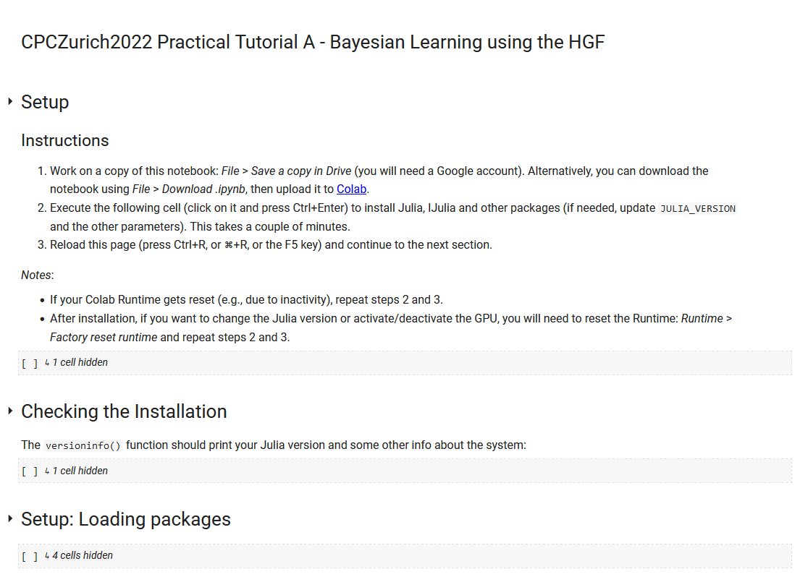

Once you have managed to execute the first three cells successfully, you’re all set up for the Practical Tutorial session ☺. (Remember that you will have to re-run these three cells taking care of the Julia installation in the beginning of the Practical Tutorial Session – or whenever you lose connection to the internet.)

Next to the code, we have prepared some slides to recap the basis of the HGF and to introduce you to the coding problems that we will be working on during the Practical Tutorial session. The slides can be found here: <https://github.com/toreerdmann/HGF-workshop>.

If you have trouble getting to this point before the Practical Tutorial Session, please consult the **#tutorial-helpdesk channel on Slack**. You will be given access to the CPC Slack workspace at the beginning of the course. Check if anyone has had the same issue and has managed to solve it and how. If no one else has encountered the same problem, post your question. **Peter, Tore and Alex** will be monitoring the channel and providing support. In addition, given the volume of attendees this year, we would be really grateful if you could assist us by answering queries on Slack yourself if you come across a problem you know and have solved.

For those who need more personalized help, Alex will be offering support hours. More information on the exact time will follow.