**CPCZurich2021 Practical Tutorial A – Bayesian Learning**

**Installation Guide**

**Authors / Tutors**: Tore Erdmann ([terdmann@sissa.it](mailto:terdmann@sissa.it)), Alex Hess ([hess@biomed.ee.ethz.ch](mailto:hess@biomed.ee.ethz.ch)), and Lilian Weber ([lilian.weber@psych.ox.ac.uk](mailto:lilian.weber@psych.ox.ac.uk)), Computational Psychiatry Course 2021, Zurich, Switzerland.

**Revision and testing**: Inês Pereira (pereira@biomed.ee.ethz.ch)

1. Make sure you install Matlab (Version 2016b or later) and that you can open and run it before installing the TAPAS Toolbox:

<https://www.mathworks.com/products/get-matlab.html>

1. Download the TAPAS Toolbox:

<https://translationalneuromodeling.github.io/tapas/> and unzip it.

1. Download the zip file of the workshop material:

<https://github.com/toreerdmann/HGF-workshop> and unzip it.

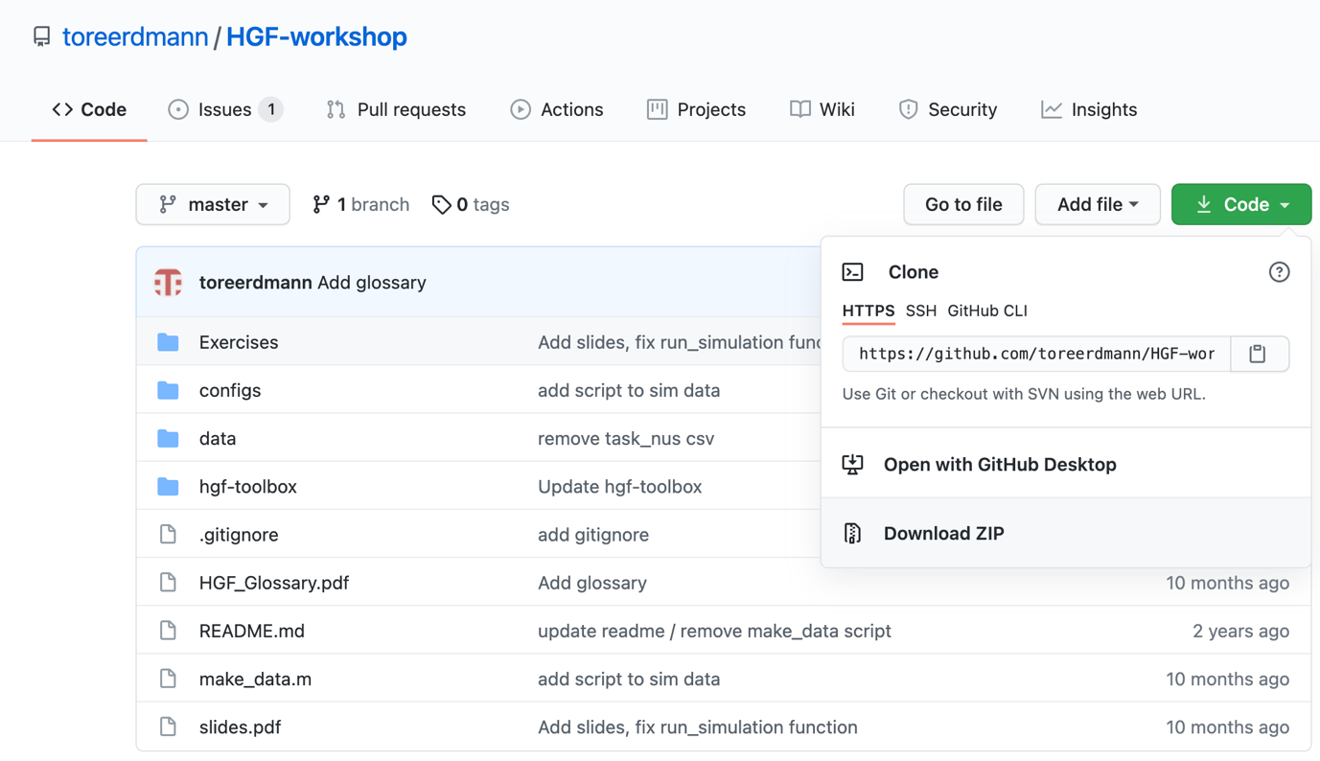

1. Put the toolbox folder and the material in a folder/directory which you will use for the practical tutorial (*e.g.*, Desktop/CPC2021/BayesianLearningTutorial).

**Make sure you do not have any spaces in the titles of your folders.**

1. **Don’t forget**: when you start the tutorial, you will have to open Matlab and, in Matlab, navigate to the folder/directory you prepared (*e.g.*, “BayesianLearningTutorial”). For that, use the “Current Folder” window. Then, right-click on this directory and on “Add to Path”, “Selected Folders and Subfolders” (See Figure 1 and Figure 2).

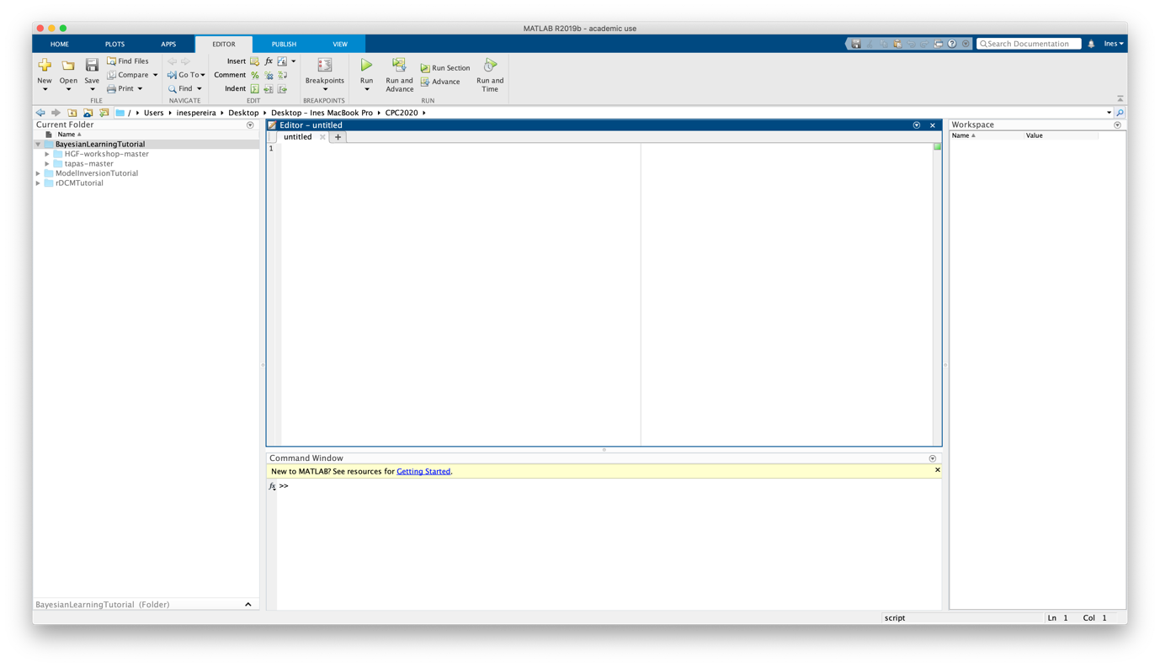Fig. 1: MATLAB graphical user interface with the Current Folder window highlighted.

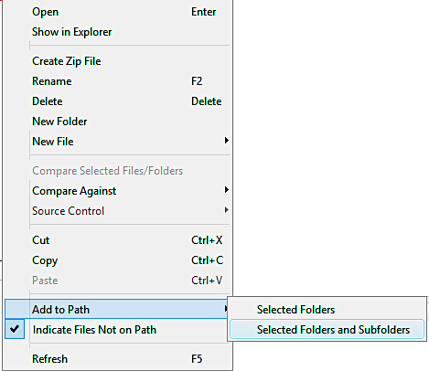

Fig. 2: Illustration of how to add a path (and all its subfolders) in MATLAB.

Well done! You’re all set up for the Practical Tutorial session.

If you have trouble getting to this point before the Practical Tutorial Session, please consult the **#tutorial-helpdesk channel on Slack**. You will be given access to the CPC Slack workspace at the beginning of the course. Check if anyone has had the same issue and has managed to solve it and how. If no one else has encountered the same problem, post your question. **Inês** will be monitoring the channel and providing support. In addition, given the volume of attendees this year, we would be really grateful if you could assist us by answering queries on Slack yourself if you come across a problem you know and have solved.

For those who need more personalized help, Inês will be offering support hours. More information on the exact time will follow.