**CPCZurich2022 Practical Tutorial B – Active Inference with SPM**

**Installation Guide**

**Authors / Tutors**: Ryan Smith ([rsmith@laureateinstitute.org](mailto:rsmith@laureateinstitute.org)), Christopher Whyte ([christopherjackwhyte@gmail.com](mailto:christopherjackwhyte@gmail.com%20)), and Rowan Hodson ([rhodson@laureateinstitute.org](mailto:rhodson@laureateinstitute.org)). Computational Psychiatry Course 2022, Zurich, Switzerland.

**Revision and Testing**: Alex Hess ([hess@biomed.ee.ethz.ch](mailto:hess@biomed.ee.ethz.ch))

1. Make sure you install Matlab and that you can open and run it: <https://www.mathworks.com/products/get-matlab.html>
2. Download SPM 12 (<https://www.fil.ion.ucl.ac.uk/spm/software/download/>).
3. Place the compressed spm12 folder in your preferred directory.
4. Open Matlab. You will see the following interface:

1. Add the SPM-folder to your search path from the Matlab ‘current folder’ window (column on the left in the above image).

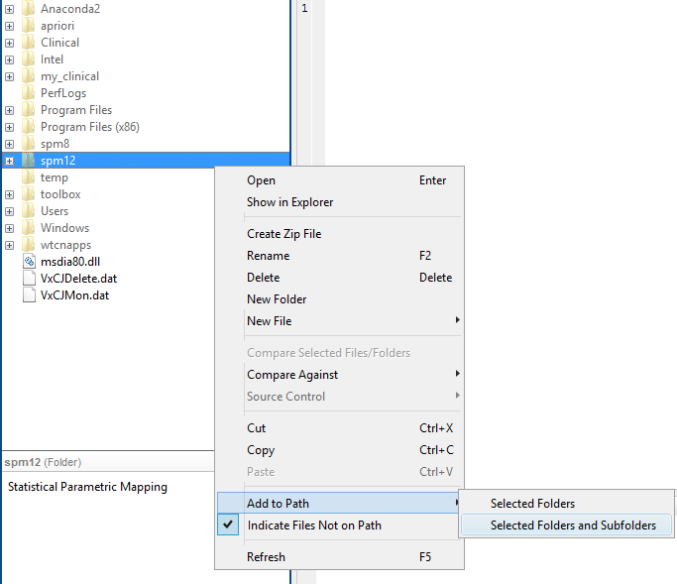

1. Next, type ‘DEM’ into the Matlab command window and press enter to open the DEM.

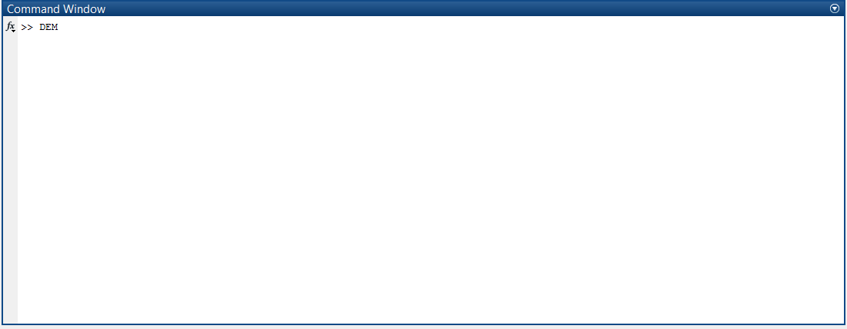

1. This invokes a graphical user interface that contains several worked examples of active inference (and much more). In the ‘Behaviour and learning (discrete)’ panel, click on the ‘+’ next to the ‘Habit learning’ button. Then click ‘run demo’ (in red text on the left).

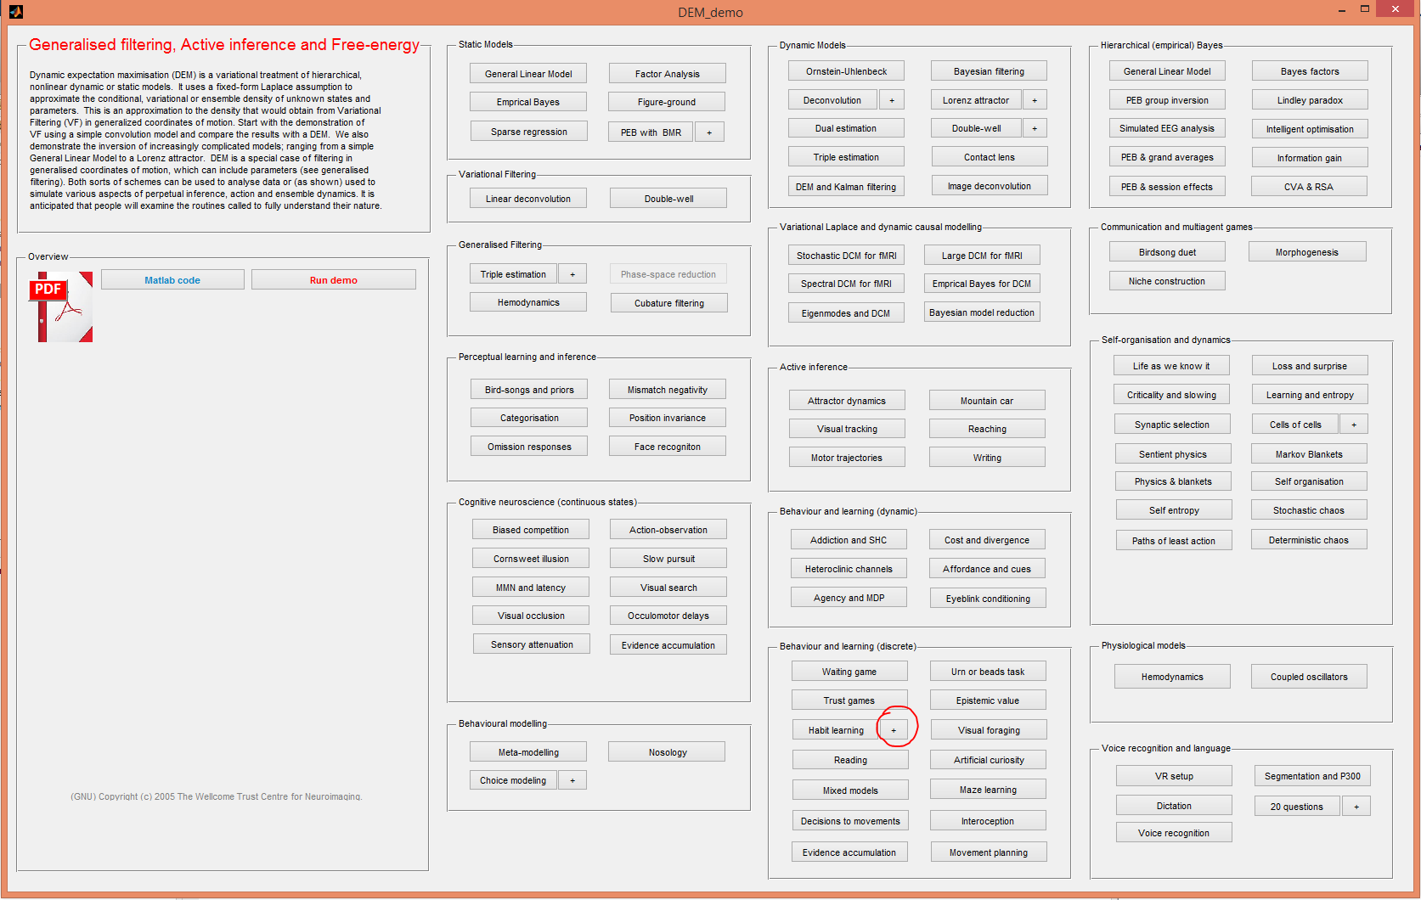

1. If this works without errors and you see several SPM figures illustrating different simulations (like the one reproduced below), then you have access to all the functions you need for the practical session and you are ready to go.

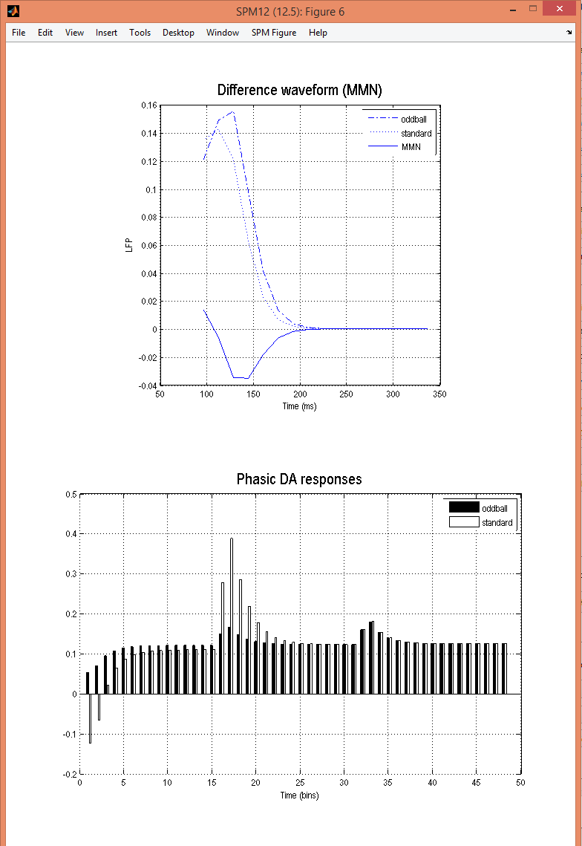

1. To close all the figures at once, just type ‘close all’ in the Matlab command window.

If you have trouble getting to this point before the Practical Tutorial Session, please consult the **#tutorial-helpdesk channel on Slack**. You will be given access to the CPC Slack workspace at the beginning of the course. Check if anyone has had the same issue and has managed to solve it and how. If no one else has encountered the same problem, post your question. **Christopher and Rowan** will be monitoring the channel and providing support. In addition, if you come across a problem you know and have solved, it would be great if you’d be willing to assist by answering queries on Slack yourself.

For those who need more personalized help, **Christopher and Rowan** will be available to offer support via Zoom upon request after the course.

__________________________________________________________________________

**If you have the following issues with MEX files on macOS Catalina**:

"*.mexmaci64" cannot be opened because the developer cannot be verified. macOS cannot verify that this app is free from malware" or "Code signature not valid for use in process using Library Validation: library load disallowed by system policy"

Please open a Terminal and navigate to the folder where you placed your spm12 folder. In the following example, the spm12 folder was placed in the Downloads folder.

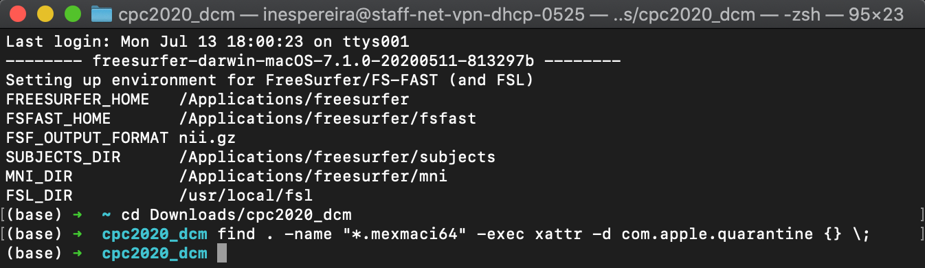

Then type the following command:

find . -name "*.mexmaci64" -exec xattr -d com.apple.quarantine {} \;



This should solve the problem and allow you to run the demo. This solution was taken from the SPM Wiki:

<https://en.wikibooks.org/wiki/SPM/Installation_on_64bit_Mac_OS_(Intel)#macOS_Catalina>