**CPCZurich2021 Practical Tutorial E – Model Inversion**

**Installation Guide**

**Authors / Tutors**: Lionel Rigoux ([lionel.rigoux@sf.mpg.de](mailto:lionel.rigoux@sf.mpg.de)) & Matthias Müller-Schrader (mueller-schrader@biomed.ee.ethz.ch), Computational Psychiatry Course 2021, Zurich, Switzerland.

**Revision and testing**: Inês Pereira (pereira@biomed.ee.ethz.ch)

1. Make sure you install Matlab and that you can open and run it before installing the VBA Toolbox: <https://www.mathworks.com/products/get-matlab.html>
2. Follow the instructions provided there: <https://mbb-team.github.io/VBA-toolbox/download/>

You will be provided with 2 possibilities to download the toolbox:

1. Downloading the toolbox via .zip File.
2. Cloning the toolbox. This allows you to keep up-to date with future changes in the toolbox. You will however need to install git on your machine.
3. For the purposes of the tutorial and if you do not have git, we advise you to use the first possibility and only download the .zip File. In that case, unzip the file and put it in a folder/directory which you will use for the practical tutorial (*e.g.,* Desktop/CPC2021/ModelInversionTutorial).
4. Open Matlab and, in Matlab, navigate to the folder/directory you prepared (*e.g.,* “ModelInversionTutorial”). Change your working directory (the folder you are currently in) to the VBA-toolbox folder by using the “Current Folder” window.

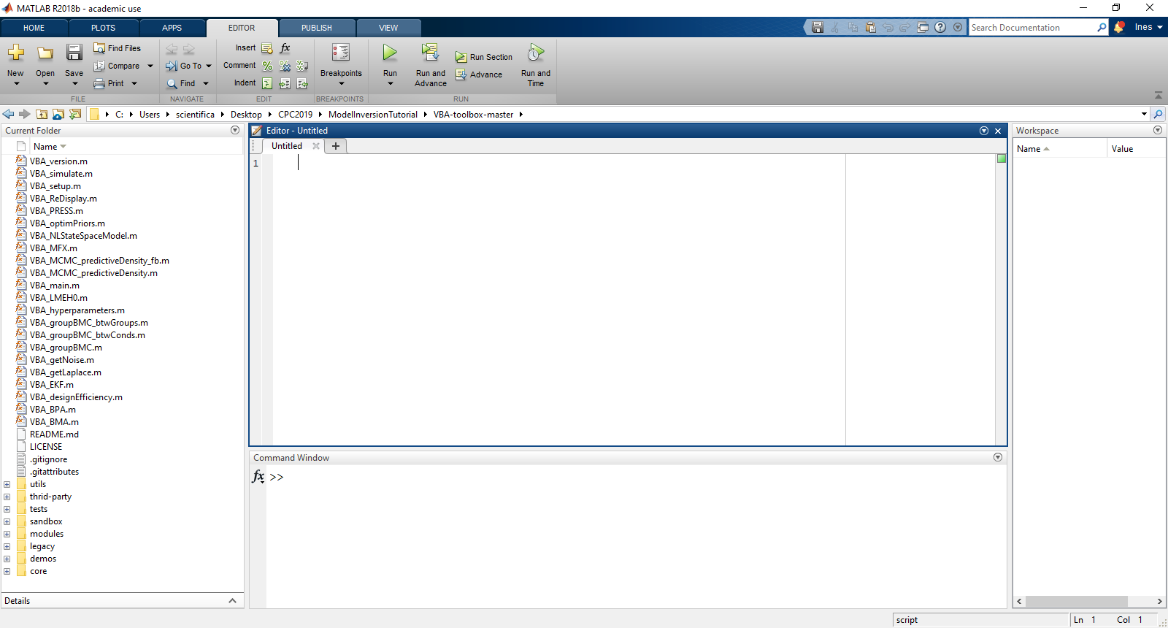Fig. 1: MATLAB graphical user interface with the Current Folder window highlighted.

1. In the Matlab Command Window run the following command.

VBA_setup()

1. Feel free to type demo_Qlearning to try a demo out and see if it runs!
2. To close all the figures at once, just type ‘close all’ in the Matlab command window.

You should be all set now and ready for the tutorial now ☺ !

If you cannot get enough of the VB-Toolbox, there is an entire wiki on the Toolbox to explore: <http://mbb-team.github.io/VBA-toolbox/wiki/>

If you have trouble getting to this point before the Practical Tutorial Session, please consult the **#tutorial-helpdesk channel on Slack**. You will be given access to the CPC Slack workspace at the beginning of the course. Check if anyone has had the same issue and has managed to solve it and how. If no one else has encountered the same problem, post your question. **Inês** will be monitoring the channel and providing support. In addition, given the volume of attendees this year, we would be really grateful if you could assist us by answering queries on Slack yourself if you come across a problem you know and have solved.

For those who need more personalized help, Inês will be offering support hours. More information on the exact time will follow.