**CPCZurich2022 Practical Tutorial H – Dynamic Causal Modeling for EEG**

**Installation Guide**

**Authors / Tutors**: Ashley Tyrer (ashley.tyrer@cfin.au.dk) and Herman Galioulline ([galioulline@biomed.ee.ethz.ch](mailto:galioulline@biomed.ee.ethz.ch)), Computational Psychiatry Course 2022, Zurich, Switzerland.

**Revision and testing**: Alex Hess ([hess@biomed.ee.ethz.ch](mailto:hess@biomed.ee.ethz.ch))

This description guides you through the installation of the code and data needed for the DCM for EEG tutorial. In case additional files are needed, we will inform you in time, so that you can also download them before the tutorial.

1. **Install MATLAB**

Make sure you install Matlab and that you can open and run it:

https://www.mathworks.com/products/get-matlab.html

1. **Download SPM12**

For this tutorial, you will need SPM12, which can be downloaded from <http://www.fil.ion.ucl.ac.uk/spm/software/spm12/>.

1. **Test the installation**
2. **Open Matlab**. You will see an interface similar to the following:

Fig. 1: Illustration of the MATLAB interface.

1. **Setup SPM:** Unzip the SPM12 zip-file and add the “spm12” folder to your Matlab path. To do this in Matlab, first navigate to the directory containing the spm12 folder. Then right-click on the spm12 directory and on “Add to Path”, “Selected Folders and Subfolders”.

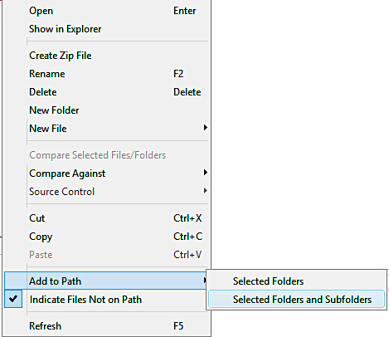

Fig. 2: Illustration of how to add a path (and all its subfolders) in MATLAB.

1. **Start SPM12**

Type “spm” into the command window and press Enter. If the installation was successful, this will open the SPM interface:

Fig. 3: Illustration of the SPM interface.

Well done! You’re all set up for the Practical Tutorial session.

If you have trouble getting to this point before the Practical Tutorial Session, please consult the **#tutorial-helpdesk channel on Slack**. You will be given access to the CPC Slack workspace at the beginning of the course. Check if anyone has had the same issue and has managed to solve it and how. If no one else has encountered the same problem, post your question. **Alex** will be monitoring the channel and providing support. In addition, given the volume of attendees this year, we would be really grateful if you could assist us by answering queries on Slack yourself if you come across a problem you know and have solved.

For those who need more personalized help, Alex will be offering support hours. More information on the exact time will follow.