**CPCZurich2022 Practical Tutorial I – Dynamic Causal Modeling for fMRI**

**Installation Guide**

**Authors / Tutors**: Jakob Heinzle ([heinzle@biomed.ee.ethz.ch](mailto:heinzle@biomed.ee.ethz.ch)) & Birte Toussaint (toussaint@biomed.ee.ethz.ch), Computational Psychiatry Course 2022, Zurich, Switzerland.

**Revision and testing**: Alex Hess ([hess@biomed.ee.ethz.ch](mailto:hess@biomed.ee.ethz.ch))

This description guides you through the installation of the code and data needed for the DCM for fMRI tutorial. In case additional files are needed, we will inform you in time, so that you can also download them before the tutorial.

1. **MATLAB**

Make sure you install MATLAB and that you can open and run it:

https://www.mathworks.com/products/get-matlab.html

We have not fully tested this, but to our knowledge you should be able to run the tutorial with the student version.

1. **Download and Setup**

Download the folder cpc2022_dcm_students.zip. To do so, go to:

https://www.tnu.ethz.ch/en/team/faculty-and-scientific-staff/heinzle/

Click on the "Download for DCM Tutorial" link under CP Course 2022 at the bottom of the page. You will be asked for a password, which is cPc2022dCm. Unzip the folder so that you have (somewhere on your computer) a folder called cpc2022_dcm.

**Notes**

1. Files that come with this tutorial folder include:

* setup_demo_cpc.m → Under the code/ folder. Checks whether your installation and all paths are set up correctly.
* cpc_glm_dcm_subject.m → Under the code/ folder. Runs an analysis on a visuomotor data set.
* data/visuomotor/Sub01 → Folder containing preprocessed functional data, behavioral information and movement regressors for a single subject.

1. External sources for software and data **included** in this tutorial folder (**no need** to download separately):

* SPM12 - SPM 12 can be downloaded from <https://github.com/spm/spm12> or from <http://www.fil.ion.ucl.ac.uk/spm/software/spm12/> .

1. **Test the installation**

Check your SPM installation and the files:

1. Open Matlab. You will see an interface similar to this:

1. Make sure the file setup_demo_cpc.m is in your code/ folder.
2. Go to the code/ folder using the Current Folder window.
3. Run output = setup_demo_cpc() in the Command Window.

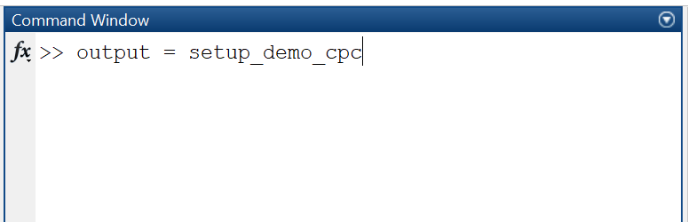

You will get some feedback on the screen and output should be a vector [1 1].

1. **Run the first-level analysis on the tutorial data**

In order to be ready for the tutorial, you need to run a first-level model analysis (GLM) with spm. In Matlab, go again to your code/ folder and type cpc_glm_dcm_subject.

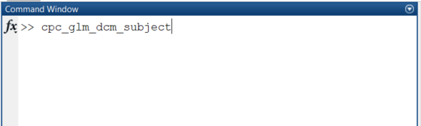

Running this program will take a bit of time and you will see things appearing in the command window. At the end, there should be a window showing you the following:

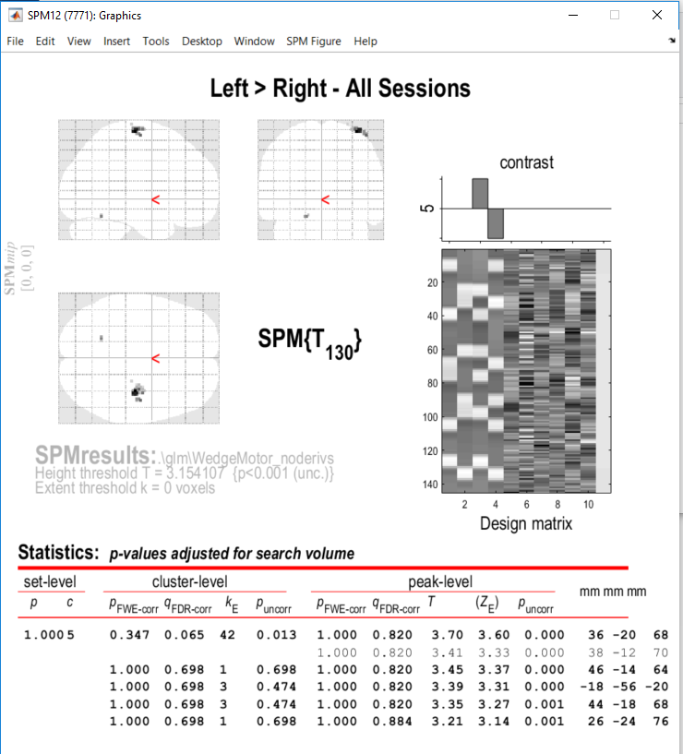

You are all set and ready for the tutorial now ☺ !

If you have trouble getting to this point before the Practical Tutorial Session, please consult the **#tutorial-helpdesk channel on Slack**. You will be given access to the CPC Slack workspace at the beginning of the course. Check if anyone has had the same issue and has managed to solve it and how. If no one else has encountered the same problem, post your question. **Alex** will be monitoring the channel and providing support. In addition, given the volume of attendees this year, we would be really grateful if you could assist us by answering queries on Slack yourself if you come across a problem you know and have solved.

For those who need more personalized help, Alex will be offering support hours. More information on the exact time will follow.

__________________________________________________________________________

**If you have the following issues with MEX files on macOS Catalina**:

"*.mexmaci64" cannot be opened because the developer cannot be verified. macOS cannot verify that this app is free from malware" or "Code signature not valid for use in process using Library Validation: library load disallowed by system policy"

Please open a Terminal and navigate to the folder where you placed your cpc2022_dcm folder. In the following example, the cpc2022_dcm folder was placed in the Downloads folder.



Then type the following command:

find . -name "*.mexmaci64" -exec xattr -d com.apple.quarantine {} \;



This should solve the problem and allow you to run cpc_glm_dcm_subject.m

This solution was taken from the SPM Wiki:

<https://en.wikibooks.org/wiki/SPM/Installation_on_64bit_Mac_OS_(Intel)#macOS_Catalina>