**CPCZurich2022 Practical Tutorial K**

**Advanced models of connectivity: regression DCM**

**Installation Guide**

**Authors / Tutors**: Stefan Frässle ([stefanf@biomed.ee.ethz.ch](mailto:stefanf@biomed.ee.ethz.ch)), Imre Kertesz ([ikertesz@biomed.ee.ethz.ch](mailto:ikertesz@biomed.ee.ethz.ch)), Computational Psychiatry Course 2022, Zurich, Switzerland.

**Revision and testing**: Alex Hess ([hess@biomed.ee.ethz.ch](mailto:hess@biomed.ee.ethz.ch))

**rDCM Toolbox**

In order to install the ***r****egression* ***D****ynamic* ***C****ausal* ***M****odeling (rDCM)* Toolbox, please follow these steps:

1. **Install MATLAB:** For this tutorial, you need MATLAB with the statistics toolbox. We recommend using MATLAB R2016a or newer (<https://www.mathworks.com/products/get-matlab.html>).
2. **Install a C Compiler:** For the rDCM Toolbox, you need a C-compiler alongside MATLAB. We recommend **MinGW** (Windows), **Xcode** (Mac) or **GCC** (Linux) which are available free of charge. Detailed instructions can be found at: <https://ch.mathworks.com/support/requirements/supported-compilers.html>.
3. **Download TAPAS** (***T****ranslational* ***A****lgorithms for* ***P****sychiatry* ***A****dvancing* ***S****cience*): Download the TAPAS toolbox (as zip-file) at: <https://translationalneuromodeling.github.io/tapas/#download>.
4. Put the code and the material in a folder/directory which you will use for the practical tutorial (e.g., Desktop/CPC2022/rDCMTutorial).

**Make sure you do not have any spaces in the titles of your folders!**

1. **Open MATLAB**. You will see the following interface:

Fig. 1: Illustration of MATLAB interface.

1. **Setup TAPAS:** Unzip the zip-file and add the “tapas/rDCM” folder to your MATLAB path by, in MATLAB, navigating to the folder/directory you prepared (e.g., “rDCMTutorial”). Then right-click on the directory and “Add to Path”, “Selected Folders and Subfolders”.

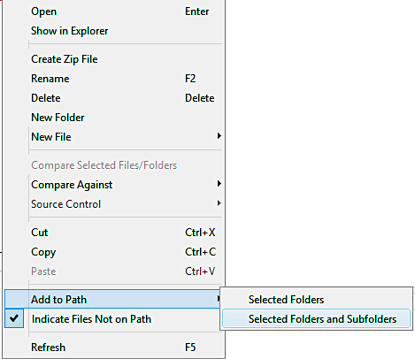

Fig. 2: Illustration of how to add a path (and all its subfolders) in MATLAB.

1. Well done! You’re all set up for the Practical session. If you are keen, you could already have a look at the manual of the toolbox and run the short beginner’s tutorial (**tapas_rdcm_tutorial.m**) before the Practical Tutorial session.

If you have trouble getting to this point before the Practical Tutorial Session, please contact Stefan Frässle ([stefanf@biomed.ee.ethz.ch](mailto:stefanf@biomed.ee.ethz.ch)).

We look forward to seeing you all at the CPCZurich2022!