**CPCZurich2022 Practical Tutorial E – Drift Diffusion Models**

**Installation Guide**

**Author / Tutor**: Ariel Zylberberg ([ariel.zylberberg@gmail.com](mailto:ariel.zylberberg@gmail.com)), Max Pensack ([mjp2143@cumc.columbia.edu](mailto:mjp2143@cumc.columbia.edu)), Computational Psychiatry Course 2022, Zurich, Switzerland.

**Revision and testing**: Alex Hess ([hess@biomed.ee.ethz.ch](mailto:hess@biomed.ee.ethz.ch))

In the tutorial we will use MATLAB. Please make sure you install MATLAB and that you can open and run it:

<https://www.mathworks.com/products/get-matlab.html>

Next, you will need to install the following MATLAB Toolboxes:

* 'Statistics and Machine Learning Toolbox’ (<https://www.mathworks.com/products/statistics.html>)
* ‘Optimization Toolbox’ (<https://www.mathworks.com/products/optimization.html>)

To install these Toolboxes, open MATLAB. You should see something like:

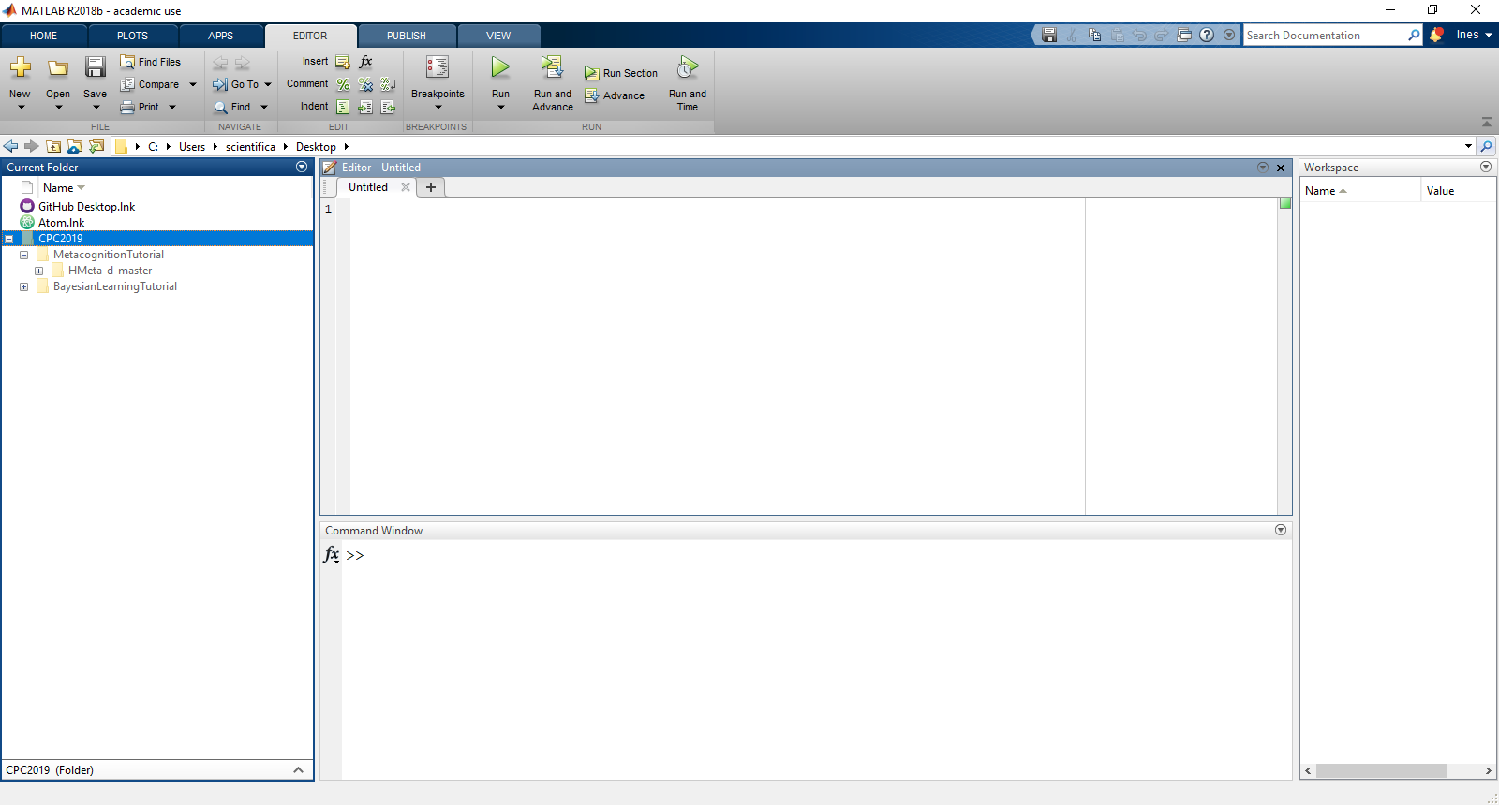

Click on the Home tab. You should see the following options:

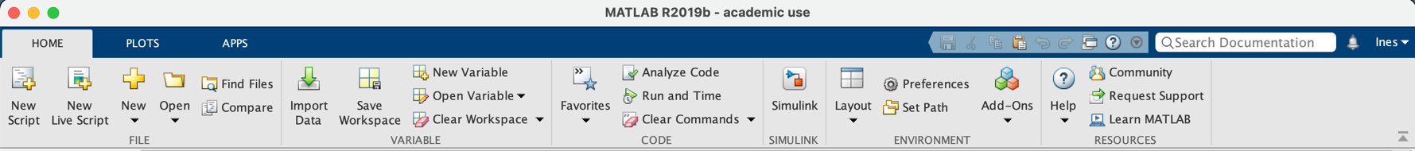

Click on the “Add-Ons”. You should now see a new window similar to the following: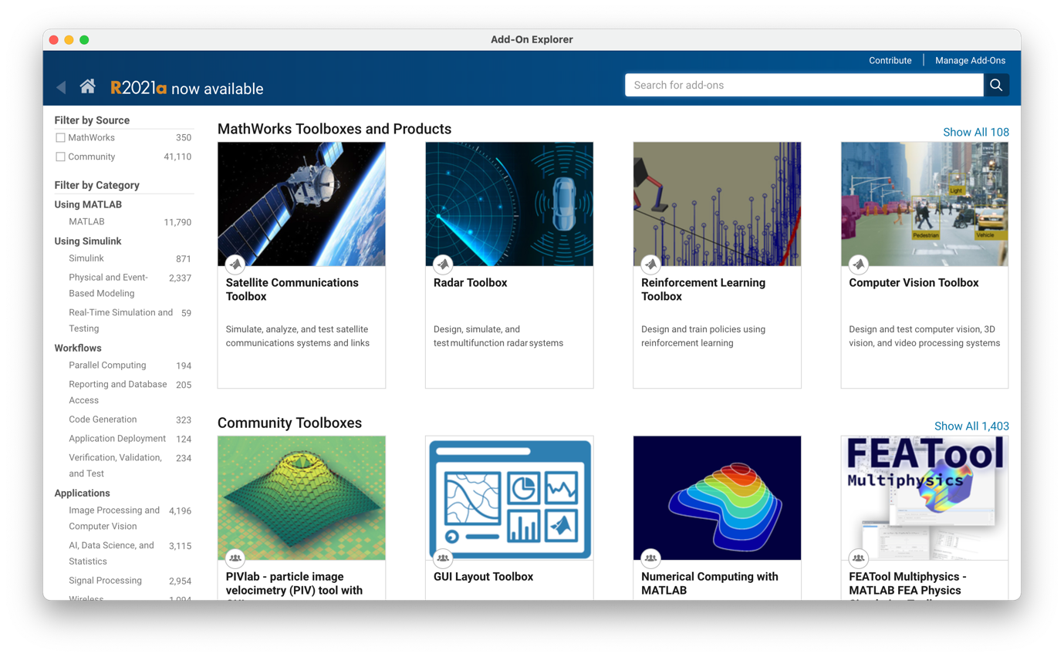

Search the toolboxes you need using the search bar in the upper right corner. You will immediately see whether these are installed. If not, click on the toolbox’s name/thumbnail and follow the instructions to install it.

We will also use custom code provided by the instructor, which will be available at:

<https://github.com/arielzylberberg/CompPsychCourse_Zurich2022>

Please wait until day 6 of the course to download these files so you have the most up-to-date version.

Now you’re all set up for the Practical Tutorial session ☺.

If you have trouble getting to this point before the Practical Tutorial Session, please consult the **#tutorial-helpdesk channel on Slack**. You will be given access to the CPC Slack workspace at the beginning of the course. Check if anyone has had the same issue and has managed to solve it and how. If no one else has encountered the same problem, post your question. **Peter, Tore and Alex** will be monitoring the channel and providing support. In addition, given the volume of attendees this year, we would be really grateful if you could assist us by answering queries on Slack yourself if you come across a problem you know and have solved.

For those who need more personalized help, Alex will be offering support hours. More information on the exact time will follow.