**CPCZurich2022 Practical Tutorial K**

**Advanced models of connectivity: regression DCM**

**Installation Guide**

**Authors / Tutors**: Stefan Frässle ([stefanf@biomed.ee.ethz.ch](mailto:stefanf@biomed.ee.ethz.ch)), Imre Kertesz ([ikertesz@biomed.ee.ethz.ch](mailto:ikertesz@biomed.ee.ethz.ch)), Computational Psychiatry Course 2022, Zurich, Switzerland.

**Revision and testing**: Alex Hess ([hess@biomed.ee.ethz.ch](mailto:hess@biomed.ee.ethz.ch))

**rDCM Toolbox**

In order to install the ***r****egression* ***D****ynamic* ***C****ausal* ***M****odeling (rDCM)* Toolbox, please follow these steps:

1. **Install MATLAB:** For this tutorial, you need MATLAB with the statistics toolbox. We recommend using MATLAB R2016a or newer (<https://www.mathworks.com/products/get-matlab.html>).
2. **Install a C Compiler:** For the rDCM Toolbox, you need a C-compiler alongside MATLAB. We recommend **MinGW** (Windows), **Xcode** (Mac) or **GCC** (Linux) which are available free of charge. Detailed instructions can be found at: <https://ch.mathworks.com/support/requirements/supported-compilers.html>.
3. **Download TAPAS** (***T****ranslational* ***A****lgorithms for* ***P****sychiatry* ***A****dvancing* ***S****cience*): Download the TAPAS toolbox (as zip-file) at: <https://translationalneuromodeling.github.io/tapas/#download>.
4. Put the code and the material in a folder/directory which you will use for the practical tutorial (e.g., Desktop/CPC2022/rDCMTutorial).

**Make sure you do not have any spaces in the titles of your folders!**

1. **Open MATLAB**. You will see the following interface:

Fig. 1: Illustration of MATLAB interface.

1. **Setup TAPAS:** Unzip the zip-file and add the “tapas/rDCM” folder to your MATLAB path by, in MATLAB, navigating to the folder/directory you prepared (e.g., “rDCMTutorial”). Then right-click on the directory and “Add to Path”, “Selected Folders and Subfolders”.

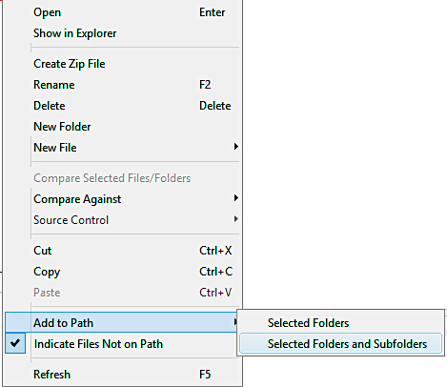

Fig. 2: Illustration of how to add a path (and all its subfolders) in MATLAB.

1. Well done! The rDCM toolbox is ready for use. If you are keen, you could already have a look at the manual of the toolbox and run the short beginner’s tutorial (**tapas_rdcm_tutorial.m**).

**SPM12 Toolbox**

Furthermore, the tutorial will make use of the *Statistical Parametric Mapping (SPM)* Toolbox. In order to install SPM12, please follow thes steps:

1. **Download SPM12** at: <https://github.com/spm/spm12>
2. Put the code and the material in a folder/directory which you will use for the practical tutorial (e.g., Desktop/CPC2022/rDCMTutorial). **Make sure you do not have any spaces in the titles of your folders!**
3. Add the “spm12” folder to your Matlab path. For this, in Matlab, navigate to the folder/directory you prepared (e.g., “rDCMTutorial”). Then right-click on the directory and “Add to Path”, “Selected Folders” (see step 6). **IMPORTANT: Do not add the subfolders for SPM12**.
4. Type “spm” into the command window and press Enter. If the installation was successful, this will open the SPM interface:  
   Graphical user interface

   Description automatically generated  
   Fig. 3: Illustration of the SPM interface.

Well done! You’re all set up for the Practical session.

If you have trouble getting to this point before the Practical Tutorial Session, please contact Stefan Frässle ([stefanf@biomed.ee.ethz.ch](mailto:stefanf@biomed.ee.ethz.ch)).

We look forward to seeing you all at the CPCZurich2022!

__________________________________________________________________________

**If you have the following issues with MEX files on macOS Catalina**:

"*.mexmaci64" cannot be opened because the developer cannot be verified. macOS cannot verify that this app is free from malware" or "Code signature not valid for use in process using Library Validation: library load disallowed by system policy"

Please open a Terminal and navigate to the folder where you placed your spm12 folder. In the following example, the spm12 folder was placed in a folder named cpc2020_dcm in the Downloads folder.

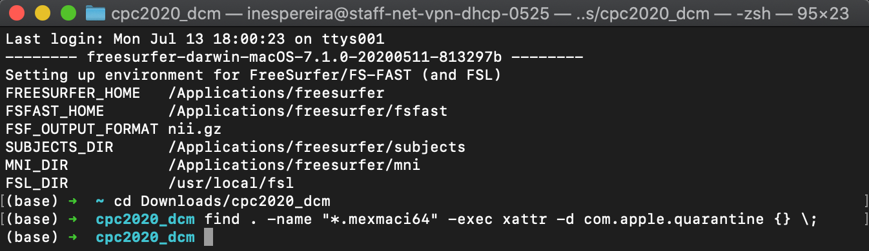

Then type the following command:

find . -name "*.mexmaci64" -exec xattr -d com.apple.quarantine {} \;



This should solve the problem and allow you to run the demo. This solution was taken from the SPM Wiki:

<https://en.wikibooks.org/wiki/SPM/Installation_on_64bit_Mac_OS_(Intel)#macOS_Catalina>