GitHub Submission Instructions
Create your branch, submit your work, and get updates from main.

The most important rule: Always check the branch name at the top of GitHub Desktop before you change, commit, pull, merge, or push anything!

Your branch name = your matriculation number
Example: 03742910

1. Make your own branch
Goal: Create one personal branch using your matriculation number.
1. Open the repository
Open GitHub Desktop. At the top-left, check that the cdf1_teaching repository is selected.
2. Start from main
Click Current Branch at the top. Select main.
3. Get the latest main
Click Fetch origin. If the button changes to Pull origin, click Pull origin.
4. Create your branch
Click Current Branch, then click New Branch.
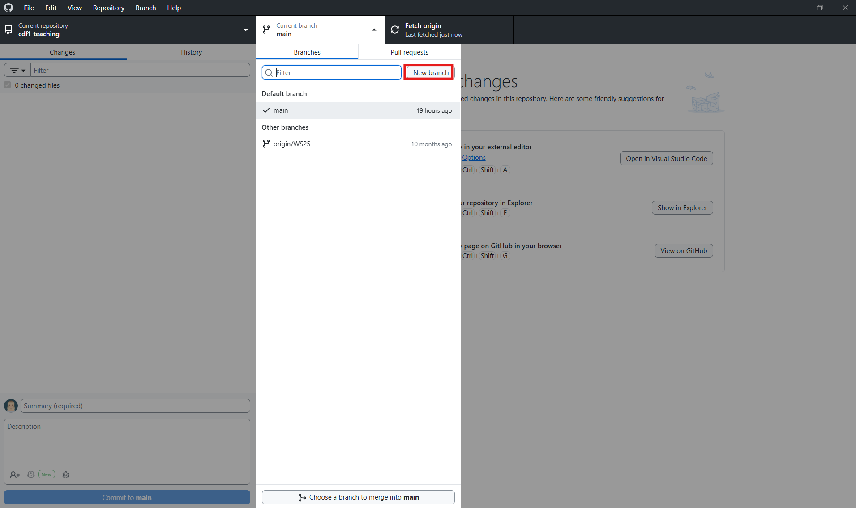
5. Name the branch
Enter your matriculation number only. Example: 03742910. Create the branch from main, then click Create Branch.
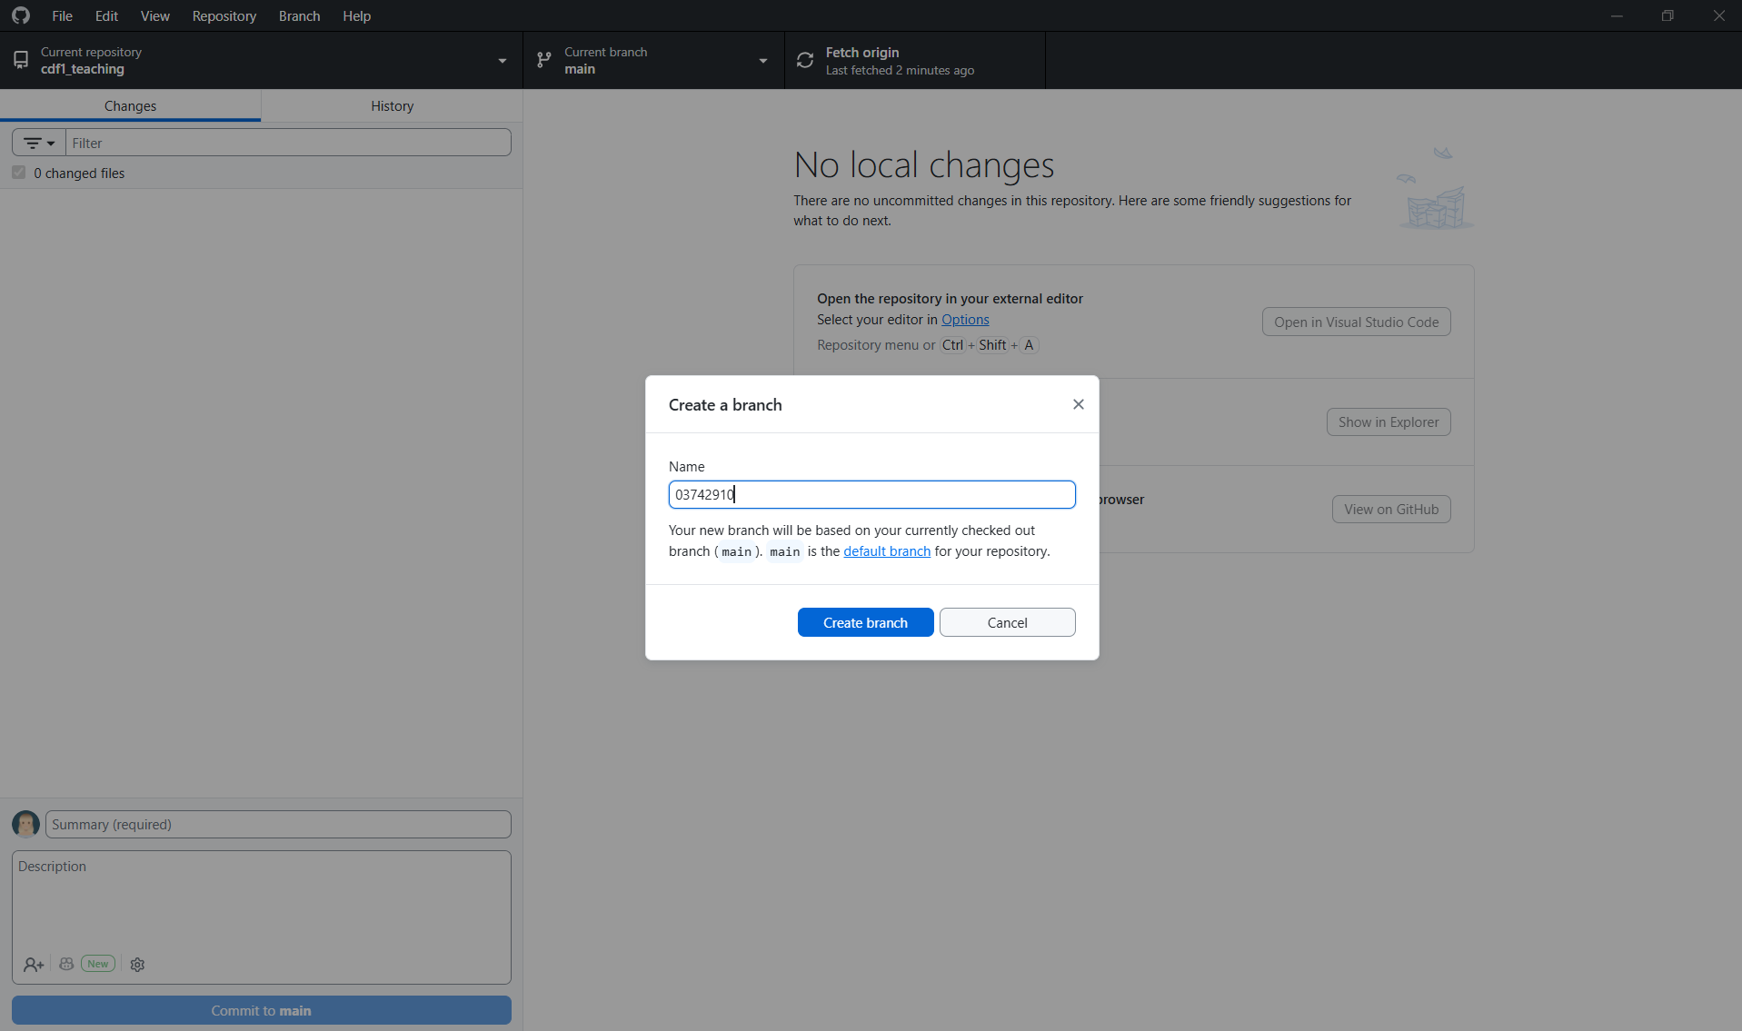
6. Publish your branch
Click Publish branch. This saves your branch on GitHub, not only on your computer.
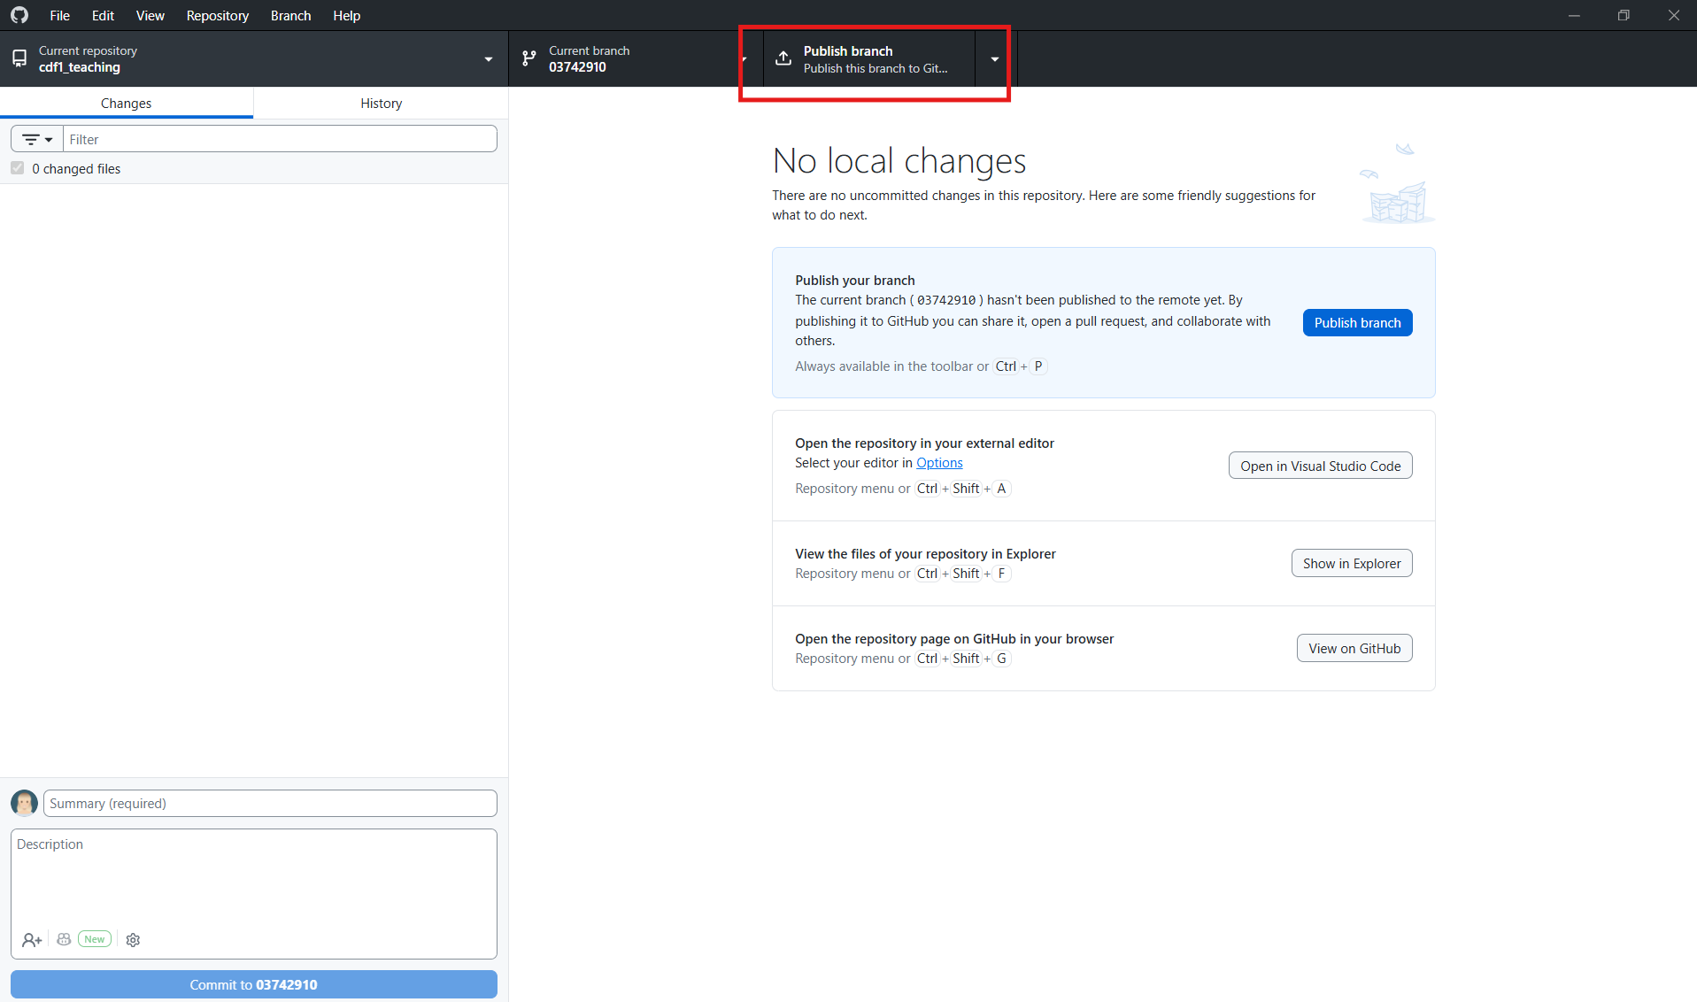
STOP AND CHECK: At the top of GitHub Desktop, Current Branch must show your matriculation number. If it shows main or another person’s number, do not continue. Switch to your own branch first.

Quick check
- ☐ My branch name is my matriculation number.
- ☐ Current Branch shows my matriculation number.
- ☐ I clicked Publish branch.

2. Submit your work on submission day
Submission means: Commit your latest changes and push them to your branch on GitHub.
1. Check your branch first
Look at Current Branch. It must show your matriculation number. Do not submit from main or from another student’s branch.
2. Review the changed files
On the Changes tab, check the file list. Make sure the files are yours and that the changes are ready to submit.
3. Write a short commit message
At the bottom-left, write a clear summary. Example: Final submission. You may add more information in Description if needed.
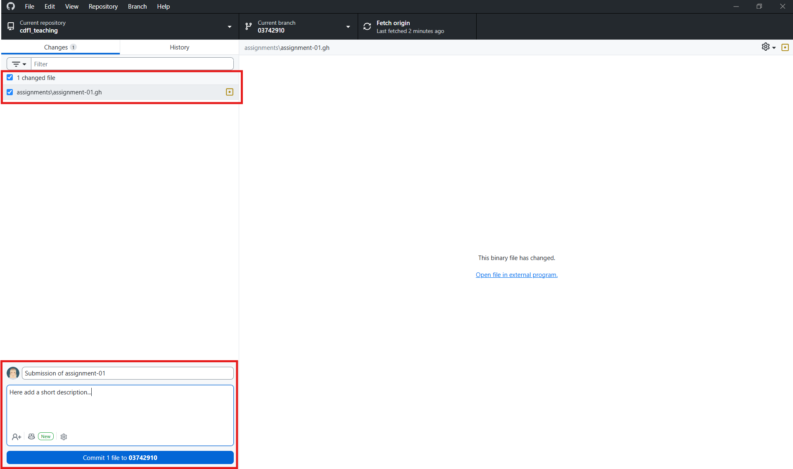
4. Commit to your branch
Click Commit to [your matriculation number]. Read the button carefully before clicking it.
5. Push to GitHub
Click Push origin at the top. Wait until the push is complete.
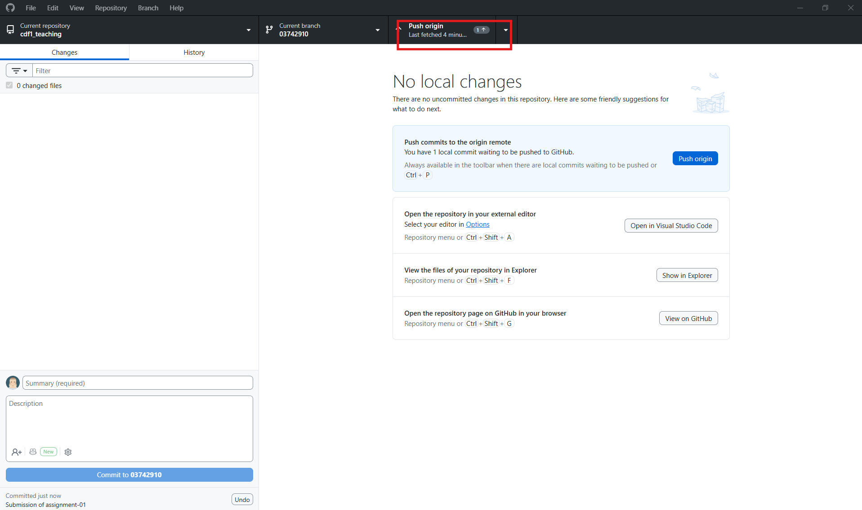
6. Final check
Click Fetch origin. If there is nothing new to push, your latest commit has been sent to GitHub.
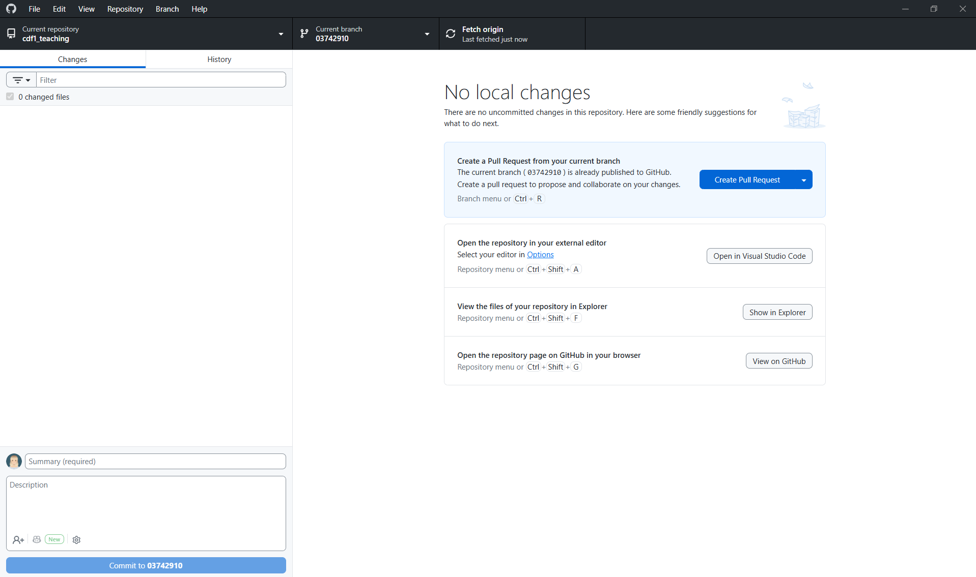
Important: A commit saves a version on your computer. Push origin sends that commit to GitHub. For submission, you need both.
You can also commit and submit multiple times before the submission date.

Submission checklist
- ☐ Current Branch shows my matriculation number.
- ☐ I committed all required files.
- ☐ I clicked Push origin.
- ☐ GitHub Desktop does not show uncommitted submission changes.

3. Get updates from main
When to do this: Use these steps when the instructor says that main has been updated.
1. Save your work first
If you have unfinished changes, commit them to your own branch before continuing. Do not switch branches with important unsaved work.
2. Switch to main
Click Current Branch and select main. Check that Current Branch now says main.
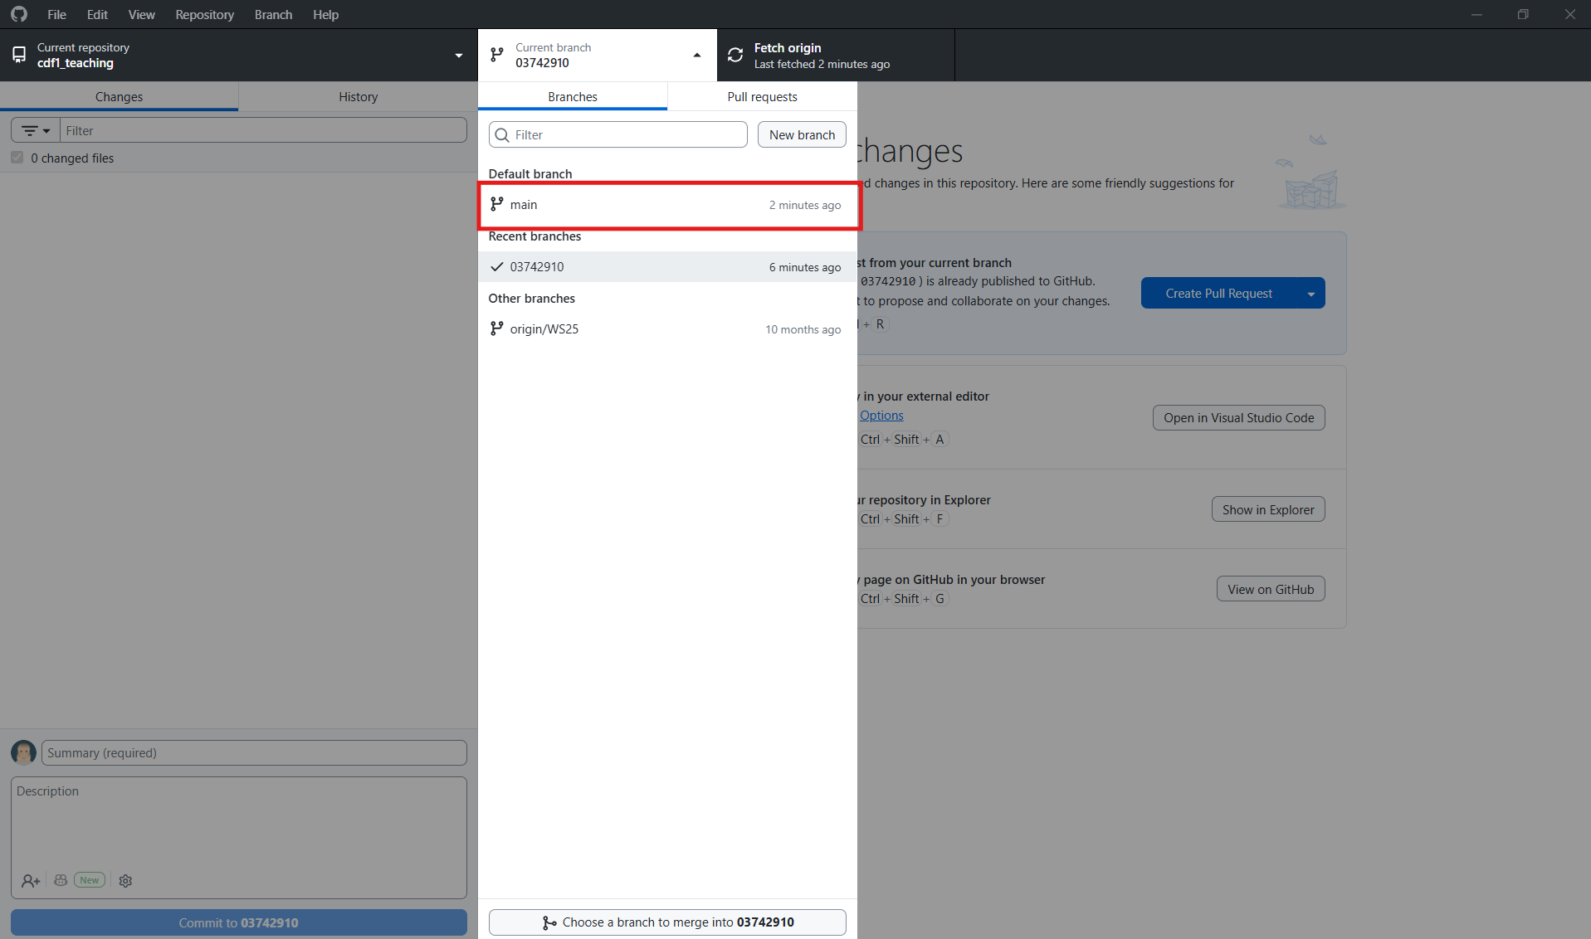
3. Update main
Click Fetch origin. If Pull origin appears, click Pull origin.
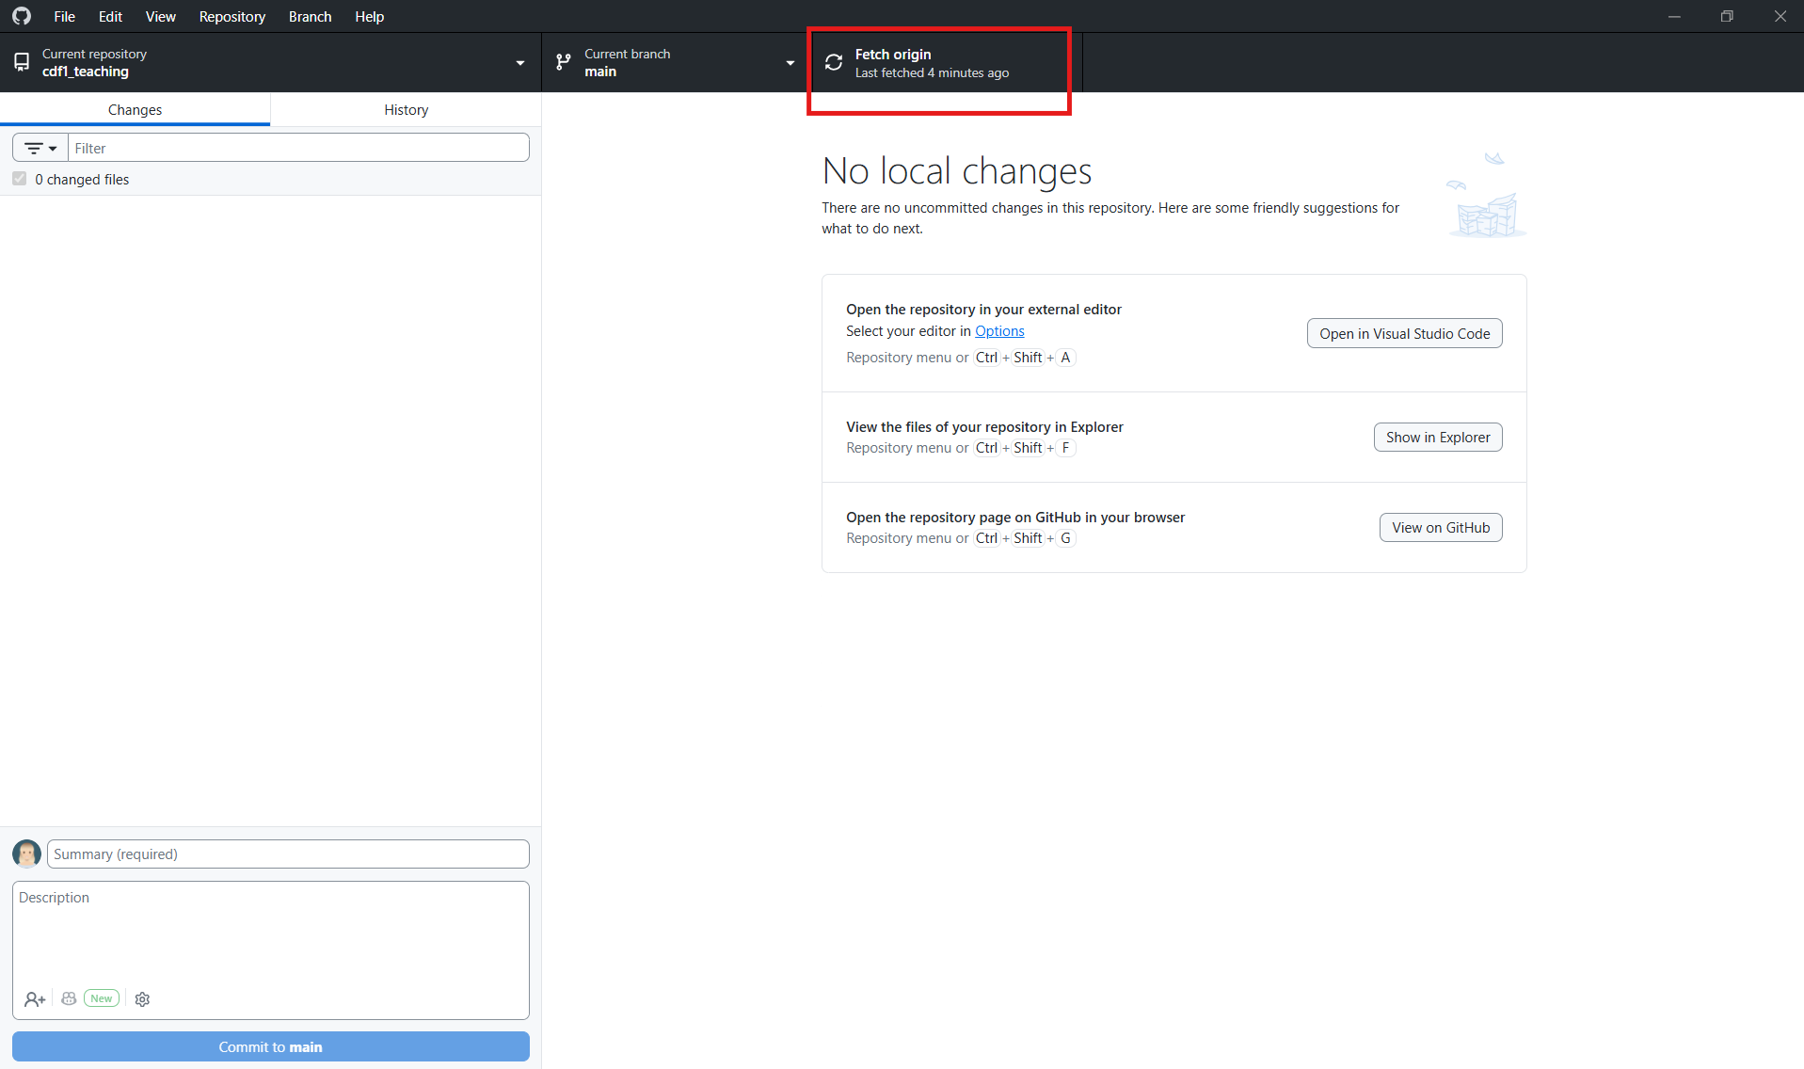
4. Switch back to your branch
Click Current Branch and select your matriculation number. Check the name carefully.
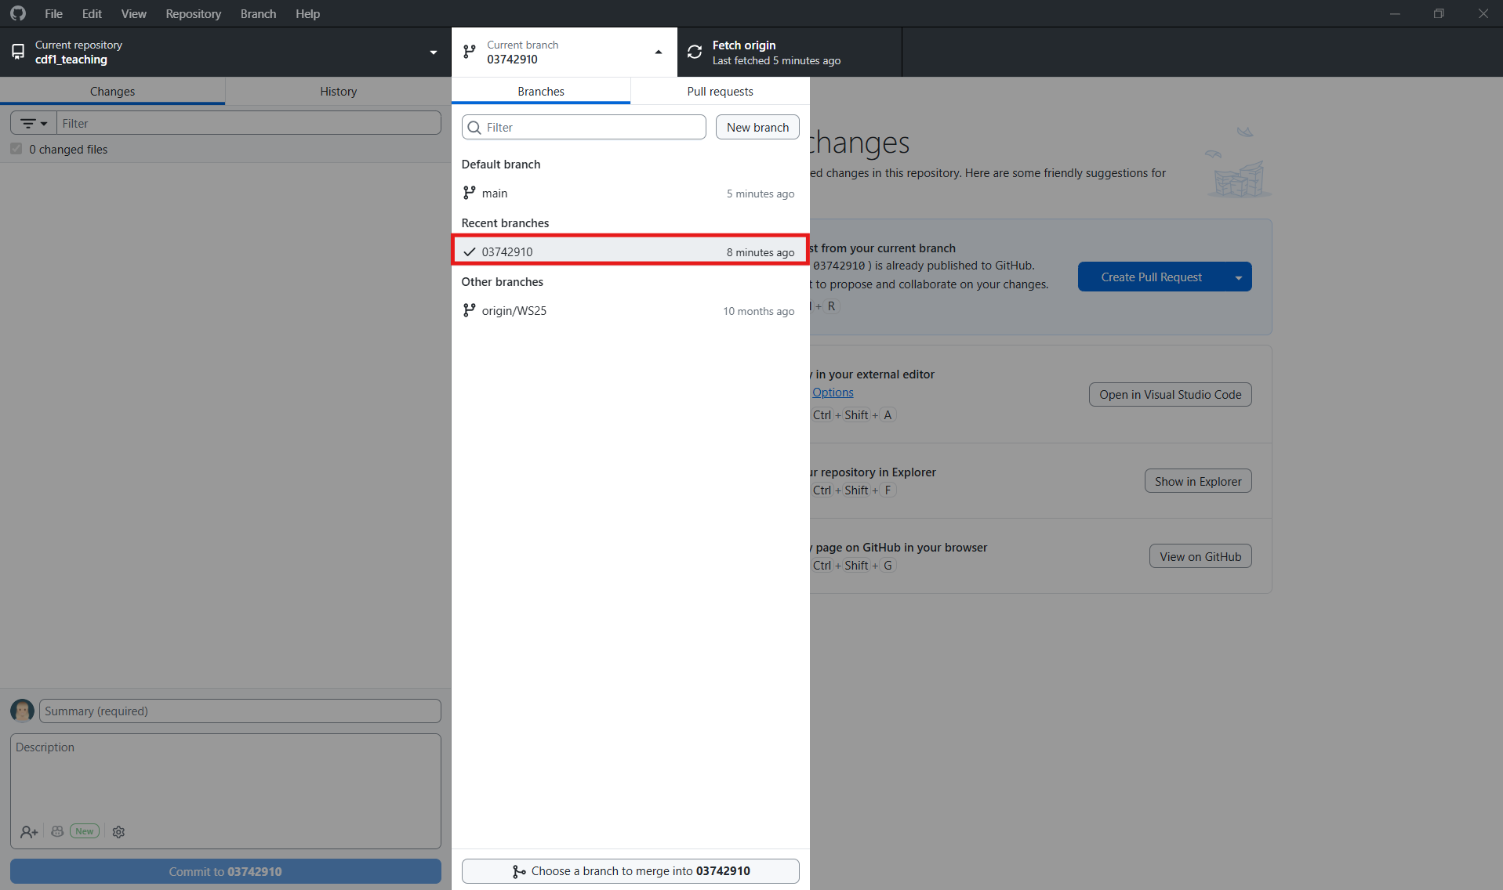
5. Merge main into your branch
In the menu, choose Branch > Choose a branch to merge into.
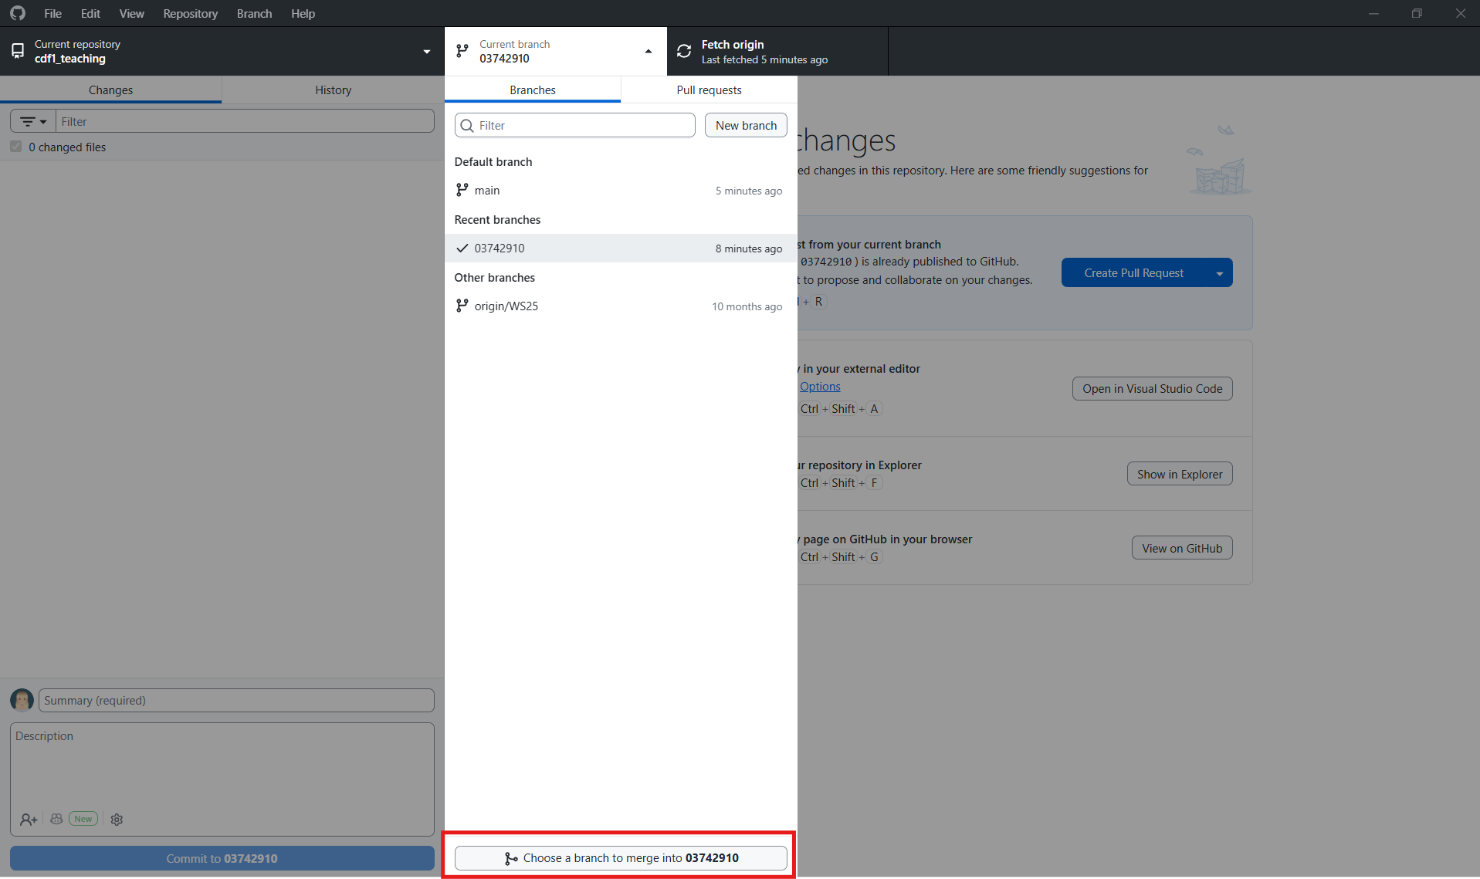

Select main, then click Create a merge commit.
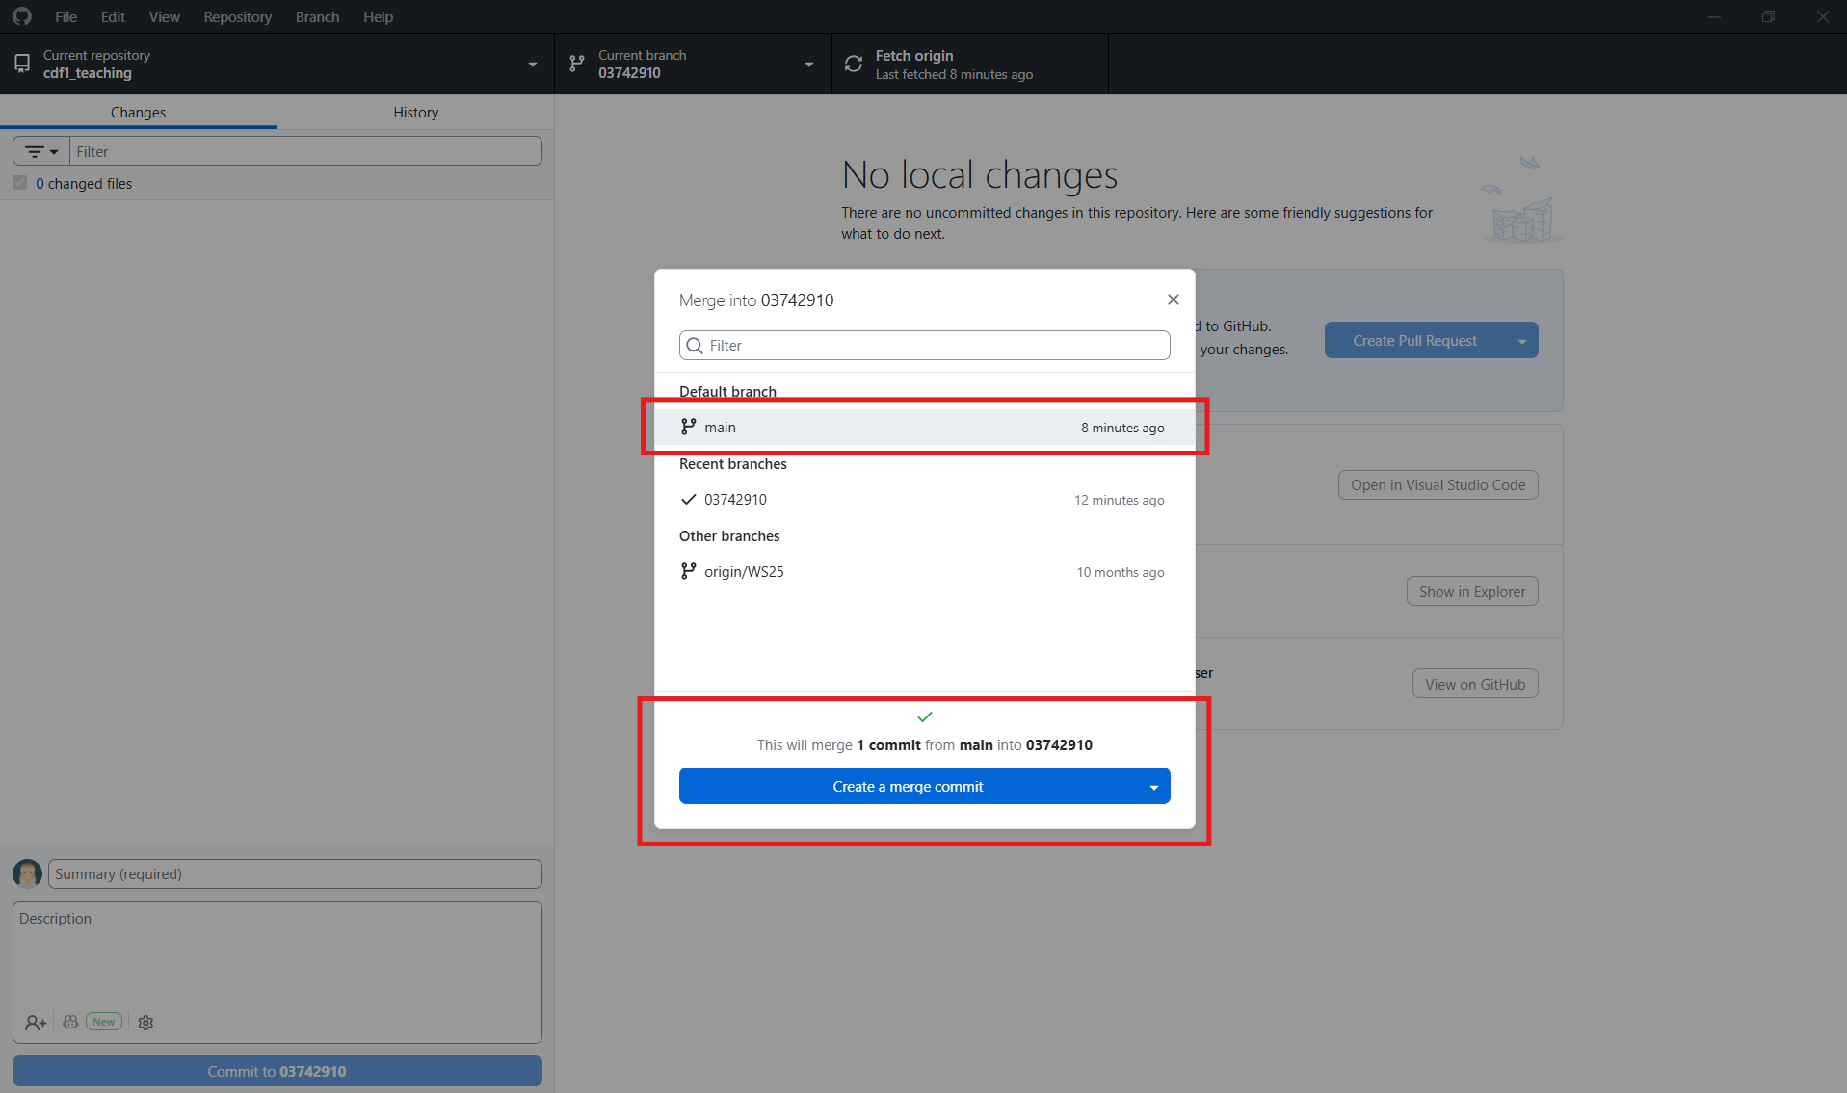
6. Push your updated branch
Click Push origin.
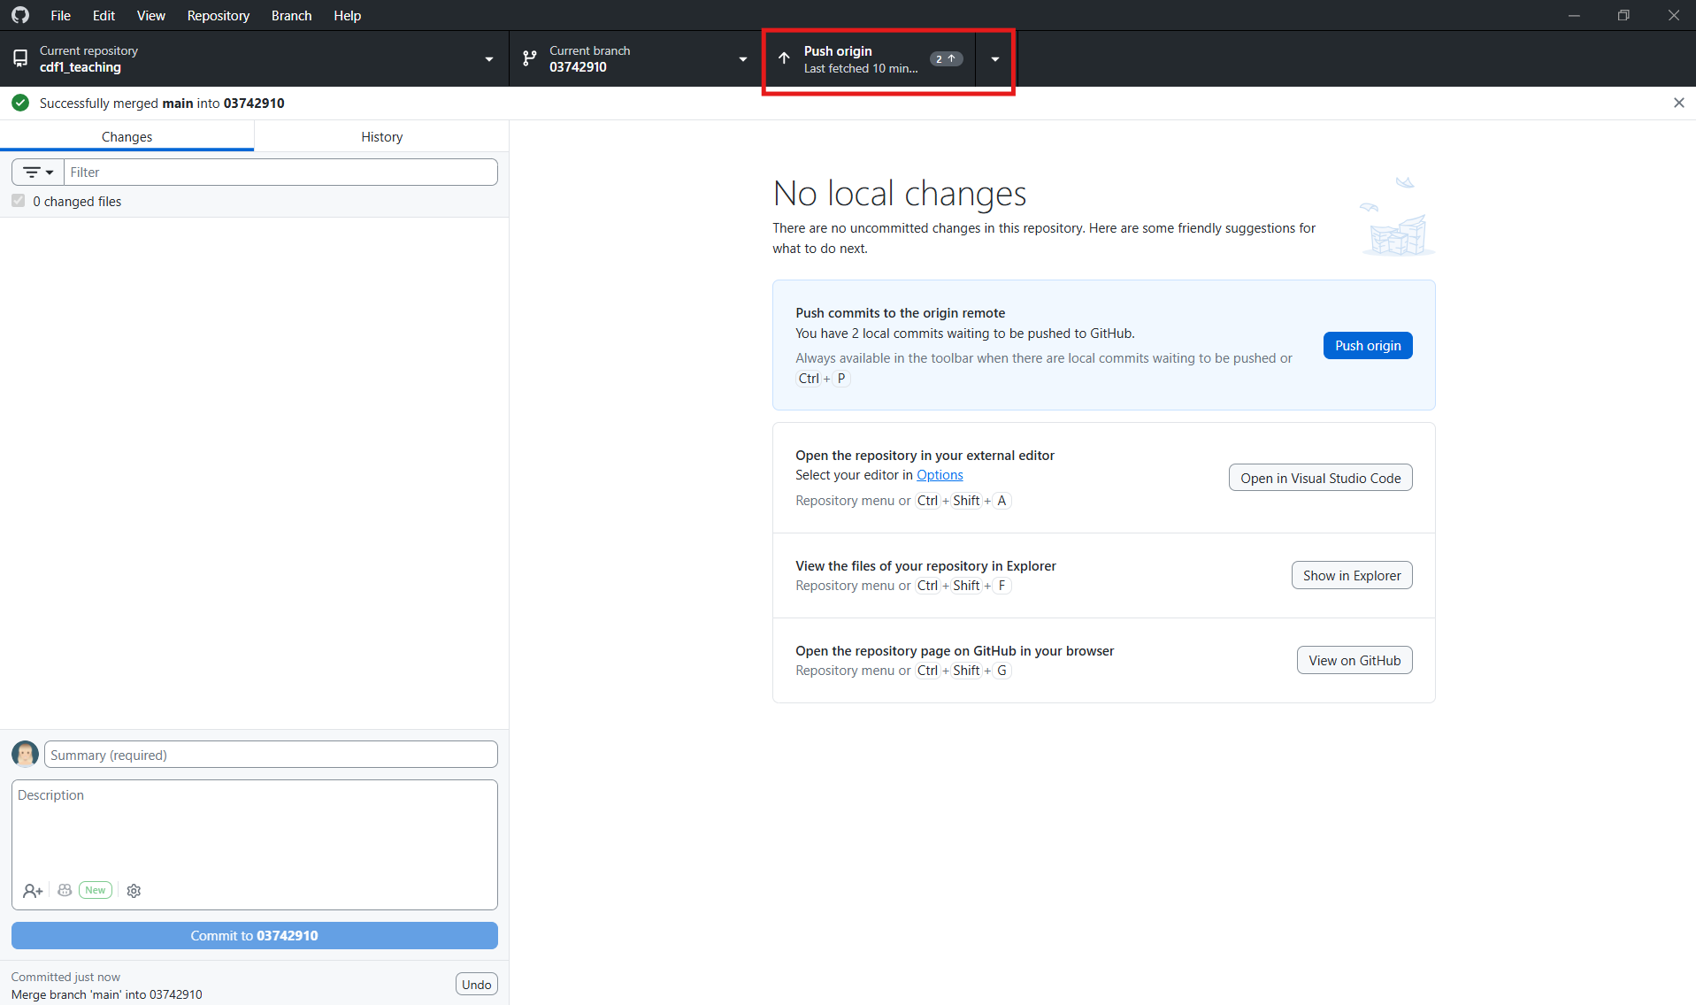
Very important: The current branch must be your matriculation number before you merge. You are bringing main into your branch, not your branch into main.

If GitHub Desktop reports a conflict
Stop and ask the instructor for help. Do not force push and do not delete files just to remove the warning.

The short version
Fetch → update main → return to your branch → merge main → push

