## *New Phytologist* Supporting Information

Article title: Plant access to belowground moisture allows sustained evapotranspiration during drought

Authors: Francesco Giardina, Pierre Gentine, Alexandra G. Konings, Benjamin D. Stocker

Article acceptance date: Click here to enter a date.

The following Supporting Information is available for this article:

**Fig. S1** Performance of the deep-learning model at predicting evapotranspiration (ET) across sites.

**Fig. S2** EF vs CWD for sites grouped according to their median fET

**Fig. S3** fET vs CWD for sites grouped according to their median fET. High fET group.

**Fig. S4** fET vs CWD for sites grouped according to their median fET. Medium fET group.

**Table S1** FLUXNET Tier 1 sites included in the analysis.

**Figures  
Fig. S1** Performance of the deep-learning model at predicting evapotranspiration (ET) across sites.ETNN and PETNN are respectively ET and PET predicted with our deep learning model. ETobs corresponds to observational ET from FLUXNET2015. **a**,PETNN vs ETNN, evaluated on moist days. **b**, PETNN vs observational ETobs, evaluated on dry days.

|  |  |
| --- | --- |
|  |  |

**Fig. S2** EF vs CWD for sites grouped according to their median fET. a, All sites. b, High fET. c, Medium fET. d, Low fET. The clustering is consistent with Figure 3. EF was scaled by dividing it by the median in its lower CWD bin (CWD < 20 mm). EF was calculated as latent heat divided by net radiation, two quantities directly downloaded from the FLUXNET2015 dataset that do not depend on any model.

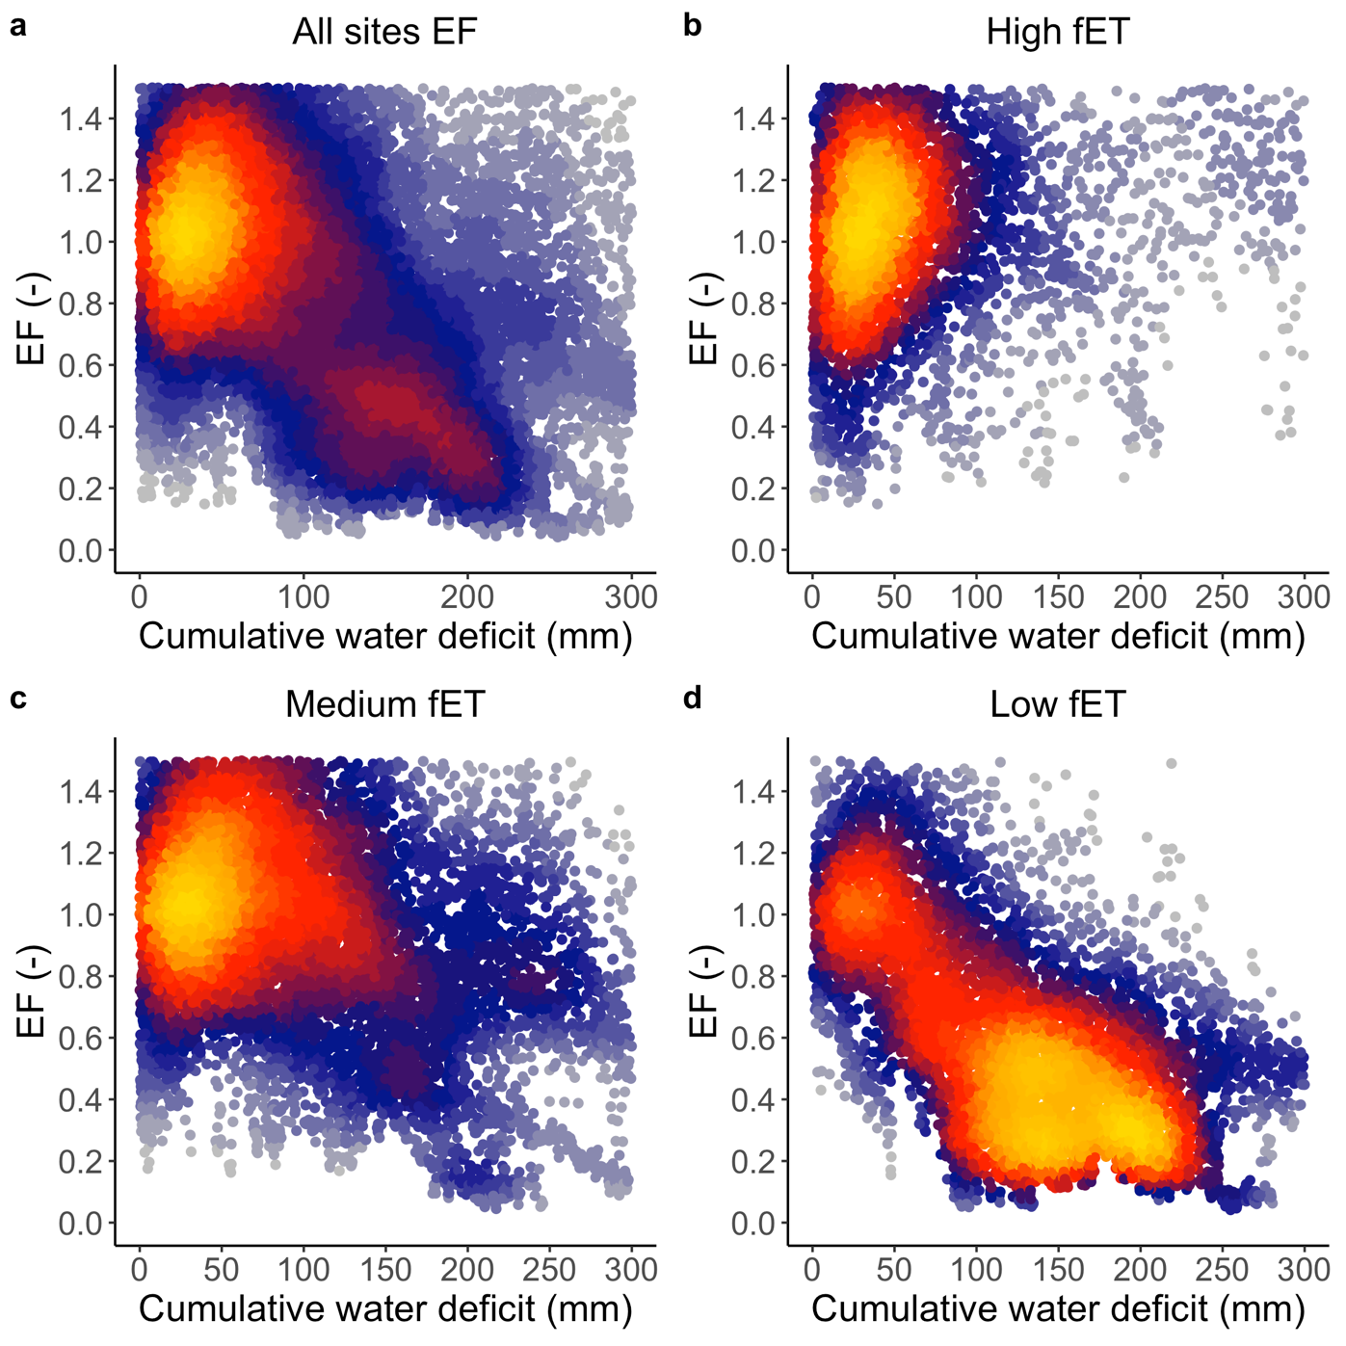

**Fig. S3** fET vs CWD for sites grouped according to their median fET. High fET group.

**Fig. S4** fET vs CWD for sites grouped according to their median fET. Medium fET group.

**Tables**

**Table S1** FLUXNET Tier 1 sites included in the analysis. Group refers to the grouping of sites according to their median fET (see Methods). Coordinates in decimal degrees. IGBP is the vegetation class (GRA, grasslands; SAV, savannah; WSA, woody savannah; ENF, evergreen needleleaf forest; EBF, evergreen broadleaf forest; DBF, deciduous broadleaf forest; CSH, closed shrubland; WET, wetland; CRO, cropland; MF, mixed forest). MAT, mean annual temperature (°C). MAP, mean annual precipitation (mm).

|  |  |  |  |  |  |  |
| --- | --- | --- | --- | --- | --- | --- |
| **Site** | **Coordinates** | **Years** | **IGBP** | **fET group** | **MAT (**°C) | **MAP (mm)** |
| **AU-Cpr** | 140.59, -34 | 2010 - 2014 | SAV | medium fET | 17.35 | 269 |
| **AU-Cum** | 150.72, -33.61 | 2012 - 2014 | EBF | medium fET | 17.28 | 850 |
| **AU-DaP** | 131.32, -14.06 | 2007 - 2013 | GRA | low fET | 27.22 | 1175 |
| **AU-DaS** | 131.39, -14.16 | 2008 - 2014 | SAV | low fET | 27.13 | 1134 |
| **AU-Gin** | 115.71, -31.38 | 2011 - 2014 | WSA | low fET | 18.53 | 697 |
| **AU-How** | 131.15, -12.49 | 2001 - 2014 | WSA | medium fET | 27.03 | 1640 |
| **AU-RDF** | 132.48, -14.56 | 2011 - 2013 | WSA | low fET | 26.98 | 958 |
| **AU-Stp** | 133.35, -17.15 | 2008 - 2014 | GRA | medium fET | 26.39 | 639 |
| **AU-Wom** | 144.09, -37.42 | 2010 - 2012 | EBF | medium fET | 10.70 | 1071 |
| **BE-Vie** | 6, 50.31 | 1996 - 2014 | MF | medium fET | 8.01 | 1085 |
| **BR-Sa3** | -54.97, -3.02 | 2000 - 2004 | EBF | medium fET | 25.50 | 1856 |
| **CH-Dav** | 9.86, 46.82 | 1997 - 2014 | ENF | high fET | 3.53 | 1053 |
| **DE-Geb** | 10.91, 51.1 | 2001 - 2014 | CRO | medium fET | 8.96 | 496 |
| **DE-Kli** | 13.52, 50.89 | 2004 - 2014 | CRO | high fET | 7.61 | 839 |
| **DE-Lkb** | 13.3, 49.1 | 2009 - 2013 | ENF | high fET | 4.20 | 1364 |
| **DE-Obe** | 13.72, 50.78 | 2008 - 2014 | ENF | high fET | 6.09 | 820 |
| **DE-Seh** | 6.45, 50.87 | 2007 - 2010 | CRO | medium fET | 10.17 | 709 |
| **DE-Tha** | 13.57, 50.96 | 1996 - 2014 | ENF | high fET | 8.26 | 754 |
| **DK-Sor** | 11.64, 55.49 | 1996 - 2014 | DBF | medium fET | 8.48 | 614 |
| **FR-LBr** | -0.77, 44.72 | 1996 - 2008 | ENF | medium fET | 12.52 | 908 |
| **FR-Pue** | 3.6, 43.74 | 2000 - 2014 | EBF | low fET | 13.35 | 683 |
| **IT-BCi** | 14.96, 40.52 | 2004 - 2014 | CRO | high fET | 16.10 | 1035 |
| **IT-CA3** | 12.02, 42.38 | 2011 - 2014 | DBF | medium fET | 14.52 | 328 |
| **IT-Col** | 13.59, 41.85 | 1996 - 2014 | DBF | medium fET | 6.95 | 789 |
| **IT-Cpz** | 12.38, 41.71 | 1997 - 2009 | EBF | medium fET | 15.54 | 757 |
| **IT-Lav** | 11.28, 45.96 | 2003 - 2014 | ENF | high fET | 6.79 | 502 |
| **IT-Noe** | 8.15, 40.61 | 2004 - 2014 | CSH | low fET | 15.85 | 748 |
| **IT-Ren** | 11.43, 46.59 | 1998 - 2013 | ENF | high fET | 3.98 | 664 |
| **IT-Ro2** | 11.92, 42.39 | 2002 - 2012 | DBF | medium fET | 14.54 | 380 |
| **IT-SR2** | 10.29, 43.73 | 2013 - 2014 | ENF | medium fET | 14.02 | 888 |
| **IT-SRo** | 10.28, 43.73 | 1999 - 2012 | ENF | medium fET | 14.02 | 888 |
| **IT-Tor** | 7.58, 45.84 | 2008 - 2014 | GRA | medium fET | 1.56 | 1317 |
| **NL-Loo** | 5.74, 52.17 | 1996 - 2013 | ENF | medium fET | 9.38 | 839 |
| **RU-Fyo** | 32.92, 56.46 | 1998 - 2014 | ENF | medium fET | 4.51 | 693 |
| **US-AR2** | -99.6, 36.64 | 2009 - 2012 | GRA | low fET | 14.22 | 600 |
| **US-ARb** | -98.04, 35.55 | 2005 - 2006 | GRA | high fET | 15.29 | 793 |
| **US-ARM** | -97.49, 36.61 | 2003 - 2012 | CRO | medium fET | 14.90 | 861 |
| **US-Blo** | -120.63, 38.9 | 1997 - 2007 | ENF | high fET | 11.04 | 1510 |
| **US-Los** | -89.98, 46.08 | 2000 - 2014 | WET | high fET | 4.12 | 833 |
| **US-MMS** | -86.41, 39.32 | 1999 - 2014 | DBF | high fET | 11.13 | 1097 |
| **US-Ne1** | -96.48, 41.17 | 2001 - 2013 | CRO | high fET | 10.24 | 799 |
| **US-Ne2** | -96.47, 41.16 | 2001 - 2013 | CRO | medium fET | 10.21 | 799 |
| **US-Ne3** | -96.44, 41.18 | 2001 - 2013 | CRO | high fET | 10.20 | 793 |
| **US-SRG** | -110.83, 31.79 | 2008 - 2014 | GRA | low fET | 17.57 | 537 |
| **US-SRM** | -110.87, 31.82 | 2004 - 2014 | WSA | low fET | 18.53 | 459 |
| **US-Syv** | -89.35, 46.24 | 2001 - 2014 | MF | high fET | 3.76 | 844 |
| **US-Ton** | -120.97, 38.43 | 2001 - 2014 | WSA | low fET | 16.14 | 656 |
| **US-Var** | -120.95, 38.41 | 2000 - 2014 | GRA | low fET | 16.20 | 639 |
| **US-WCr** | -90.08, 45.81 | 1999 - 2014 | DBF | high fET | 4.23 | 828 |