**МИНИСТЕРСТВО ОБРАЗОВАНИЯ РЕСПУБЛИКИ БЕЛАРУСЬ**

**УЧРЕЖДЕНИЕ ОБРАЗОВАНИЯ**

**ГОМЕЛЬСКИЙ ГОСУДАРСТВЕННЫЙ ТЕХНИЧЕСКИЙ**

**УНИВЕРСИТЕТ ИМЕНИ П. О. СУХОГО**

Факультет автоматизированных и информационных систем

Кафедра «Информационные технологии»

ОТЧЁТ ПО ЛАБОРАТОРНОЙ РАБОТЕ №2

по дисциплине: «Архитектура ЭВМ»

на тему: **«**Логические и арифметические операции над двоичными числами**»**

Выполнил: студент гр. ИТП-21

Клевцов А.О.

Проверил: доцент

Савельев В.А.

Гомель 2022

**Цель**: получение навыков выполнения арифметических и логических операций над двоичными числами.

Вариант 11

Задание 1. Выполнить логическое сложение двоичных чисел, представленных в шестнадцатеричном коде.

|  |  |  |  |  |  |  |  |  |
| --- | --- | --- | --- | --- | --- | --- | --- | --- |
| № вар. | 9 | 10 | 11 | 12 | 13 | 14 | 15 | 16 |
| 1 оп. | 23AD | AFD0 | 3509 | 1F00 | A456 | 12FF | 5F34 | EF00 |
| 2 оп. | E45A | 56AD | 80FC | 9F10 | BA00 | 5123 | FF01 | 4560 |

=

=

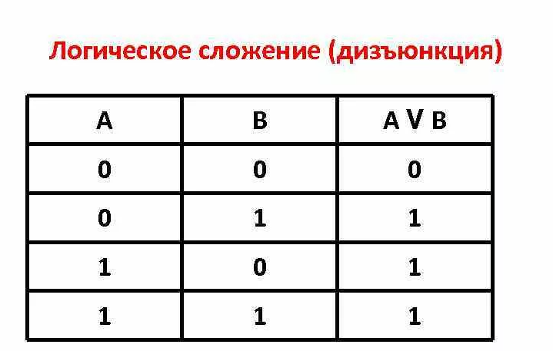

Рисунок 1 – Логическое сложение

|  |  |  |  |  |  |  |  |  |  |  |  |  |  |  |  |  |
| --- | --- | --- | --- | --- | --- | --- | --- | --- | --- | --- | --- | --- | --- | --- | --- | --- |
|  |  |  |  | 1 | 1 | 0 | 1 | 0 | 1 | 0 | 0 | 0 | 0 | 1 | 0 | 0 |
|  | 1 | 0 | 0 | 0 | 0 | 0 | 0 | 0 | 1 | 1 | 1 | 1 | 1 | 1 | 0 | 0 |
|  | 1 | 0 | 0 | 1 | 1 | 0 | 1 | 0 | 1 | 1 | 1 | 1 | 1 | 1 | 0 | 0 |

Задание 2. Выполнить логическое сложение по модулю 2 двоичных чисел, представленных в шестнадцатеричном коде.

|  |  |  |  |  |  |  |  |  |
| --- | --- | --- | --- | --- | --- | --- | --- | --- |
| № вар. | 9 | 10 | 11 | 12 | 13 | 14 | 15 | 16 |
| 1 оп. | 2CFD | AF60 | 35E9 | 1700 | A466 | 122F | 5F34 | 4F00 |
| 2 оп. | E4BA | 56BD | 80EC | 9A10 | BA50 | 4123 | FF01 | 4562 |

=

=

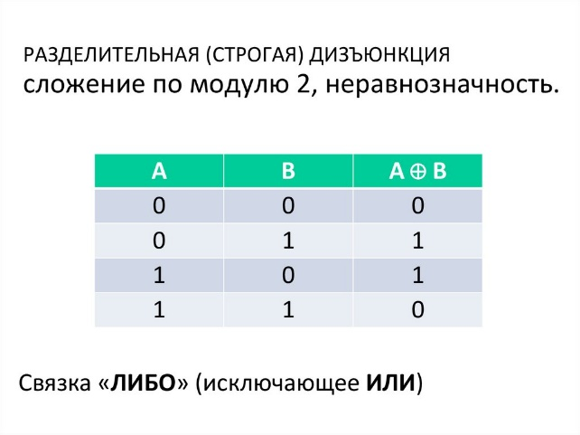

Рисунок 2 – Исключающие или

|  |  |  |  |  |  |  |  |  |  |  |  |  |  |  |  |  |
| --- | --- | --- | --- | --- | --- | --- | --- | --- | --- | --- | --- | --- | --- | --- | --- | --- |
|  |  |  | 1 | 1 | 0 | 1 | 0 | 1 | 1 | 1 | 1 | 0 | 1 | 0 | 0 | 1 |
|  | 1 | 0 | 0 | 0 | 0 | 0 | 0 | 0 | 1 | 1 | 1 | 0 | 1 | 1 | 0 | 0 |
|  | 1 | 0 | 1 | 1 | 0 | 1 | 0 | 1 | 0 | 0 | 0 | 0 | 0 | 1 | 0 | 1 |

Задание 3. Выполнить логическое умножение двоичных чисел, представленных в шестнадцатеричном коде.

|  |  |  |  |  |  |  |  |  |
| --- | --- | --- | --- | --- | --- | --- | --- | --- |
| № вар. | 9 | 10 | 11 | 12 | 13 | 14 | 15 | 16 |
| 1 оп. | 2CFD | AF60 | 35E9 | 1700 | A466 | 122F | 5F34 | 4F00 |
| 2 оп. | FD45 | EE2D | 3AA9 | F4F0 | A456 | 126F | 5113 | EF30 |

=

=

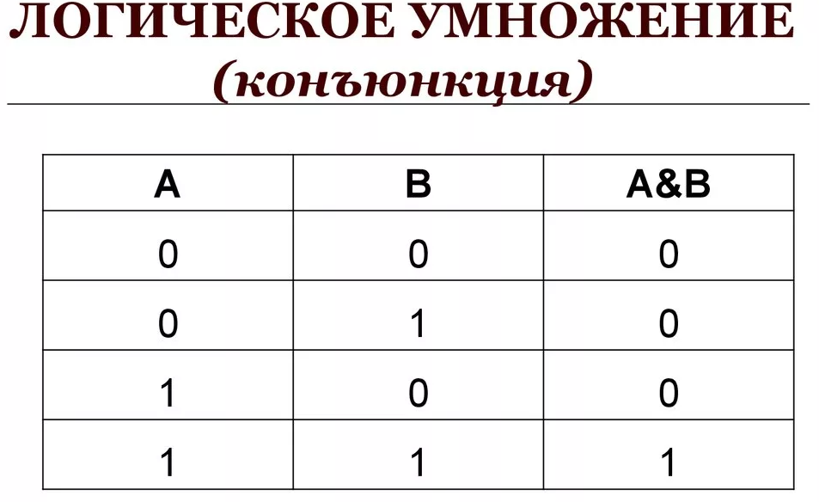

Рисунок 3 – Логическое умножение

|  |  |  |  |  |  |  |  |  |  |  |  |  |  |  |  |  |
| --- | --- | --- | --- | --- | --- | --- | --- | --- | --- | --- | --- | --- | --- | --- | --- | --- |
|  |  |  | 1 | 1 | 0 | 1 | 0 | 1 | 1 | 1 | 1 | 0 | 1 | 0 | 0 | 1 |
|  |  | 1 | 1 | 1 | 1 | 0 | 1 | 0 | 1 | 0 | 1 | 0 | 1 | 0 | 0 | 1 |
|  |  | 0 | 1 | 1 | 0 | 0 | 0 | 0 | 1 | 0 | 1 | 0 | 1 | 0 | 0 | 1 |

Задание 4. Выполнить сложение целых двоичных чисел без знака, представленных в шестнадцатеричном коде. Все операнды перевести в десятичный код.

|  |  |  |  |  |  |  |  |  |
| --- | --- | --- | --- | --- | --- | --- | --- | --- |
| № вар. | 9 | 10 | 11 | 12 | 13 | 14 | 15 | 16 |
| 1 сл. | 23AD | AFD0 | 3509 | 1F00 | A456 | 12FF | 5F34 | EF00 |
| 2 сл. | E45A | 56AD | 80FC | 9F10 | BA00 | 5123 | FF01 | 4560 |

=

=

|  |  |  |  |  |  |  |  |  |  |  |  |  |  |  |  |  |
| --- | --- | --- | --- | --- | --- | --- | --- | --- | --- | --- | --- | --- | --- | --- | --- | --- |
|  |  |  |  |  |  |  |  | 1 | 1 | 1 | 1 | 1 | 1 |  |  |  |
|  |  |  |  | 1 | 1 | 0 | 1 | 0 | 1 | 0 | 0 | 0 | 0 | 1 | 0 | 0 |
|  | 1 | 0 | 0 | 0 | 0 | 0 | 0 | 0 | 1 | 1 | 1 | 1 | 1 | 1 | 0 | 0 |
|  | 1 | 0 | 0 | 1 | 1 | 0 | 1 | 1 | 1 | 0 | 0 | 0 | 0 | 1 | 0 | 0 |

Задание 5. Выполнить сложение целых двоичных чисел со знаком (в дополнительном коде), представленных в десятичном коде. Все операнды перевести в десятичный код.

|  |  |  |  |  |  |  |  |  |
| --- | --- | --- | --- | --- | --- | --- | --- | --- |
| № вар. | 9 | 10 | 11 | 12 | 13 | 14 | 15 | 16 |
| 1 сл. | -24 | -654 | -54 | -52 | 3333 | 12553 | 6733 | -543 |
| 2 сл. | -1655 | -5438 | 1500 | 5431 | -400 | -76 | -333 | -867 |

=

Обратный: 1111 1111 1100 10012

Дополнительный (+1): 1111 1111 1100 10102

=

|  |  |  |  |  |  |  |  |  |  |  |  |  |  |  |  |  |
| --- | --- | --- | --- | --- | --- | --- | --- | --- | --- | --- | --- | --- | --- | --- | --- | --- |
|  | 1 | 1 | 1 | 1 | 1 | 1 | 1 | 1 | 1 |  | 1 | 1 |  |  |  |  |
|  | 1 | 1 | 1 | 1 | 1 | 1 | 1 | 1 | 1 | 1 | 0 | 0 | 1 | 0 | 1 | 0 |
|  | 0 | 0 | 0 | 0 | 0 | 1 | 0 | 1 | 1 | 1 | 0 | 1 | 1 | 1 | 0 | 0 |
| 1 | 0 | 0 | 0 | 0 | 0 | 1 | 0 | 1 | 1 | 0 | 1 | 0 | 0 | 1 | 1 | 0 |

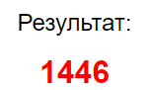

Задание 6. Выполнить умножение целых двоичных чисел без знака, представленных в шестнадцатеричном коде. Все операнды перевести в десятичный код.

|  |  |  |  |  |  |  |  |  |
| --- | --- | --- | --- | --- | --- | --- | --- | --- |
| № вар. | 9 | 10 | 11 | 12 | 13 | 14 | 15 | 16 |
| 1 мн. | E4 | 7A | AA | CC | CA | B4 | DD | 7F |
| 2 мн. | 23 | FE | 10 | 56 | 49 | C6 | 87 | 23 |

=170

=16 16*170=2720 = 101010100000

|  |  |  |  |  |  |  |  |  |  |  |  |  |  |  |  |  |
| --- | --- | --- | --- | --- | --- | --- | --- | --- | --- | --- | --- | --- | --- | --- | --- | --- |
| X |  |  |  |  |  |  |  |  | 1 | 0 | 1 | 0 | 1 | 0 | 1 | 0 |
|  |  |  |  |  |  |  |  |  |  |  |  |  |  |  |  |
|  |  |  |  |  |  |  |  |  |  |  | 1 | 0 | 0 | 0 | 0 |
| + |  |  |  |  |  |  |  |  | 0 | 0 | 0 | 0 | 0 | 0 | 0 | 0 |
|  |  |  |  |  |  |  | 0 | 0 | 0 | 0 | 0 | 0 | 0 | 0 |  |
|  |  |  |  |  |  | 0 | 0 | 0 | 0 | 0 | 0 | 0 | 0 |  |  |
|  |  |  |  |  | 0 | 0 | 0 | 0 | 0 | 0 | 0 | 0 |  |  |  |
|  |  |  |  | 1 | 0 | 1 | 0 | 1 | 0 | 1 | 0 |  |  |  |  |
| = |  |  |  |  | 1 | 0 | 1 | 0 | 1 | 0 | 1 | 0 | 0 | 0 | 0 | 0 |

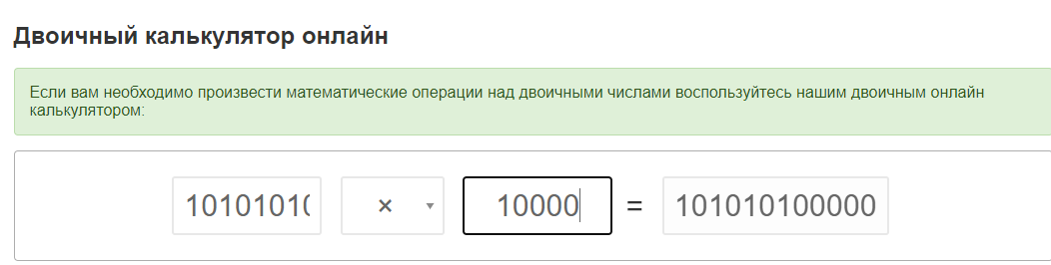

Задание 7. Выполнить деление целых двоичных чисел без знака,

представленных в шестнадцатеричном коде. Все операнды перевести в десятичный код.

|  |  |  |  |  |  |  |  |  |
| --- | --- | --- | --- | --- | --- | --- | --- | --- |
| № вар. | 9 | 10 | 11 | 12 | 13 | 14 | 15 | 16 |
| Делимое | E224 | 751A | A3A8 | CC22 | CDFA | 11B4 | D18D | 711F |
| Делитель | 23 | FE | 10 | 56 | 49 | C6 | 87 | 23 |

=41896

|  |  |  |  |  |  |  |  |  |  |  |  |  |  |  |  |  |  |  |  |  |  |  |  |  |  |  |  |  |  |
| --- | --- | --- | --- | --- | --- | --- | --- | --- | --- | --- | --- | --- | --- | --- | --- | --- | --- | --- | --- | --- | --- | --- | --- | --- | --- | --- | --- | --- | --- |
| 1 | 0 | 1 | 0 | 0 | 0 | 1 | 1 | 1 | 0 | 1 | 0 | 1 | 0 | 0 | 0 | 1 | 0 | 0 | 0 | 0 |  |  |  |  |  |  |  |  | |
| 1 | 0 | 0 | 0 | 0 |  |  |  |  |  |  |  |  |  |  |  | 1 | 0 | 1 | 0 | 0 | 0 | 1 | 1 | 1 | 0 | 1 | 0 | | 1 | |
|  |  | 1 | 0 | 0 | 0 | 1 |  |  |  |  |  |  |  |  |  |  |  |  |  |  |  |  |  |  |  |  |  |  | |
|  |  | 1 | 0 | 0 | 0 | 0 |  |  |  |  |  |  |  |  |  |  |  |  |  |  |  |  |  |  |  |  |  |  | |
|  |  |  |  |  |  | 1 | 1 | 1 | 0 | 1 |  |  |  |  |  |  |  |  |  |  |  |  |  |  |  |  |  |  | |
|  |  |  |  |  |  | 1 | 0 | 0 | 0 | 0 |  |  |  |  |  |  |  |  |  |  |  |  |  |  |  |  |  |  | |
|  |  |  |  |  |  |  | 1 | 1 | 0 | 1 | 0 |  |  |  |  |  |  |  |  |  |  |  |  |  |  |  |  |  | |
|  |  |  |  |  |  |  | 1 | 0 | 0 | 0 | 0 |  |  |  |  |  |  |  |  |  |  |  |  |  |  |  |  |  | |
|  |  |  |  |  |  |  |  | 1 | 0 | 1 | 0 | 0 |  |  |  |  |  |  |  |  |  |  |  |  |  |  |  |  | |
|  |  |  |  |  |  |  |  | 1 | 0 | 0 | 0 | 0 |  |  |  |  |  |  |  |  |  |  |  |  |  |  |  |  | |
|  |  |  |  |  |  |  |  |  |  | 1 | 0 | 0 | 0 | 0 |  |  |  |  |  |  |  |  |  |  |  |  |  |  | |
|  |  |  |  |  |  |  |  |  |  | 1 | 0 | 0 | 0 | 0 |  |  |  |  |  |  |  |  |  |  |  |  |  |  | |
|  |  |  |  |  |  |  |  |  |  |  |  | 1 | 0 | 0 | 0 | 0 |  |  |  |  |  |  |  |  |  |  |  |  | |
|  |  |  |  |  |  |  |  |  |  |  |  | 1 | 0 | 0 | 0 | 0 |  |  |  |  |  |  |  |  |  |  |  |  | |
|  |  |  |  |  |  |  |  |  |  |  |  |  |  |  | 0 | 0 |  |  |  |  |  |  |  |  |  |  |  |  | |

=16 41896/16 = 2618.5 = 1010001110101

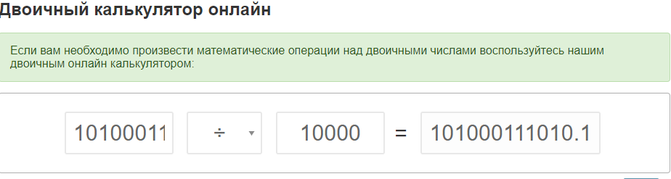

Задание 8. Записать дробное число, представленное в десятичной форме, в шестнадцатеричной форме в стандарте IEEE754 (32 бита с плавающей

точкой).

|  |  |  |  |  |  |  |  |  |
| --- | --- | --- | --- | --- | --- | --- | --- | --- |
| № вар. | 9 | 10 | 11 | 12 | 13 | 14 | 15 | 16 |
|  | 239,08 | -54,07 | -3,748 | -2,348 | 549,78 | 432,85 | -4,769 | -12,6 |

Делим на 2 кона целая часть не станет 1. Кол-во делений будет порядком.

У моего числа порядок 1

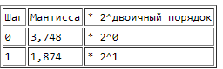

Экспонента со смещением: 1 + 127 = 128 = 1000 0000

Число отрицательно – знаковый бит равен 1.

1.874 в двоичном с точностью 23 бита = 1101 1111 1011 1110 0111 011

|  |  |  |  |  |  |  |  |  |  |  |  |  |  |  |  |  |  |  |  |  |  |  |  |  |  |  |  |  |  |  |  |
| --- | --- | --- | --- | --- | --- | --- | --- | --- | --- | --- | --- | --- | --- | --- | --- | --- | --- | --- | --- | --- | --- | --- | --- | --- | --- | --- | --- | --- | --- | --- | --- |
|  |  |  |  |  |  |  |  |  |  |  |  |  |  |  |  |  |  |  |  |  |  |  |  |  |  |  |  |  |  |  |  |
| 1 | 1 | 0 | 0 | 0 | 0 | 0 | 0 | 0 | 1 | 1 | 0 | 1 | 1 | 1 | 1 | 1 | 1 | 0 | 1 | 1 | 1 | 1 | 1 | 0 | 0 | 1 | 1 | 1 | 0 | 1 | 1 |

Переведём в 16-ричную систему: = 0xc06fdf3b

Задание 9. Записать число, представленное в шестнадцатеричной форме в стандарте IEEE754 (32 бита с плавающей точкой) в десятичной форме.

|  |  |  |  |  |  |  |
| --- | --- | --- | --- | --- | --- | --- |
| № вар. | 7 | 8 | 9 | 10 | 11 | 12 |
|  | C045A027 | 4116E148 | C3ACFC29 | C2170F5C | C11A793E | A678F544 |

 0xC11A793E=1100 0001 0001 1010 0111 1001 0011 1110

Бит знака 1

Порядок со смещением +127: 10000010 = 130 => 2^3

Дробная часть 1.00110100111100100111110 = 1.2068250179290771484375

Умножим на порядок и допишем знак -9.6546001434326171875