1

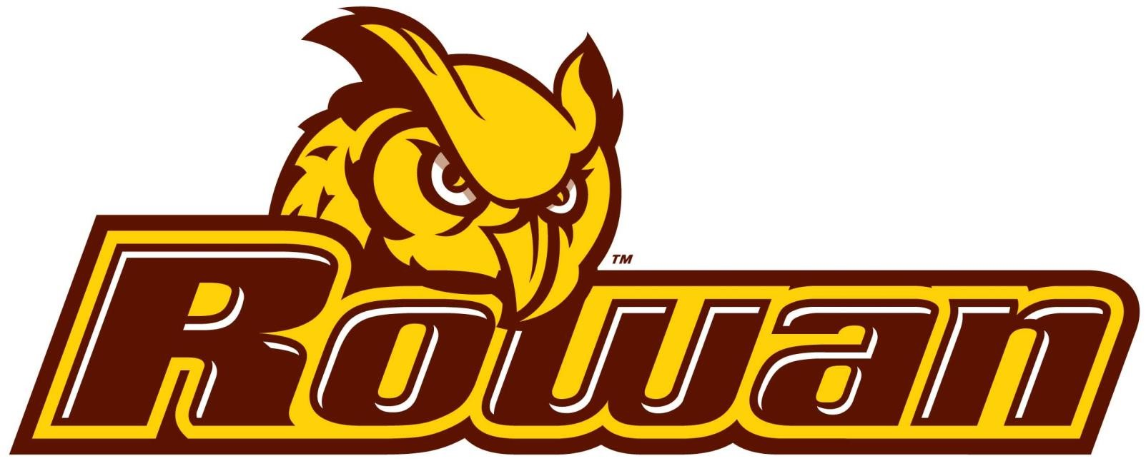

**SW**

**Engineering**

**Tool**

**Suite**

***Rowan University***

***Senior Project***

***Dr. Baliga***



Principle

Innovators

:

**Dharmik**

**Pandya**

**Yousuf**

**Ahmed**

**Roger**

**Miller**

**Cole**

**Christensen**

**Tim**

**McClintock**

**Krunal**

**Patel**

***https***

***//***

***:***

***github***

***.***

***com***

***/***

***computer***

***-***

***science***

***-***

***team***

***/***

***seniorproject***

***101***

Project Title***: “Software Engineering Tool Suite”***

Project Summary:

Rowan University - Software Engineering Tool Suite (RU-SWETS) is a web based social toolkit framework that organizes software engineering resources into Student *Tools* stored within a *Toolkit*, which is based upon available resources to Students in Engineering majors at Rowan University and other nearby Universities. This app will help Rowan University and nearby Universities make available a universal set of resources Students in Engineering majors will need throughout their respective College experiences. One example of a Student *Tool* available within the *Toolkit* framework is “SWE Toolkit”. “SWE Toolkit” maintains "Tools". When an Engineer requires a specific “Tool” from “SWE Toolkit”, they may choose the “Tool” based on the need for their project and what is available at their University. Two other artifacts include the “Guideline Of Success” and the “List Of Clubs”. These two artifacts store information that the professors would like to have made known to their Students and that are available at the Students University. This framework will enable communication for all available resources that exist for Students which might initially be unknown to them such as Microsoft student tools, Hackathons and contests, and Subscriptions to tutorial sites, discount sites, and magazines. The tools may be ranked and added by the Professor in any given order desired.

Project Goals:

The initial goals that are fundamental to the overall success of this project include:

1. A Working website that is available and error free (respectively.)
2. A Database with the ability to store information appropriately.
3. User friendly web interface that includes sign on (Login) and sign up (Register)
4. AWS Framework that is scalable.

Product Features:

The product features will include:

* + Front End User Interface
  + Back End Server

Database Services

Web Hosted

API Accessibility

Project Limitations:

Threats that have been analyzed and anticipated include a lack of time and material resources. This project is being architected to embrace engineering concepts and programming concepts that have been learned throughout our collective experiences as Students at Rowan University. Outside of this scope we face challenges in knowledge gathering. It is imperative that we quickly learn how to better ascertain the tools that other Universities are using, and from an Administrative standpoint, which frameworks Universities are already using for the deployment of ‘like’ resources that benefit their Students and that may compete with our Tool/Web Service.

Project Stretch Goals:

The vision of this group is that we may develop this web app into a mobile app available on Android and Mac OS platforms. We desire scalability and reusability so cloud services are the most optimal end-game to support our application. Once scalability and mobility are achieved we wish to extend this App from Rowan and nearby universities to all universities. This is designed to eventually become a social media tool which many Universities can create adaptations from. At this stage, our project will develop a self-formed community of networked professionals who can share tools and create fast forming teams based upon the latest available tools. In turn, it is our hope that our tool may effectively accelerate learning, especially in the field of Computer Science.