Noah Xu HW4
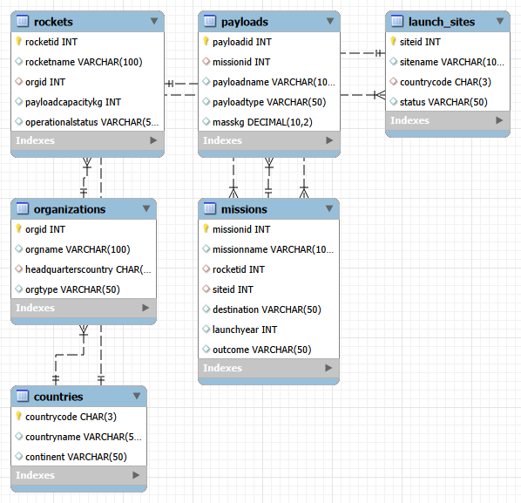
Problem 1.
SELECT missions.missionname, rockets.rocketname, organizations.orgname, launch_sites.sitename, missions.destination, missions.launchyear, missions.outcome
FROM missions
INNER JOIN rockets ON missions.rocketid = rockets.rocketid
INNER JOIN organizations ON rockets.orgid = organizations.orgid
INNER JOIN launch_sites ON missions.siteid = launch_sites.siteid
ORDER BY missions.launchyear DESC, missions.missionname ASC;
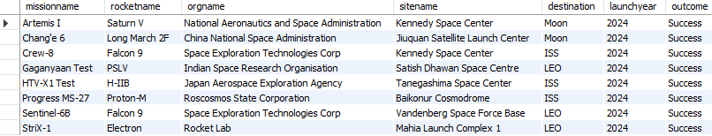
Problem 2.
SELECT missions.missionname, rockets.rocketname, payloads.payloadname, payloads.payloadtype, payloads.masskg
FROM payloads
INNER JOIN missions ON payloads.missionid = missions.missionid
INNER JOIN rockets ON missions.rocketid = rockets.rocketid
WHERE missions.launchyear = 2024
ORDER BY payloads.masskg DESC;
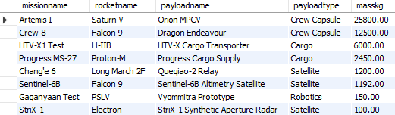
Problem 3.
SELECT launch_sites.sitename, missions.missionname, rockets.rocketname, missions.launchyear
FROM launch_sites
LEFT JOIN missions ON launch_sites.siteid = missions.siteid AND missions.launchyear = 2024
LEFT JOIN rockets ON missions.rocketid = rockets.rocketid
ORDER BY launch_sites.sitename ASC, missions.missionname ASC;
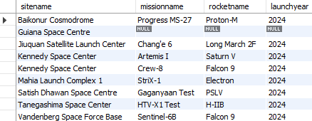
Problem 4.
WITH organization_payload_total AS (
SELECT rockets.orgid, SUM(payloads.masskg) AS total_payload_masskg
FROM payloads
INNER JOIN missions ON payloads.missionid = missions.missionid
INNER JOIN rockets ON missions.rocketid = rockets.rocketid
GROUP BY rockets.orgid
)
SELECT organizations.orgname, organizations.headquarterscountry, organizations.orgtype, organization_payload_total.total_payload_masskg
FROM organizations
LEFT JOIN organization_payload_total ON organizations.orgid = organization_payload_total.orgid
ORDER BY organization_payload_total.total_payload_masskg DESC;
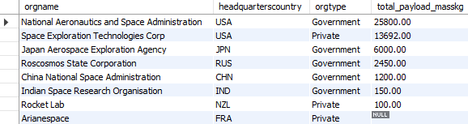

Problem 5.
WITH country_mission_total AS (
SELECT launch_sites.countrycode, COUNT(missions.missionid) AS total_missions
FROM missions
INNER JOIN launch_sites ON missions.siteid = launch_sites.siteid
GROUP BY launch_sites.countrycode
),
country_payload_total AS (
SELECT launch_sites.countrycode, SUM(payloads.masskg) AS total_payload_masskg
FROM payloads
INNER JOIN missions ON payloads.missionid = missions.missionid
INNER JOIN launch_sites ON missions.siteid = launch_sites.siteid
GROUP BY launch_sites.countrycode
)
SELECT countries.countryname, country_mission_total.total_missions, country_payload_total.total_payload_masskg
FROM countries
LEFT JOIN country_mission_total ON countries.countrycode = country_mission_total.countrycode
LEFT JOIN country_payload_total ON countries.countrycode = country_payload_total.countrycode
ORDER BY country_payload_total.total_payload_masskg DESC;
