Noah Xu HW5
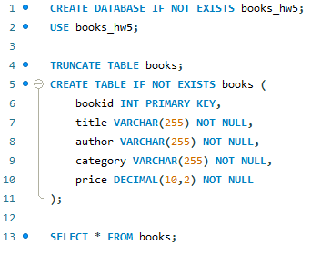
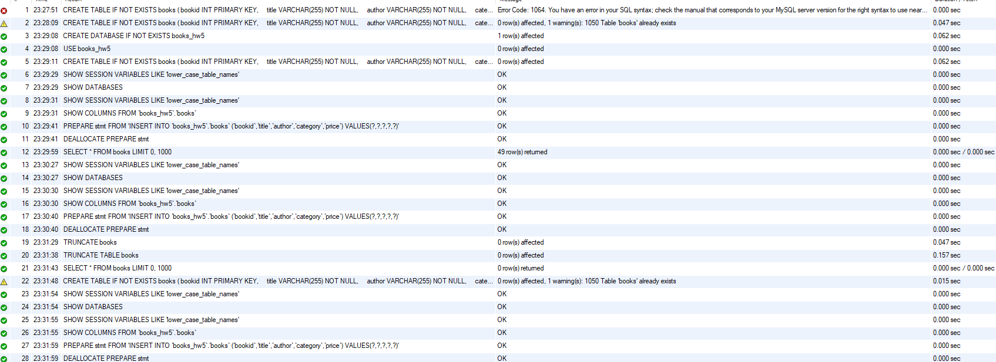
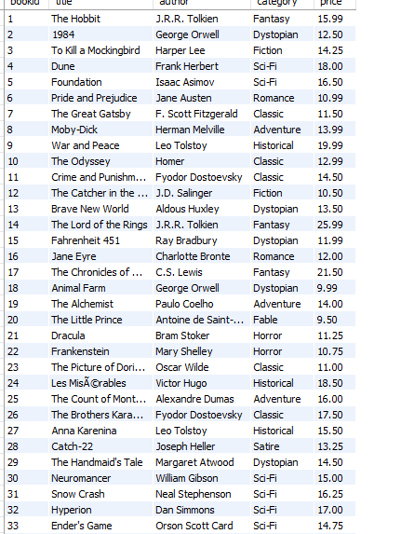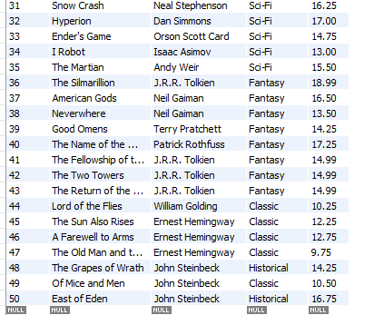

http://localhost:3000/?author=J.R.R.%20Tolkien&format=text
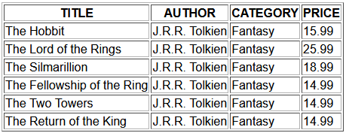
http://localhost:3000/?author=J.R.R.%20Tolkien
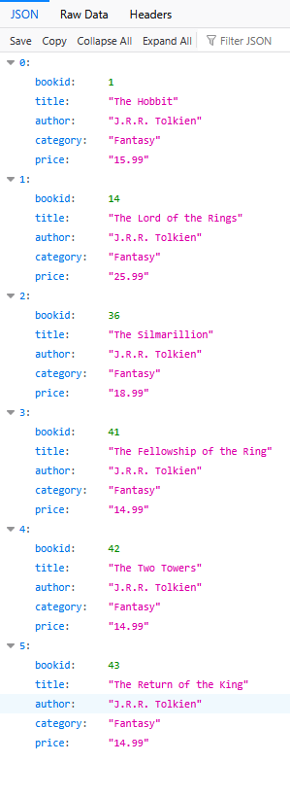

http://localhost:3000/?category=Fantasy&format=text
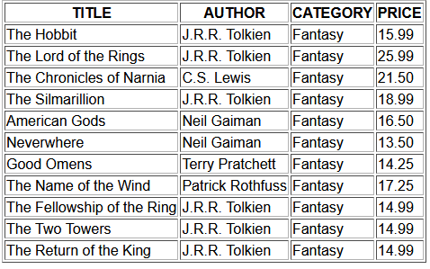
http://localhost:3000/?category=Fantasy
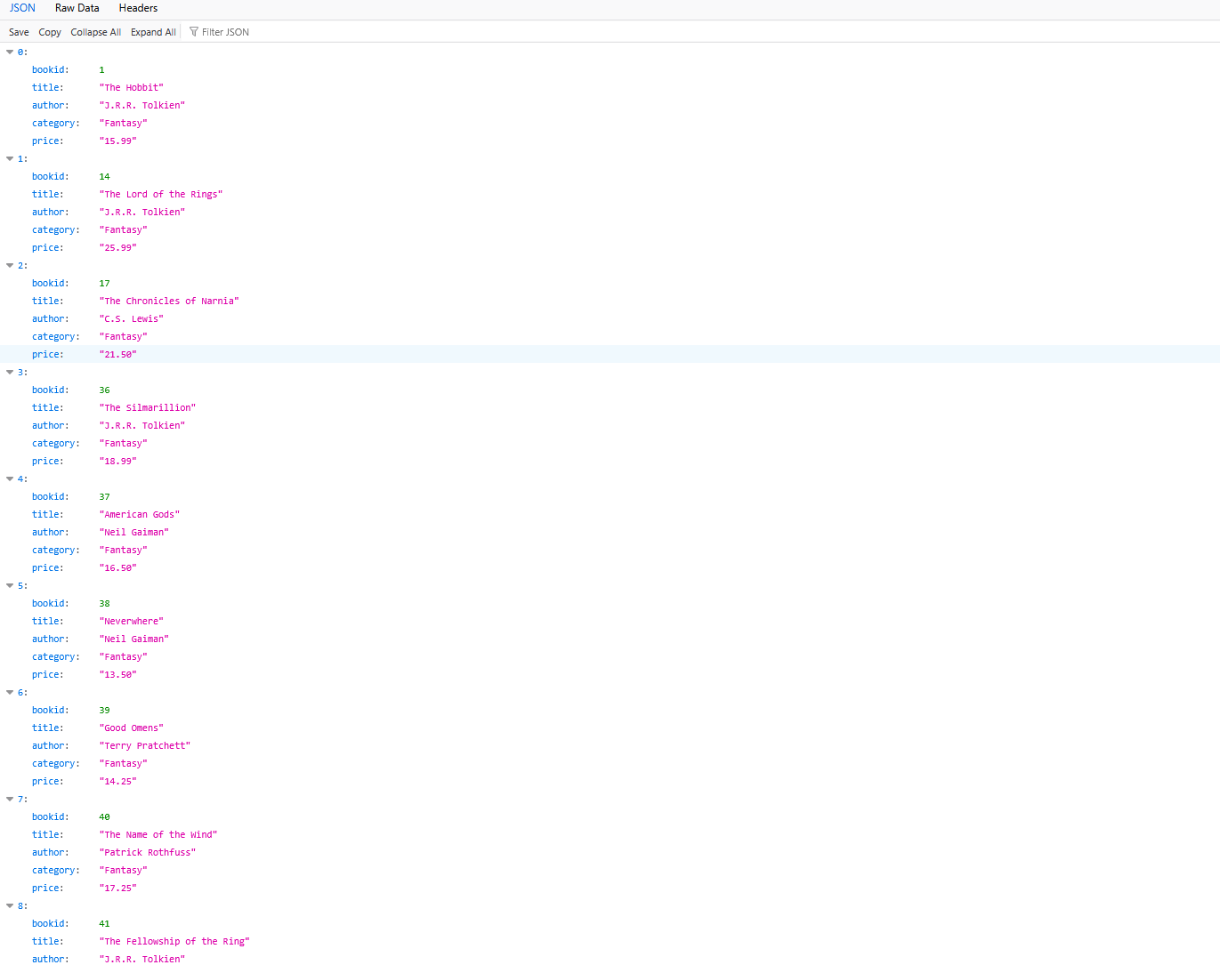

mysql.js
// mysql.js - The Database Connection Pool Module

const mysql = require('mysql2/promise');

// Configuration details
const dbConfig = {
host: "localhost",
user: "root",
password: "hihello123", // !! CHANGE THIS TO YOUR ACTUAL PASSWORD !!
database: "books_hw5",
// Connection Pool settings are optional but good practice
waitForConnections: true,
connectionLimit: 10,
queueLimit: 0
};

// Create and export the connection pool
const pool = mysql.createPool(dbConfig);

// A simple check to ensure the pool is working on startup
pool.getConnection()
.then(connection => {
console.log("Database Pool: MySQL connection successful and pool established.");
connection.release(); // Release the test connection immediately
})
.catch(err => {
console.error("Database Pool Error: Could not connect to MySQL! Check credentials and if the server is running.", err.message);
});

module.exports = pool;

search.js
//******************************************************************************
//*** set up an HTTP server off port 3000
//******************************************************************************
const express = require('express');
const app = express();
const PORT = 3000;

// Requires the exported pool object from the local 'mysql.js' file
const pool = require('./mysql');

//******************************************************************************
//*** This routing table handles all the GET requests from the browser
//******************************************************************************

// All GET handlers now use async/await by calling the async readAndServe utility

//******************************************************************************
//*** this handles a specific GET requests from the browser (/)
//******************************************************************************
app.get("/", async (req, res) => {
// extract the string received from the browser
const category = req.query.category;
const author = req.query.author;
// return format of html table or json object
const format = req.query.format;

// SECURITY FIX: Use prepared statements (the '?' placeholder)
let sql_query;
let input;

if (category) {
sql_query = "SELECT * FROM books WHERE category = ?";
input = category;
} else if (author) {
sql_query = "SELECT * FROM books WHERE author = ?";
input = author;
} else {
return res.status(404).send("Please provide category or author");
}

try {
const [rows] = await pool.execute(sql_query, [input]);

if (format == "text") {
let html_body = "<HTML><STYLE>body{font-family:arial}</STYLE><BODY><TABLE BORDER=1>";
html_body += "<TR><TH>TITLE</TH><TH>AUTHOR</TH><TH>CATEGORY</TH><TH>PRICE</TH></TR>";
for (let i = 0; i < rows.length; i++) {
html_body += `<TR><TD>${rows[i].title}</TD><TD>${rows[i].author}</TD><TD>${rows[i].category}</TD><TD>${rows[i].price}</TD></TR>`;
}
html_body += "</TABLE></BODY></HTML>";
res.send(html_body);
} else {
res.json(rows);
}
} catch (err) {
console.error("SQL Error in / GET:", err);
res.status(500).send("<html><body><h1>Database Query Error</h1><p>An error occurred while fetching data: " + err.message + "</p></body></html>");
}
});

// --- Global Error Handler Middleware ---
// Kept as a fallback for non-route-specific errors or errors passed by next()
app.use((err, req, res, next) => {
// Log the error stack for debugging purposes
console.error(err.stack);
res.status(500).json({ error: 'An unexpected server error occurred.', details: err.message });
});

//*** set up an HTTP server off port 3000
app.listen(PORT, function () {
console.log("NodeJS app listening on port " + PORT);
});

**wasn’t sure if meant pasting code in here when it would be pushed with github repo anyway, but figured safer to include both.

