Implementation details
All requirements are satisfied as follow:
1. Each item in the list view contain at least one image, text description, and the title of film indicating the index of the item.

The corresponding code can be found in component/FilmCard.kt, ui/MovieScreen.kt, ui/HomeScreen.kt, and MainActivity.kt
2. The image should be loaded asynchronously
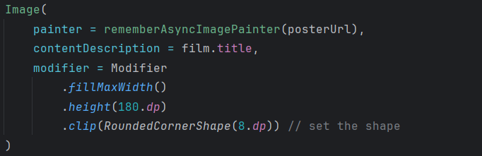
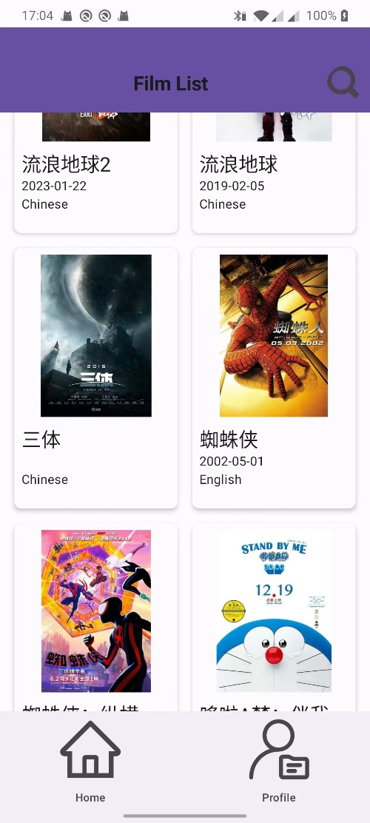
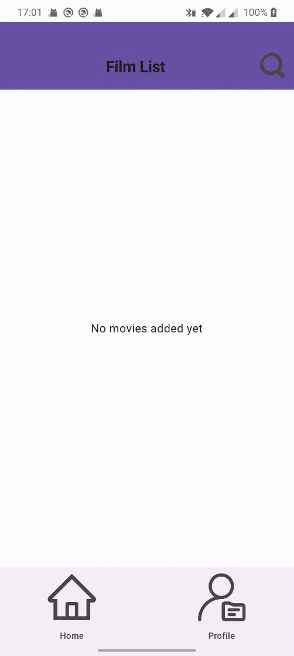
Using coil.compose.rememberAsyncImagePainter to achieve.
After adding elements
It is inside component/FilmCard.kt and component/SearchCard.kt

3. The item should be clickable to jump to another activity
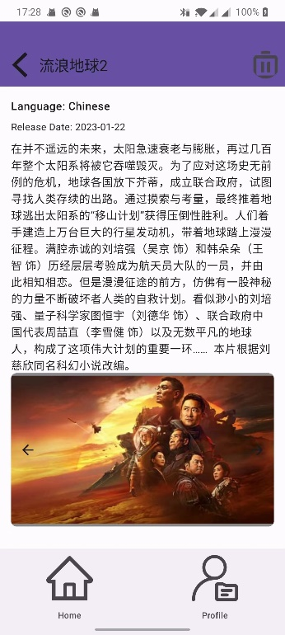
If you click the item of each film, it will go to the detail page and show the detail information of the film
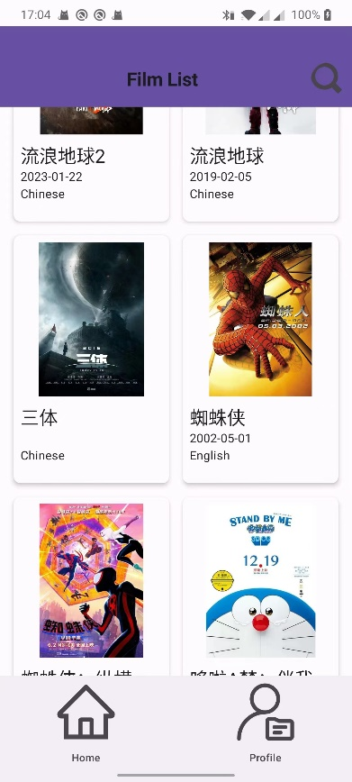
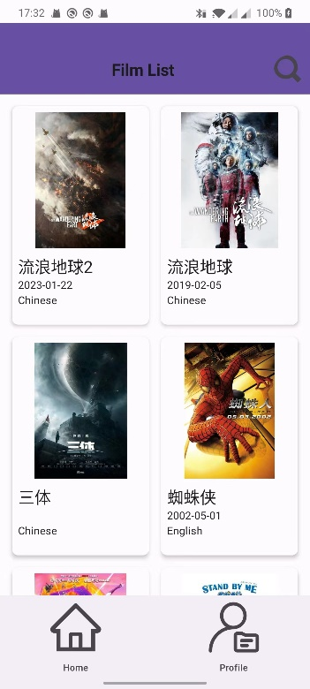
After clicking the film “流浪地球2”, it jumps to show the details

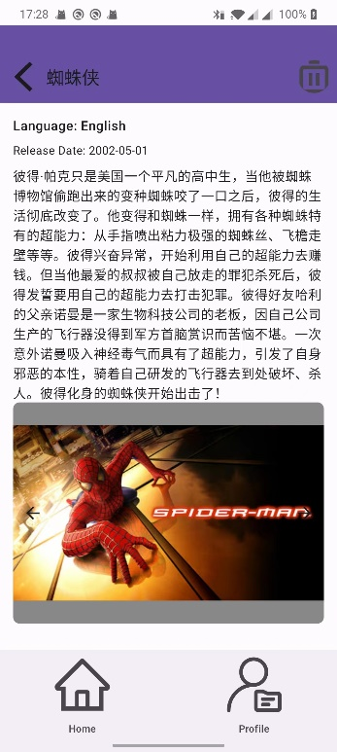

After clicking the film “蜘蛛侠”, it jumps to show the details

The corresponding code can be found in component/FilmCard.kt and ui/DetailScreen.kt

4. The new activity contain an image slider with multiple images.
The detail page contains multiple images of the film, click the arrow of the image slider and it will change to next image of the film.
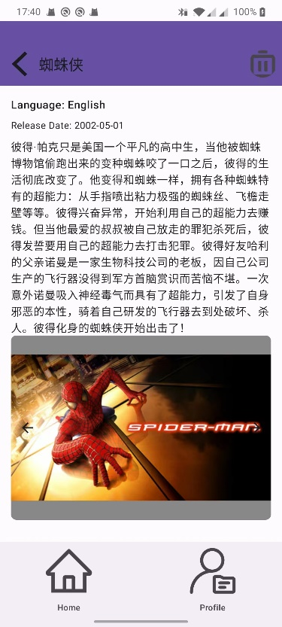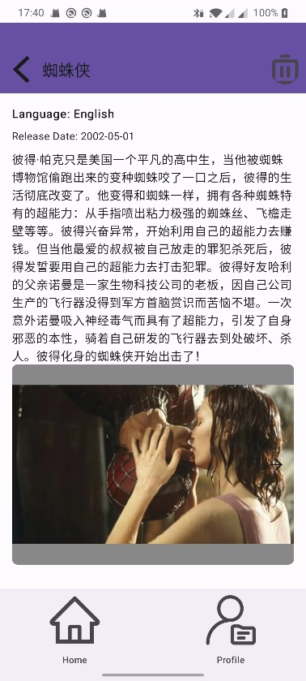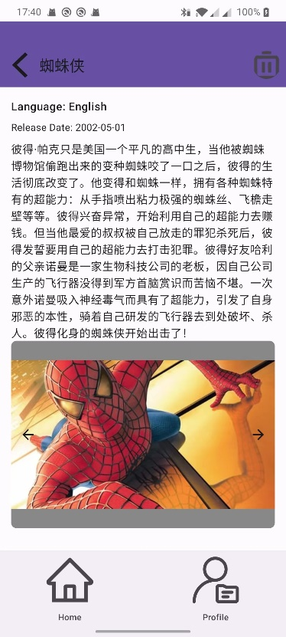
The corresponding code can be found in ui/DetailScreen.kt

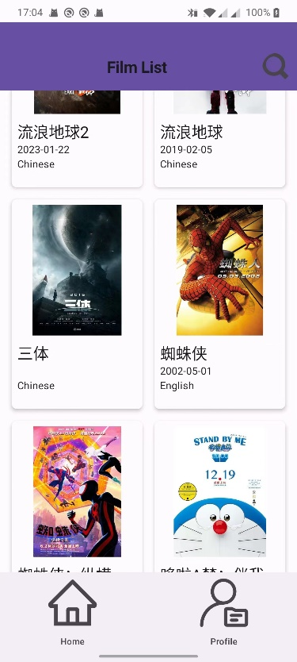
5. The ListView is scrollable. And click the search button in the top right corner, search the film you want to add, click the add button of the result, and the new item will be added to the ListView.
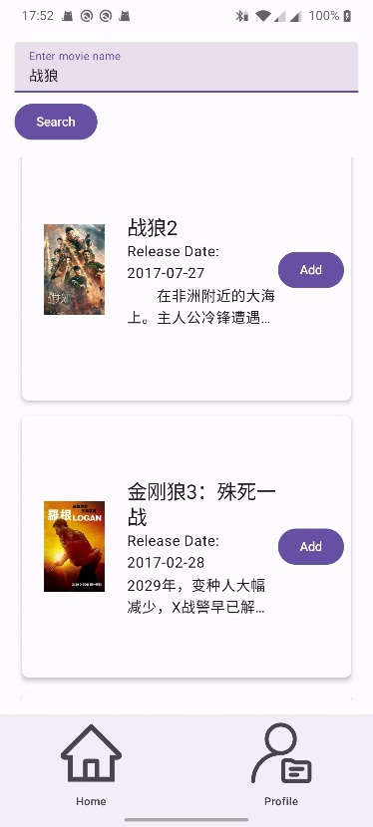
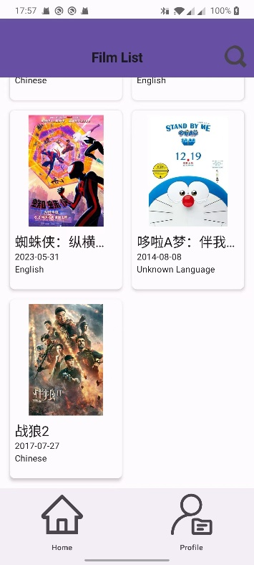

Click to add the film to your ListView
Click to search the film you want

And if you don’t find the film you want, you can click the manually add film button and add add new item by yourself.

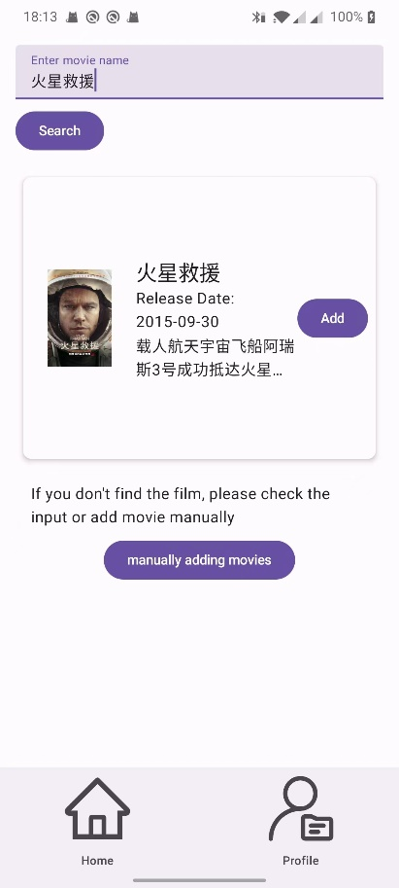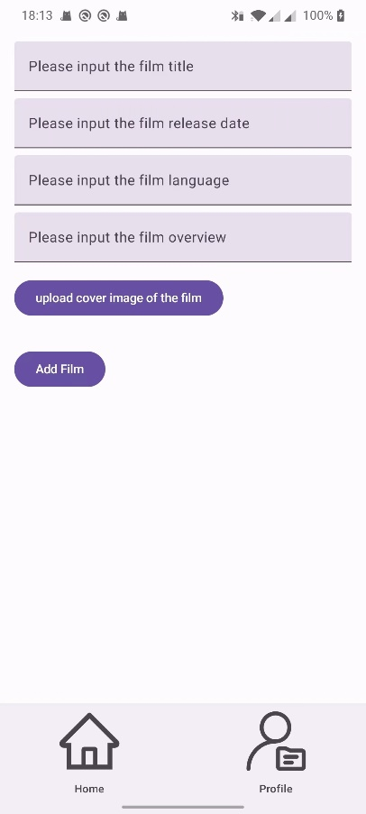
Input the information of the film here
The corresponding code can be found in MainActivity.kt, ui/SearchScreen.kt, component/SearchCard.kt, data/FilmApi.kt and data/FilmApiResponse.kt

6. After pull-and-release for five times, the list view should indicate there is no more new content
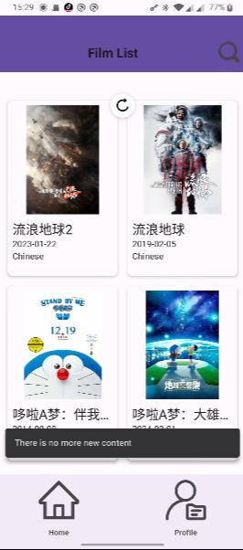
The corresponding code can be found in ui/MovieScreen.kt

7. The item can be deleted (2%)
To delete the item of ListView, you should click it and go to the detail page, click the delete button on the top right, and then the film will be deleted from the ListView.
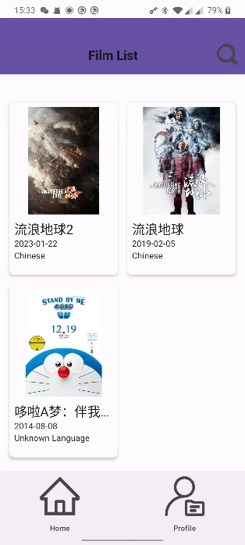
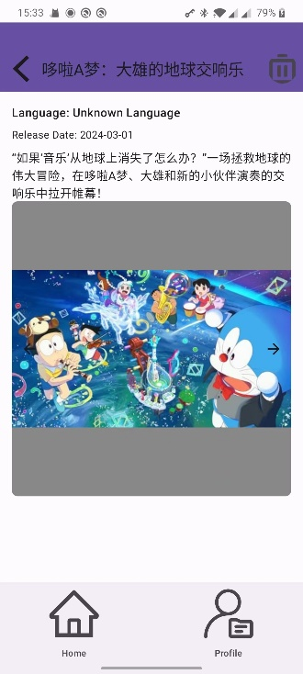
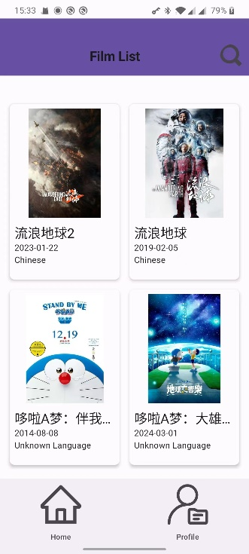
Click the delete button, the film will be deleted
Click the film and go to the detail page
The corresponding code can be found in ui/DetailScreen.kt
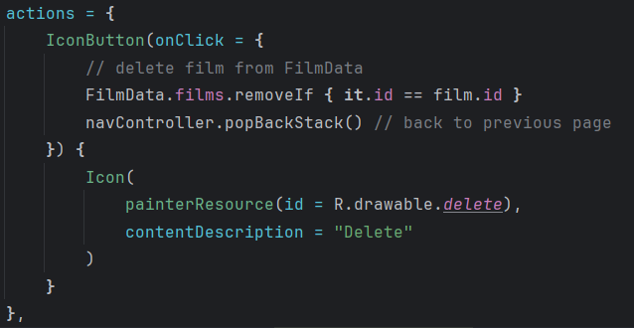

7. In pressing home button and re-enter the APP, the APP should stay in the content page of previous usage and do not crash.
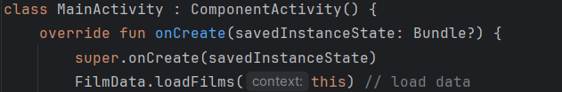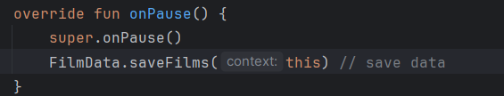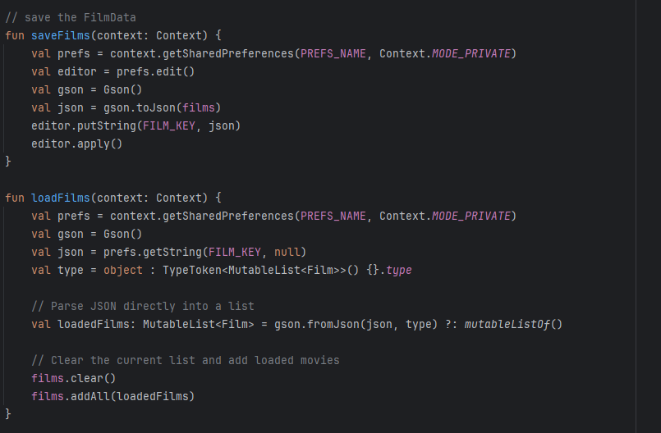
The app will use the above functions to save the data. If you have already added some films to the content page and close the app, it will automatically save what films you have added, and next time when you reopen the app, it will load the film data that you have already added to your list view.
The code can be found in MainActivity.kt and FilmData.kt

8. Load the contents in the listview from online resources.
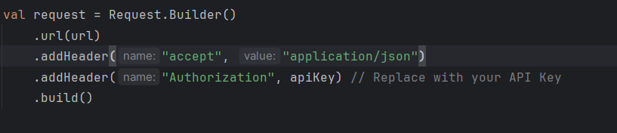
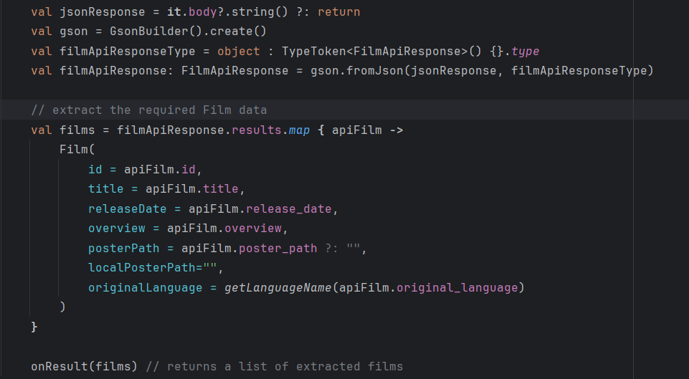

In FilmApi.kt, we have fetchMovie functions to help us load the online information of film. User can search the film they want to add, and in the search screen it will show the return information of the API. And if user add a film to the list view, the app will record the online resource and add it to the list view, including the information of the movie was added. And if a user can’t the film they want from the API, they can also add the movie manually. Because these kinds of film don’t have online resource, the information include poster image will store and load locally.
The mainly code can be found in ui/SearchScreen.kt, component/SearchCard.kt, component/FilmCard.kt, data/FilmApi.kt and data/FilmApiResponse.kt
What’s more is that the API of online resources needs VPN to connect, and I use my personal API key.

