Bootstrapping
Computer Science’s very own chicken-or-egg problem

Foreword: The following is not original. It consists of the author’s opinions, impressions and primarily his understanding of a certain topic.

Although technology in its ideal form might be the closest thing to magic, it is my personal opinion that the pleasures of technology are better enjoyed by demystifying it. One of the more elegant things we’ve managed to do since the initial days of computing is abstraction. Lower level languages have given way to higher level languages that have allowed more people to be able to code. We all know that compilers and interpreters facilitate this abstraction. An extremely interesting facet of these compilers is that a lot of them are written in the language that they compile!

The modern day C compiler, itself is a binary that was written in C! This is achieved by bootstrapping; a term that originates from the idea of one pulling themselves up by their own bootstraps. The C compiler, in the same manner, is written in C and sometimes compiled by the same compiler for better performance and a variety of other reasons.

The idea of bootstrapping is best explained by what are known as T-diagrams, which I personally prefer thinking of as puzzle pieces that can fit together in a few ways.

You need a program that takes in C code and turns it into a binary. Let’s say that this binary has a quality described by N. Now, we could write an assembly program that does this (a compiler) and assemble it to produce a binary of quality A(another compiler). Now this binary would be poorer in quality than N and will be extremely hard to write. It would be impractical & difficult for this binary A to compile C code into a binary N. This is because assembly is a very low level language. It is limited to simple memory manipulation and basic operations. It has no support for data types like structures, which form a very integral part of writing code in C.

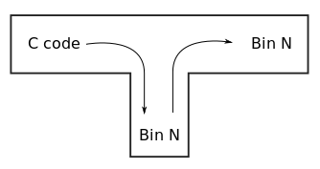
Expectation Not Good
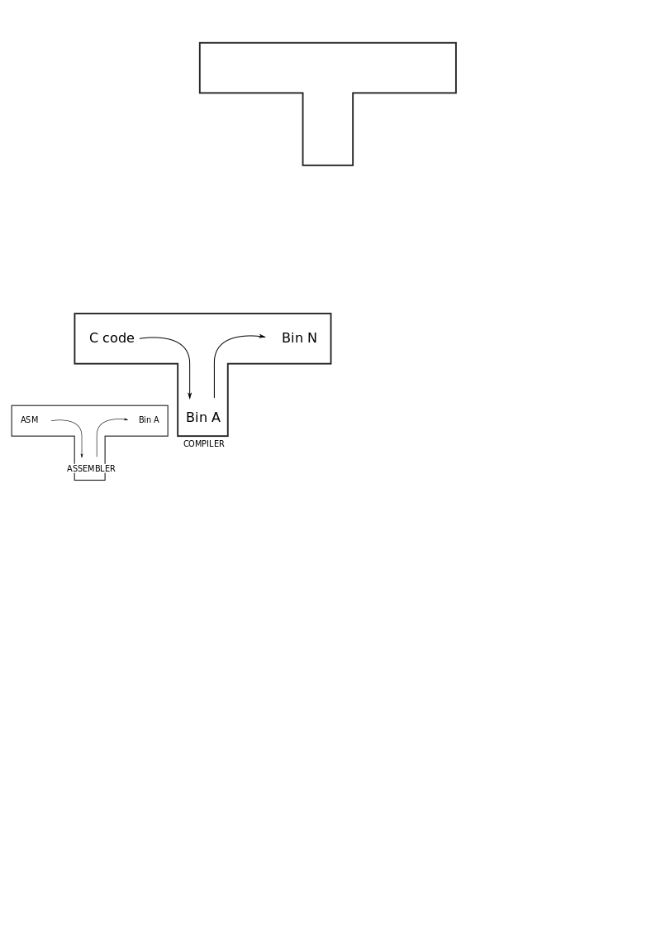

1.a | 1.b

We can’t efficiently generate a binary of high quality N, using a compiler of quality A(written in assembly). We can generate a binary of quality B(slightly better) using a binary A. Imagine we write a program with code-generation capability and give it to the binary A(assembled compiler). It will be compiled to give us a binary of quality A. This resulting binary A, itself will be a compiler!

What we have as input in fig 2 is a C program for a compiler. This C program needs to be converted into a binary and that is done using the compiler that was written in assembly(fig 1.b - lower). Now, this compiler(assembled) takes a C program as input and produces another binary of quality A. What we have as output here is a binary(compiler) of quality A, written in the C programming language. Due to the input code, this resulting binary is a compiler(quality A). Let's call this resulting compiler, compiler Mark I.

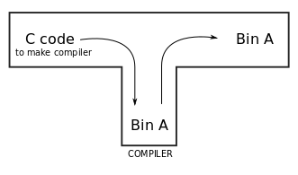
Fig 2

We have a compiler, Mark 1 which could be made much better. In all fairness, this compiler was compiled using an assembled binary(lower quality). So let’s write another piece of C code, which can also compile other programs, but better. Now if we compile this code, using compiler Mark I, we get a binary of quality B, which is a better compiler; Mark II.

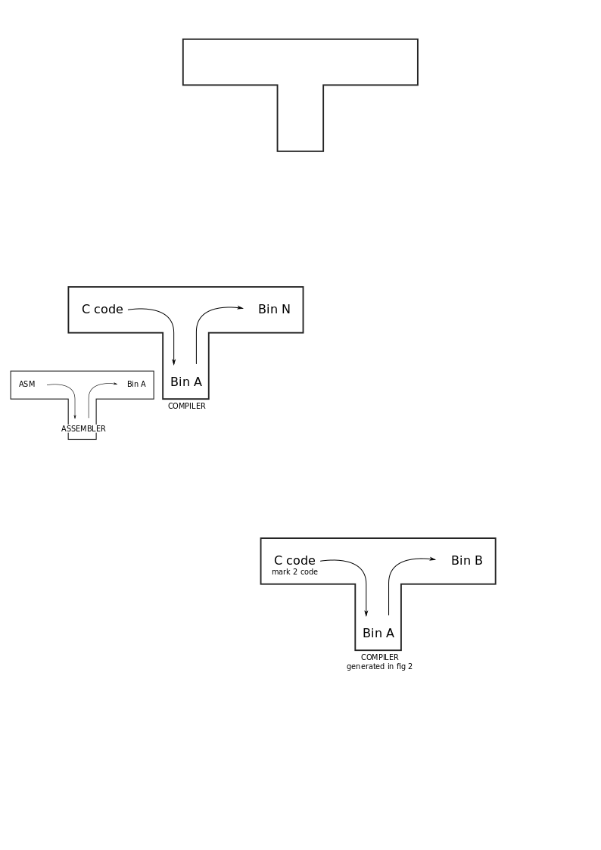
Fig 3

The input in fig 3 is the new compiler code that was written(mark II). We use the old compiler, mark I to compile this code(mark II) to generate a binary of quality B. Now, we have a much better compiler(mark II) which could take in C, compile it and produce a binary of quality B.

This binary B, has one weakness; it itself is running on Binary A, which is an older, poorer version of our compiler. But, at this point, we have with us, compiler Mark 2, which is a much better version than the binary A compiler, mark I. What we can do here, is take the C code(mark II) written for the input in fig 3 and compile it using our Mark II compiler to produce a binary that is even better than our original Mark II(compiled using mark I). This output binary(Mark III) is of quality B, can produce code of quality B and is compiled using our compiler, which itself is of quality B! This was our initial expectation. This entire process can be visualised by putting together the above figures.
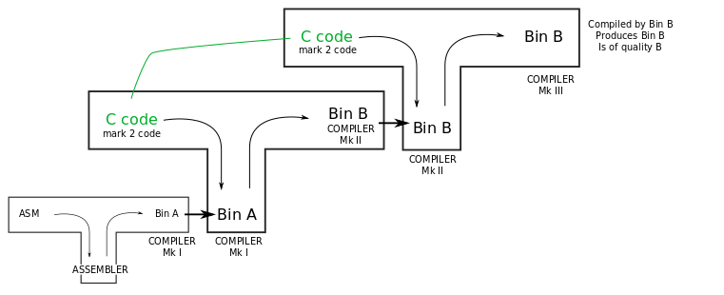
An article by
Prithivi Maruthachalam
1st Year - CSE
2019103561

