REDTACTON
WHERE FANTASY MEETS FACTS!!
Can you imagine swapping the business cards just by shaking your hands or being able to print a photo by placing one hand on the laptop and other on the printer?! It might sound fictitious but the Japanese Communication Company, Nippon Telegraph and Telephone Corporation(NTT), has brought this innovative idea into the real picture with prodigious RedTacton Technology. The RedTacton is a novel communication technology that pioneers the electronic future by using the human body surface as a high speed and safe network transmission path . It solely scrapes up the minute electric fields exuded on the surface of the body to transmit/receive data at 10 Mbs

HERE'S A CATCH
Here's a glimpse of how the name, ‘RedTacton’ was derived. ‘Red’, owing to the fact that it symbolises good luck conforming to the auspicious Japanese culture, here signifies the cordiality and warmth of interpersonal communication . ‘Tacton’ is nothing but “Touch-Act-On” ,which literally refers to jump-starting an action by touching.
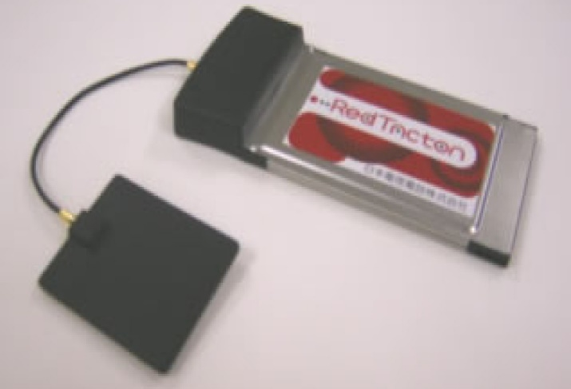

HOW DOES IT WORK?
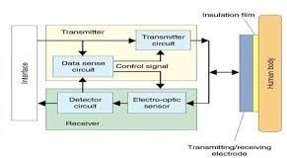
We all have heard of LAN(Local Area Network),WAN(Wide Area Network) and MAN(Metropolitan Area Network) but RedTacton is a break-through technology that successfully uses HAN( Human Area Network). It is neither wireless or wired communication rather it enables communication by touching. A transmission path is formed at the moment, a part of the human body comes in contact with a RedTacton transceiver and physical separation ends the contact. The transceiver encompasses the Data Sensing circuit which checks the incoming signals from the interface for data and dispatches it to the transmitter. The transmitter inturn induces a weak electric field on the body surface that is passed on to the receiver. The photonic electric field sensor in the receiver varies the optical properties of electro-optic crystal in accordance with the received weak electric field. The laser which is passed through the crystal, scrutinizes the change in optical properties of crystal and converts the upshot into electric signals inside the detector circuit. Hence, logical hodgepodge of communication emerges in harmony with the natural and physical movements of the user.
WHY REDTACTON?
Tech-geeks might have a question: “There are a lot of well-established technologies like Wi-Fi, Bluetooth, Zigbee, IrDA etc.., then what is the need for RedTacton?”. Well, the answer is obvious. The arriving signals can be hacked easily, so security becomes a problem in the aforementioned technologies . However, hacking the RedTacton is nearly inconceivable as the transmission takes place only among RedTacton transceivers. Unlike Bluetooth , there is no user limitation and no pell-mell drop in transmission speed even in multi-user environments prompting ‘congestive collapse’.
HOW IS IT USEFUL?
Now I'll just endeavor to enlighten its pragmatic application with genuine-life example .The Iraq war is most arguably the most controversial event in recent history, where gun security would be highly salutary. Guns are most often detracted from dead troopers in the scuffle and utilized by the foe or it could be sold in the astronomically immense bootleg market for glommed weapons. If those Firearms have built-in transceiver programmed to transceiver worn by soldier, then it would be rendered futile in devoid of allied transceiver that is programmed to authorise the weapon to be shot. Redtacton lodged medicine bottles trigger an alarm whenever the utilizer physically contacts the erroneous medicine. Customers can get entire information on products immediately after touching it. One of its potential uses is Automatic user authentication and log in with just a touch. This innovation opens up a portal to trade private data in a splitsecond, personalize the automobiles and detect human ailments.
HUMAN SAFETY
Transceivers are completely insulated leaving no chances for the current to flow inside the body.When communication embarks, displacement current is engendered by the electrons in the body because the body is subjected to the minute electric field. Such displacement currents are not an immensely colossal deal as they are daily occurence to which we are habituated. Redtacton conforms to "Radio-frequency exposure protection standard"(RCR STD-38).
FINAL WORD
Though Redtacton holds innumerable benefits, the crux of matter is the implementation cost and short-range transmission. But the bottom line is that, within a few years from now , NTT’s utopian vision of RedTacton will unquestionably transform humans into striding ethernet cables and revolutionize the entire hustle-bustle communication world.
BY
S.SUWETHA
EEE DEPARTMENT,FIRST YEAR

