TABLE OF CONTENTS
S.NO | CONTENT | PAGE.NO
1 | FOUNDATIONS OF AI & PROMPTING | 2
2 | AI FOR TEXT & CONTENT | 17
3 | AI FOR DESIGN & CREATIVITY | 24
4 | AI FOR VOICE & VIDEO | 30
5 | AI FOR DEVELOPERS & PRODUCTIVITY | 33
6 | AI IN DAILY LIFE & CAREERS | 36
7 | AI TOOLS REFERENCE | 39

1. FOUNDATIONS OF AI & PROMPTING

1.1 Introduction to AI
Artificial Intelligence (AI) is the science of building systems that can think, learn, and act like humans. Instead of giving computers step-by-step instructions, AI enables them to analyze data, recognize patterns, and make decisions.

Categories of AI Tools
1. Text-based AI – Works with natural language.
Examples: ChatGPT, Perplexity AI, Poe.
Uses: Writing, summarization, email drafting, translation.
2. Image-based AI – Generates or edits pictures.
Examples: DALL·E, Stable Diffusion, Bing Image Creator.
Uses: Logos, posters, digital art, product mockups.
3. Video-based AI – Creates or enhances videos.
Examples: Pika Labs, CapCut AI.
Uses: Short animations, promotional ads, explainer videos.
4. Voice-based AI – Produces synthetic speech or clones voices.
Examples: ElevenLabs, Play.ht.
Uses: Audiobooks, dubbing, voice assistants.
5. Code-based AI – Assists developers in writing and debugging code.
Examples: GitHub Copilot, Codeium, Codium AI.
Uses: Code generation, bug fixing, test creation.

1.2 What is Prompting?
Prompting is the art of giving clear instructions to an AI tool so it produces the desired output.
Think of it as talking to a human assistant: the clearer your request, the better the result.

Prompting Framework (R-T-C-S-C)
1. Role – Tell AI what role it should play.
Example: “Act as a career coach.”
2. Task – What you want AI to do.
Example: “Write a professional email to apply for an internship.”
3. Context – Provide background or details.
Example: “The company is a startup in fintech.”
4. Style – Define tone and format.
Example: “Keep it polite and concise.”
5. Constraints – Any limits or rules.
Example: “Limit to 150 words.”
Example Prompt:
“Act as a career coach. Write a polite internship application email for a fintech startup. Keep it concise (150 words).”

1.3 Evaluating AI Outputs
AI is powerful, but it is not always accurate.
- Accuracy – AI may provide correct-looking answers, but sometimes they are wrong.
- Hallucination – When AI confidently makes up false facts.
- Best Practice – Always fact-check AI responses, especially for academic or business use.
Tip: Use Perplexity AI for research since it cites sources, while ChatGPT is great for brainstorming and creativity.

1.4 Free Tools to Start With
1. ChatGPT (by OpenAI)
Purpose: General writing, Q&A, idea generation
Access: https://chatgpt.com/

Interface:
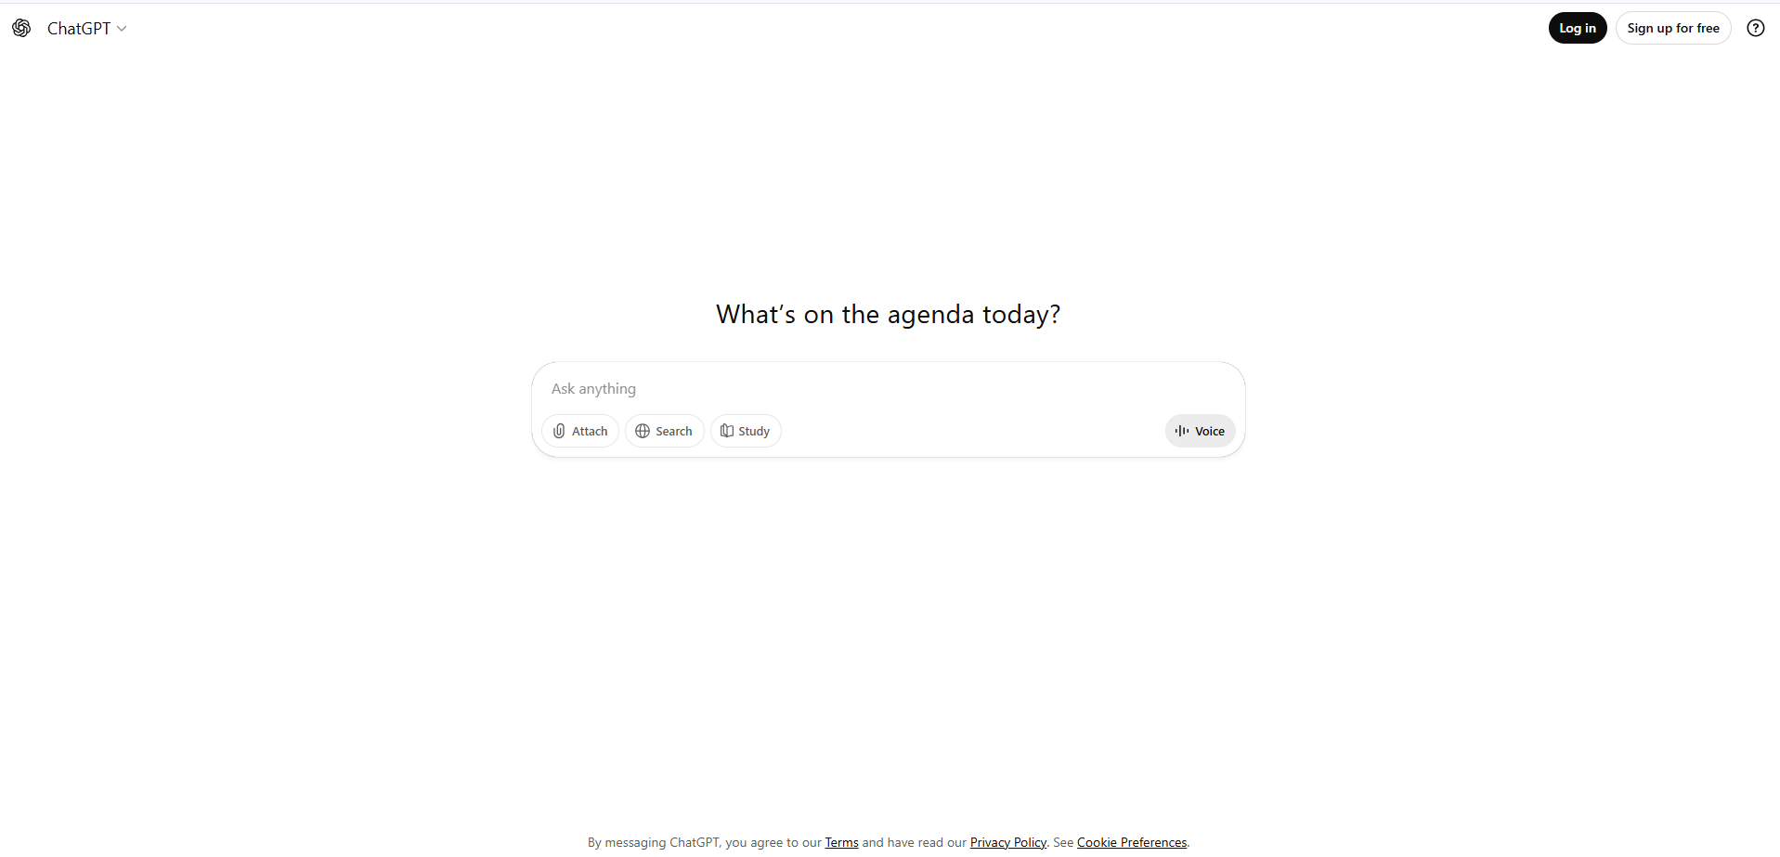
2. Perplexity AI
Purpose: Research-focused assistance with citations
Access: https://www.perplexity.ai/
Interface:
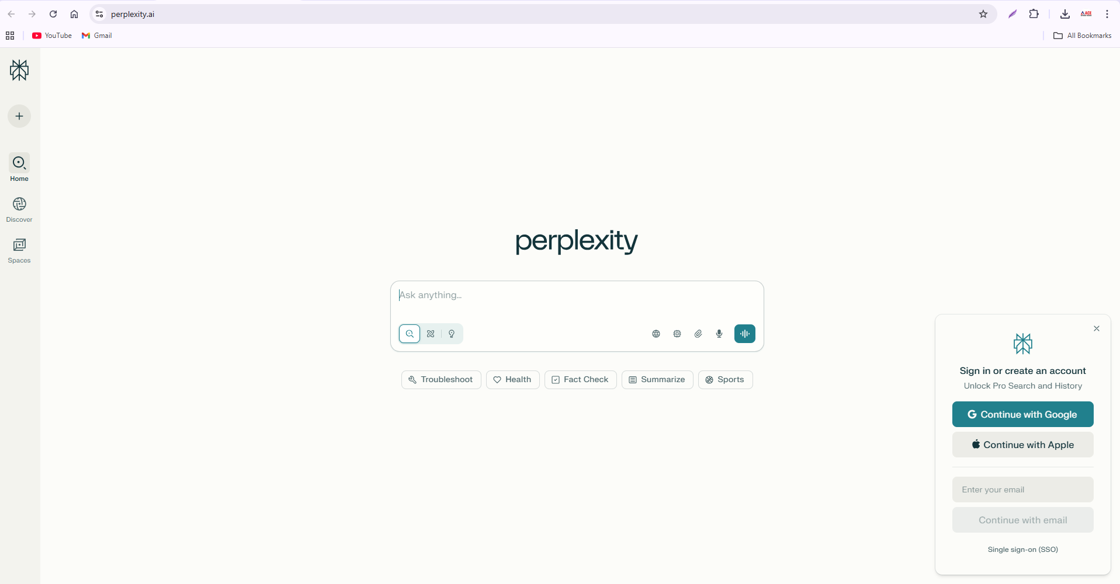
3. Poe (by Quora)
Purpose: Aggregates multiple AI models in one interface
Access: https://poe.com/
Interface:
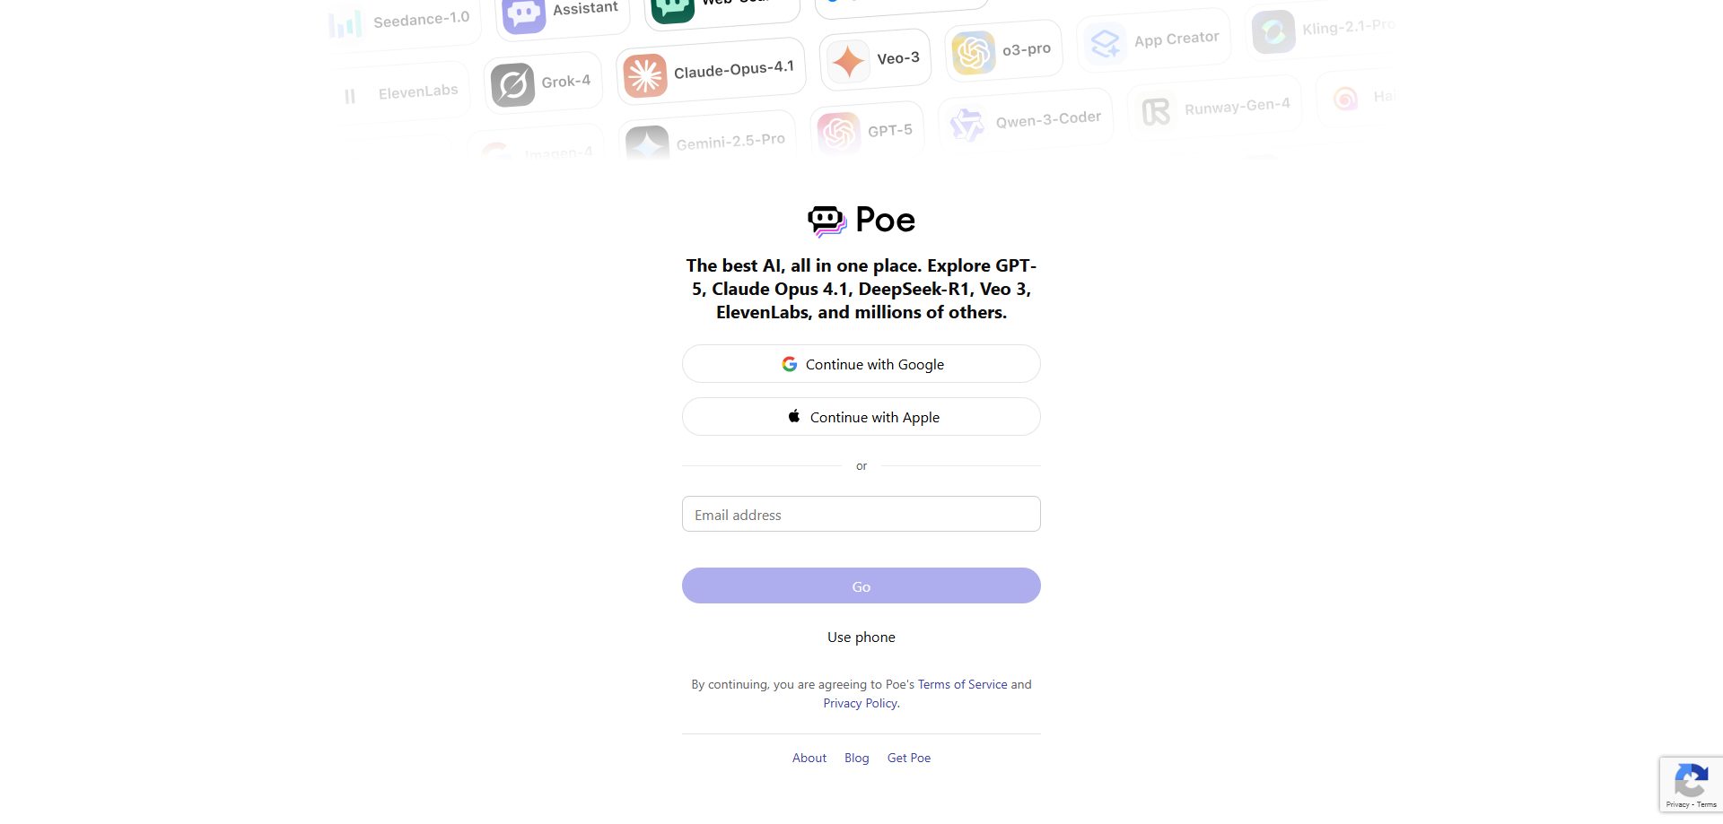
4. Hugging Face Spaces
Purpose: Open-source AI models for text, images, and more
Access: https://huggingface.co/spaces
Interface:
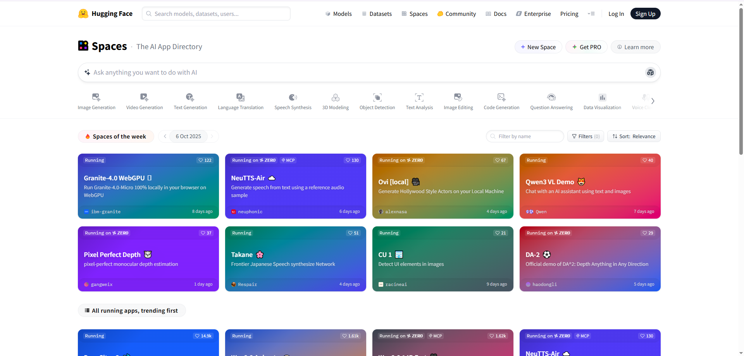
5. Notion AI
Purpose: Organizes ideas, notes, and auto-generates documents inside Notion.
Access: https:// www.notion.so/signup
Interface:
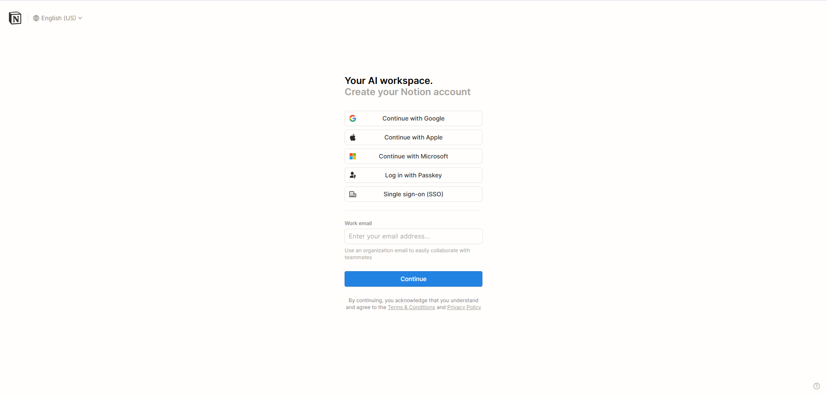
6. Bing Image Creator
Purpose: Free, easy-to-use image generation powered by DALL·E.
Access: https://www.bing.com/images/create
Interface:
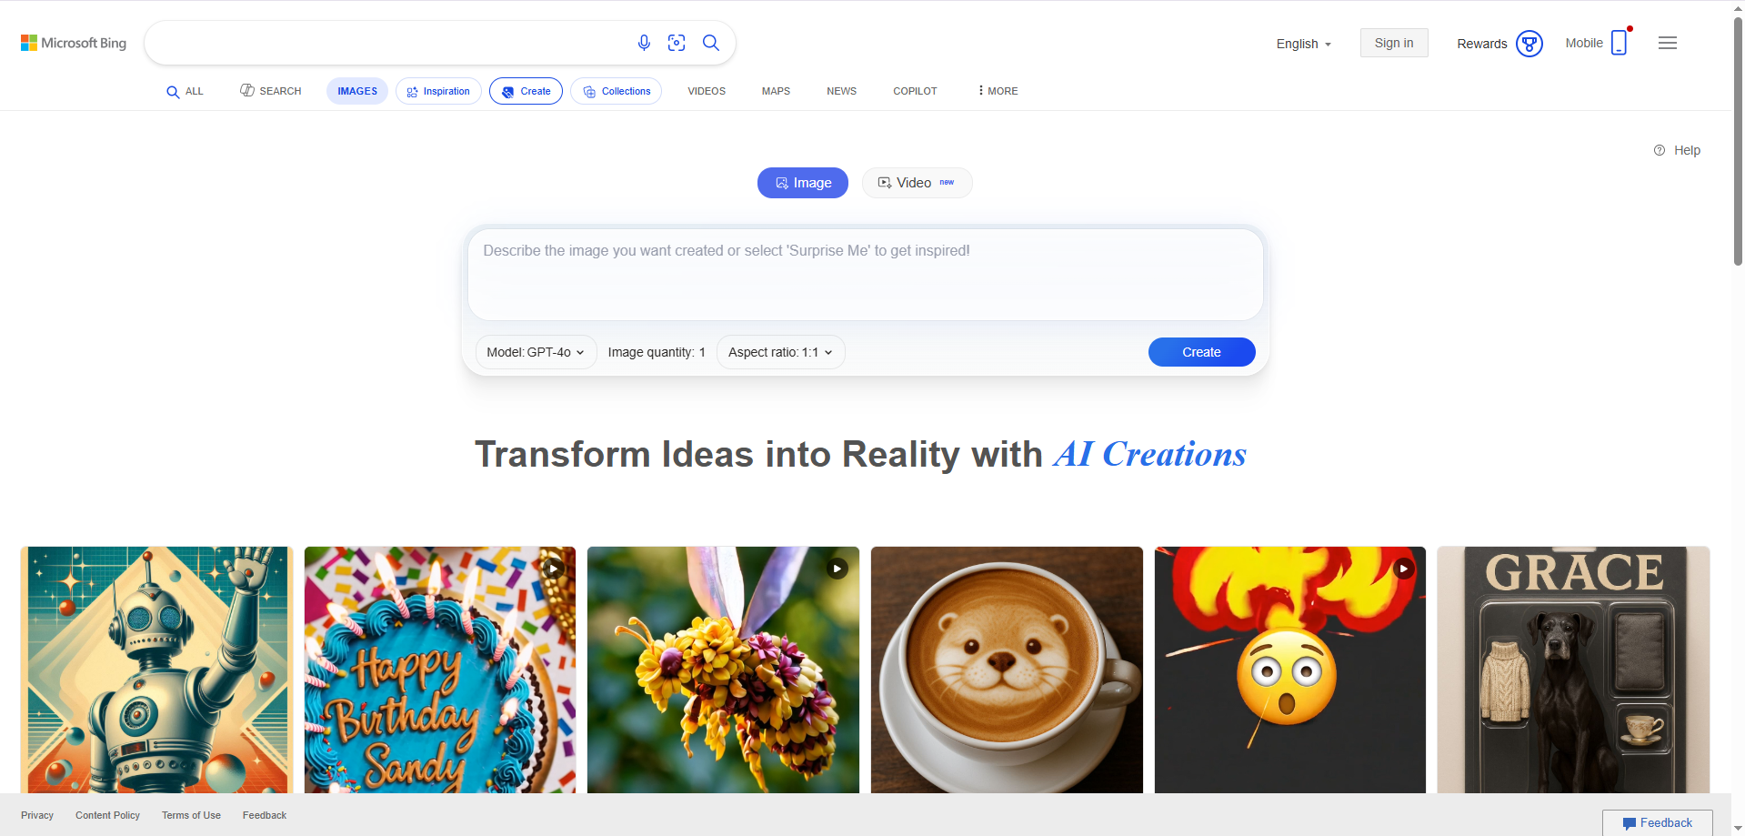
7. Canva AI
Purpose: AI-powered design tool for posters, presentations, and social media.
Access: https://www.canva.com/ai-assistant/
Interface:
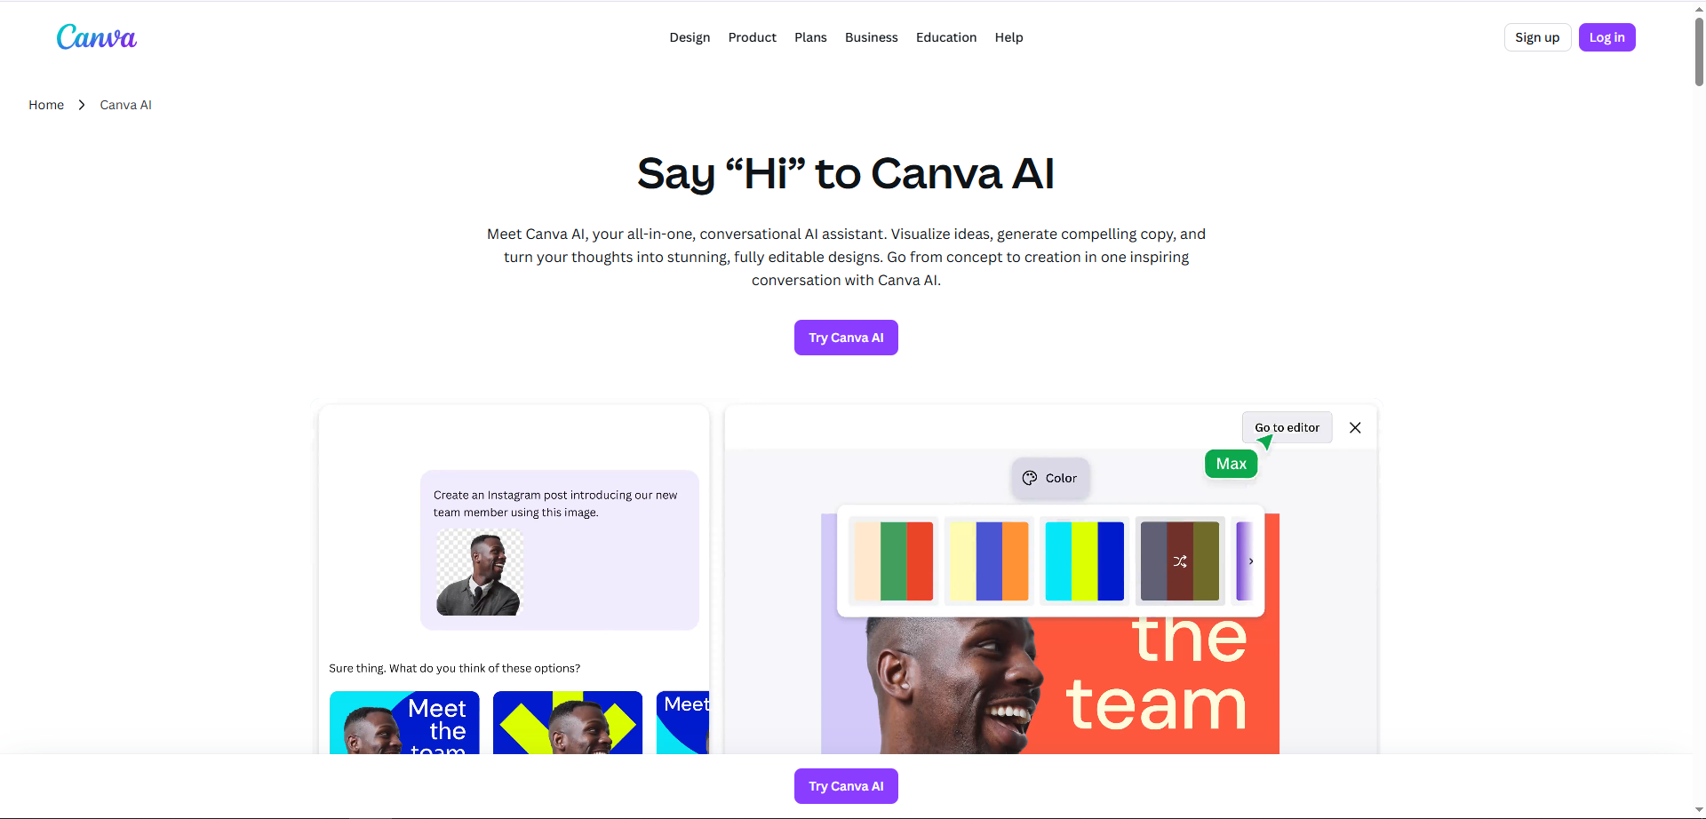
8. Stable Diffusion
Purpose: Open-source, highly customizable image generation.
Access: https://stablediffusionweb.com/
Interface:
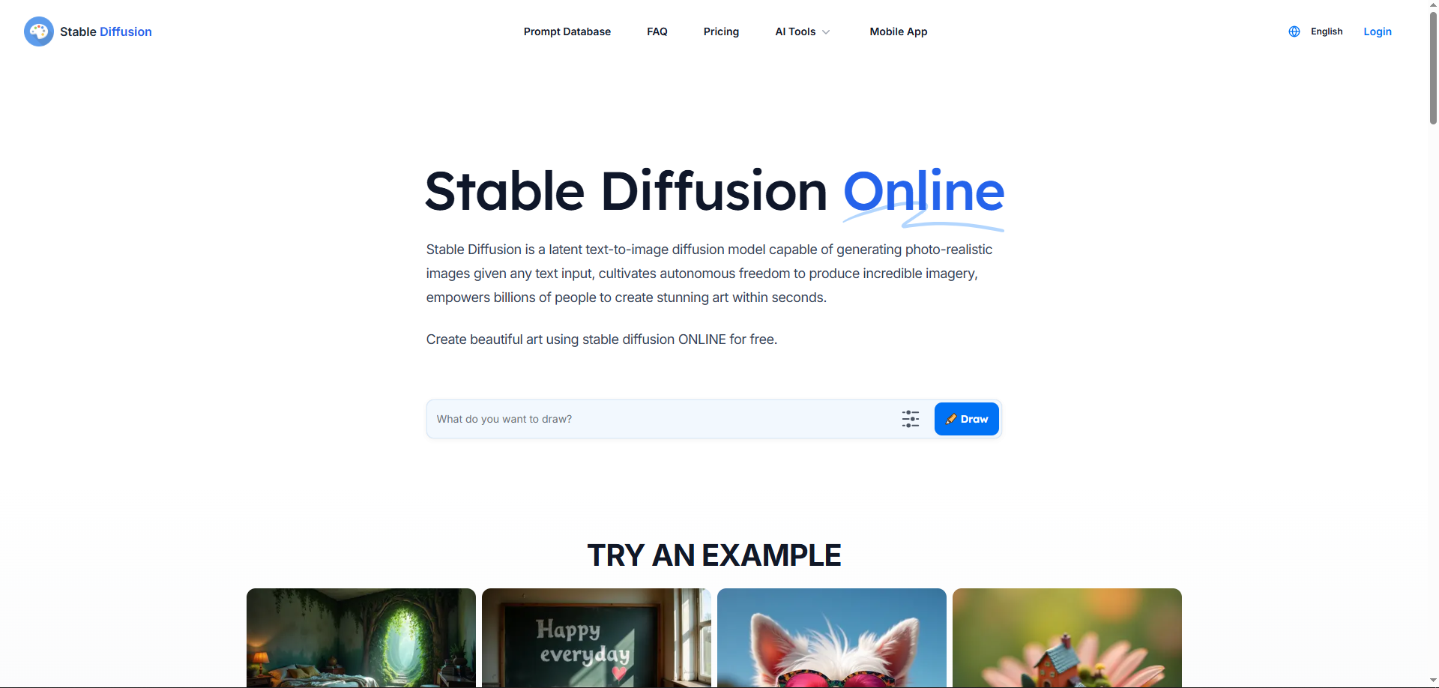
Signing Up or Signing In
To access your account, follow these steps:
- Click on the "Continue with Google" button.
- A new window or popup will appear with a list of Google accounts.
- Select your preferred Google account (mail ID) from the list.
  - If your account isn’t listed, click "Use another account" and log in with your email and password.
- Once selected, you will be automatically signed in or signed up, depending on whether it’s your first time.
✅ Note: This method allows quick access without needing to create a separate username or password.

1.5 Exercises
1. Write the same message in 3 different tones using prompts:
- Formal: “Dear Sir/Madam, I would like to request a leave of absence…”
- Casual: “Hey! I need to take a day off tomorrow…”
- Creative: “Imagine a bird asking its boss for a break… now write my leave request in that style!”
2. Use ChatGPT to:

- Summarize today’s news in 50 words.
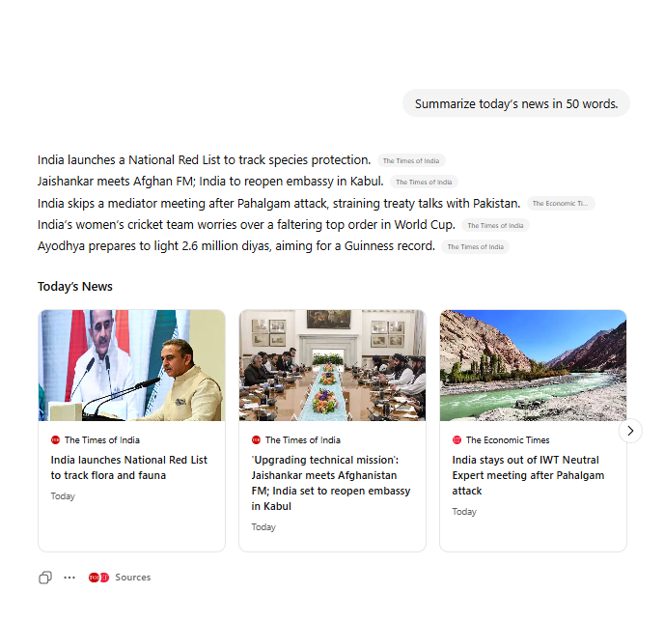

- Rewrite it as a tweet.
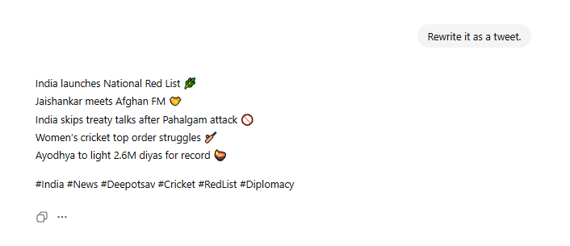

- Rewrite it as a formal report.
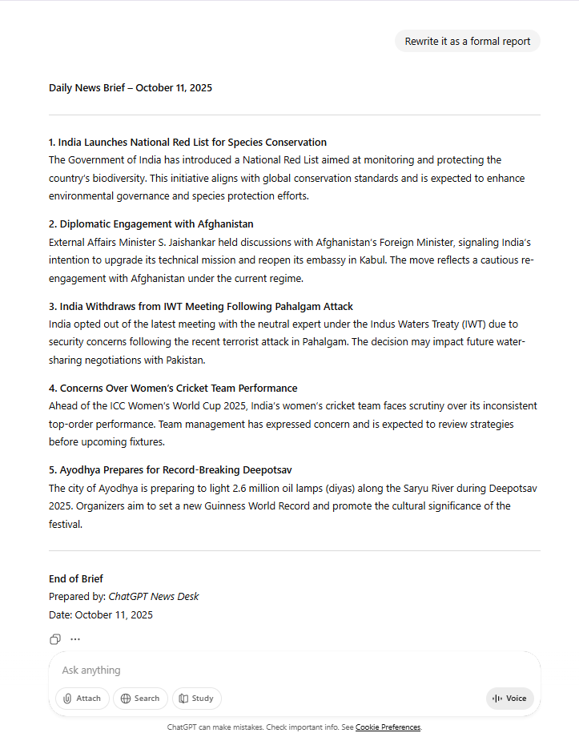
3. Use Perplexity AI to:
- Ask “What is the latest trend in AI education?”
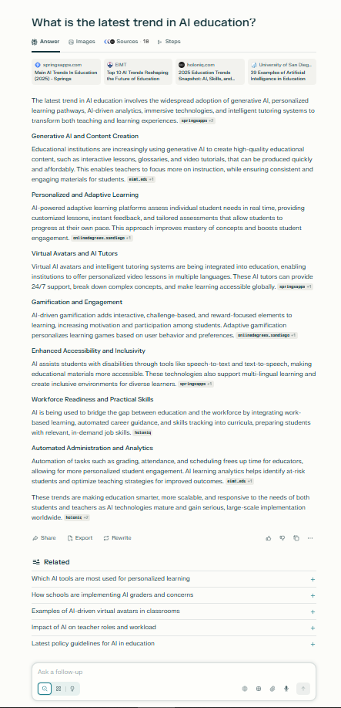
- Check the cited sources.
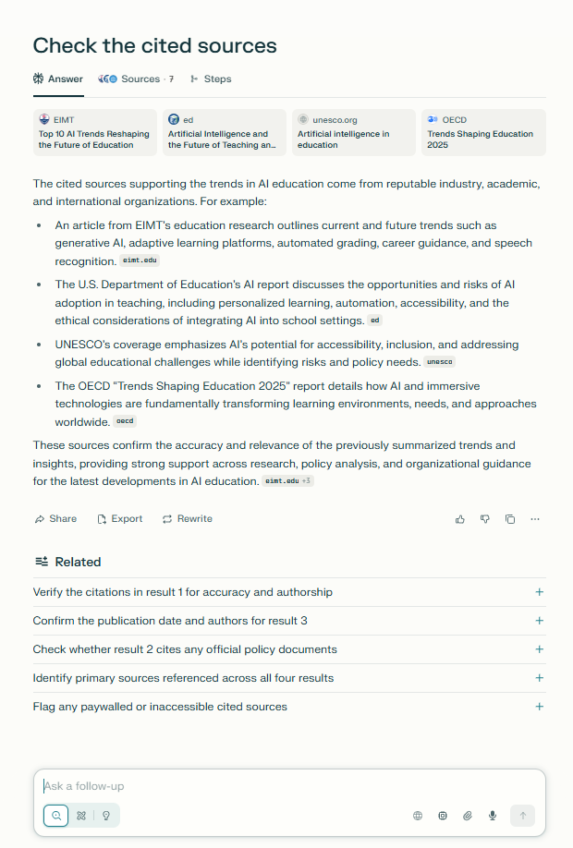
1.6 Tasks
- Prompt:
👉 Write 3–5 sentences about what you read today in [book title].
Use: Helps young readers practice short summaries and recall.
- Prompt:
👉 Tell the story from Chapter [X] in 3 short messages, like you’re texting a friend.
Use: Makes summarizing fun and modern using familiar formats.
- Prompt:
👉 What were the most important things in today’s reading? Write them like a list.
Use: Builds focus and organization without needing full sentences.
- Prompt:
👉 Pretend you are a news reporter. What happened in today’s reading?
Use: Sparks creativity while practicing retelling in a structured way.
- Prompt:
👉 Pick a character from the story. What would they say about what happened today?
Use: Encourages empathy and understanding of character perspective.

2. AI FOR TEXT & CONTENT

2.1 Introduction
Text is the most common use of AI. Developers, students, and businesses use AI to create, edit, and optimize content. Instead of spending hours writing, you can use AI tools to quickly generate professional-quality documents, blogs, emails, and reports.

2.2 Applications of AI in Text
1. Blogs & Articles
- AI can draft blog posts based on topics, keywords, and tone.
- It saves time for content creators and marketers.
- Example: “Write a 500-word blog on the future of AI in healthcare, in a simple, engaging style.”
2. Resumes & Cover Letters
- Generate professional resumes in minutes.
- AI tailors cover letters for specific job applications.
- Example: “Create a resume for a Java developer with 2 years of experience.”
3. Emails
- AI can write formal, casual, or persuasive emails.
- Example: “Write a professional follow-up email for a job interview.”
4. Proposals & Reports
- Draft business proposals with correct structure.
- Summarize lengthy reports into key points.

2.3 Summarization, Rewriting & Translation
1. Summarization
- Condense long articles into short notes.
- Example: “Summarize this 10-page report into bullet points.”
2. Rewriting
- Rephrase content for clarity or to avoid plagiarism.
- Example: “Rewrite this paragraph in a simpler tone.”
3. Translation
- Convert text into multiple languages instantly.
- Example: “Translate this English paragraph into French.”

2.4 SEO & Marketing Content
AI helps generate content optimized for search engines (SEO):
- Keyword-based blog posts.
- Social media captions.
- Product descriptions.
- Example: “Write a product description for a smartwatch using keywords: fitness, health tracking, long battery.”
This makes AI a powerful assistant for marketers, entrepreneurs, and freelancers.

2.5 Tools for Text Content
ChatGPT – General writing, emails, resumes, blogs.
Perplexity AI – Research and fact-checking with citations.
Notion AI – Organizes ideas, notes, and auto-generates documents inside Notion.

2.6 Exercises
1. Blog Writing
Use ChatGPT: “Write a 600-word blog on ‘Top 5 Skills Every Developer Needs in 2025’ in an engaging style.”
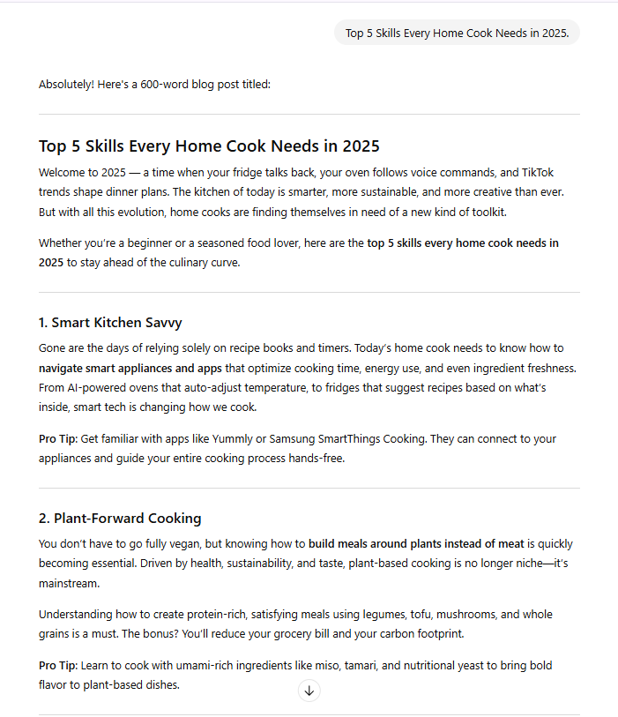
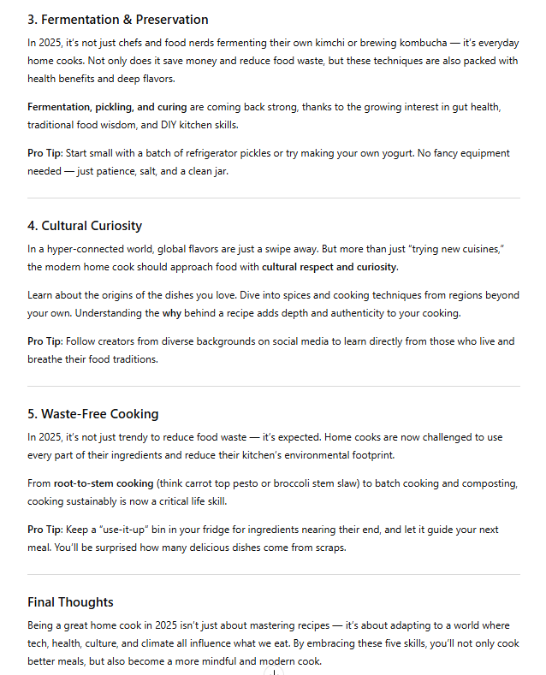
2. LinkedIn Post
Rewrite the blog as a short LinkedIn update: “Summarize the above blog into a 150-word LinkedIn post with a motivational tone.”
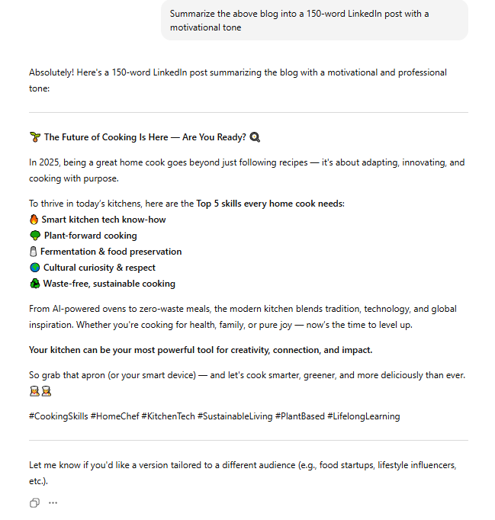

3. SEO Description
Ask Notion AI or ChatGPT Free: “Write an SEO-friendly meta description for the above blog within 160 characters.”
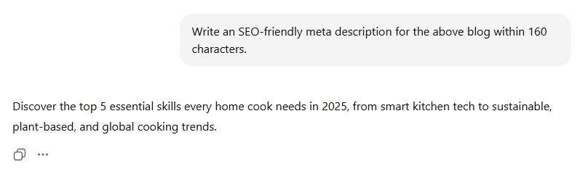

2.7 Tasks
- Prompt:
👉 Imagine you’re a travel blogger visiting Madurai for the first time. Write 3–5 sentences describing your experience at the Meenakshi Temple.
Use: Encourages descriptive writing and cultural appreciation.
- Prompt:
👉 List the top 3 things someone must eat, see, or do in Madurai — and explain why.
Use: Builds research, critical thinking, and decision-making skills.
- Prompt:
👉 Pretend you met someone from the past — like a king or poet from ancient Madurai. What 3 questions would you ask them?
Use: Sparks historical curiosity and imagination.
- Prompt:
👉 Describe Madurai in one tweet (or message): highlight its vibe, people, or food in under 280 characters.
Use: Practices concise writing and modern digital expression.
- Prompt:
👉 Create a mini travel itinerary for a friend visiting Madurai for one day. What should they not miss?
Use: Combines planning, creativity, and local knowledge.

3. AI FOR DESIGN & CREATIVITY

3.1 Introduction
Artificial Intelligence is transforming the creative industry by generating high-quality visuals. Designers, marketers, and content creators can now produce logos, posters, banners, and even 3D art in minutes. Instead of needing advanced design skills, you can use AI with simple prompts.

3.2 How AI Generates Images
Most AI art tools use diffusion models.
  - A diffusion model starts with random noise (like static on a TV screen).
  - The AI gradually removes noise step by step to create a clear image based on your prompt.
  - This allows flexibility in creating styles such as realistic, cartoon, anime, or abstract.
Example:
Prompt – “A futuristic city skyline at sunset, ultra-realistic, 4K.”
Output – AI removes noise until the final image matches the description.

3.3 Prompt Styles for Creativity
1. Realistic
Looks like a photograph.
Example: “Portrait of a young woman in natural sunlight, DSLR style.”
2. Anime
Inspired by Japanese anime/manga.
Example: “Anime-style character with blue hair holding a sword.”
3. 3D / CGI
Game-like or cinematic renders.
Example: “3D render of a golden dragon flying over mountains.”
4. Abstract
Artistic, imaginative, non-realistic.
Example: “Abstract art of emotions represented as colorful waves.”

3.4 Creative Use Cases
- Logos – Generate brand identities quickly.
- Posters – Create marketing posters for events.
- Banners – Design web and social media banners.
- Thumbnails – Eye-catching visuals for YouTube and blogs.

3.5 Tools for Design
Bing Image Creator – Free, easy-to-use image generation powered by DALL·E.
Canva AI – AI-powered design tool for posters, presentations, and social media.
Stable Diffusion – Open-source, highly customizable image generation.

3.6 Exercises
Task: Create a Brand Kit
- Use Bing Image Creator to design a Logo for a fictional company.
Example Prompt: “Minimalist logo of a coffee shop with brown and cream tones.”

 | 
 | 

- Use Canva AI to design a Poster promoting the coffee shop’s grand opening.
Example Prompt: “Modern poster with coffee beans, warm colors, and big sale text.”

 | 
 | 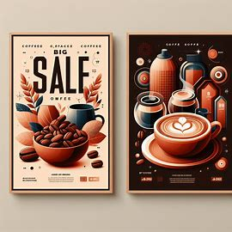

- Use Stable Diffusion to generate a Web Banner.
Example Prompt: “Wide banner for a coffee shop website, cozy vibes, wooden textures.”

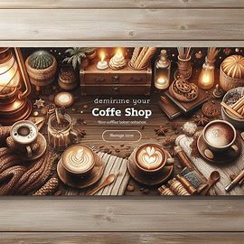 | 
 | 

3.7 Tasks
  - Pick a theme (e.g., Travel Blogger, Tech Startup, Fitness Trainer).
  - Create: (1 Logo, 1 Poster, 1 Banner).
  - Compare results across Bing, Canva, and Stable Diffusion.
  - Choose the best design and explain why it works.

4. AI FOR VOICE & VIDEO

4.1 Introduction
AI is no longer limited to text and images. With modern tools, anyone can create realistic voiceovers, podcasts, dubbing, and even full videos without expensive equipment. This makes content creation faster and more accessible to students, educators, marketers, and developers.

4.2 AI for Voice
AI voice tools use text-to-speech (TTS) and voice cloning:
  - Text-to-Speech (TTS): Converts written text into natural human-like voice.
  - Voice Cloning: Creates a synthetic copy of a specific person’s voice.
Applications
  - Narration for videos or presentations.
  - Audiobooks and podcasts.
  - Customer service chatbots with human-like voices.
  - Dubbing content into multiple languages.
Example Prompts:
  - “Convert this script into a professional British male voice.”
  - “Read this text in a female voice with a friendly tone.”

4.3 AI for Video
AI video tools use generative video models to turn text or images into motion visuals.
Applications
  - Explainer videos for businesses.
  - Animated ads and social media reels.
  - Talking avatars that read scripts.
  - Educational content with subtitles.
Example Prompts:
  - “Create a 30-second explainer video about online safety for students.”
  - “Generate a promotional ad for a mobile app with upbeat music.”

4.4 Tools for Voice & Video
ElevenLabs – Natural, realistic voice generation and cloning.
Play.ht – Text-to-speech with multiple voice styles.
Pika Labs – AI tool for text-to-video generation.
CapCut AI – Easy-to-use video editor with AI templates and effects.

4.5 Exercises
Task: Create a Short Ad
- Use ElevenLabs or Play.ht to generate a voiceover.
Example Prompt: “Read this script in a warm, professional female voice.”
- Use Pika Labs to generate a short animation.
Example Prompt: “30-second animated video about a startup launching a food delivery app.”
- Import both into CapCut AI to combine voice + video.
Add background music, text, and effects.

4.6 Taskss
  - Write a 1-minute self-introduction script.
  - Use Play.ht or ElevenLabs to generate your narration.
  - Create a simple video in CapCut AI with your voiceover, images, and text highlights.
  - Export it as your AI-powered video resume.

5. AI FOR DEVELOPERS & PRODUCTIVITY

5.1 Introduction
AI is not just for writers and designers — developers can also boost their productivity by using AI-powered coding assistants, debugging helpers, and project management tools. AI saves time by automating repetitive coding tasks, suggesting fixes, and even generating complete applications.

5.2 AI for Developers
Applications
1. Code Generation
Generate boilerplate code for faster development.
Example: “Write a Python function that connects to MySQL and fetches all rows.”
2. Debugging
AI can analyze error messages and suggest fixes.
Example: “Fix this JavaScript error: Cannot read property ‘map’ of undefined.”
3. Test Cases
Automatically generate unit tests.
Example: “Create JUnit tests for a Spring Boot login controller.”
4. Documentation
Generate clear explanations for your code.
Example: “Document this API in Swagger format.”

5.3 AI for Productivity
AI can also streamline daily work for developers, students, and teams:
Task Management: Generate task lists from meeting notes.
Automation: Create scripts for repetitive jobs.
Knowledge Base: Quickly find solutions with AI search engines.
Email & Reports: Draft technical or project reports faster.

5.4 Tools for Developers & Productivity
GitHub Copilot – AI coding assistant for multiple languages.
Codeium – Fast code generation and autocomplete.
Tabnine – AI-powered code suggestions.
Notion AI – Organize projects, tasks, and notes.
Perplexity AI – Research with cited sources for technical queries.

5.5 Hands-on Exercise
Task: Build a Mini Project with AI
1. Use Copilot/Codeium to generate boilerplate code for a To-Do App.
2. Ask AI to create unit tests for the app.
3. Use Notion AI to generate a project plan (features, timeline, tasks).
4. Summarize progress into a weekly report with AI’s help.

5.6 Mini Project – AI Productivity Workflow
Step 1: Use AI to create a simple web app (e.g., Notes App).
Step 2: Document the app using AI-generated README.md.
Step 3: Use AI to generate unit tests and debug errors.
Step 4: Present the app with an AI-generated project report.

This project demonstrates how developers can integrate AI into their daily workflow — from planning and coding to documentation and reporting.

6. AI IN DAILY LIFE & CAREERS

6.1 Introduction
- AI is becoming part of everyday life, not just for tech experts.
- Students, freelancers, business owners, and professionals can save time and boost productivity.
- Learning how to use AI effectively helps in studies, work, and personal growth.

6.2 Applications of AI in Daily Life
1. For Students
- Summarize textbooks and articles.
- Generate assignment/presentation ideas.
- Translate difficult topics into simple terms.
- Example Prompt: “Explain Quantum Computing in very simple terms as if I am 10 years old.”
2. For Entrepreneurs & Business Owners
- Write product descriptions, ads, and marketing content.
- Create logos, posters, and pitch decks.
- Automate customer support with AI chatbots.
- Example Prompt: “Write a catchy Instagram caption for a coffee shop’s new cold brew launch.”
3. For Professionals
- Draft resumes, cover letters, and LinkedIn summaries.
- Generate reports and meeting minutes.
- Improve presentations and proposals with AI.
- Example Prompt: “Write a LinkedIn summary for a software engineer with 5 years’ experience in Java and Spring Boot.”
4. For Freelancers & Creators
- Write blogs, social posts, and video scripts.
- Design thumbnails, posters, and banners.
- Record professional voiceovers.
- Example Prompt: “Create a 1-minute YouTube script about healthy morning routines in a motivational style.”

6.3 Career Opportunities in AI & Prompting
Prompt Engineer – Create effective prompts for businesses.
AI Content Specialist – Write blogs, ads, and posts using AI.
AI Consultant – Help companies adopt AI tools.
AI Designer/Creator – Make logos, videos, or voiceovers with AI.
Tip: Even non-tech people should learn AI skills, just like using Word/Excel.

6.4 Hands-on Exercise
1. Student: Summarize a textbook chapter in 10 bullet points → Rewrite as flashcards.
2. Professional: Turn “I managed a team project at college” into a strong resume bullet.
3. Entrepreneur: Ask AI to write 3 ad copies for the same product (formal, casual, funny).

6.5 Mini Project – AI Career Portfolio
Task: Build an AI-powered career portfolio.
1. Resume (text with AI).
2. LinkedIn Summary (personal branding).
3. Logo/Banner (visual identity).
4. Voice/Video Intro (AI-based pitch).
Outcome: A professional portfolio to stand out in studies, jobs, or business.

7. AI TOOLS REFERENCE
S. No | Tool Name | Category | Owner / Company
1 | ChatGPT (Free) | Text, Prompting | OpenAI
2 | Perplexity AI | Text, Research | Perplexity AI Inc. (Aravind Srinivas & team)
3 | Poe | Text, Aggregator | Quora Inc.
4 | HuggingFace Spaces | Open-source AI Models | Hugging Face Inc.
5 | Notion AI | Productivity, Text | Notion Labs Inc.
6 | Bing Image Creator | Image Generation | Microsoft (powered by OpenAI’s DALL·E)
7 | Canva AI | Design & Creativity | Canva Pty Ltd (Melanie Perkins & team)
8 | Stable Diffusion | Image Generation | Stability AI Ltd. (Emad Mostaque)
9 | ElevenLabs | Voice Generation | ElevenLabs Inc.
10 | Play.ht | Text-to-Speech (TTS) | Play.ht (Akshay Hallur & team)
11 | Pika Labs | Video Generation | Pika Labs Inc.
12 | CapCut AI | Video Editing | ByteDance Ltd. (TikTok parent company)
13 | GitHub Copilot | Coding Assistant | GitHub (Microsoft), powered by OpenAI Codex
14 | Codeium | Coding Assistant | Exafunction Inc.
15 | Tabnine | Coding Assistant | Tabnine Ltd. (Dror Weiss & Eran Yahav)

