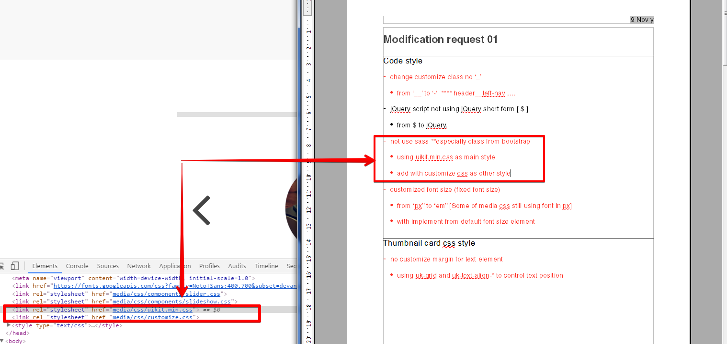

From my point, your customize css had unnecessary class and not a good clean stylesheet enough. such as some part in the attached. And there was much more unnecessary class here. And the customize css size is about 1/5 of uikit.min which too large for this custom style. Our design was relied on normalize.css that implement via uikit framework. There was no reason of your initial code to clean element property here as well.

h1, .h1 {

font-weight: 700

}

h2, .h2 {

font-weight: 700

}

\* {

box-sizing: border-box;

padding: 0;

margin: 0;

border-collapse: collapse

}

\* :before, \* :after {

box-sizing: border-box

}

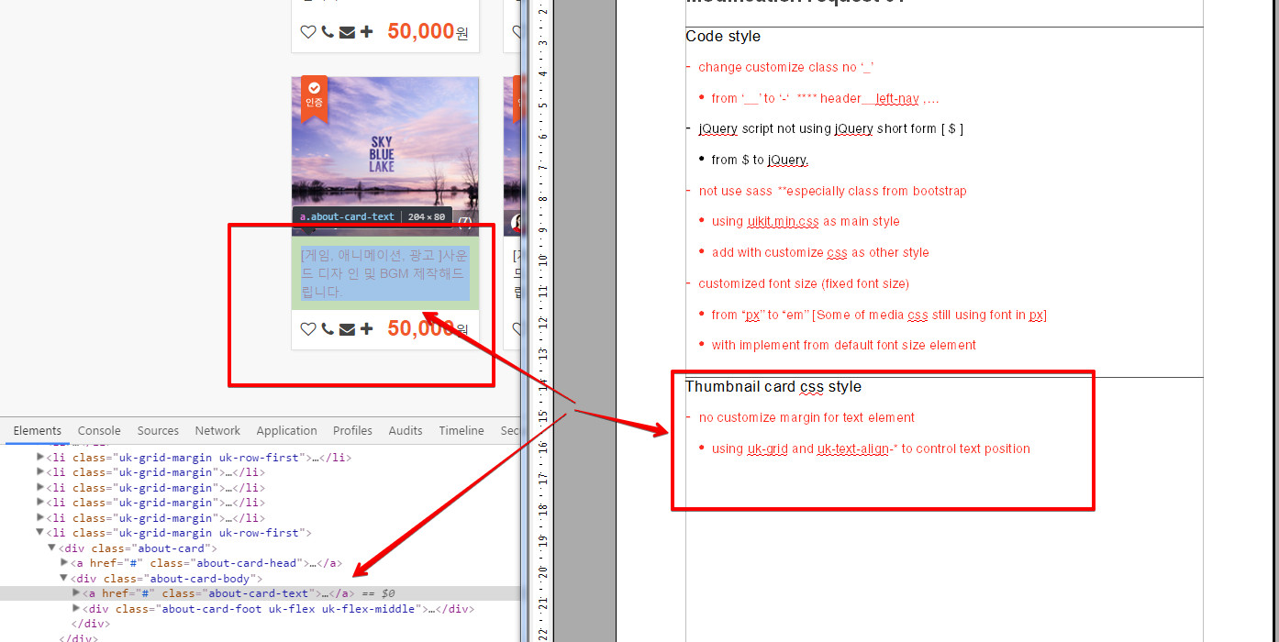

Is there using uk-grid or uk-align or uk-text-align in here?? Your card style sheet is not effective used framework, Also as your “margin-left: auto” class is not reasonable enough and this is not a good nested class working with framework.

<div class="about-card">

<a href="#" class="about-card-head">

<span class="about-card-img-w">

<img src="media/img/news-img.jpg" alt="">

</span>

<span class="about-card-badge">

<img src="media/img/badge.png" alt="">

</span>

<span class="about-card-author">

<span class="author-thumb">

<span class="author-thumb-info">

<img src="media/img/about-card-author.png" alt="">

<span>hyerin55</span>

</span>

<span class="author-thumb-review">

<span class="author-thumb-stars">

<i class="uk-icon-star"></i>

<i class="uk-icon-star"></i>

<i class="uk-icon-star"></i>

<i class="uk-icon-star"></i>

<i class="uk-icon-star"></i>

</span>

<span class="author-thumb-num">(7)</span>

</span>

</span>

</span>

</a>

<div class="about-card-body"><a href="#" class="about-card-text">

[게임, 애니메이션, 광고 ]사운드 디자

인 및 BGM 제작해드립니다.</a>

<div class="about-card-foot uk-flex uk-flex-middle">

<div class="about-card-actions">

<a href="#" class="uk-icon-heart-o"></a>

<a href="#" class="uk-icon-phone"></a>

<a href="#" class="uk-icon-envelope"></a>

<a href="#" class="uk-icon-plus"></a>

</div>

<div class="about-card-price">

<span class="nums">50,000</span>원

</div>

</div>

</div>

</div>

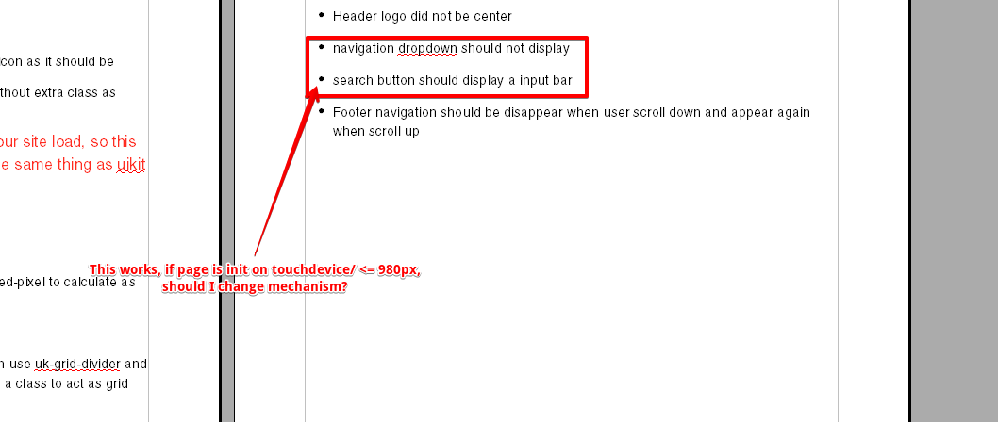

On my point, something like this scree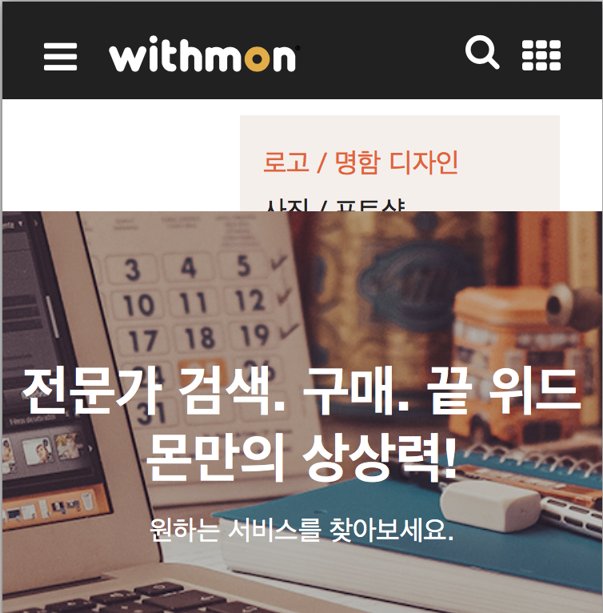nshot is something that should not happen.

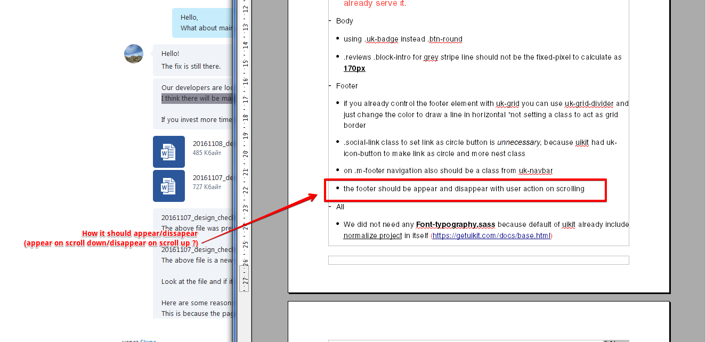

The footer bar should be appear in case if your scroll-up an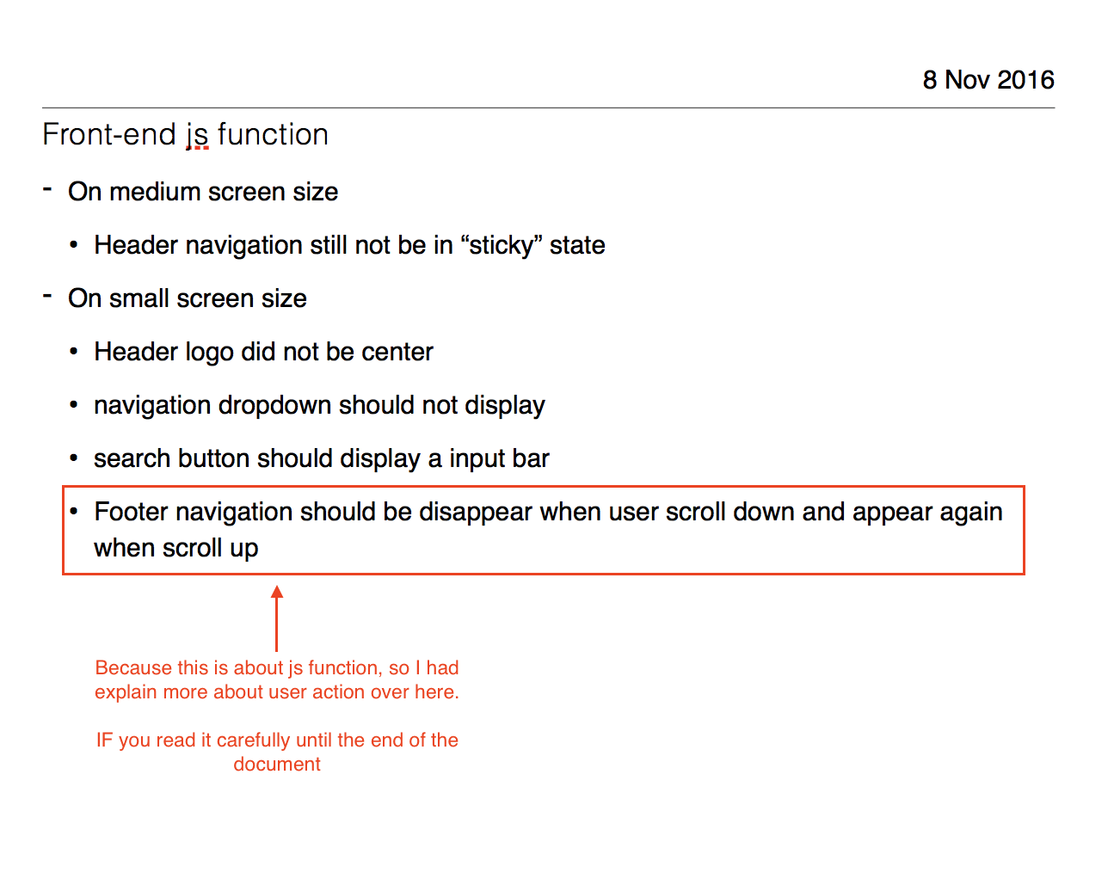d the explanation was in the same document. Also as in attached.