Project Proposal

Prepared for: Nir Hannes

Pre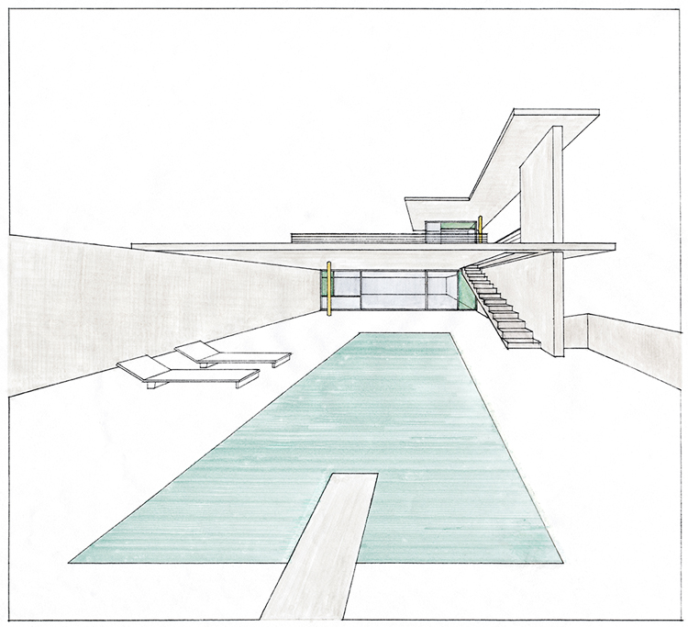pared by: Pavel Samsonov

WEb store

8 January 2020

Proposal number: 1

# Executive Summary

## Objective

## Goals

Allow small businesses to open online store with minimal efforts from business owner.

WEB store

## Solution

Simple and easy to use web store

## Target Audience

Any

## User Story

Web store

## Requirements:

End User:

* I want be able to view the images of items
* I want be able to view short description
* I want to view rating of the item
* I want to add item to basket
* I want be able to review my basket
* I want to be able to pay with PayPal (optional)

Web store

* I want be able to search for items by keywords

Manager User:

* I want be able to upload new items to the gallery
* I want be able to remove sold out items

## Mockups:

Main page

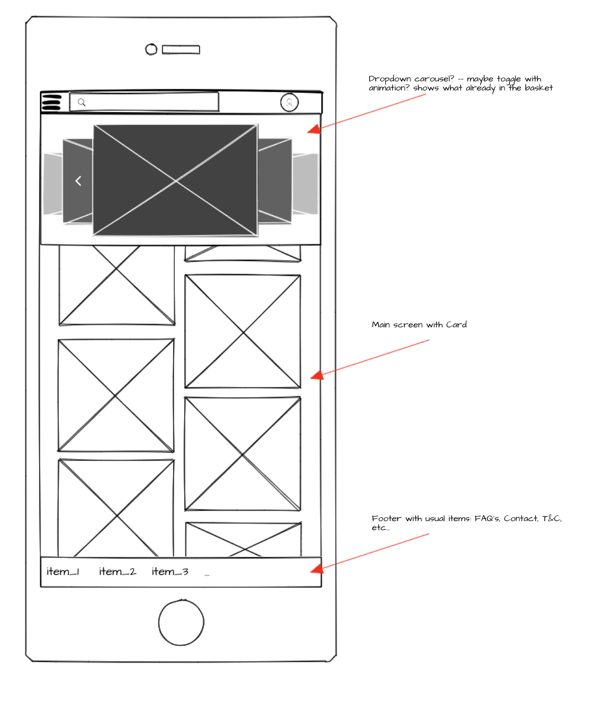

Login page

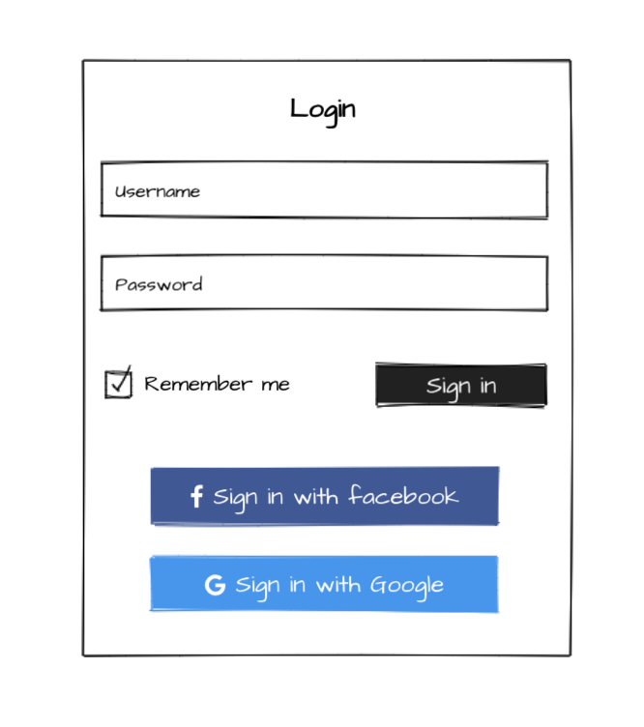

Item for sale

