EXT: EasyGoogleMap
Extension Key: easy_googlemap
Language: en
Keywords: google, map, googlemap, typo3, extension, extbase, stable, 6.2, cms
Copyright 2000-2010, Andres Lobacovs, <info@comsolit.ch>

This document is published under the Open Content License
available from http://www.opencontent.org/opl.shtml

The content of this document is related to TYPO3
- a GNU/GPL CMS/Framework available from www.typo3.org
Table of Contents
EXT: Readable name of your extension 1
Introduction 3
What does it do? 3
Screenshots 3
Users manual 4
FAQ 4
Administration 5
FAQ 5
Configuration 6
FAQ 6
Reference 6
Tutorial 7
Known problems 8
To-Do list 9
ChangeLog 10
Important guidelines 11
Issues with Open Office documentation for TYPO3 12
Inserting images 12
Paragraph styles 12
Linking 13
Meta data and updates 13
HowTo: Update a manual to the new layout 13
HowTo: (alternative) Import the styles from another document 14
HowTo: Fix the Table Of Contents when it is empty 14
HowTo: Fix the Table Of Contents when a chapter is missing 14
Help by documentation.openoffice.org 14

Introduction

What does it do?
- A simple customizable Google Maps extension that displays 1 or more locations on your website.

Screenshots
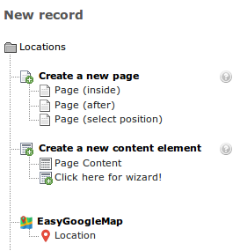
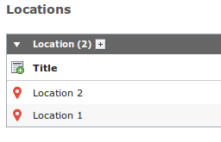
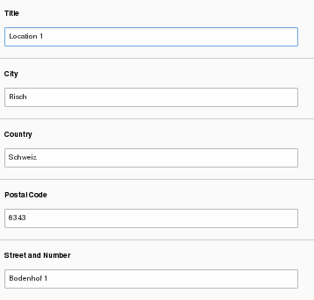

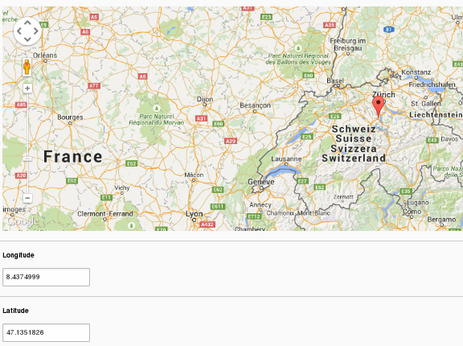

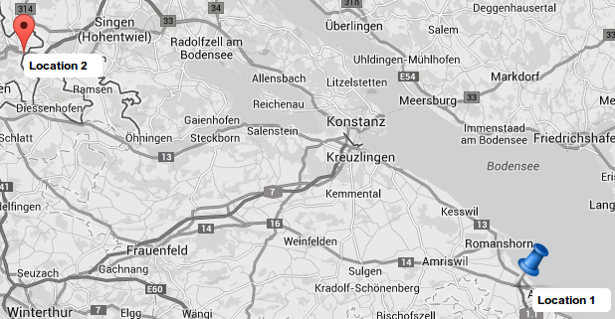
- You can create as many records as you want
- You can upload a custom marker icon if you want to
- If you don't have a custom marker icon or you like the default Google marker then just don't upload any icon. The default one will appear by itself.

Users manual

1. Download and install the extension via “Extension Manager”

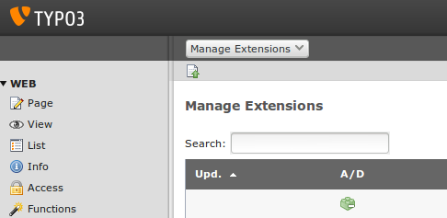

2. Activate the extension

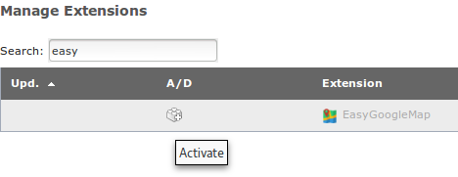
3. Include the static TypoScript

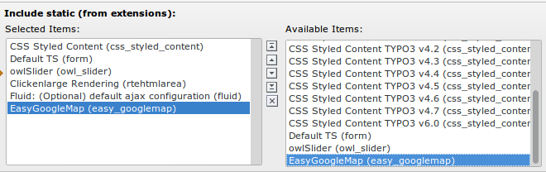

4. Create a system folder

Go to Page > Create new pages > Folder. Drag “Folder” to your Pagetree. Rename that folder to “Locations” or any other name of your choice.

5. Set storagePID

In that backend view scroll down to the “Default storage PID” and change it to the ID of your Folder you created in the Step 4:

Go to Template > “Your Root-Page” > Constant Editor. Choose “PLUGIN.TX_EASYGOOGLEMAP” in the “Category” - drop-down. Now your should see the backend view where you can customize the map extension.

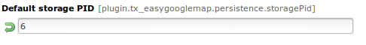

6. Add one or more Locations

Go to List > “Your storage folder” > Create new record. Click on “EasyGoogleMap Location” to create an object.

7. Place the Map Extension in your content

Switch to Page > “Page you want to put the map on” insert the Plugin by clicking on “Add a new record at this place”

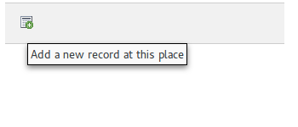
After that switch to the “Plugins” tab, click on “General Plugins” and then switch to the “Plugin” tab. In the dropdown-menu choose “EasyGoogleMap” and save the record.

8. Displaying only certain locations on different pages

If you don't want EasyGoogleMap to display all of your saved Locations on the same page, you can do it by creating a “location”-record on the page you want it to be shown on by going to List > “Page of your choice” and doing the same thing as you would have done in Step 6. Once you created all the Locations you want for that particular page, you need to set the storagePID for this page only. You can do it by changing to “Template” and clicking on “Click here to create an extension template”

Then change the value of the Default storage PID to the ID of the current page.

FAQ
- Possible subsections: FAQ

Configuration

Reference

plugin.tx_easygooglemap properties: TS configuration.

Persistence
Property: | Data type: | Description: | Default:
storagePid | string | PageId of page containing Location objects.  Example:  plugin.tx_easygooglemap.persistence {  storagePid = 4  }

Files and paths
Property: | Data type: | Description: | Default:
templateRootPath | string | Path to template root directory.  Example:  plugin.tx_easygooglemap.view {  templateRootPath = fileadmin/templates/  }
partialRootPath | string | Path to partials root directory.  Example:  plugin.tx_easygooglemap.view {  partialRootPath = fileadmin/partials/  }
layoutRootPath | string | Path to template layouts.  Example:  plugin.tx_easygooglemap.view {  layoutRootPath = fileadmin/layouts/  }
cssfile | string | Path to custom css file.  Example:  plugin.tx_easygooglemap.configuration {  cssfile = fileadmin/css/map.css  }
includeJquery | boolean | Enable or disable jQuery.  Example:  plugin.tx_easygooglemap {  includeJquery = 1  }
jquery | string | Set jQuery source.  Example:  plugin.tx_easygooglemap {  jquery = jquery-2.1.1.min.js  }

Map setup
Property: | Data type: | Description: | Default:
centerMapLatitude | string | Sets the initial latitude.  Example:  plugin.tx_easygooglemap.configuration {  centerMapLatitude = 47.6554401  }
centerMapLongitude | string | Sets the initial longitude.  Example:  plugin.tx_easygooglemap.configuration {  centerMapLongitude = 8.1758800  }
fadeoutcats | string | A comma-separated list of categories to fade out. All options available here: https://developers.google.com/maps/documentation/javascript/reference#MapTypeStyleFeatureType.  Example:  plugin.tx_easygooglemap.configuration {  fadeoutcats = transit, poi.business  }
zoom | Int+  [0 - 18] | Initial map zoom level.  Example:  plugin.tx_easygooglemap.configuration {  zoom = 9  } | 8

Map styling
Property: | Data type: | Description: | Default:
gamma | string | Modifies the gamma by raising the lightness to the given power. Valid values: [0.01, 10], with 1.0 representing no change.  Example:  plugin.tx_easygooglemap.configuration {  gamma = 0.67  } | 0.79
saturation | int  [-100 - 100] | Shifts the saturation of colors by a percentage of the original value if decreasing and a percentage of the remaining value if increasing.  Example:  plugin.tx_easygooglemap.configuration {  saturation = 50  } | -98

Dimensions and offset
Property: | Data type: | Description: | Default:
height | string | The height of the map.  Example:  plugin.tx_easygooglemap.configuration {  height = 400px  } | 350px
width | string | The width of the map.  Example:  plugin.tx_easygooglemap.configuration {  width = 900px  } | auto
anchorpositionx | int | The horizontal position at which to anchor an image in correspondance to the location of the marker on the map.  Example:  plugin.tx_easygooglemap.configuration {  anchorpositionx = 20  }
anchorpositiony | int | The vertical position at which to anchor an image in correspondance to the location of the marker on the map.  Example:  plugin.tx_easygooglemap.configuration {  anchorpositiony = 30  }

ChangeLog

Version | Changes:
1.0.0 | Initial Release
1.0.1 | Additional customizable constants
1.0.2 | Cleanup and DB updates
1.0.3 | Fixed issues regarding fade-out categories
1.1.0 | Compatible with TYPO3 v7
1.1.1 | Tested with TYPO3 v7.3. jQuery update. Removed fluid debug.
1.2.0 | Integrated address search with visual map into backend. Added additional fields to location.

