EXT: owlSlider
Extension Key: owl_slider
Language: en
Keywords: slider, responsive, mobile, customizable, item-slider, jquery, desktop
Copyright 2014, Andres Lobacovs, <info@comsolit.com>

This document is published under the Open Content License
available from http://www.opencontent.org/opl.shtml

The content of this document is related to TYPO3
- a GNU/GPL CMS/Framework available from www.typo3.org
Table of Contents
EXT: Readable name of your extension 1
Introduction 3
What does it do? 3
Screenshots 3
Users manual 4
FAQ 4
Administration 5
FAQ 5
Configuration 6
FAQ 6
Reference 6
Tutorial 7
Known problems 8
To-Do list 9
ChangeLog 10
Important guidelines 11
Issues with Open Office documentation for TYPO3 12
Inserting images 12
Paragraph styles 12
Linking 13
Meta data and updates 13
HowTo: Update a manual to the new layout 13
HowTo: (alternative) Import the styles from another document 14
HowTo: Fix the Table Of Contents when it is empty 14
HowTo: Fix the Table Of Contents when a chapter is missing 14
Help by documentation.openoffice.org 14

Introduction

What does it do?
- Responsive carousel slider for TYPO3, Touch enabled based on the jQuery OWL Carousel.
- to TYPO3. It's responsive and supporting touchswipe functionality for iOS, Android and others.

Screenshots

Frontend
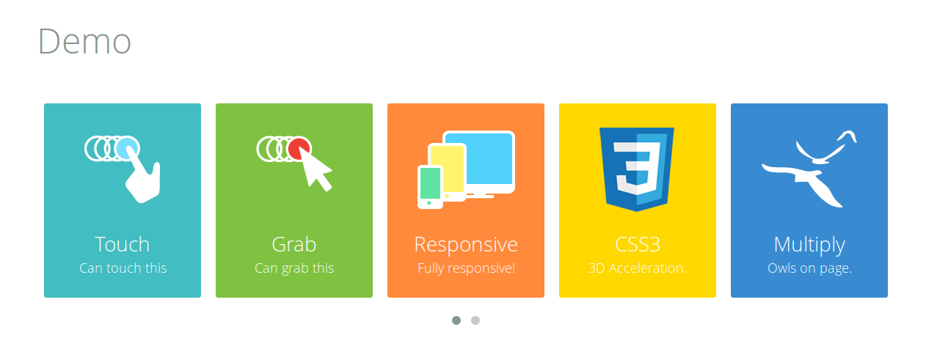

Check http://owlgraphic.com/owlcarousel/ for more demos!

Backend

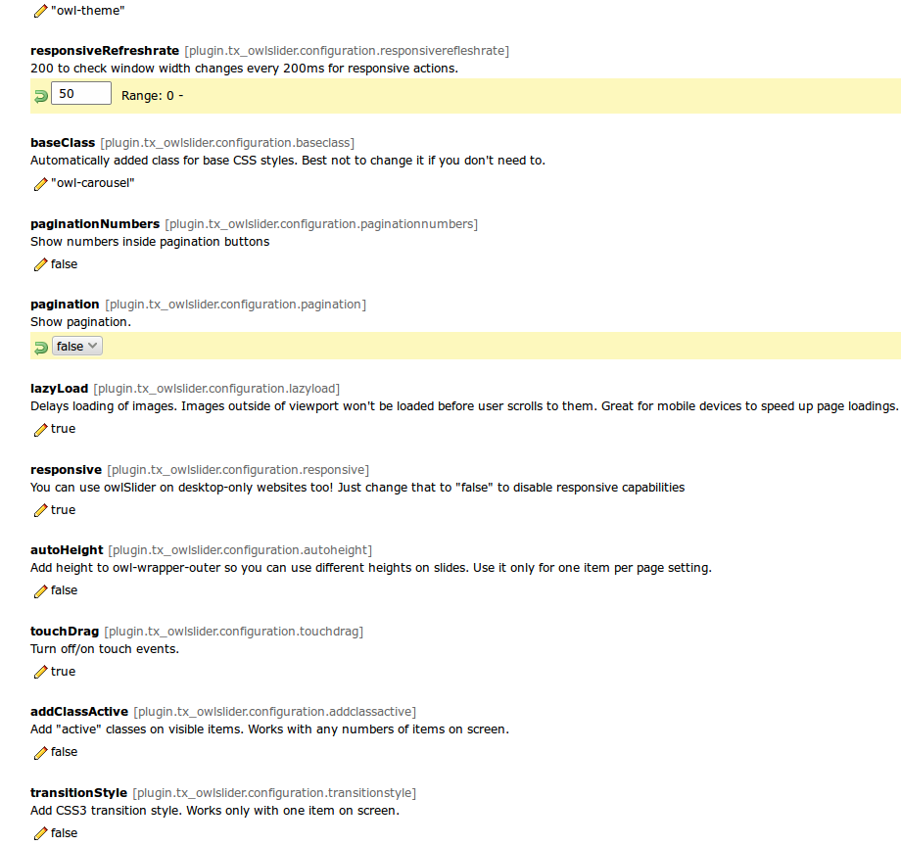

- Slider customization

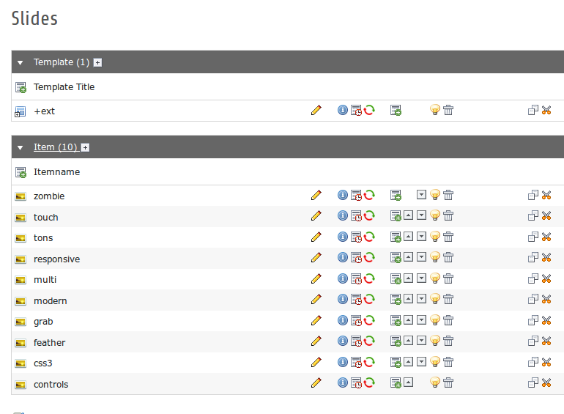

- Slider-Items

Users manual

1. Download the Extension

2. Go to “Extension Manager” of your TYPO3-Page and upload the Extension
by clicking on the icon shown below:

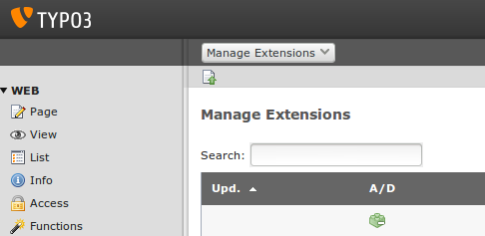

3. Activate the Extension:
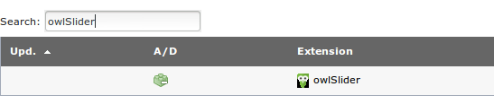

4. Include the Static TypoScript:

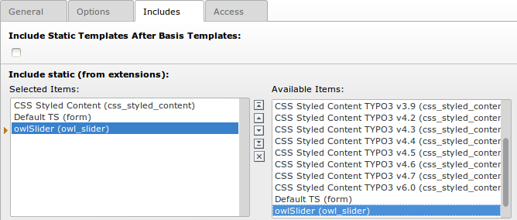

5. Create Sysfolder
Go to Page > Create new pages > Folder. Drag “Folder” to your Pagetree. Rename that folder to e.g. “Slides”.

6. Set storage PID
In that backend view scroll down to the “Default storage PID” and change it in the ID of your Folder you created in the Step 5. Go to Template > “Your Root-Page” > Constant Editor. Choose “PLUGIN.TX_OWLSLIDER” in the “Category” - Drop-down. Now your should see the backend view where you can customize the slider.

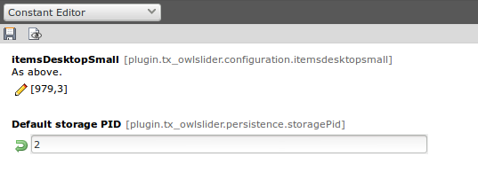
You can find out the ID of the Folder by hovering the mouse over it in the pagetree.

7. Add Slider Items
Go to List > “Your storage folder” > Create new record. Click on “owlSlider Item” to create an object. This object contains one image (you'll have to upload) that will be rendered in frontend and settings like settings like a link of that image (optional), title of the image

8. Place Slider-Plugin in Content
Switch to Page > “Page you want to put the slider on” insert the Plugin by clicking on “Add a new record at this place”
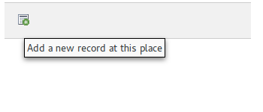
After that switch to the tab “Plugins” and click on “General Plugins” then switch to the tab “Plugin” once again. In the dropdown-menu you'll see choose the “owlSlider” and click to save the record.

8. Configure the Extension via TypoScript
Go to Template > “Your Root-Page” > Constant Editor. Choose “PLUGIN.TX_OWLSLIDER” in the “Category” - Drop-down. Now your should see the backend view where you can customize the slider.

Important:

Set the amount of images and breakpoint for responsive and fixed views.
ItemsMobile, itemCustom, itemsTablet, itemsDesktopSmall, items and itemsDesktop

FAQ
- Setup and Installation tested on blank TYPO3 and Intoduction Package

Configuration

jQuery
- To use Owl Carousel, you’ll need to make sure jQuery 1.7 or higher scripts is included. The Slider-Extension brings a jQuery 1.11.0 with. But if you have already jQuery running on your page, you can disable the one in the extension by unchecking the option in backend.


- You can also include a new version of jQuery by uploading the jQuery-file to typo3conf/ext/owl_slider/Resources/jquery/ Folder in your TYPO3-Project and changing the text shown below into the name of the new jQuery file.



Custom Navigation
You can replace this type of navigation:

with this one:

To do so you need to set customNavigation true in the backend:
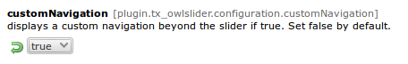
Don't forget to disable standard navigation. Otherwise you will habe both navigations displayed on your page.

Adding Content to an Image
You can add some text to each sliding image by adding content in the “Rich Text Editor” in backend-menu of every Item or just one or two Items you want to upload:

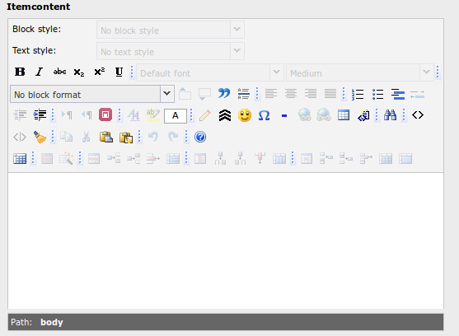
This content will be displayed beneath the slide you've chosen.

Items per Page
In order to prevent Images of laying over each other or to be just cut off because there is not enough space for all of them, you need to specify the maximum amount of images that will be displayed on your page by changing the following items setting:

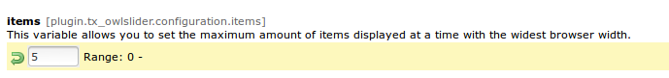
For mobile Webpages that are being displayed on Smartphones and Tablets as well , the settings itemsMobile and itemsDestop should be specified if the default specifications don't fit.
e.g.

The format is [x,y] whereby x=browser width and y=number of slides displayed.

Synced Owls

If you want your Slider look like something like this

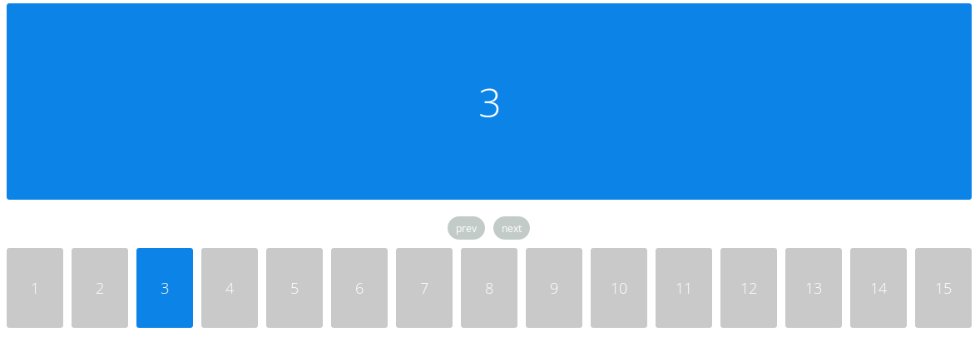

The each content-element of a slide is synchronized with its slide-element. All content-elements are displayed at once, but each of them if clicked scrolls the slider to the maching slide.

To see how it works and to try it out please visit http://owlgraphic.com/owlcarousel/demos/sync.html

In order to make your slider look like “Synced Owls”-version you simply need to choose Synced Owls oprion in the dropdown menu by editing the slider-element on your page in backend like shown below:

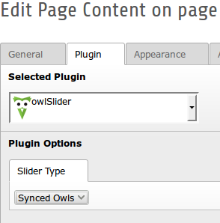

Than save your changes and you are good to go.

FAQ
- For configuration examples please visit the owl carousel website http://www.owlgraphic.com/owlcarousel/
- IMPORTANT: Please reinstall your owlSlider Plugin if you're updating it from the version lower than 2.0.0

ChangeLog

Version | Changes:
1.0.0 | Initial release
1.0.1 | Documentation added
1.1.0 | New Features: sorting of images, set image size, link image with link wizard, add standard navigation
1.1.1 | Custom Navigation Example, Documentation Update
1.2.0 | Feature: Image content
2.0.0 | “Synced Owls” - feature added
2.0.1 | Some JacaScript fixes
2.1.0 | TYPO3 7.0 Compability
2.1.1 | TypoScript constants groups and order
2.1.2 | Jquery Update and 7.3 combat version

