**L. N. Gumilyov Eurasian national university**

**Faculty of Information technology**

**Department of Informatinon system**

«Object-oriented programming»

**REPORT**

|  |  |  |
| --- | --- | --- |
| Prepared by |  | Kalybek A. K. |
|  |  |  |
| Prepared for |  | Zhukabaeva T. K. |

**Astana, 2024**

**Content**

**Introduction** 3

1.1. GitHub 4

1.2. Jira 4

**2.** **Technical specification** 6

2.1. Introduction with project 6

**3.** **Realization** 7

3.1. Main fucntion of program 7

3.2. Creating database 9

3.3. Connection with database 10

3.4. UML and Flowchart 10

**5.** **Conclusion** 23

**INTRODUCTION**

The modern pace of life increasingly dictates the need for effective interaction with technology, and in this context, online shopping is becoming an integral part of our daily experience. As part of this project dedicated to the creation and development of an online electronics store, I set myself the task of providing customers with a wide range of equipment and convenience of the purchase process. In this report, I will provide a detailed overview of the main stages of my project's development, from setting the task and choosing a strategy to the technical details of implementation. The development of this project gave me the opportunity to apply practical skills and consolidate my knowledge during this semester. I hope that this project will become the basis for further development and optimization of our project, and the online electronics store I created will successfully meet the expectations of modern consumers and will become a popular destination for everyone who strives to be at the forefront of technological innovations.

**Jira**

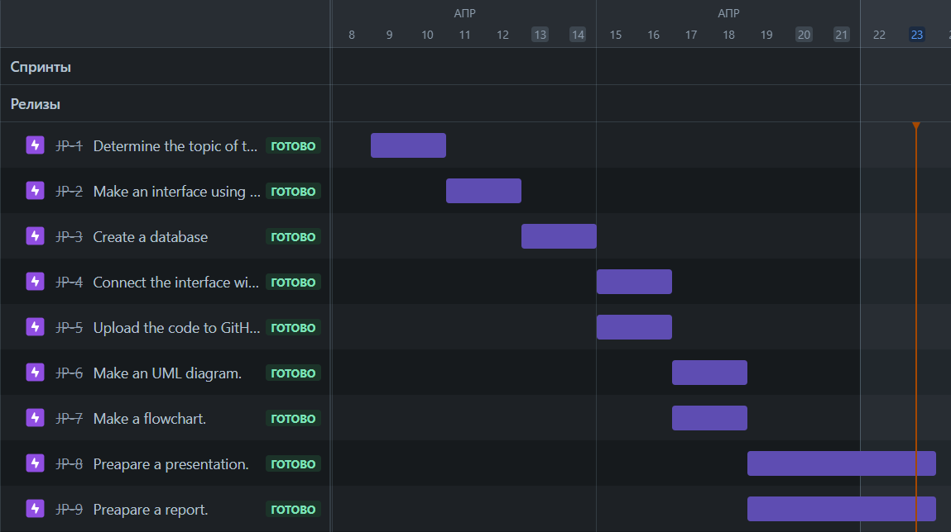

**GitHub**

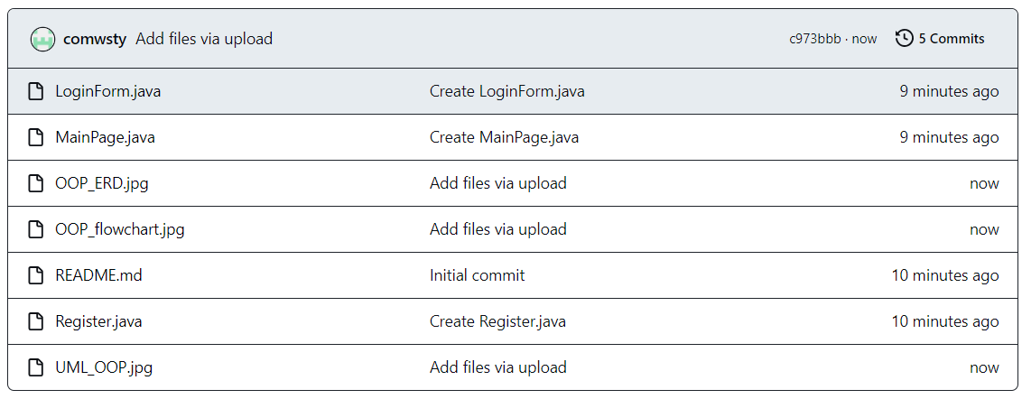

**TECHNICAL SPECIFICATION**

This JAVA project constitutes a robust graphical user interface (GUI) application designed for an online shopping platform. The application seamlessly integrates user authentication, product exploration, and a streamlined shopping cart feature. Developed using the Swing library for GUI components and linked to a PostgreSQL database for user and product information management, the script serves as a comprehensive solution for an immersive online shopping experience.

The script incorporates a login/signup system. Users can sign up by providing essential information such as a username, password, address, and phone number. The password confirmation during the signup process ensures data integrity.

Upon successful login, users are directed to a dynamic main shopping window. This window showcases an array of available products, creating an engaging and visually appealing interface.

To enhance user experience, the application facilitates product filtering based on brand, category, and price range. Users have the option to filter by "All Brands" or "All Categories," providing a comprehensive view of the product catalog.

A central component of the application is the shopping cart, where users can view a curated list of selected items. Adding items to the cart is made intuitive by clicking on products in the main window. The cart window additionally allows users to remove items individually, promoting flexibility.

Users can access and review their profile information, including username, address, phone number, and password. A dedicated "Leave" button offers users the convenience to log out, seamlessly transitioning back to the login/signup screen.

A PostgreSQL database serves as the backend for the application, handling the storage and retrieval of both user and product information. Structured queries are employed to fetch products based on user preferences, ensuring a responsive and personalized experience.

**REALIZATION**

**Main function of project**

The application offers users a seamless experience by providing functionalities for user registration and login through distinct windows. Users can conveniently input their information during the registration process or create a new account. During the registration process, an additional window is presented to gather supplementary details, such as the user's address and phone number, enhancing the user profile.

A dedicated section in the main window facilitates product searches, incorporating filters for brand, category, and price range. The search results are elegantly presented in a table or list format within the main window, offering users a comprehensive view of the available products. Furthermore, users have the flexibility to scrutinize and manage the contents of their shopping cart, allowing them to add or remove specific products based on their preferences.

The project implements a robust user profile feature, showcasing essential details such as the user's address, phone number, and password. This user profile provides a centralized location for users to review and update their information. In the event of errors, such as mistyped credentials or database-related issues, the application offers additional windows to address and rectify these issues, ensuring a smooth and error-tolerant user experience.

The graphical user interface (GUI) of the application is designed using Tkinter elements, including Labels for displaying information, Buttons for user interactions, and Entry fields for data input.

**Creating database**

I’ve provided SQL statements for creating tables in a relational database. There are three tables: for products, for clients data, for purchases.

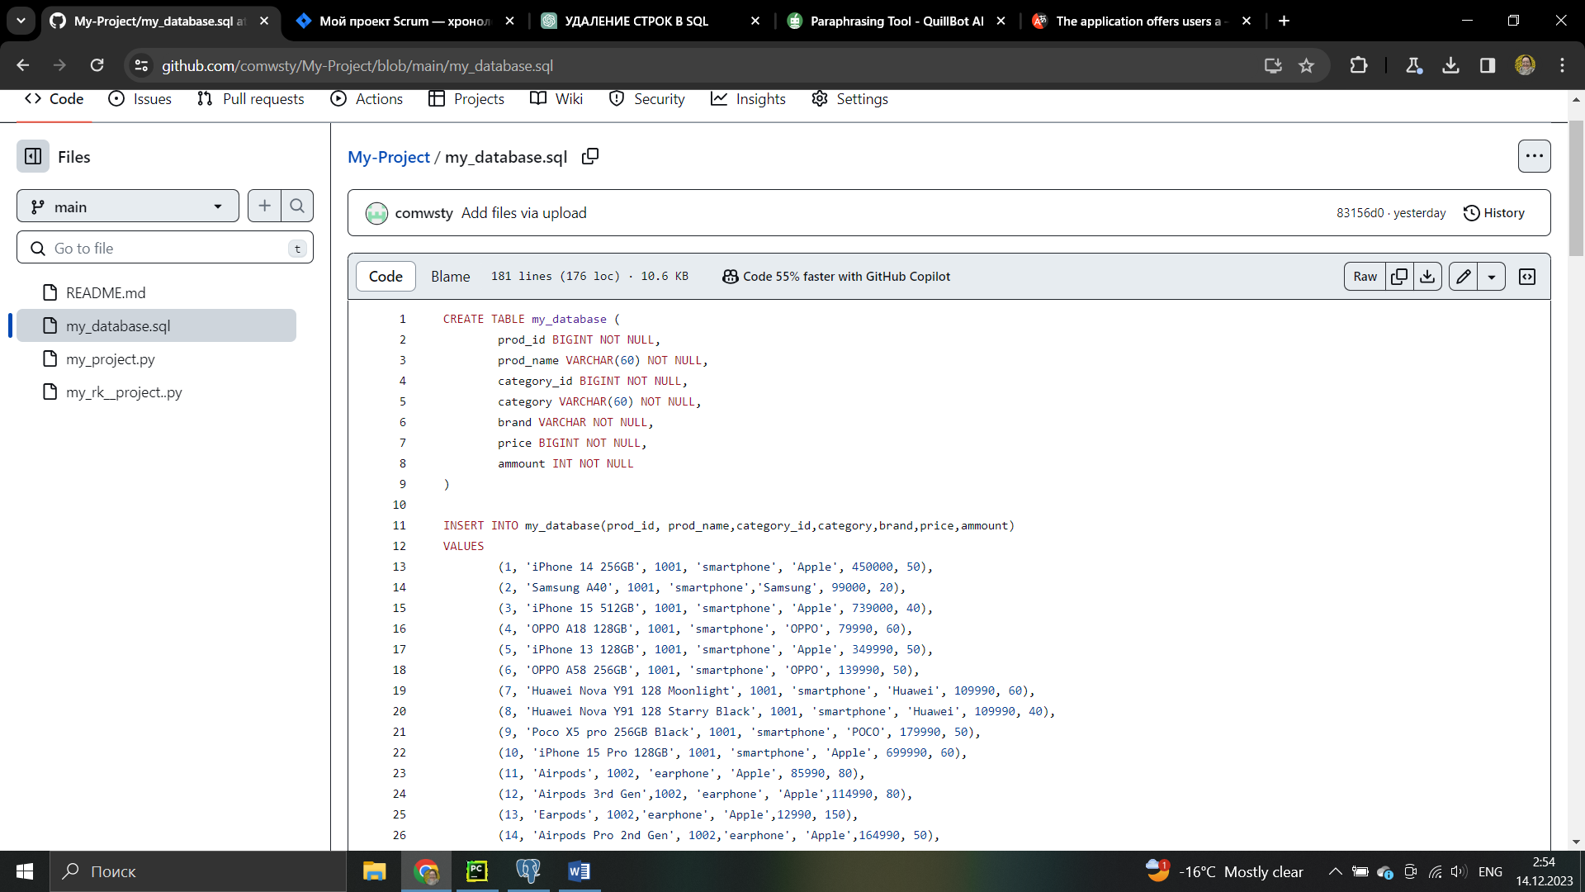

Pic. 1. Database for products

This table appears to store information about products available in the online store. The data in this table is used for displaying products in the main window. It is also used for filtering products based on brand, category, and price range. In database, there are 150 products.

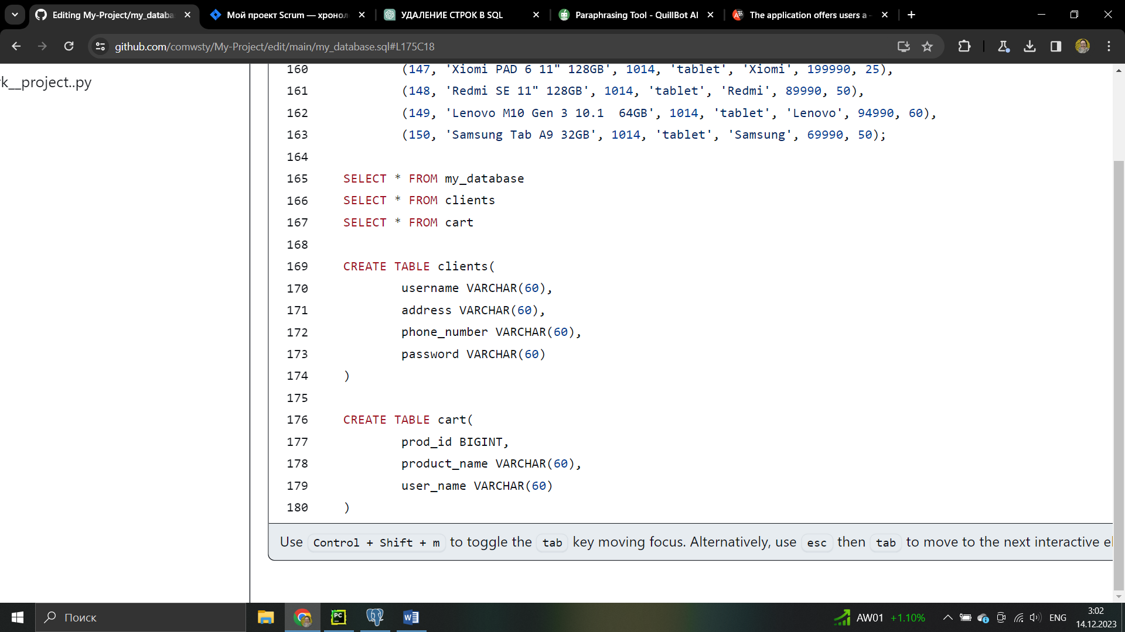

Pic. 2. Databases for clients and purchases

Clients table stores information about registered users. During user registration, information is inserted into this table. When a user logs in, the entered credentials are checked against this table to verify the user.

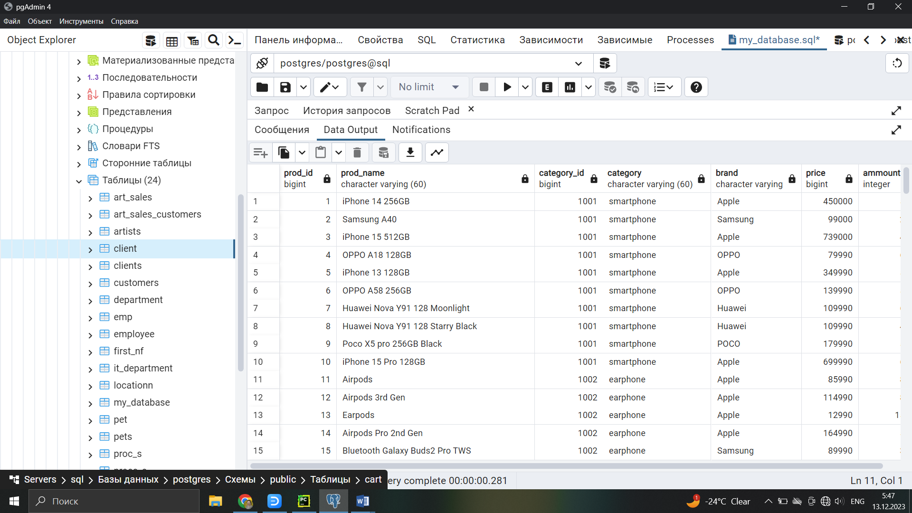

Pic. 3. My_database

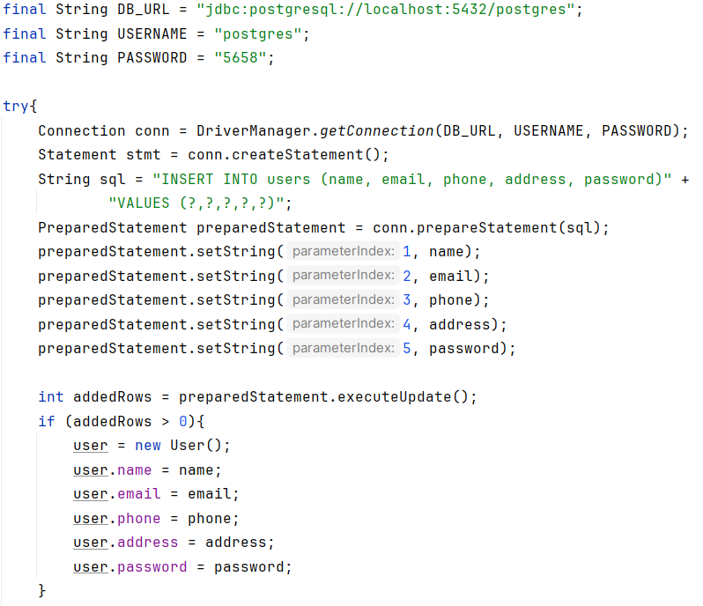

Pic. 4. Connection with database

**UML**

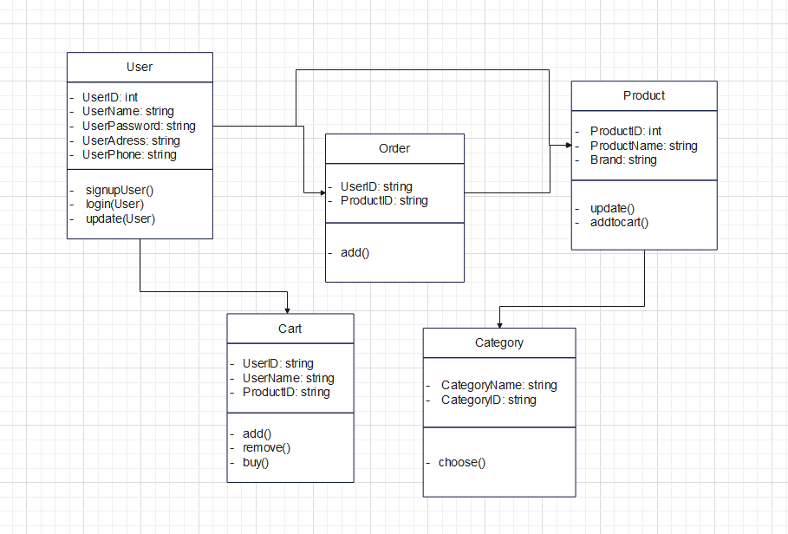

**Flowchart**

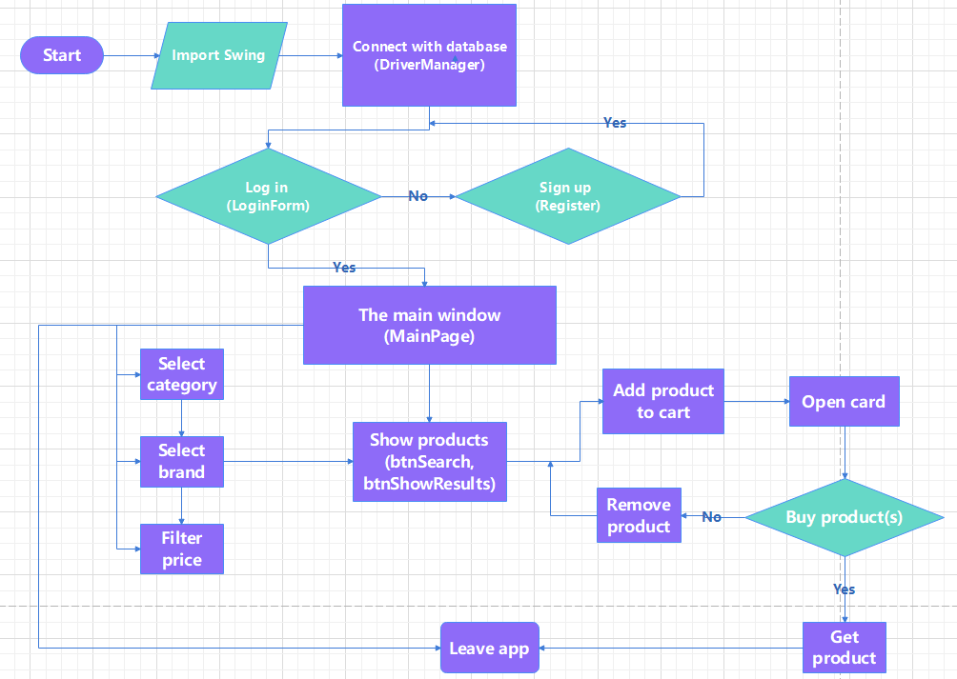

**ERD**

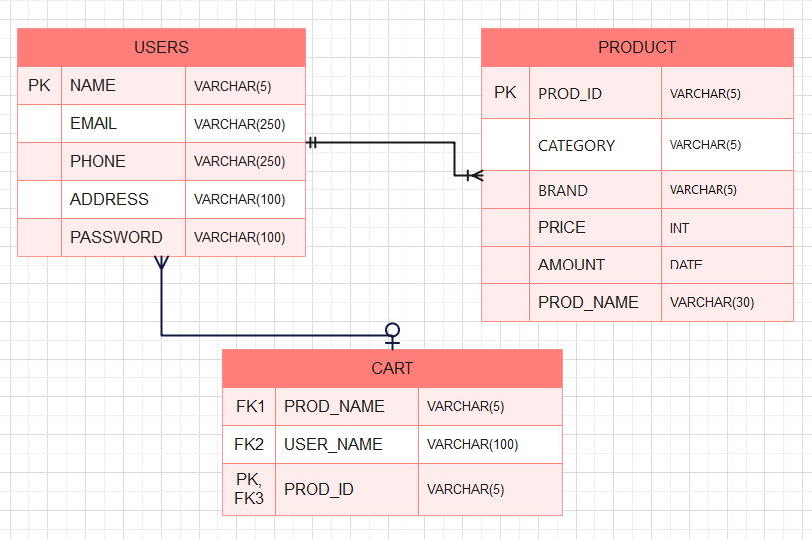

**CONCLUSION**

In conclusion, the project has successfully achieved its objectives and demonstrated a robust implementation of a user authentication system and an interactive online shopping platform. The integration of a PostgreSQL database with Swing for the graphical user interface has provided a seamless user experience.

We has addressed various challenges, including database connectivity, user input validation, and the implementation of dynamic features such as filtering, searching, and shopping cart management. The creation of modular functions has enhanced code readability and maintainability.