G-CLOUD AUTOMATION
PA CONSULTING G-CLOUD PROPOSAL APPLICATION
CONOR MACKLIN
2025
Contents
1 G-Cloud Proposal Automation Application 1
1.1 G-Cloud v15 1
1.2 Current Problem 1
1.3 Solution (AWS Implementation) 1
1.4 Unit Tests & Example Results 1
1.5 AWS Architecture Overview 2
1.6 Azure Replication Plan 2

G-Cloud Proposal Automation Application

G-Cloud v15
UK Crown Commercial Service (CCS) G-Cloud is the procurement framework for cloud hosting, software, and support.
Version 15 refreshes service definitions, accessibility standards, and catalogue validation rules.
Suppliers must deliver concise service descriptions with strict word counts and formatting.

Current Problem
- Manual word counting introduces human error and repeated rework.
- Draft templates stall because there is no guided workflow or validation.
- Teams rely on email reminders and spreadsheets instead of automated tracking.
- Enumerated bullets in Word conflict with portal validation.
- Final Word/PDF packaging requires manual formatting and SharePoint uploads.

Solution (AWS Implementation)
- FastAPI service on AWS Lambda (via API Gateway) parses DOCX input, strips numbering, validates word counts, and syncs with SharePoint.
- React SPA served from Amazon S3 + CloudFront provides guided forms, autosave drafts, and validation feedback.
- Dedicated PDF converter Lambda container running LibreOffice preserves formatting when generating PDFs.
- S3 buckets segregate templates, uploads, sharepoint outputs, and generated PDFs with lifecycle policies.
- Session storage and backend parsing ensure bullets never surface in template boxes; document generation is fully automated.
- IAM roles & policies:
  - gcloud-automation-dev-api-role – Lambda execution role scoped to templates/sharepoint/uploads buckets and Secrets Manager.
  - gcloud-automation-dev-pdf-role – Lambda execution role scoped to output bucket with CloudWatch logging.
  - CloudFront origin access identity restricted to static content bucket.
  - AWS Secrets Manager policies limited to SharePoint OAuth credentials.

Return of Investment (ROI)

FOR LEE

Future Longterm Support

This application will be supported long term by the G-Cloud Support team. Support will include L2/L3 maintenance, validation, security updates and image scanning via DevSecOps practices.

Unit Tests & Example Results
- backend/tests/test_document_generation.py – numbering resets and About PA block retention.
- backend/tests/azure/test_number_prefix.py – ensures strip_number_prefix handles non-breaking spaces.
- backend/tests/azure/test_blob_path_resolver.py – validates blob naming scheme.
- backend/tests/azure/test_pdf_event.py – validates PDF converter contract.
- backend/tests/azure/test_healthcheck.py – confirms /health returns OK.
Latest run: pytest backend/tests/azure -q → 9 passed in 1.77s (warnings: Pydantic deprecations).

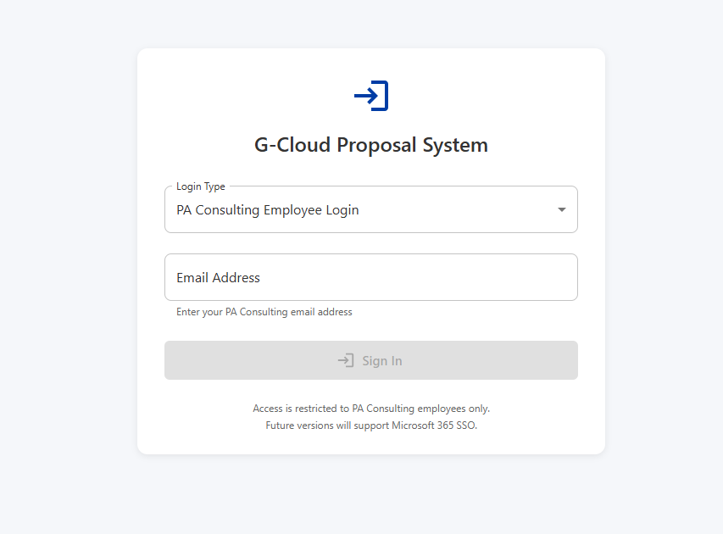
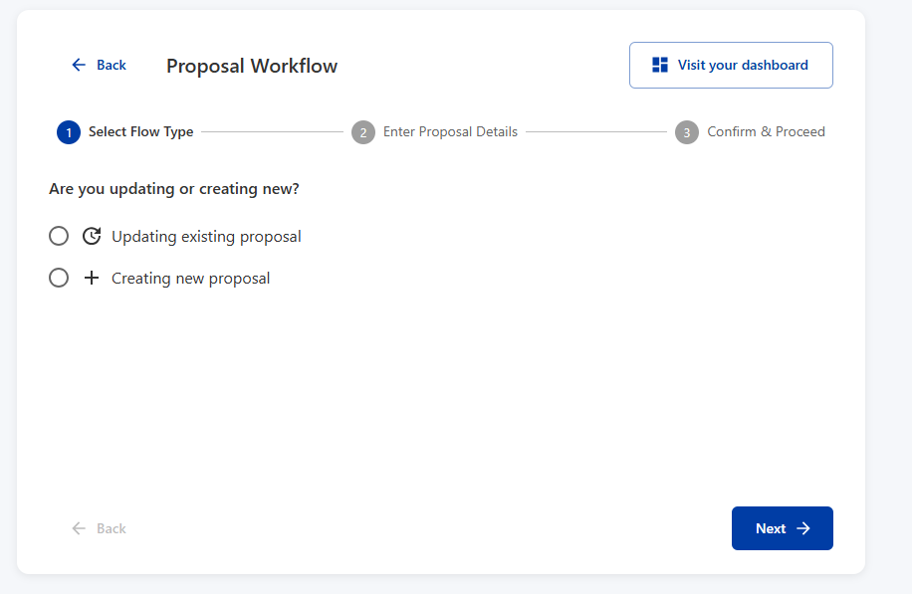

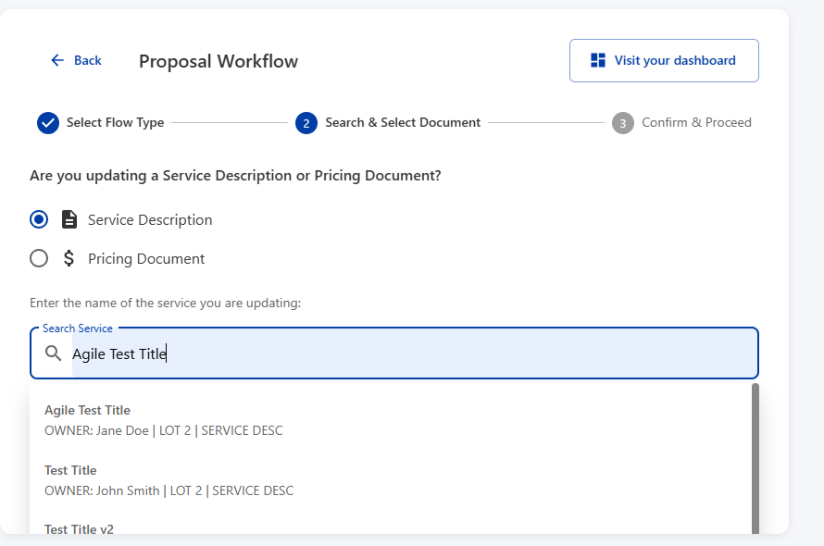

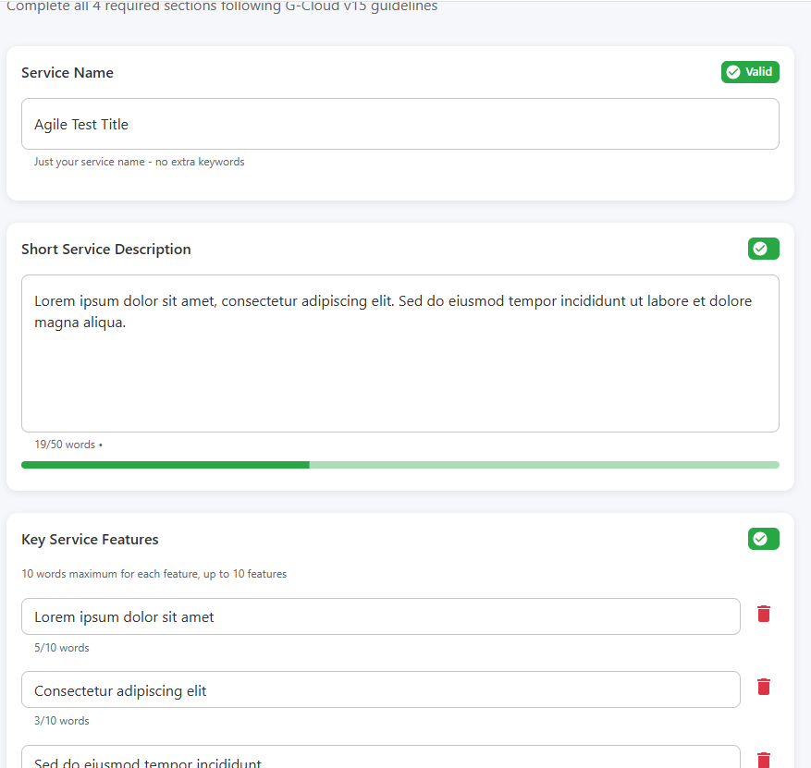

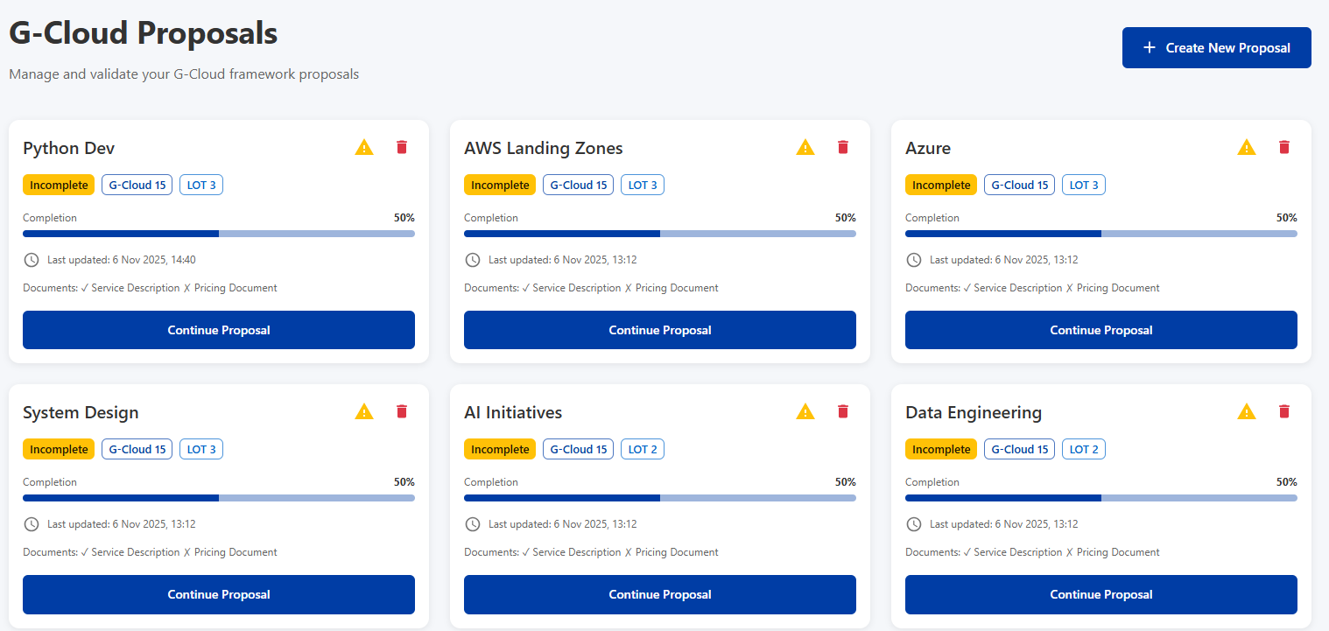

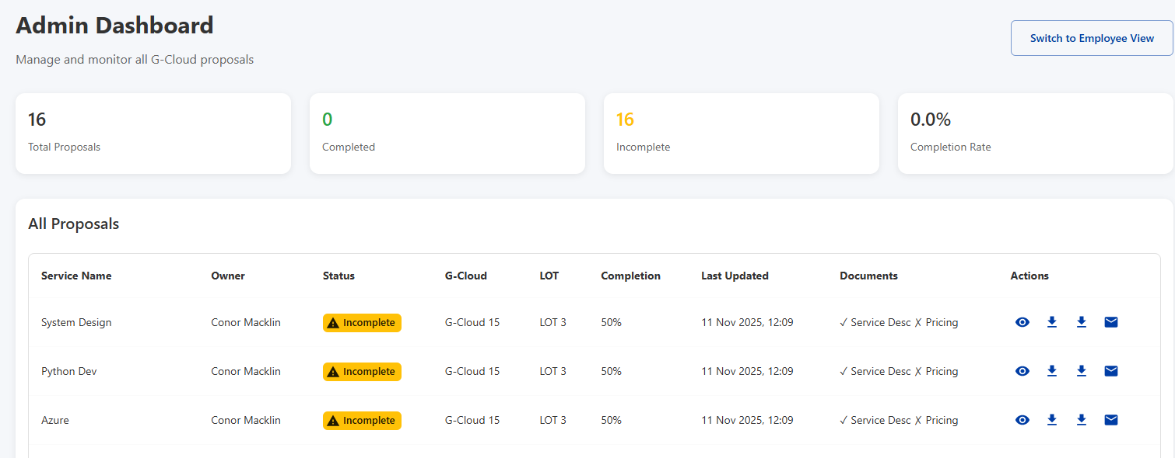

AWS Architecture Overview
Users (Browser)
│
▼
Amazon CloudFront (Static SPA)
│
├──> Amazon S3 (Frontend assets)
│
▼
Amazon API Gateway
│
├──> AWS Lambda (FastAPI service)
│ ├──> Amazon S3 (Templates / SharePoint / Uploads)
│ └──> AWS Secrets Manager (SharePoint OAuth)
│
└──> AWS Lambda (PDF converter container)
└──> Amazon S3 (Output PDFs)

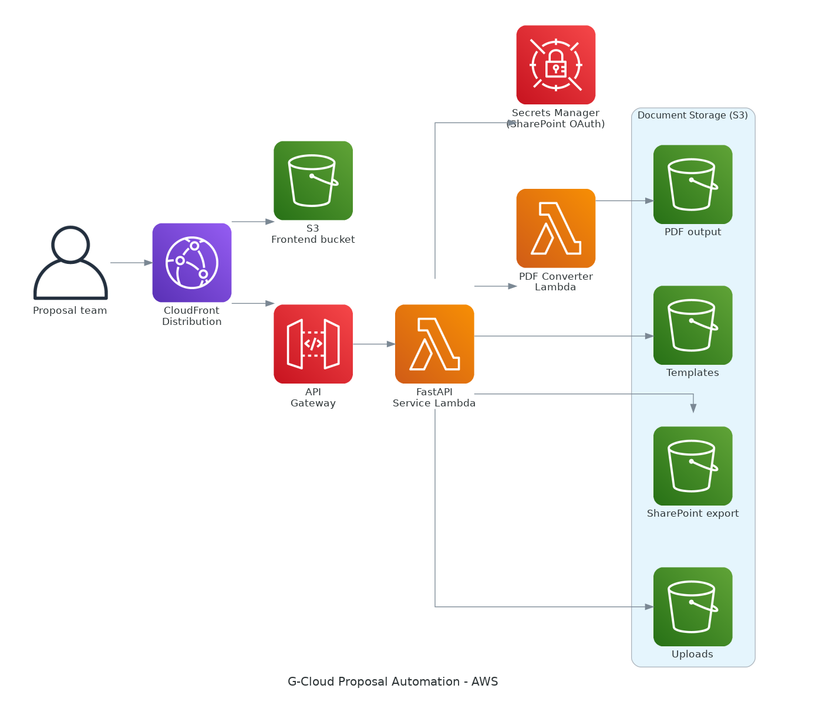

Azure Replication Plan
- Azure Functions (HTTP-trigger FastAPI, container PDF converter) replace Lambda workloads.
- Azure Static Web Apps + Azure Front Door serve the SPA.
- Azure Storage containers mirror S3 buckets (sharepoint, output, uploads, templates).
- Secrets stored in Azure Key Vault; managed identities with Key Vault Secrets User access.
- Azure API Management adds throttling and request inspection.
- RBAC: API Function identity → Storage Blob Data Contributor (sharepoint/uploads/templates).
- RBAC: PDF Function identity → Storage Blob Data Contributor (output).
- RBAC: Deployment principal → Website Contributor, Storage Blob Data Contributor, AcrPush (time-bound).
- RBAC: Key Vault policies limited to get/list for runtime identities.

