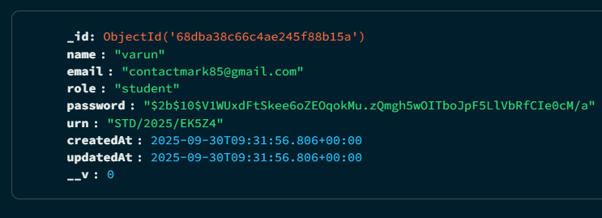

* 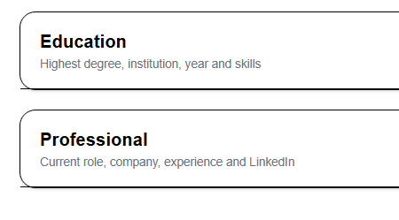/user/profile
* 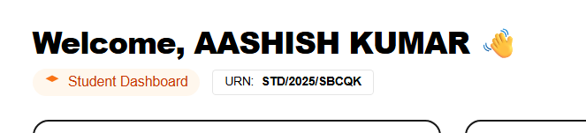Student/dashboard
* After Enrolling in course -> in “Enrolled course” its not reflecting any course