Lecture 11

Confidence Intervals. Power.

The development of a methodology for testing whether the mean value is equal to 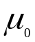 leads to providing a plausible range for the true value of the mean.

A so called interval estimate or Confidence Interval

Suppose I estimate the Modulus of Rupture (MOR) for planks of a certain origin to be 15N/mm². I have calculated 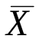to be 15.

But was this the average MOR of 3 planks, 300 or 3mln? What is the variance (SD) ? Were the instruments used accurate to within 0.1, 1 or 10 or 100N?

It is reasonable to argue that without some statement of precision the estimate is useless.

If I take another sample am I likely to get a value close to 15 eg 14.5 or 16 or might I get 3 or 37?

A confidence interval gives a plausible range for the mean. The extent of the plausibility is defined by the confidence level 1-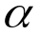.

It is stated in this way because it is precisely the set of values for which we would not reject the hypothesis 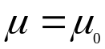 vs the not equal alternative at significance level

If we test:

H₀ vs 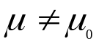 and do not reject this at 5%.

There are other for which we would not reject H₀ , on the basis of this data. The set of all those is the 95% confidence interval.

Formally the confidence interval covers (includes) the mean with probability 1-.

The only point is that the interval is random not the value of the mean

Frequentists make a strong point about any parameter being an unknown constant not a random variable. Because another school called Bayesian’s make a very strong point about it being a random variable!

So 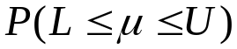=0.95 is a valid statement, but it is U and L that are random.

Construction of a confidence interval for a mean

=5% , assume known variance.

We do not reject H₀ if:

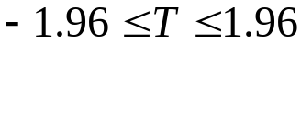
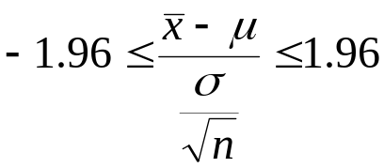 where 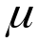 is the hypothesised mean.

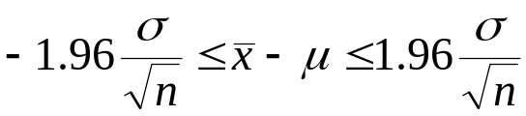

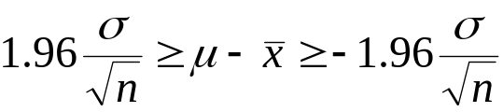
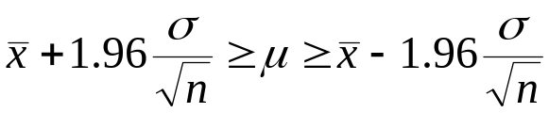

In practice, I would use 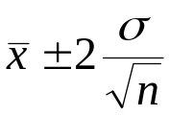 .

For different we have a number different than 1.96, for 90% confidence use 1.64. etc. If variance is unknown use the appropriate value from TINV(,df).

Example

Suppose that the to sample of planks with 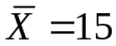 we add the information that the sample size n = 49 and that the standard deviation was 8.4.

95% confidence interval then is:
With n = 49 it will not make much difference whether we use the normal or the T distribution.

The standard error = 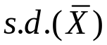 = 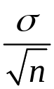 = 1.2

The “quick” 95% confidence interval is :

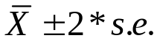 = 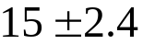

We are 95% confident that the mean is in the range :

12.6 to 17.4

Precisely: the interval (12.6,17.4) includes the mean with probability 0.95. (near enough 0.95)

For the “exact” normal confidence interval we use 1.96 rather than 2.

12.648 to 17.352 but I suggest the accuracy is spurious.

Finally for the proper T based interval we use:
TINV(0.05,49) =2.009574

The confidence interval not only tells us what we think the mean is but also gives a measure of the precision of the estimate.

Comments

Confidence intervals are probabilistically centred. If the parameter is outside the interval, the chances of it being either side of the interval are equal 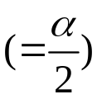.
For the mean (based on a normal) they are also numerically centred – estimate in the middle.

Power of a test.

When testing a hypothesis we control for the probability of type I error by deciding on a significance level.

P(Reject H₀ | H₀ true )= .

Again:
The reason we do this is so that we only have to compute the distribution of the test statistic only for the case H₀ true. This allows the alternative, H₁ , to be a general hypothesis such as 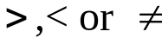 and makes the approach usable in practice.

We chose the test statistics in such a way so that probability of type II error is minimised.

P(fail to reject H₀ | H₀ is false).

In the special (artificial) case where H₁ specifies a single value for the parameter we can compute P(Type II error).

The power of a test is:

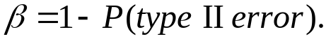

Lets go back to our wire example.

We had a sample of 25 observations and the standard deviation is known to be 150.

We observed 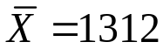 and were able to reject H₀ vs H₁ 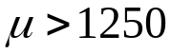 at a significance level of 2%. So all worked out OK. Had we failed to reject we would have learned nothing – the conclusion would have been insufficient evidence to reject H₀.

It is obviously desirable to avoid such situations. Can we get some assurance that we will reject H₀ when it is false?

Yes if we opt for a simple alternative. A simple hypothesis is one that specifies the values of the parameter(s). H₀ is always simple, H₁ usually isn’t, it is a compound hypothesis. It consists of an infinity of simple hypotheses.

H₁: is equivalent to the set of hypotheses

H₁: 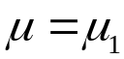 for all 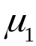>1250.

For each simple hypothesis we can compute the power.
For example:

n=25, 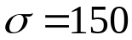, 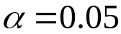.

H₀: 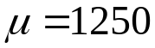 vs H₁: 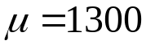

The power is the probability of rejecting H₀ when the mean is 1300.

We reject H₀ if the T statistic is big enough. (one tailed test because small T would not suggest mean = 1300)

With the significance level at 5%, the rule is reject H₀ if :

T > 1.64

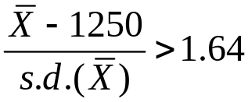 the only variable here is 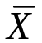.

If H₁ is true, the mean of X is 1300, the mean of is 1300 and the standard deviation hasn’t changed = 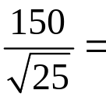30.

So
P(reject) =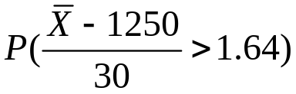 where 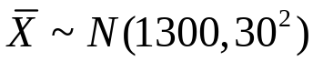

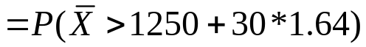

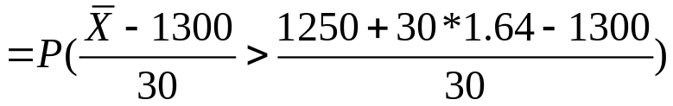

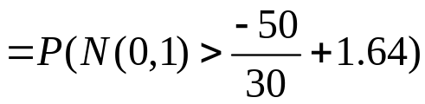 ***

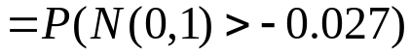 = 0.5106

So if the true mean were 1300 we would need to be lucky (toss of a coin) to reject at 5% with 25 observations.

We can do this for other H₁ 1260, 1275 , 1400 etc. the general form of the *** equation is:

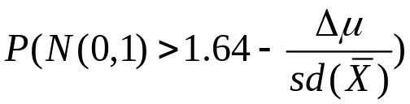
where: 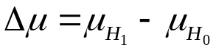

Power as a function of true mean
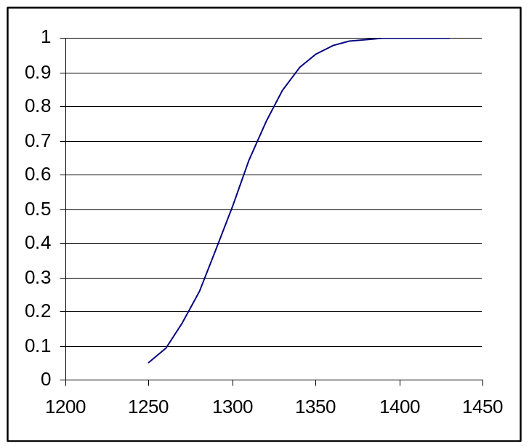

Designing the experiment.

Before we collect the data we want to ensure that we have reasonable power.

The power depends on:

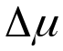 - the difference in means the bigger this is the easier it is to reject.
We can chose this to be sensible. Not demand too much from the data.

- The significance level. How sure we want to be that H₀ is false before we reject it?
The numbers are:

10% 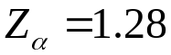
5% 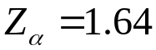
1% 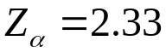
The bigger the 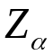, the lower the power.

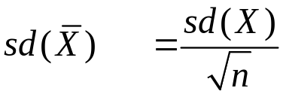 . Probably not much you can do about sd(X) but more accurate measuring might help.
What you can do is increase n =get more data.

What sample size (n) do you need to guarantee an acceptable level of power?

Suppose we pre-assign the power to be at least 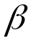.

The we have:

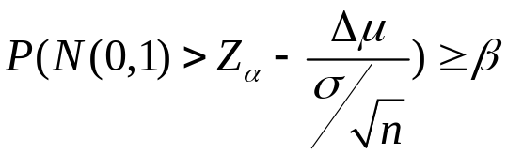

If we want, 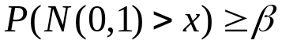 then we have to have
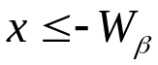. where 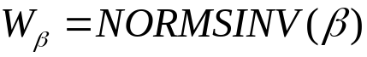

So: 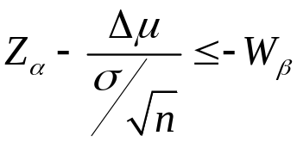
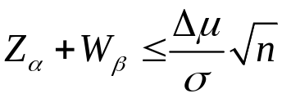
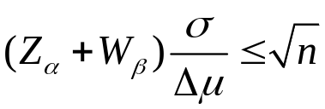

Note: 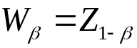
Example:
To be 90% sure that we will reject H₀ (significance =5%) if the mean is 10 higher than the hypothesised mean, sd(X)=150 we need:
=1.64, 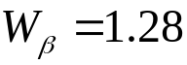, 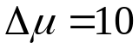,
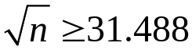 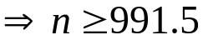 i.e n=992 observations.

Don’t demand to much of the poor data.

If we are considering alternatives less than H₀ everything reflects about 0. The formula is the same as long as measures the distance (positive) from the H₀ mean. is also treated as a positive value. (for this case reject H₀ if
if T<-)

With a two sided test, 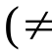), will be different because of the two tailed test (5% -> 1.96) . There is also the possibility of rejecting H₀ on the “wrong side” , but as the probability of this is tiny it can be ignored.

Comments.

We need to know 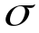. If we don’t know the test should be a t-test, unless n>30 . Try as Z-test if n comes out less than 30, use n=30 or if the data are very expensive use the proper method. Requires non-central t distribution but is all done for you in MINITAB.

But you still need an estimate of . This is got from a pilot sample (small just to get ). This can be used as part of the sample later.

However as estimates of are lousy unless you have a lot of observations you would usually allow some safety factor using the bigger than it really is will give you a larger n and hence a better than you require. That is not as bad as concluding nothing.

