Multiple Linear Regression

There is no difficulty in extending the idea to having more than one X in a regression

Y= a +bX1 +c X2 + ....

The least squares solution for a,b,c .. is a solution of a system of linear equations.
In practice use package.

The equation can still be used to predict Y, however standard errors of predictions involve complicated matrix formulae - need to use the package output for these : MINITAB is better at this than Data desk.

r² is still a valid criterion for deciding on the quality of the regression.

Residual plots should be used for model checking.

Equation development

A new issue arises in Multiple regression - which predictor X variables really influence Y?

A model should be parsimonious -using as few X variables as possible and yet reflect the data.

We want a simple model because:

1 -It will be easier to interpret not obscured by spurious relationships.

House prices in Dublin will be related to stocks of Cod in the North sea !

As the cod stocks have dwindled so the house prices have gone up.

2. The variance of the predictions improves if the model does not include spurious variables.

Thus we have the task of selecting an appropriate equation.

The basic tool is the marginal t-test.

All packages that do regression provide a test of each β=0.

This is of the form :

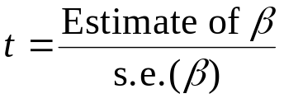

A value of 2 (or -2) is used as the deciding criterion. (p-value 0.05)

Example:
Developing an equation for the price of a Car (Cars91 data).

In the initial model we include all possibly relevant variables.

Dependent variable is: Price
No Selector

R squared = 73.1% R squared (adjusted) = 71.5%
s = 4756 with 91 - 6 = 85 degrees of freedom

Source Sum of Squares df Mean Square F-ratio
Regression 5.22351e9 5 1.0447e9 46.2
Residual 1.92267e9 85 2.26197e7

Variable Coefficient s.e. t-ratio prob
Constant -19395. 6878 -2.82 0.0060
Weight 6.89128 2.546 2.71 0.0082
Horsepower 117.728 23.46 5.02 < 0.0001
Eng. Displc -36.4007 25.66 -1.42 0.1597
Cylinders 1006.49 949.8 1.06 0.2923
Drive ratio 346.258 1407 0.246 0.8062

r² is good at 73%, The last three variables are not significant (prob>0.05) so we drop them from the model.

We note though that dropping variables will in general alter the p-values of the others.

Drive ratio and Cylinders and Eng disp are a long way from 0.05 so we drop all these.

Dependent variable is: Price
No Selector

R squared = 72.4% R squared (adjusted) = 71.7%
s = 4738 with 91 - 3 = 88 degrees of freedom

Source Sum of Squares df Mean Square F-ratio
Regression 5.17093e9 2 2.58546e9 115
Residual 1.97526e9 88 2.24461e7

Variable Coef s.e. t-ratio prob
Constant -13811 3099 -4.46 <0.0001
Weight 4.70558 1.732 2.72 0.0079
Horsepower 125.699 21.6 5.82 < 0.0001

Of the variables available, Weight and Horse power are all that is needed to predict Price.
Note that the have been some changes in the coefs. when the non-significant variables were dropped.
r² is still very good at 72%
The equation is:

Price $ = -13811 +4.706*Weight +125.7*HP

Residual Plot

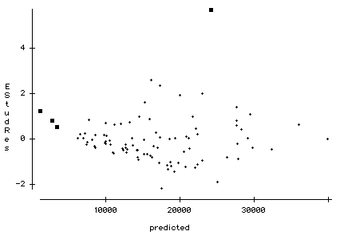
The highlighted points are troubling ...

The Merc (check) stands out as an extremely expensive car. This car does not fit the current model and should be excluded from the data.

The three cars with the lowest predicted prices all have positive residuals suggesting that the equation may not work for very cheap cars (less than $3500).

Excluding the merc gives:

Dependent variable is: Price
No Selector
91 total cases of which 1 is missing

R squared = 76.8% R squared (adjusted) = 76.3%
s = 4065 with 90 - 3 = 87 degrees of freedom

Source Sum of Squares df Mean Square F-ratio
Regression 4.7716e9 2 2.3858e9 144
Residual 1.43755e9 87 1.65236e7

Variable Coefficient s.e. t-ratio prob
Constant -13266.9 2661 -4.99 <0.0001
Weight 4.72278 1.486 3.18 0.0021
Horsepower 119.336 18.57 6.43 < 0.0001

