Lecture 17

Extending regression Transformations. Indicator variables.

The regression equation is a linear equation; we can however transform the variables to accommodate other relationship.

Suppose we want to fit the relationship:

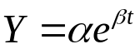

This is achieved by transforming the Y variable:

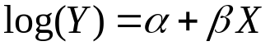.

The usual regression assumptions are assumed to hold for the transformed variables.

The full model is

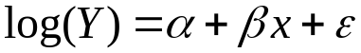
Where 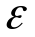 are 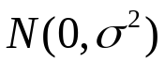 .

Note: this means that for the original model we have a multiplicative error term (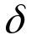).

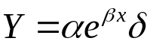

has a log-normal distribution 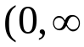) – the distribution so that its log() is Normal.

If we wanted to have the error to be additive

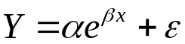

This would be a non-linear least squares problem a much harder algorithm to minimise the sum of residuals . (iterative).

Fortunately it often makes sense in practice to have multiplicative error with such a relationship.

Example : Such a model is often used for growth of a biological entity.
Y= size (say weight)
x = time.
Having a multiplicative error means that the percentage variation is constant – that makes physical – large individuals vary more in weight than small ones in absolute units.
Other model sometimes used are:

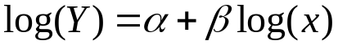 corresponding to a power relationship:
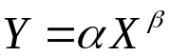

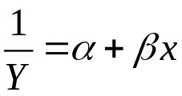 and 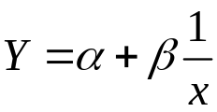 for reciprocals

The key issue about transformed models is that fitting and inference takes place in the transformed variable space.

Example
Broadband has hit the island of San Seriffe. The local telephone company has monthly records of the number of subscribers to broadband.

 | months | Subscribers
 | 1 | 31
 | 2 | 44
 | 3 | 58
 | 4 | 71
 | 5 | 85
 | 6 | 144
 | 7 | 148
 | 8 | 226
 | 9 | 244
 | 10 | 328
 | 11 | 408

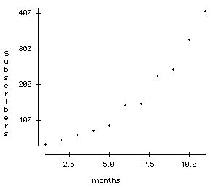

It is reasonably clear that the relationship is a curve.
There is some evidence that the “adoption of new technologies” follows an exponential curve, at least in the early stages.

We want to fit the model :

Subscribers = 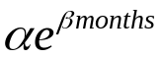

This is equivalent to:

Dependent variable is: ln(s)
No Selector

R squared = 99.0% R squared (adjusted) = 98.9%
s = 0.08973 with 11 - 2 = 9 degrees of freedom

Source Sum of Squares df Mean Square F-ratio
Regression 7.17937 1 7.17937 892
Residual 0.0724632 9 0.00805147

Variable Coefficient s.e. of Coeff t-ratio prob
Constant 3.25561 0.05803 56.1 < 0.0001
months 0.255474 0.008555 29.9 < 0.0001

Thus: a=3.25561 and b=0.255474

Transforming back to the original variables:

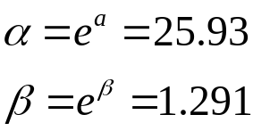

Meaning : 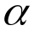 size at time 0 i.e. about 26 subscribers initially
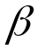 multiplication factor for each unit of x (=month)

Thus the number of subscribers is increasing at 29.1% each month.

Confidence interval for the monthly increase:

Confidence interval for the b coefficient:

0.255474 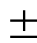 2 *0.008555
(0.238364, 0.272584)

We get the confidence interval for coefficient by exponentiating the ends .

(1.269171, 1.313354)

Thus the monthly growth rate is estimated to be between 26.9% to 31.3%

12 month prediction:
We obtain the estimate for the ln(subscribers) for months=12

3.25561 + 12*0.255474 = 6.321298
corresponding to 556.29 subscribers.

To construct a confidence interval for this prediction we need 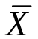 and SSX . The regression output does not provide these values.
The Data Desk Summary Reports provides:

Summary of months
No Selector
Count 11
Sum 66
Mean 6
SSQ 506 (sum of squares)
Variance 11

So 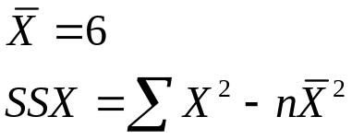

The s.e. for a prediction at x is:

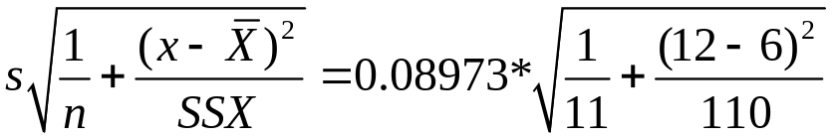=0.05826

Thus
6.321298 2 * 0.05826 for log subscribers.

(425, 625) subscribers after 12 months.

We could use the model to produce predictions for

24 months = 11932
36 months = 255934 exceeds the total population of San Seriffe .

These are well beyond the observed data and rely on the model holding into the future – which it will not.

In Multiple regression we have the additional possibility that the individual Xs can be constructed variables.

Instead of fitting an exponential model to the data above we might use a polynomial in time:

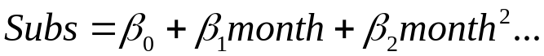

We can create the powers of month using “Derived variables” in data desk.

Linear R squared = 91.3%
Variable Coefficient s.e. t-ratio prob
Constant -53.1091 25.08 -2.12 0.0633
months 35.9273 3.698 9.72 <0.0001

Quadratic R squared = 99.0%
Variable Coefficient s.e. o t-ratio prob
Constant 43.7394 15.68 2.79 0.0236
months -8.77203 6.006 -1.46 0.1823
m2 3.72494 0.4875 7.64 <0.0001

Cubic R squared = 99.1%
Variable Coefficient s.e. t-ratio prob
Constant 21.1061 24.74 0.853 0.4218
months 9.92327 17.07 0.581 0.5793
m2 -0.00582751 3.234 -0.0018 0.9986
m3 0.207265 0.1777 1.17 0.2817

The problem is that months, months², months³ are similar variables and least squares cannot disentangle their individual contributions

Indicator variables
A very important class of variables are indicator variables and variables derived from them.

If condition 1 then Z1 =1 else Z1 =0
If condition 2 then Z2=1 else Z2 =0

Example
Two communication protocols XC23 and YD28 may be used for transferring files on a certain system. Test files of various sizes were transferred using the different protocols resulting in the following data:

Time to transfer, File Size, Protocol Used

 | Time | size kb | protocol
 | 5.29 | 65 | 1
 | 1.56 | 25 | 1
 | 1.64 | 34 | 1
 | 2.83 | 49 | 1
 | 2.21 | 32 | 1
 | 4.89 | 90 | 1
 | 7.37 | 140 | 1
 | 6.21 | 120 | 1
 | 6.37 | 118 | 1
 | 4.12 | 90 | 1
 | 3.55 | 70 | 1
 | 0.87 | 16 | 2
 | 0.97 | 18 | 2
 | 2.11 | 48 | 2
 | 2.19 | 43 | 2
 | 4.27 | 89 | 2
 | 3.35 | 65 | 2
 | 3.54 | 72 | 2
 | 2.37 | 52 | 2
 | 7.87 | 160 | 2

Code Z =1 if YD28 else 0.

We now consider 4 models for this data:

Model 0.
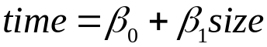 - this model assumes no differences between protocols

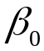 -set up time, 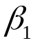 - secs/kb

Model 1.
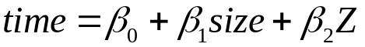

For protocol XC23 this model is:

For protocol YD28 it is:

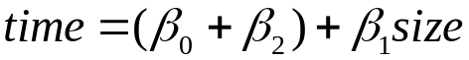

the set-up time for protocol 2 is 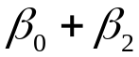 the time to transfer 1kb is assumed the same for both protocols.

We now create another artificial variable
W = Z*size

Thus W = size if YD28
= 0 if XC23

Model 2
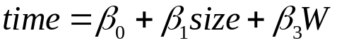

For XC23

For YD28 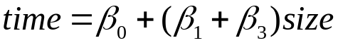
W and size have identical values if YD28.

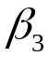 measures the difference in slopes (secs/kb), set-up time is the same for both protocols.

Model 3
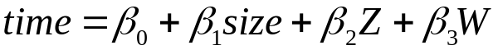
This allows for different lines – different set-up times and different transfer rates for the two protocols.

Model 0 is obtained by setting 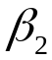 and to 0 in Model 3
Can compare using F-test
Similarly can compare 3 with 1 and 2, 2 with 0, 3 with 0
Cannot compare 2 and 3 using F-test as not nested.

Dependent variable is: Time
No Selector

R squared = 99.2% R squared (adjusted) = 99.0%
s = 0.2433 with 20 - 4 = 16 degrees of freedom

Source Sum of Squares df Mean Square F-ratio
Regression 110.769 3 36.9229 624
Residual 0.947009 16 0.0591881

Variable Coefficient s.e. t-ratio prob
Constant 2.20584 0.1657 13.3 <0.0001
size kb 0.050151 0.001962 25.6 <0.0001
Z -0.218204 0.2221 -0.982 0.3405
W 0.0186435 0.002785 6.69 <0.0001

As the coefficient of Z is not significant we conclude:

Set-up time the same for both protocols 2.20 s
time to transfer 1kb using XC23 is estimated at 0.0502s
time to transfer 1kb using YD28 is 0.01864s longer i.e.
0.06866s

