Training a simple Perceptron

Taken from “Fundamentals of Neural Networks” by L. Fausett.
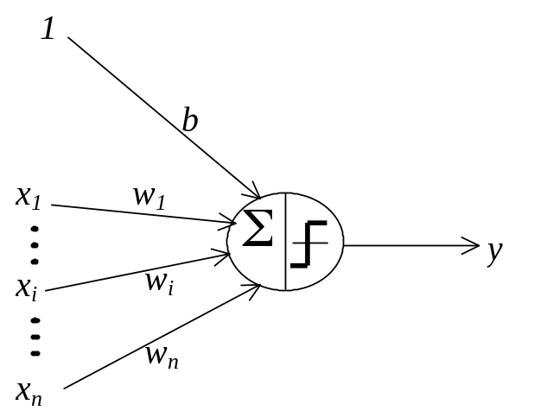

Step 0. Initialize weights and bias.
(For simplicity, set weights and bias to zero.)
Set learning rate α (0 < α ≤ 1) .
(For simplicity, α can be set to 1.)
Step 1. While stopping condition is false, do Steps 2-6.
Step 2. For each training pair s:t, do Steps 3-5.
Step 3. Set activations of input units:
x_{i} = s_{i}.
Step 4. Compute response of output unit:
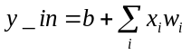;
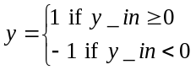
Step 5. Update weights and bias if an error occurred for this pattern.
If y ≠ t,
w_{i}(new) = w_{i}(old) + αtx_{i}
b(new) = b(old) + αt
else
w_{i}(new) = w_{i}(old)
b(new) = b(old)
Step 6. Test stopping condition:
If no weights changed in Step 2, stop; else, continue.

