Lecture 11 ctd

Confidence intervals for variance.

The point estimate of variance is:

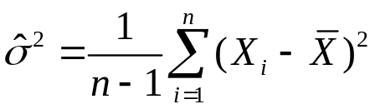

The distribution of :

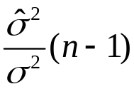 has been worked out. It is called the Chi-Square distribution on n-1 degrees of freedom. Inconsistently CHIDIST(x,df) = P(X>x)

In fact it is a special case of the Gamma distribution.

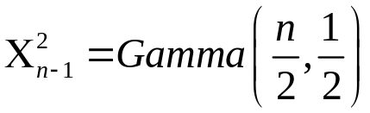.

Like the t it has one parameter and in tables the percentage points are tabulated.

To construct, say, a 95% confidence interval we look up the values such that:

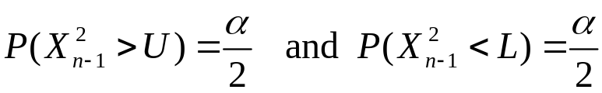

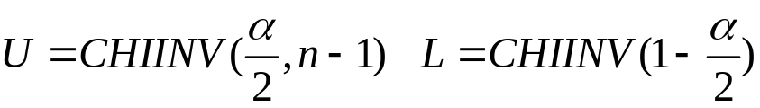
The function CHIINV(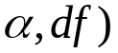 returns the value so that there is a probability of 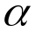to the right of this.

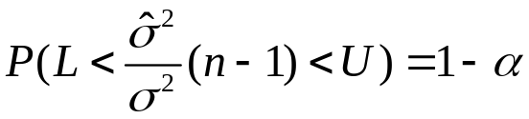

Rearranging gives

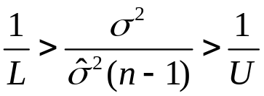

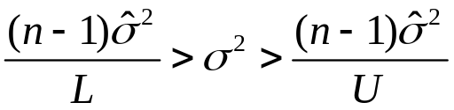

gives the confidence interval.

If you want standard deviation just take the square root of the limits.

Example:
20 observations give an estimate of variance 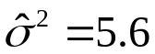.

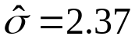

The 95% confidence interval for the variance is:

L=CHIINV(0.975,19)=8.907

U=CHIINV(0.025,19)=32.852

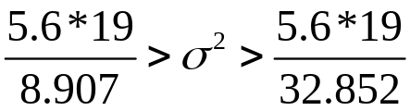

11.95 > 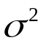> 3.24

3.46 > 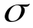 > 1.80 for standard deviation.

So quite a big range the standard deviation could be 50% larger or 50% smaller than the estimated value.

The chi-square can be used for testing whether the variance is a given value. (Not a common thing to want to do).

It also arises in a different type of test but this will (probably) not be covered in this course.

