9 Hypothesis Testing

The two most common statistical applications are:

• Estimation: use data to find likely values of population mean, variance, proportion, etc.

• Hypothesis Tests: use data to say if a hypothesis about population mean, variance, proportion is true or false

• Hypotheses are usually about mean μ;

“Mean height is 160cm”

“Mean strength is ≥ 100,000 N”

“Mean lifetime is ≤ 130 days”

etc.

Example: (from Chatfield, p. 134)

• Company makes wire.

• It is known that wire strength has mean μ0 = 1250 and s.d. σ = 150.

• Company has new production process.

• Measures strength of 25 new wires and finds
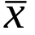 = 1312. (assume s.d. of new wire is also 150)

Question: does new process significantly increase strength of wires?

So, we want to test to see if μ = μ0 = 1250

The Null Hypothesis is the hypothesis that we want to test. It is denoted H0

In example:

H0: μ = 1250

New possibility is that mean strength is increased. So opposing theory to H0 is that μ > 1250

The Alternative Hypothesis is the hypothesis that opposes H0. We accept it only if we reject H0. It is denoted H1.

In example:

H1: μ > 1250

Which Hypothesis is Which?

• With 2 hypotheses, how do we know which is H0 and H1?

H0 is the hypothesis that

1) is assumed true now, and/or

2) must be disproved before we consider the other, and/or

3) we are most interested in departures from

Currently, μ = 1250. We must disprove this before accepting that strength has increased.

We are more interested in seeing if μ has changed from 1250

So, H0: μ = 1250 ( = μ0 )
H1: μ > 1250

Another Example

A new drug is being tested.

We must be sure it works before production

Two hypotheses: drug works
drug does not work

H0?

H1?

The Null hypothesis must specify the model fully.

i.e. must have H0: μ = μ0

cannot have H0: μ > μ0 or H0: μ < μ0

If we want to test:

H0: μ ≤ μ0
H1: μ > μ0

then in practice, we say

H0: μ = μ0
H1: μ > μ0

We structure the procedure so that if we reject H₀ , we would also reject 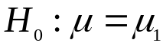 for any 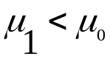.
Test Statistics

• We have formed H0 and H1

• Now use data to decide if we can reject H0

• To do this, we form a test statistic from data

• This shows us if the data is departing from H0

Go back to wire strength example

1) Assume H0 is actually true

2) If H0 true, then has mean 1250 and standard deviation 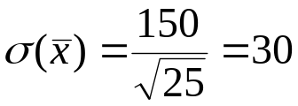.

3) If H0 was true, would we expect to observe =1312 ?

1312 is to the far right of the distribution (2.06 standard deviations) away from the mean (1250) – if H0 true, it is an “extreme” value (less than 2% chance of observing a value as big as this, assuming 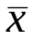 Normal).

1312 is unlikely to be observed

So we might think that H0 mean=1250 is not true.

This is pretty standard scientific method:

Construct a hypothesis (model): H₀
Compute the consequences: ~N(1250,30²).
If observation does not agree with the consequences reject the model (hypothesis)

Formal approach

This was developed in the 30s by Neyman and Pearson.
 |  | The Universe
 | Decision | H₀ true | H₀ False
 | Reject H₀ | Error Type I | Correct
 | Do not reject H₀ | Correct | Error Type II

Fix the P(Error Type I) at some small value called the significance level denoted by 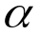.

Construct a test statistic T. Define a critical region C so that P(T belongs to C | H₀ true)=.

If data returns a value of T that is in C reject H₀ .

There are a couple of things that should be noted:

We never demonstrate that H₀ is true – we either demonstrate it as false ( with a chance of error = ) or we say we cannot reject the possibility it is true.

To use this approach we only need to calculate the distribution of T when H₀ is true. We don’t need to know this when H₀ is false, this makes the approach usable in practice:

We can compute distribution of if 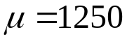, but this could not be done for the case 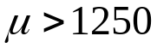.

The choice of is arbitrary – how sure you want to be that you do not reject H₀ when it is false. Typical values (thanks to available tables) are

5% - statistically significant (according to US Supreme Court),

1% - highly significant.

Why not 0! . Because it is a fact of life that then H₀ will never be rejected no matter how false it is. (Except for cases in which there is no randomness).

Note that the choice of T is not specified by the approach. This is very useful in complicated situations where working out the distribution of a “best T” might be impossible.

N-P theory goes on to tell us how to get the “best T” and the best critical region for most situations, but this is beyond this course.

The best T is defined as the one that minimizes:
P(Type II Error) ie the probability of not rejecting H₀ when it is false.

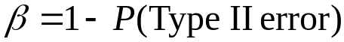 is called the power of the test. Power can only be computed if we can specify the distribution of T when H₀ is false.

Applying the formal approach.

The wire problem.

The company wants to be fairly sure that the wire is not of the same strength so we chose 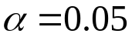.

The best T for testing this turns out to be based on the sample mean .

If H₀ is true and we assume a Normal distribution for . Then:

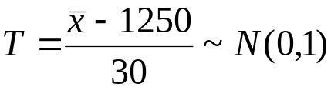

And the best C is T>c. Intuitively it is obvious that large values of and hence T would lead us to reject H₀ in favor of H₁ . N-P theory just confirms this.

All that is left is to compute c such that:

P(T>c|H₀)=0.05

From Normal tables we observe c=1.645 does the business.

The observed T=2.06 so we reject H₀ at 5%.

We note that:

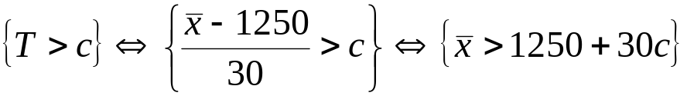
So in the end we reject H₀ if is big enough.

In general, for testing whether the mean is larger than the value 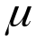 we have the decision rule:

Reject H₀ if:
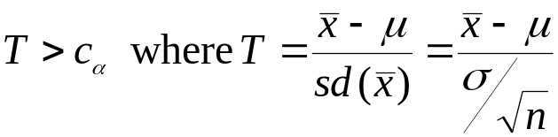

where
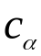 is such that 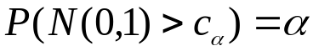,
is the hypothesized mean,
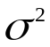 is the variance of the data and
n is the sample size.

The alternative hypothesis H₁

In the above we did not use H₁ explicitly, but we did use it to determine the form of the critical region: {T>c} i.e. big enough, we would not reject H₀ if was abnormally small.

If we had
H₁ 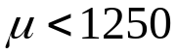
The critical region would be {T<c}.

We need to think about the case:

H₁: 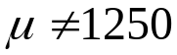 the mean is different from 1250.

We want to reject H₀ if the data indicate the actual mean is bigger or smaller than 1250.

The critical region is of the form: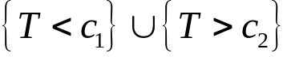 to satisfy N-P theory we have:

P(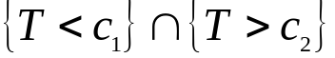|H₀)=

There isn’t a unique way of choosing c₁ and c₂ , conventionally (and sensibly) we take:
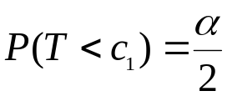 and 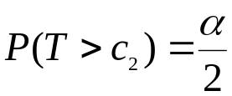

If T is N(0,1) then c₁ = - c₂ .

For 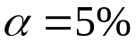, c₁ =-1.96 and c₂ =1.96 (or effectively –2 and +2).

The first two tests are called one tailed tests and the last is a two tailed test.

We reject H₀ if the statistic is in the tails of the distribution.

Example of a two tailed test

Example: chemist wants to confirm that proportion of iron in a chemical is 0.12

Variance in prop. of iron known to be 0.01

Takes 10 samples: sample mean is 0.131

Question: is proportion of iron 0.12?

H0: 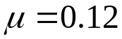

H1: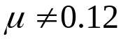

Take 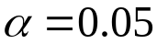.

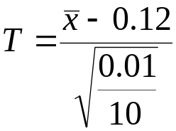=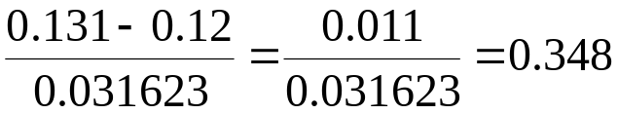

As T is not less than –2 nor greater than +2 we cannot reject H₀ . The observations are consistent with the theory that .

Note however that this does not mean that . Just this data does not contain sufficient evidence to reject H₀ – with more data we might be able to do so. Suppose 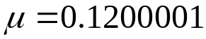 i.e. H₀ is false but we would need millions of observations to have a hope of rejecting it.

A more pragmatic approach

The business of fixing a significance level for the test a priori is a philosophical requirement rather than a practical one. In practice we often quote the observed significance level . The at which we would have just rejected H₀. This is usually called the p-value.

For the wire strength test we observed T=2.06

P(N(0,1)>2.06) = 0.019699 =p

For the iron content:

P(-0.348>N(0.1) or N(0,1) >0.348) = 0.72748
(verify as exx).

Discussion
The N-P approach is completely general – calculate the distribution of T when H₀ is true and reject H₀ is the observed T is unlikely.
In particular T does not have to be Normally distributed although it often is.

Choice of the significance level is somewhat arbitrary.

5% has been accepted as a criterion for scientific hypotheses. It was chosen when only a few values of the Normal distribution were accurately calculated but it has stuck.

1% is used for more critical situations such as medical or legal situations.

Quoting a p-value gets round this by ducking the issue.

In the context of clinical trials the US supreme court has recently stated that 2 sd (5%)(from mean) is importantly different and 3sd (~1%) is extremely different.

As we shall shortly see choosing too small means that we rarely reject H₀ when it is false (i.e. frequently commit type II error) .

N-P theory does go on to tell us how to choose “best” T and critical regions – quite general procedures for situations when the exact distributions are known.

