A game of chance

Urn 1 contains 3 red and 5 black balls
Urn 2 contains 6 red and 2 black balls.

As a contestant you do not know which Urn is which. You win a prize if succeed in drawing 2 red balls before two back balls.

Procedure:
Select an urn and draw from it. Compute the probability of wining. Given that you win what is the probability that you picked Urn 1?
If you initially pick Urn 1 what is the probability of Winning, what is it for urn 2?

The game becomes a little more interesting though if you are permitted to change urns in between draws. To keep the example to a reasonable size we shall only permit a swap after 2 draws (not after the first). You can now use the knowledge of the draws to improve your decision.
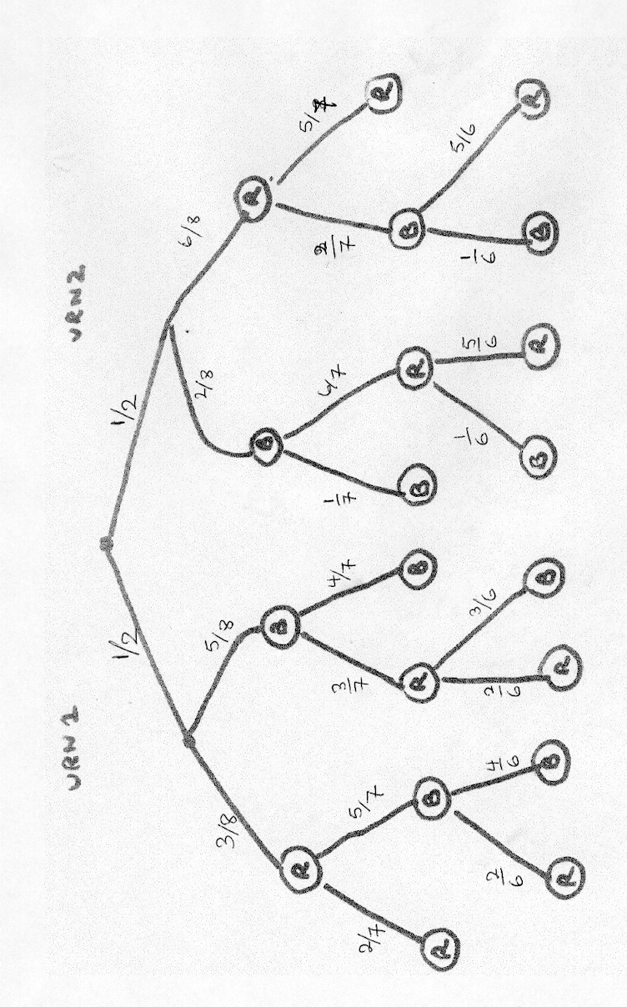

The numbers on the arcs are the conditional probabilities of each colour given the state of the system – determined by the previous draws.
The probability of following any path down the tree is just the product of these probabilities.
Why?
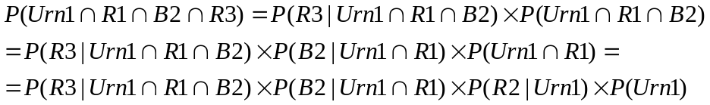

We use this method to compute the probability of every sequence in the tree and sum up the probability of winning.

So 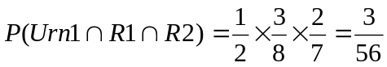

Complete the calculation as an exercise.

Making the decision.
We must have observed BR or RB. Win if get a Red , Lose if black.
If the two draws have been from Urn 1 then it now contains 2R and 4 B. so
P(Win | Urn1)= 2/6 if we stay with Urn 1.
If we swap
P(Win| next draw form 2) = 6/8

If Urn 2 it now has 5R and 1B

P(Win | Urn 2) =5/6
If we swap
P(win| next draw from 1) =3/8

If we don’t swap

If we do Swap

What is probability inUrn1? Not ½ (the original) because we have drawn BR

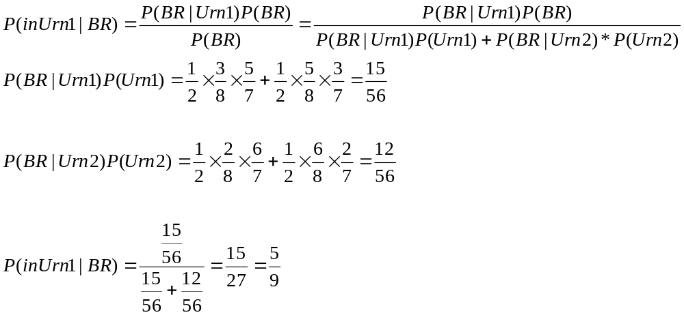Finally

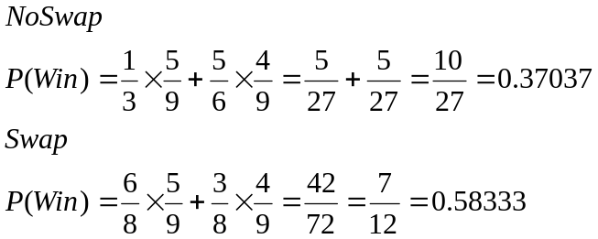

DO SWAP
