C Programming Training:

Problem description 1：What is minimum spanning tree (MST)?
Problem description 2：Write a MST program to obtain the shortest path?

Suggestion:
First step: Knowing the definition of MST problem.
Second step: Thinking about how to write this program with proper data structure.
Do not COPY the source code from internet or text books. Try to think about it by yourself.

Input File: test1.txt
N1(0,0);
N2(2,3);
N3(3,5);
N4(3,6);
N5(6,5);
N6(1,4);
N7(8,9);
N8(11,13);
N9(16,17);
N10(15,66);
N11(100,99);

Output File: mst1.txt
(N1,N2) Length = ???
(N2,N6) Length = ???
(N6,N3) Length = ???
…
Total Wire Length = ???

Notes:
- This program has one file input and the output file name must relate to the input file name. As shown as below:
Input File Name | test1.txt | test2.txt
Output File Name | mst1.txt | mst2.txt

- In different test cases, only you can do is changing the name of input file. The input files may have at least three nodes. Try to make the program more flexibility.
Example:

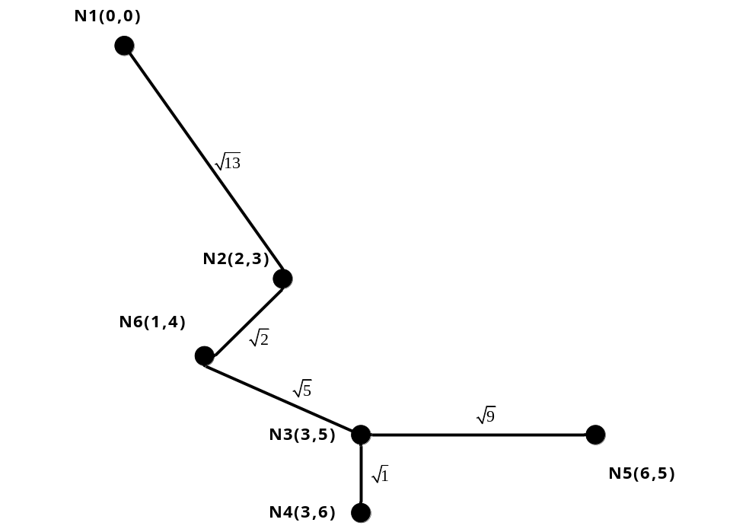

EX:
Output File (mst1.txt):
(N1,N2) Length = 3.605...
(N2,N6) Length = 1.414…
(N6,N3) Length = 2.236…
(N3,N4) Length = 1
(N3,N5) Length = 3
Total Wire Length = 11.255…

