CHAPTER I
INTRODUCTION

BACKGROUND AND RATIONALE
In today’s world where environmental sustainability has become a pressing concern, it is a common refrain that we humans are the root cause of all the problems that we face today. One of the major issues that we need to address as a society is the improper waste disposal of waste. This is a critical condition that affects all the communities and we must take an action to tackle it head-on. In a world increasingly conscious of our environmental impact, the effective waste management has become a matter of a great importance. The solution, aims to automate the process of waste segregation which is traditionally a labor intensive and error-prone tasks.
In many parts of the world, waste segregation is still done manually, which can be inefficient and prone to error. By improving the accuracy and efficiency of waste segregation, we can enhance recycling rates, reduce the throwing waste to land, and contribute to a more sustainable circular economy. This is often a legal requirement in many municipalities and by implementing it, this waste segregation ensures compliance with a waste management regulation and promotes responsible waste disposal practices wherein, it helps maintaining a clean and hygienic environment. This contributes to a better public health and sanitation conditions in all communities.
Municipalities that provide waste segregation demonstrate their commitment to sustainable development and environmental stewardship. It is very important to educate and raise awareness among residents about the importance of waste segregation and support for effective waste management that is why our Local Government Units (LGUs) have implemented a solid waste management program that encourages people to dispose their waste or garbage in the correct trash bin. The said program has proven to be effective but there is also a risk of losing its effectiveness if people put their garbage or waste in the wrong trash bin.
In embracing the use of technology, the need for automation for the process of waste segregation is highly recommended as it can accurately distinguish between various types of waste material such as metal, plastic and organic waste. This automated system can sort waste faster and more accurate than normal. Building this

project, we can significantly enhance the recycling rates, reduce the volume of waste send to landfills, and contribute to a healthier environment.
A waste segregator utilizes the state of art and technology to accurately differentiate between various types of waste. This is not only to improve the efficiency of waste management but also to ensure higher rate of recycling. By properly segregating waste, recyclable materials can be recovered and reused, reducing the demand for virgin materials. Through this project, we can share and inspire a wave of change on how we handle waste, reducing our environmental footprint and paving the way for a cleaner planet and also with the addition of monitoring system to the project, this takes steps further by automating the process and providing valuable data on the types and quantities of waste being processed. With the rapid growth of population, urbanization and industrialization, the project can be traced back to the increasing problem of waste management where the generation of waste has significantly increased. And this wastes, if not properly managed, it can lead to environmental pollution, health hazards, and depletion of natural resources.
SMS notification plays a big part also in the project, as it provides accurate message to the authority about the state and condition of the project. It sends an alarm so that the authority will automatically drive away to look and maintain the operation of the project.
To come up the solution of the problem, the researchers introduce the Web-Based Waste Segregator with SMS Notification which is designed to automate and revolutionize the process of waste segregation. It is a cost-effective management system that operates without the continuous attention of a person, making it convenient solution for waste management. The monitoring aspect of the system could involve tracking the amount of waste and alerting the personnel when it is filled and a type of data being processed which can be useful for data collection and improving the waste management strategies. Overall, the project is an excellent solution for managing waste efficiently and keeping communities hygienic.

OBJECTIVES
The main goal of this project is to develop a web-based waste segregator with SMS notification capabilities. The specific objectives of the project include:
- To segregate the waste from:
  - biodegradable
  - non-biodegradable
  - metallic waste;
- To send an SMS notification to the waste management personnel for collecting and replacing the bin.
- To provide a web-based monitoring system that allows to monitor and updates phone number.
- To generate sunlight into a usable electricity using a solar panel that powers up the entire machine.
- To provide quality performance by the evaluation of software quality, ISO standard 9001:2015 software quality product model in terms of the following:
  - Functionality
  - Reliability
  - Efficiency
  - Portability
  - Accuracy
  - Maintainability

SCOPE AND LIMITATION
The project scope is to provide and develop a fully functional Web-Based Waste Segregator to the residents of Barangay Garden with SMS notification capabilities for the waste segregator personnel. The study was specifically undertaken at Barangay Garden, Arteche, Eastern Samar because the area has a lot of number of people meaning, more people, more waste materials. The project is designed to be cost-effective and easy to use.
Nonetheless, the project has limits. One of the two limitations is that it relies on the availability of a network provider to transmit SMS messages and also the project is well operated by the use of solar panel to generate its energy. Notably, it is not capable of waste transportation which is also, it has a limited level of capacity.
It is crucial to note that the project can’t cover the entire barangay waste materials. Instead, it is one of the instruments that can help the community to better segregate their wastes and showcase the importance of waste segregation up to this day.

SIGNIFICANCE OF THE STUDY
The development of a Web-Based Waste Segregator with SMS Notification aims to address the challenges in waste management. This project is significant to the following:
Community and General Public. This project is beneficial as it provides awareness and encourages people to proper dispose their wastes.
Waste Management Personnel. This will help them to save time and effort in segregating wastes.
Researchers. As for the researchers, the project will help them to gain more ideas in promoting and developing projects in relating to waste segregation.

DEFINITION OF TERMS
Arduino Uno Board. A microcontroller board used as the brain of our project the waste segregator machine.
Arduino IDE. An Integrated Development Environment used to compile and upload sketches to the Arduino Uno board.
Breadboard. A construction base used to connect different components and build semi-permanent prototypes of electronic circuits in the waste segregator machine.
Database. Is an organized collection of data used in the monitoring system to store or collects data.
Semaphore. An online platform where we purchase credits and API Key.
SMS Notification. Short Messages Service notifications sent via text messages as an alarm message to inform and update the waste management officer on waste segregation reminders, collection and other announcements.
Visual Studio Code. Is a code editor redefined and optimized for building and debugging the web-monitoring of the project.
Web-Based Waste Segregator. A digital platform accessible through web browsers designed to guide the administrator/s in segregating waste effectively.
Waste Segregation. The process of sorting and separating different types of materials into specific categories for appropriate disposal.
XAMPP. Is an open-source software used in the project to provide a local web server environment for testing and development.

CHAPTER II
RELATED STUDIES AND RELATED SYSTEM
Due to the critical issue that we are facing today, the researchers have been widely researched in regards to the effectiveness of web-based segregator with SMS notification in all communities.
RELATED STUDIES
According to Jai-Wei Lu et. al., Urban solid waste prevention and recycling are needed at the local scale rather that heavily relying on the treatment and disposal at the regional scale. Differentiated collection is necessary but complicates the current schemes of waste collection. To bridge this gap and construct an efficient, effective, and sustainable scheme, this study developed a smart and green system (SGS) which embodies the in-depth integration of various informatics and strategy of sustainable waste management. Smart and green urban solid waste collection system are a major advancement, especially in urban areas. These systems utilize state of the art technology to manage and collect waste in more efficient and environmentally friendly manner. One significant aspect of these system is the use of smart waste segregators. These devices help in the segregation of waste at the source, which can significantly enhance the efficiency of waste collection and management.
Based on Shubham Thakker et. al., in many places, the Municipal garbage bins are overflowing and they are not cleaned at proper time. As a result of which the consequences are severe. It includes overflow of garbage which results in land pollution, spread of disease, also it creates unhygienic conditions for people, and ugliness to that place. There needs to be system that gives prior information of the filling of the bin that alerts the municipality so that they can clean the bin on time and safeguard the environment. To avoid of such situations, we intend to propose a solution for this problem “Smart Garbage Bin”, which will alarm and inform the authorized person when the garbage bin is about to fill. Now, instead of plastic resins (which are not biodegradable) by using NIR spectroscopy and use the rest of biodegradable waste to produce biogas. In relation to web-based waste segregator with SMS notification, these smart systems often incorporate them into framework to enhance their functionality. For example, a smart and solar-powered solid waste segregator can be designed and implemented using Arduino microcontroller. This

device can segregate waste at the source, making the waste collection process more efficient.
From the point of view of K. Sujatha et. al., in the present scenario, waste management has become a serious issue due to rapid urbanization, economical activities and increase in human population. The amount of solid waste generated in the world is steadily increasing; insufficient collection and inappropriate disposal of solid wastes represents a source of water, land and air pollution, and pose risks to human health and the environment. Government in all countries is currently focusing on efficient techniques to approach the challenges faced in Solid Waste Management (SWM). Various technologies were proposed and using for the efficient management and segregation of solid waste. One such technology involves the use of waste segregators. These devices are designed to automatically sort waste into different categories, these technologies are crucial in the waste management chain as they help in effective Reuse, Recycle, and Recovery of waste materials.
As explained by Mahmoud A Hussein et. al., platinum group metals have gained significant interest due to their unique characteristics, which make them the main constituents in advanced applications. In this work, we introduce new pH-dependent optical mesocaptors for the colorimetric monitoring and separation of Au (III) from E-waste leach liquors without a preconcentration process. The mesoporous silica nanospheres are fabricated via simple, reproducible, and low-cost procedures. The optical mesocaptor is designed via indirect immobilization of thiazole yellow G (TYG) and amacid yellow M (AYM) chromogenic probes onto mesoporous nanostructured scaffolds. The silanol groups in the mesopores of silica surface robustly anchored dilauryl dimethyl ammonium bromide (DDAB) linker to introduce the interactions with the TYG and AYM chelates, thereby leading to the fashioning of a stable optical mesocaptors without releasing of the chelates throughout absorption and sensing assays. In relation to our project, these nanoporous colorant sensors and captors can enhance the efficiency and effectiveness of waste segregation and management. This is especially true in the context of E-waste, where valuable metals like gold can often be found.
As indicated by Saruhan Furkan Sentruk et. al., environmental pollution poses a threat to the ecological balance, economy and budgets of states. For this reason, many studies have been carried out recently to reduce environmental pollution,

increase recycling, protect the environmental order and prevent economic deterioration. Many municipalities all over the world put recycling bins at certain points in cities, districts and even neighborhoods. However, these boxes are only designated to dispose of materials that can be recycled according to certain chambers with human hands and eyes. People separate their garbage and come and throw their garbage into that bin. Despite this, it can be seen that different wastes are in different bin and a manpower is needed to separate them again. In the project, recyclable materials (metals, transparent materials and others) will be separated into different bins by using sensors and smart systems without using human power. The relevant of this study to our project is, these sensor-based systems can significantly enhance functionality. For instance, they can be integrated into waste segregators to improve the accuracy of waste segregation. This is particularly useful in recycling, where the correct sorting of materials is crucial for effective recycling process.
In conclusion, the integration of advanced technologies, such as smart waste segregators, wireless monitoring systems, and sensor-based solutions into waste management practices has the potential to revolutionize waste segregation and improve overall waste management efficiency and sustainability.

RELATED SYSTEMS
Remote Smart Waste Segregation and Garbage Level Monitoring System
With the increasing of population, there is a growing need for low-cost waste management solutions. By leveraging the benefits of modern technological tools, smarter solutions for this basic problem can be provided. A proposed system by S. Shetty and Salvi (2020) SAF-Sutra: A Prototype of Remote Smart Waste Segregation and Garbage Level Monitoring Systems states that, “there is a need for a low-cost waste management solution where the system can be remotely monitored and which is built at a very low cost. The design of the proposed system considers portability and ease of assembly as essential factors during implementation.” Although our project is not that physically portable but it is through the web-based monitoring system and also promoting same advocacy, “Do-It-Yourself spirit”.

Electronically Assisted Automatic Waste Segregation
The increasing urbanization has led to a major waste management crisis with the proliferation of improperly planned structures having no proper facility to collect, segregate and process waste. Domestic waste has increasing chemical and plastic content. The “Electronically assisted automatic segregation” of S. Nandhini et. al. (2019), is a robotic arm that uses a distance sensor to collect rubbish and places it on a binary classifier platform. The platform has a camera attached to take pictures and an algorithm that determines whether the waste is biodegradable or not so that it may be sorted into the appropriate bins. Instead of a robotic arm that separates the wastes based on its classification, our project prototype is a machine that detects the type of wastes and segregate it accordingly by using sensors. The two-system treatments necessitate timely collection, segregation and if possible, decomposition, reuse or recycling. By combining electronic assistance with a web-based technology, waste segregation can become more efficient, convenient and transparent wherein users can have a greater control over the waste segregation process and make informed decisions based on real time data.
Smart Garbage Segregation and Management System using Internet of Things (IoT) and Machine Learning (ML)
According to S. N. et. al., (2019), for eliminating or alleviating the garbage’s and to keep up the cleanliness, it requires a smart garbage managing architecture. This helps in clearing the wastage from dustbin in an efficient and smartest way. The relationship of the concept is that a smart garbage segregation and management system using IoT and machine learning can be integrated with a web-based platform to enhance its functionality and accessibility. The web-based platform can provide users with real time data and insights from the IoT devices, allowing them to make decisions regarding waste management.
Automatic Health Care Waste Segregation and Disposal System
Hospitals produce a vast amount of potentially dangerous wastes. Most of the waste segregations at present are done by rag pickers. Currently the separation of harmful hospital wastes and containers containing disposed pus, needles, glucose drip bottles, plastic papers and bandages are segregated by hand thereby leading to adverse chronic health effects like tuberculosis, cancer and infectious diseases. This

may lead to decreased to standard of living, decreased longevity and also after effects to generation of children born to such affected parents. To automate the segregation of the biomedical waste that is generated in the hospital, an automated waste segregator is proposed. This system has a specific implementation or application of a waste segregator within the health care industry.
Dry and Wet Waste Segregator
With the always rising populace, India endures disturbing danger in regard to accessibility of living space, usage of assets, schooling and work. Another noxious reason following is the colossal measure of waste India produces, heightening each moment by a person, an astounding 62 million tons of waste is produced in India consistently and notices a normal yearly development pace of 4%. The simplest technique sent is isolation of the loss at removal level. Dry and wet waste segregator is a specific type of waste segregator that focuses on the separation of dry and wet waste.
Each of these related systems may have their unique features and capabilities, they all share the common goal of improving waste management practices through effective waste segregation. By implementing these systems, waste can be sorted, recycled, and disposed in a more efficient and environmentally friendly manner.

CHAPTER III
Methodology
This chapter presents the methodology used for collecting the data for the study. It explains the system development life cycle used, research design, sampling method, instrumentation and data analysis. It also gives details about the population and sampling techniques used for the research.

System Development Life Cycle
The proponents utilized evolutionary model under prototyping model. This approach requirements that may necessitate modifications throughout the project progression. It facilitates flexibility and adaptability to accommodate changing requirements, empowering the development to integrate stakeholder’s feedback and continuously enhance the waste segregation machine through iterative improvement.
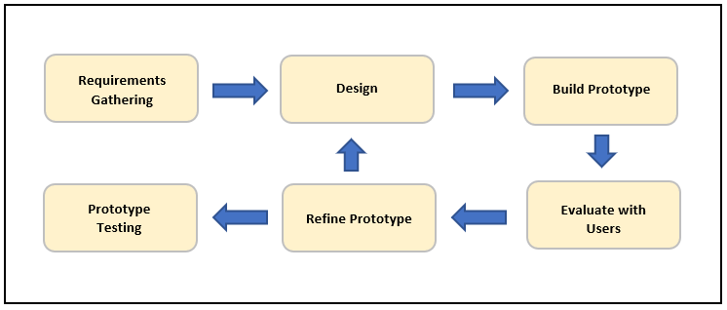
Figure 1. Evolutionary Model
The figure above shows the flow of tasks in developing the Web-Based Waste Segregator with SMS Notification: Requirements Gathering where the researchers first step to gather useful information. Design, to outline the project prototype. Build Prototype, to construct the project outline. Evaluate with Users, to test the project from the respondents. Refine Prototype, to adapt and apply user’s feedback/suggestions and finally, Prototype Testing for project implementation. This approach uses continuous, working prototype that is refined after each iteration of customer feedback then proceed to prototype testing for implementation.

Planning
This is how the project is built. The researcher’s ability in building the project, all the strategies they have is determined upon this stage. Requirements gathering entailed establishing the peoples needed using the method of observation to assist proponents in designing and better understanding about the project they are about to build.
Requirements Gathering
Based on the problem that we are facing, the researcher’s initiation on their observation come up the solution to develop a web-based segregator with SMS notification. The proponents gather data from the target area of Arteche, Eastern Samar.
Operational Feasibility
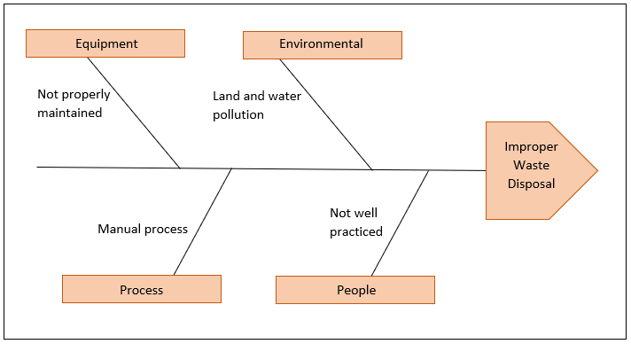
Figure 2. Fishbone/Ishikawa Model

The figure above shows the cause and effect of the problem. There are four (4) causes namely equipment, environmental, process and people. Equipment like the trash bins are not properly maintained due to lack of awareness and also by the increasing of population. Environmental such as land and air pollution due to the wrongly behavior of the people. Process due to a manual process of segregating waste

materials and people for being not well practiced or lack of awareness about the importance of waste segregation in result of improper waste disposal.
In solving the problem, the researchers are developing a web-based waste segregator with SMS notification to communities like the barangays of Arteche in maintaining cleanliness. The following are the necessary technology and resources available as well as the aspects during the assessment.

- Infrastructure
The project relies on solar energy to keep its operation and also an internet connection to track its status as well as sending an SMS notification to alarm the authority. It uses sensors to identify the type of waste material and segregate it accordingly in the designated bins.

Technical Risks
The performance or functionality of the project is affected due to the following technical risks.
Table 1. Technical risks that may face by the project.
Technical Risks | Description
Lost Connection | When the network in the area is not well stable.
Phone Number Losses | When the phone number losses for an emergency checking.
Energy | When the energy is not enough to operate the project.

Technical Feasibility
This contains the hardware and software specification during development and implimentation of the project.
Table 2. Technical Requirement: During Development
Software Requirements
Name of components | Specification
Operating System | Windows 11
Language | VS Code
Database | XAMPP
Browser | Chrome
Web Server | XAMPP

Hardware Requirements
Name of components | Specification
Processor | AMD Ryzen 5 3500U
RAM | 8 GB
Hard disk | -
Monitor | -

Scheduling Feasibility
The proponents used a gantt chart to serve as a guide about the the target date of developing the project.
The chart below shows the list of activities with an expecting time periods. The progress of each activity displayed where, the start date, duration and finish of the activity are presented by the location and length of the box.

Table 2. Symbols that represent the figure in the gantt chart
Figure | Definition
Vertical Line | Represents the series of activities to be done.
Horizontal Line | Represents the number of months for the completion of the project.
Light Green Box | Represents as done process (completion of activity)
Orange Box | Represents as InProgress process (started but not yet complete)

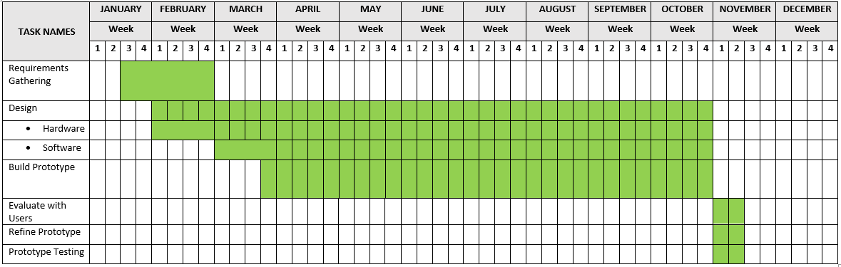

Figure 3. Project Timeframe
In the development of the project which is the Web-Based Waste Segregator with SMS Notification, the Requirements Gathering (first phase) was done in the 3rd week of January to the 4th week of February where the researchers gather data from the target area. In the design (second phase) is divided into two parts (hardware and software design), the hardware design was done from the 1st week to the 4th week of October where the researchers designed a blueprint of the prototype or product while

the software is started from 1st week of March to the 4th week of October. The build prototype (third phase) was started from the 4th week of March to the 4th week of October. The rest was done in the month of November.

Design
This phase involves critical decision-making processes, including the project blueprint, process design, data design and the project architecture. This is a crucial stage in the project lifecycle that bridges the gap between the initial concept and the final execute
Project Blueprint

Solar Panel
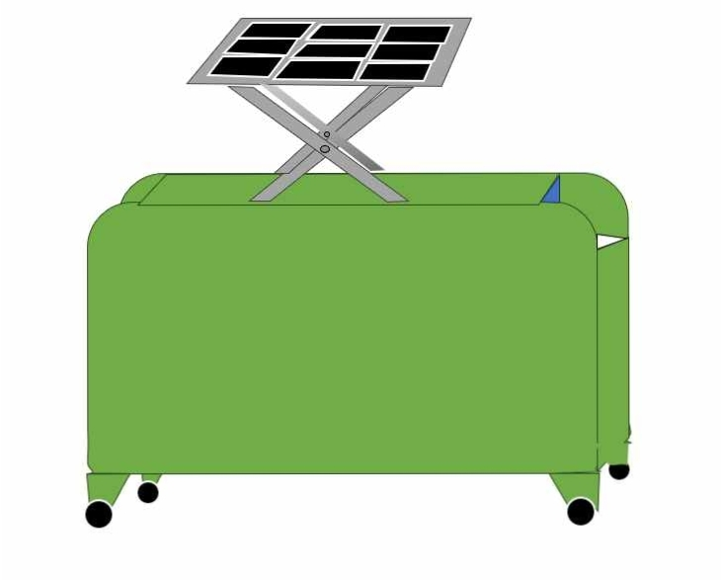

Housing
Figure 4. Prototype Design
Housing
Solar Panel
The figure above shows the prototype design of the project. It has the parts of Solar panel and housing.

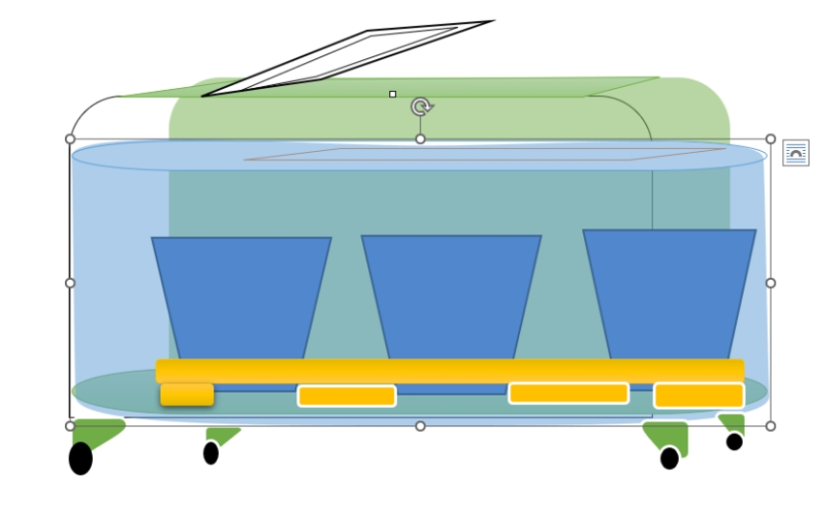
Trash Bins
Figure 5. Trash bins located
The figure above shows the inside part of the prototype which is the trash bins.

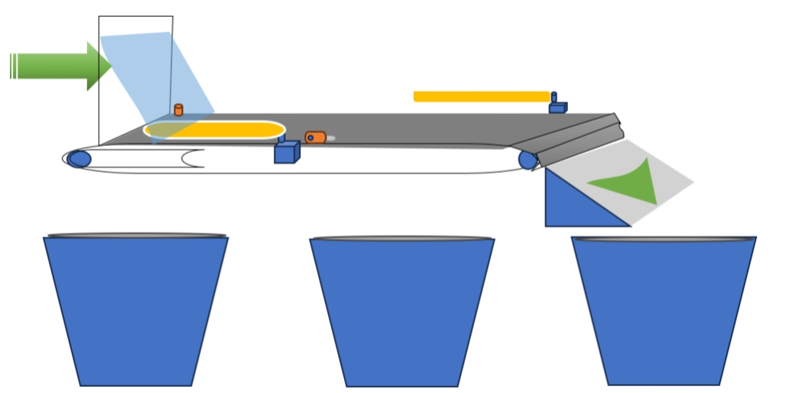
Escalator
Trash Bins
Arm

Figure 6. Inside part of the prototype
The figure above shows the inside parts of the prototype which includes the escalator, arms and the trash bins.

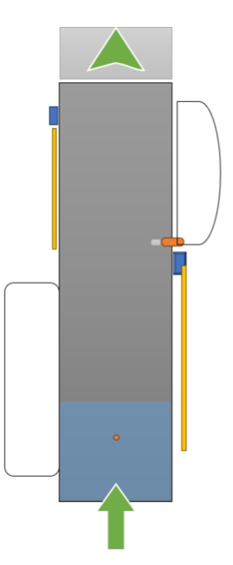

Hole
Servo motor

Plastic sensor

Escalator

Arm

Figure 7. Top view of the escalator
The figure above shows the top view of the escalator and its parts included the escalator itself, the arm and the funnels.

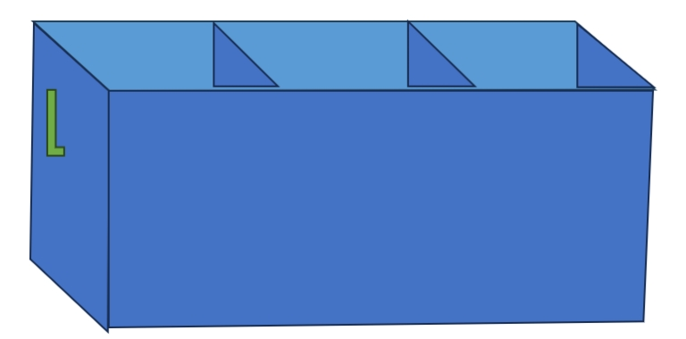

Figure 8. Alternative option for the bins.
The figure above shows the alternative option of the bins.

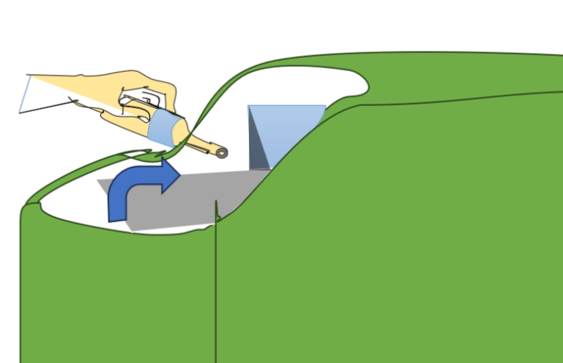

Figure 9. Instruction Logo
The figure above shows the instruction logo of disposing waste.

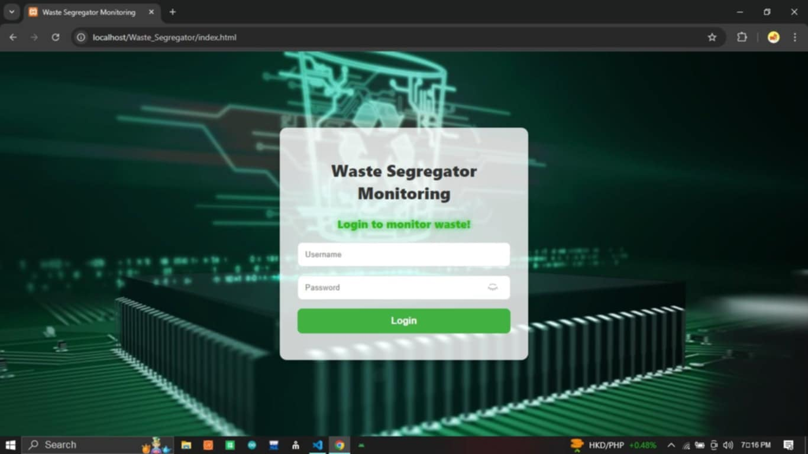

Figure 10. Web Login Form
The figure above shows the login form of the web monitoring of the machine.

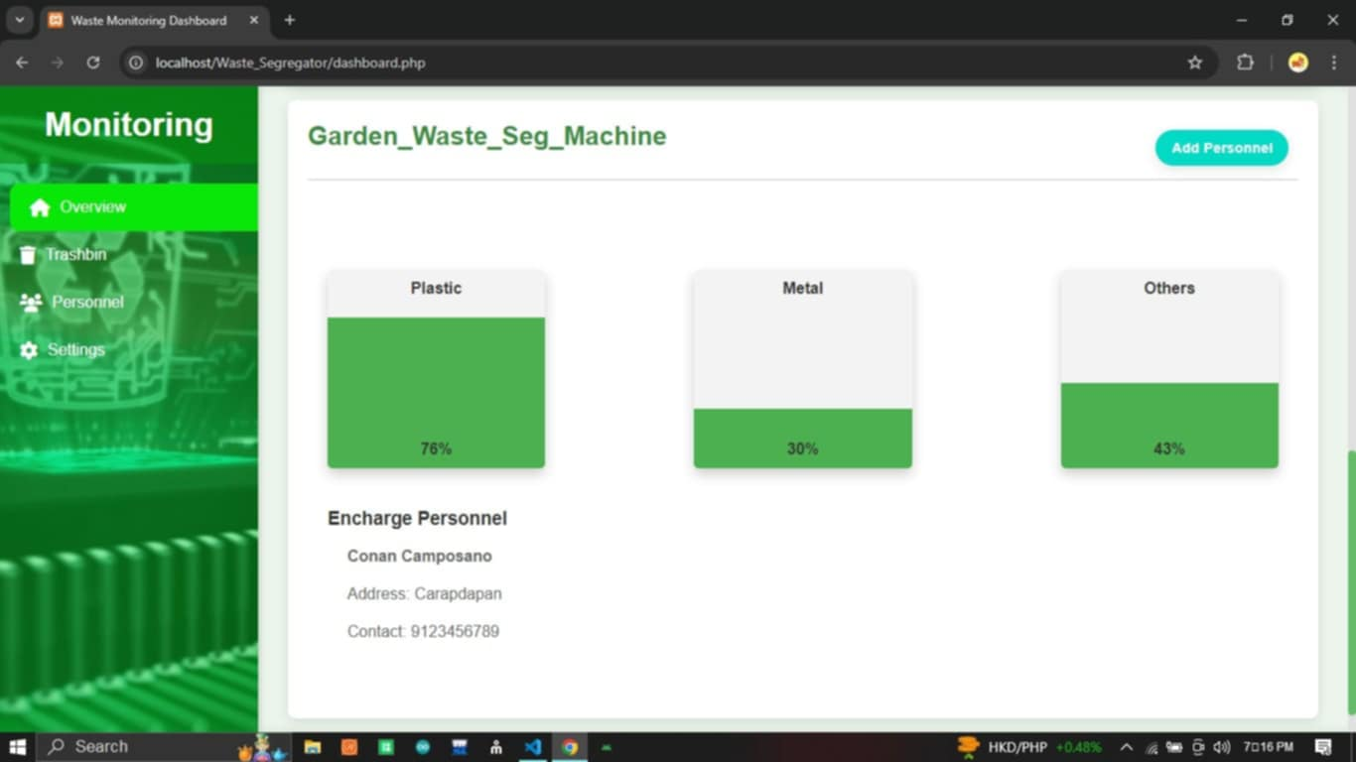

Figure 11. Web Monitoring Dashboard
The figure above shows the status of the bins. The percentage in the levels indicates the volume of waste stored. Also included the exchange personnel with name, address and phone number.

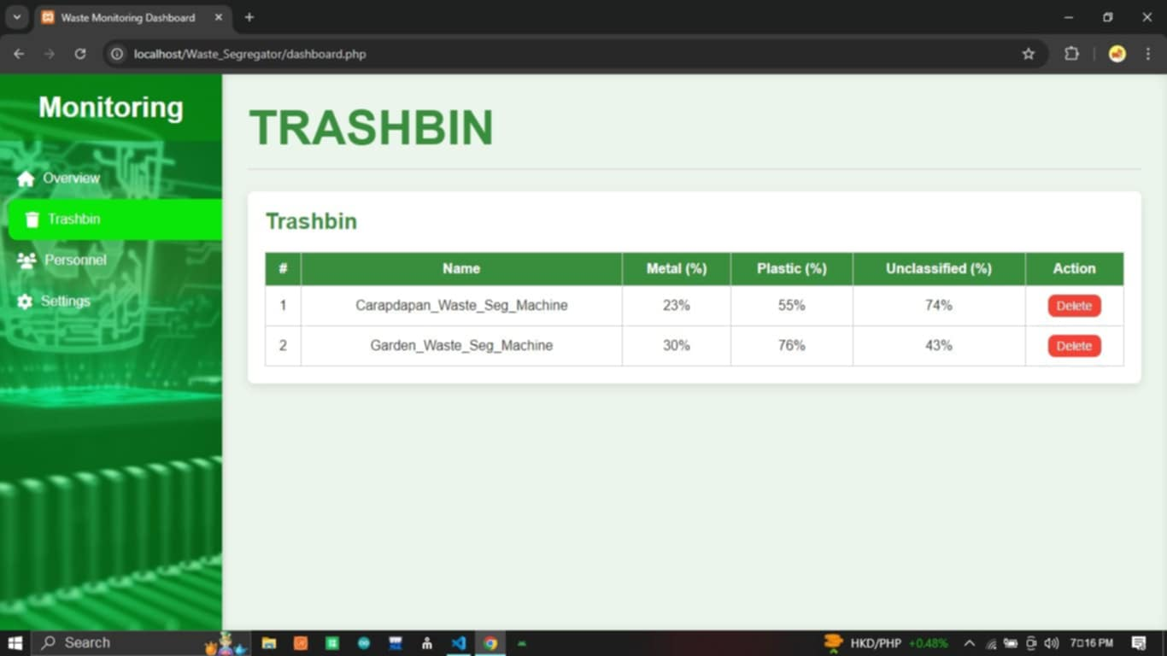

Figure 12. Monitoring Trashbins
The figure above shows the machine’s trashbins, the machine name, metal in percent, plastic in percent and unclassified in percent, also an action to delete.

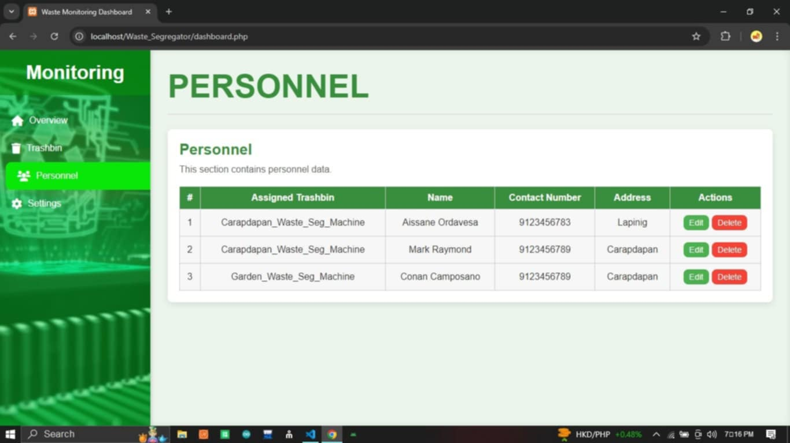

Figure 13. Monitoring Personnel
The figure above shows the monitoring personnel data contains the assigned trashbin, name of personnel, contact number, address and the action to edit and delete.

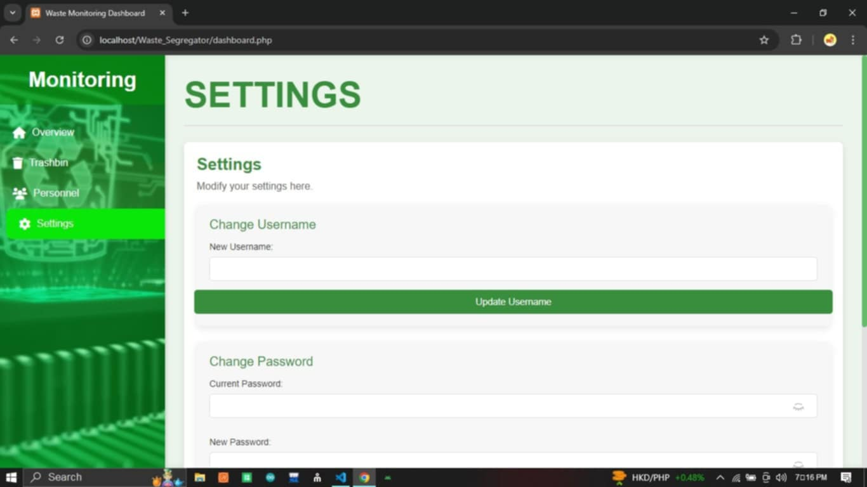

Figure 14. Web Monitoring Settings
The figure above shows the monitoring settings that includes changing username, password and update.

Process Design
This section is the process development of the project to understand its processes and how to improve it. This is a way of figuring what the project needs to do and doing it.

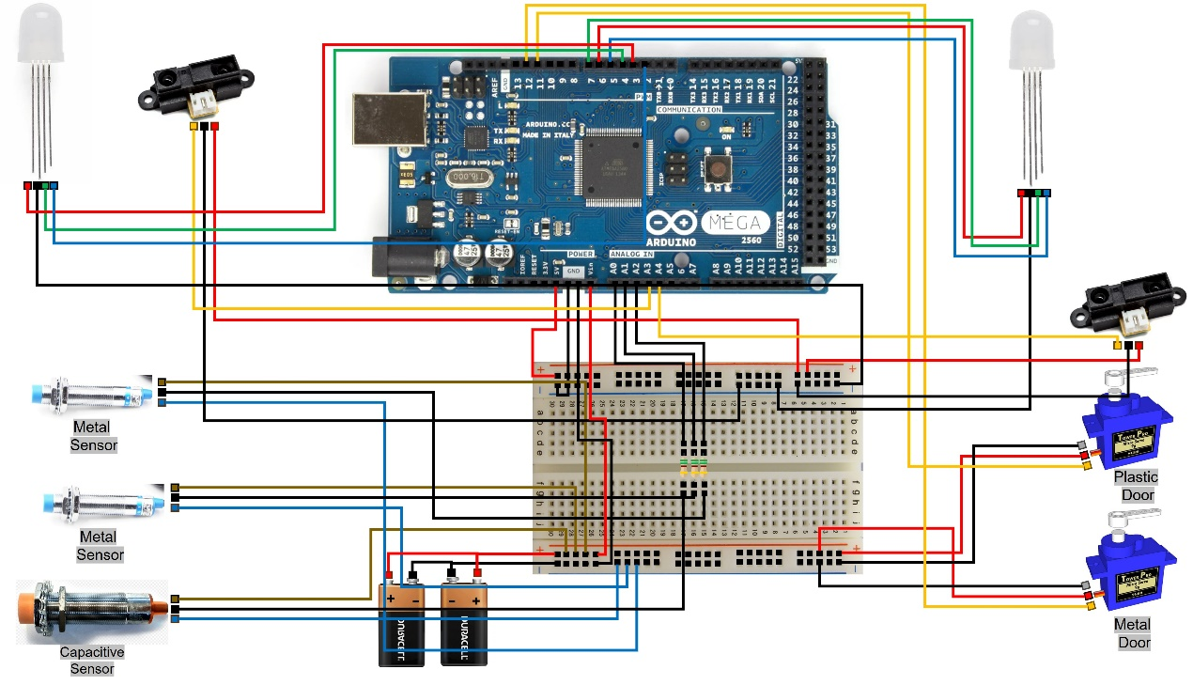
Figure 15. Project Development Process
The figure above shows the project development process where, all the components, circuits is shown.

Project Architecture
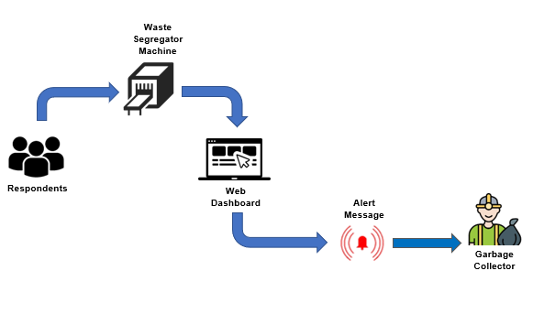
Figure 16. Project Architecture
The figure above shows the project architecture where, the respondents dispose waste to the waste segregator machine. The machine will process the waste and segregate the wastes to the appropriate bin/s. The machine and the bin/s status are monitored web-based, and sends a notification message to the authority.

Use Case
This part is a graphical depiction of a user’s interaction with a system.
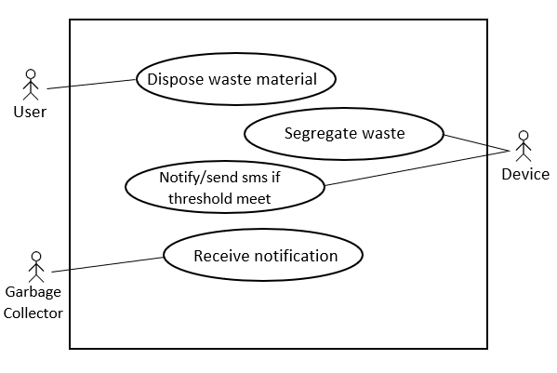
Figure 17. Use Case Diagram
The figure above illustrates the user interaction with the system. A user who disposes waste material, a device that segregates waste materials as well as to notify user or send sms notification if threshold meet and the garbage collector who will receive the notification.

Macro Processes
This part are a set of processes and activities of the project.
System Flow Diagram
System flow diagram is the graphical representation of the flow of data in the system and signifies the process of the system.
Table 3. Figure Definition
Name | Symbol | Description
Terminal |  | An oval indicates both the starting point and the ending point of the process.
Input/Output |  | A parallelogram designed for input and output as presented in a system flowchart.
Process |  | A box that represents individual step or activity in the process.
Flow lines |  | Flow lines are used to show the reading or connection to the symbols which is used to read the flow of the process.
Decision |  | This includes the condition and/or question in a process flow.
On-page connector |  | A circle indicates that a particular step is connected to another page wherein a letter placed clarifies the continuation of the process.
Off-page connector |  | This connects a page of document to another page as it proceeds to the first page.

The following are the system flow of the project.. This includes diagrams that represents the process of the project functionality.
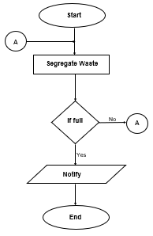

Figure 18. The entire operation of the project.
The figure above illustrates the complete flow of the system. After the start terminal, the system will segregate waste (process) then directed to condition (decision). If the system meets the needed requirement (full), in resultant to notify and

proceed to end terminal. If not, there is an on-page connector (A) which signifies the continuation of the process.

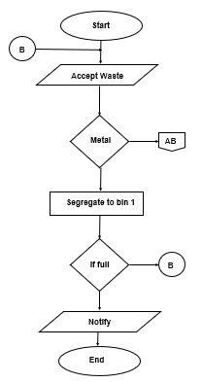

No

Yes

Figure 19. Bin 1 segregation process
The figure above shows the bin 1 segregation. Starting from the start terminal to the input/output process where to accept waste then proceed decision (detection of metal waste). If the waste is metal, then it will segregate to bin 1. And if the bin 1 is full, the system will notify then proceed to end terminal. If the bin is not full, there is an on-

page connector (B) that signifies the continuation of the process. And now, if the waste is not metal, there is an off-page connector (AB) that signifies the next process.

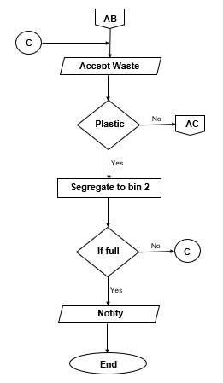

Figure 20. Bin 2 segregation process
The figure above shows the second segregation process after the first one. Like the first process, it begins from the start terminal then accept waste materials.

After accepting the waste materials, it proceeds to processing it which the plastic detection. If the waste is plastic, it will segregate to the plastic bin or the bin2 then if it is full, it will notify and proceed to end process. If the bin is not full, there is an on-page connector (C) that represents the continuation of the process. If the waste is not plastic, then it will proceed to the next process (AC).

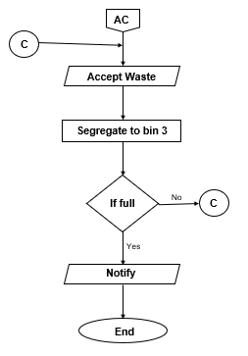

Figure 21. Bin 3 segregation process
The figure above shows the third segregation process after the two processes. Like the two processes, it begins at the start terminal then accept waste materials and proceed to the bin 3. If the bin 3 is full, the system will notify and proceed to end

process. If the bin is not full, there is an on-page connector (D) that represents the continuation of the process until the bin is filled.

Development
This phase consists of the hardware and components used in developing the project as well as the programming environment used.
Hardware Components
Table 4. The table above shows the hardware components of the project.
Hardware Components | Quantity
Arduino UNO | 1
Breadboard | 1
Jumping Wires/Wires | 10m
12v Battery | 1
Ultrasonic Sensor | 3
Capacitive Sensor | 1
IR Distance Sensor | 3
Proximity Sensor | 1
RGB LED | 3
Ply wood/Flat iron | 2
Nails | 3kilos
Wheels | 4
Servo Motor | 2
ESP8266P | 1
Voltage Regulator | 1
Resistor | 10
DC Motor | 1
Garbage Bin | 3
Solar Panel | 1

Programming Environment
The program environment consists of the software components and modules used to developed the project.

Figure 22. Arduino IDE
The project is operated by Arduino and it will not work without the code and so, the proponents utilized Arduino IDE to write the code and upload it to the Arduino board.



Figure 23. Visual Studio Code
The web monitoring is developed using this software.



Figure 24. XAMPP
XAMPP is an application for the Apache web server wherein the web monitoring is thoroughly tested in an end-to-end web development environment.



Figure 25. SEMAPHORE
Semaphore is used as the concurrent environment’s method of process synchronization and access control which employed to send messages across long distance.

Testing
This part includes the evaluation method, research designed used, respondents as well as the locale of the study, instrumentation, data analysis, unit testing and statistical tool.
Evaluation
The evaluators were the respondents from Barangay Garden of Arteche, Eastern Samar and IT experts. The project is evaluated through survey questionnaires with an open and closed-ended questions distributed to the respondents.
Research Design
The proponents employed exploratory research design in the interest of developing a web-based waste segregator with SMS notification and also to mark out the project based on the functionality, reliability, efficiency, accuracy, portability, and maintainability of the project.
Locale of the Study
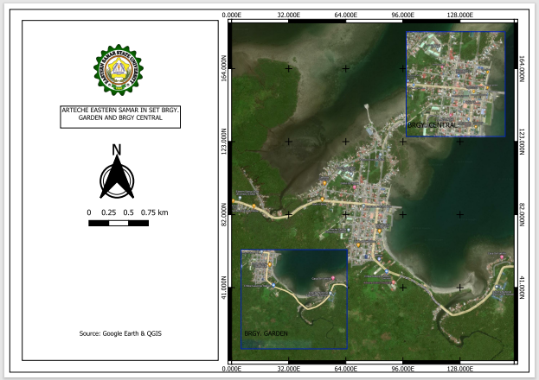
Barangay Central
Barangay Garden
Figure 26. Locale of the Study

The proponents conducted the study at Barangay Garden of Arteche, Eastern Samar. The researchers find the area as big as high expected of population and increased of waste materials.
Respondents
The respondents are the five (6) IT experts and two thousand four hundred ninety-six (2,496) from Barangay Garden of Arteche, Eastern Samar.
Table 5. Distribution of Respondents
Respondents |  | Total
IT Experts | ESSU-Arteche  IT Department | 6
Brgy. Garden |  | 345
Total Respondents |  | 351

The table above shows the distribution of the IT experts for the hardware testing, or “alpha testing.” Acceptance testing or Beta Testing: respondents from Barangay Garden of Arteche, Eastern Samar wherein there are five (6) IT experts from IT Department of ESSU-Arteche including the three hundred forty-four (344) from Barangay Garden of Arteche, Eastern Samar in total of three hundred forty-nine (350) respondents.
Table 6. Respondents (Barangay Garden)
Barangay | Number of Residents | Sample Size
Garden | 345 | 345

Table 7. Respondents (IT Experts)
Department | Number of IT Experts | Sample Size
IT Experts | 6 | 6

Table 8. Respondents (Overall Respondents)
 | Number of Respondents | Sample Size
Garden | 44 | 44
IT Experts | 6 | 6
Total | 50 | 50

The table depicts the distribution of IT experts for system testing, known as “alpha testing”. Acceptance or Beta Testing : residents from Barangay Garden. Six (6) IT specialists and forty-four (44) from the residents total of fifty (50) respondents.
Research Instrument
The proponents created a survey questionnaire to collect data. The questionnaires were distributed to the respondents and their responses were systematically evaluated. Using the Slovin’s technique, the proponents determined the sample population of the target area.
n = N/(1+Ne²).
N = sample size in numbers
N is the total number of respondents from Barangay Garden of Arteche, Eastern Samar
e = error margin/error margin
n = 2, 496 / (1+ 2, 496 x 0.05²)
n = 2, 496 / (1+ 2, 496 x 0.0025)
n = 2, 496 / (1+ 6.24)
n = 2, 496 / 7.24
n = 344.8
n = 345 sample population from Barangay Garden and Central of Arteche, Eastern Samar.

The Slovin’s formula is used by the proponents to determine the sample population from the Barangay Garden of Arteche, Eastern Samar. As an exploratory research, the proponents used non-probability sampling as a good choice that they can’t access the complete list of the sample population. The sampling method used is convenience sampling method in which the respondents are selected based on their availability during the evaluation of the project. The researchers discovered a total of forty-four (44) respondents from the area.
Instrumentation
In this study, utilization of questionnaire to evaluate the system using ISO 9001:2015 Software Quality and the Five-Point Likert Scale to rate its acceptability on a scale of 5, 4, 3, 2, and 1. A scale of 5 indicates “highly acceptable”, while 1 indicates “not acceptable” in terms of functionality, reliability, efficiency, portability, accuracy, and maintainability.
Data Gathering Procedure
The researchers ask first a permission to the head of the department to conduct the study in the target area. The proponents prepared a survey questionnaires and distributed to the respondents. The data gathered are tallied, tabulated and interpreted with the appropriate statistical tools to come up with the findings and conclusion, eventually the recommendations.
Data Analysis
Tests for functional suitability, performance efficiency, maintainability, and accuracy are all included in the evaluation. In order to get user feedback on the designated parameter, we will employ the Five-Point Likert Scale in this section to assess how well the hardware and software complied with all the of the client’s needs.
Table 9. The Five-Point Likert Scale
Scale | Range | Interpretation
5 | 4.21 – 5.00 | Highly Acceptable
4 | 3.41 – 4.20 | Acceptable
3 | 2.61 – 3.40 | Neutral
2 | 1.81 – 2.60 | Less Acceptable
1 | 1.00 – 1.80 | Not Acceptable

Unit Testing
In this section, the execution of codes was performed correctly, even though we find difficulties in developing the hardware and software but it executes exactly, functions and other processes of the system was functional.
Statistical Tool
We will utilize the Likert Scale to assess how the administration and community of Arteche, Eastern Samar felt about the usage of the project. The evaluation results will be calculated using a weighted mean. Based on a predetermined interpretation, the evaluation results were presented using the Quality Likert Scale Chart below.
Table 10. Questionnaire Parameter
Optional Parameter | Range | Interpretation
Functionality | 4.21 – 5.00 | Highly Functional
 | 3.41 – 4.20 | Functional
 | 2.61 – 3.40 | Neutral
 | 1.81 – 2.60 | Less Functional
 | 1.00 – 1.80 | Not Functional
Reliability | 4.21 – 5.00 | Highly Reliable
 | 3.41 – 4.20 | Reliable
 | 2.61 – 3.40 | Neutral
 | 1.81 – 2.60 | Less Reliable
 | 1.00 – 1.80 | Not Reliable
Efficiency | 4.21 – 5.00 | Highly Efficient
 | 3.41 – 4.20 | Efficient
 | 2.61 – 3.40 | Neutral
 | 1.81 – 2.60 | Less Efficient
 | 1.00 – 1.80 | Not Efficient
Portability | 4.21 – 5.00 | Highly Portable
 | 3.41 – 4.20 | Portable
 | 2.61 – 3.40 | Neutral
 | 1.81 – 2.60 | Less Portable
 | 1.00 – 1.80 | Not Portable
Accuracy | 4.21 – 5.00 | Highly Accurate
 | 3.41 – 4.20 | Accurate
 | 2.61 – 3.40 | Neutral
 | 1.81 – 2.60 | Less Accurate
 | 1.00 – 1.80 | Not Accurate
Maintainability | 4.21 – 5.00 | Highly Maintained
 | 3.41 – 4.20 | Maintained
 | 2.61 – 3.40 | Neutral
 | 1.81 – 2.60 | Less Maintained
 | 1.00 – 1.80 | Not Maintained

The survey samples overall answer, including whether or not they agreed with a particular statement was measured using a weighted mean.
The following formula was used to calculate the weighted mean.
X=Ns/n Where
X is the weighted mean
N is the total of all the scores.
S is the scale.
n is the sample size number.
Percentage
The ratio of affirmative response to total responses is examined in survey percentages.
Here is the formula:
P = (n/t) x 100
Where:
P is the percentage
t is the total number of respondents
n is the number.

Table 11. Total Grand Mean
Total Grand Mean | Range | Interpretation
 | 4.21 – 5.00 | Highly Accepted
 | 3.41 – 4.20 | Accepted
 | 2.61 – 3.40 | Neutral
 | 1.81 – 2.60 | Less Accepted
 | 1.00 – 1.80 | Not Accepted

System Testing (Alpha Testing)
The IT experts assessed the proposed project before deploying. They assessed evaluated the hardware as well its web monitoring if it is fully functional and ready for deployment.
Acceptance Testing (Beta Testing)
Acceptance testing is one way for determining whether or not a project meets its requirements. The evaluation criteria were based on key factors such as functionality, reliability, efficiency, portability, accuracy, and maintainability. There are thirty (30) respondents from Barangay Garden, Arteche, Eastern Samar.
Implementation
The project is a turning point where our innovative ideas will be transformed into reality. Its main objective is to revolutionize waste management by incorporating modern technology into conventional practices. The project consists of two main components: a web-based platform that provides real-time updates and reminders. At this stage, we will execute our carefully planned strategies, utilizing the resources gathering phase. We will guide the project implementation process with strict monitoring and control mechanisms to ensure that it aligns with the predefined standards and achieves its intended goals. The successful execution of this project will not only improve waste segregation practices but also pave the way for future technological advancements in the field of waste management.

CHAPTER IV
RESULTS AND DISCUSSION
The IT experts are the expert evaluators from Eastern Samar State University – Arteche Campus. The basis of the evaluation criteria is the ISO/IEC 25010:2011 software quality product.
System Testing (Alpha Testing)
Alpha testing is an early stage of testing product to ensure that it meets its functional standards and requirements. The initial end-to-end testing is to confirm that the product works properly and performs all of its intended functions.
Table 12. Frequency and Percentage Distribution – Mandatory Parameter
Question | Response
 | Yes |  | No
Mandatory Parameter | Frequency | Percentage | Frequency | Percentage
Does the machine have sensors to identify different types of waste materials? | 6 | 100% | 0 | 0%
Does the web monitoring have admin? | 6 | 100% | 0 | 0%
Is the SMS notification working? | 1 | 16.67% | 5 | 83.33%
Mean |  | 72.22% |  | 27.78%

The table shows the mandatory parameter where it has six (6) total number of IT experts in Eastern Samar State University – Arteche for the system testing. The mandatory parameter has three (3) questions and all answered by the IT experts. Under the mandatory parameters of three (3) questions, the six (6) IT experts answered yes with the percentage of 72.22% while 27.78% answered no. Therefore, the needed requirements by the end-user are not all present in the project.

Table 13. Results System Testing – Functionality
Sub-Parameter | Questions | 5 | 4 | 3 | 2 | 1 | Total | WM | Interpretation
Functionality | The machine detects and separates waste materials from biodegradable, non-biodegradable and metallic waste. | 3 | 2 | 1 |  |  | 6 | 4.3 | Highly Functional
 | The machine sends an SMS notification to solid waste personnel. |  |  | 5 |  | 1 | 6 | 2.6 | Neutral
 | The web-based monitors the garbage level updates phone number for emergency or phone losses. | 1 | 5 |  |  |  | 6 | 4.1 | Functional
Total |  | 4 | 7 | 6 |  | 1
Grand Mean |  |  |  |  |  |  |  | 3.6 | Functional

The table above shows the functionality parameter wherein, it has three (3) questions and rated as highly functional, neutral, and functional. The grand mean resulted 3.6 which indicates as functional to the functionality level of the project.

Table 14. Results System Testing – Reliability
Sub-Parameter | Questions | 5 | 4 | 3 | 2 | 1 | Total | WM | Interpretation
Reliability | The machine is reliable in continuous operation. | 2 | 4 |  |  |  | 6 | 4.3 | Highly Reliable
 | The data and information of the web monitoring is reliable. | 4 | 2 |  |  |  | 6 | 4.6 | Highly Reliable
 | The SMS notification is reliable in sending alert message. |  | 1 | 4 |  | 1 | 6 | 2.8 | Neutral
Total |  | 6 | 7 | 4 |  | 1
Grand Mean |  |  |  |  |  |  |  | 3.9 | Reliable

The table above shows the reliability parameter wherein, it has three (3) questions and rated as highly reliable, highly reliable, and neutral. The grand mean resulted 3.9 which indicates as reliable to the reliability level of the project.

Table 15. Results System Testing – Efficiency
Sub-Parameter | Questions | 5 | 4 | 3 | 2 | 1 | Total | WM | Interpretation
Efficiency | The machine is efficient in detecting and segregating waste. | 2 | 3 | 1 |  |  | 6 | 4.1 | Efficient
 | The web-based monitoring is efficient updating data in real-time. | 2 | 4 |  |  |  | 6 | 4.3 | Highly Efficient
 | The project is efficient in sending SMS notification. |  | 1 | 4 |  | 1 | 6 | 2.8 | Neutral
Total |  | 4 | 8 | 5 |  | 1
Grand Mean |  |  |  |  |  |  |  | 3.7 | Efficient

The table above shows the efficiecy parameter wherein, it has three (3) questions and rated as efficient, highly efficient, and neutral. The grand mean resulted 3.7 which indicates as efficient to the efficiency level of the project.

Table 16. Results System Testing – Portability
Sub-Parameter | Questions | 5 | 4 | 3 | 2 | 1 | Total | WM | Interpretation
Portability | The machine is designed to carry easily. | 3 | 3 |  |  |  | 6 | 4.5 | Highly Portable
 | The web monitoring is well performed and supported by the browser. | 5 | 1 |  |  |  | 6 | 4.3 | Highly Portable
 | The SMS notification send message to any device with a phone number registered. |  | 1 | 3 |  | 2 | 6 | 2.5 | Less Portable
Total |  | 8 | 5 | 3 |  | 2
Grand Mean |  |  |  |  |  |  |  | 3.7 | Portable

The table above shows the portability parameter wherein, it has three (3) questions and rated as highly portable, highly portable, and less portable. The grand mean resulted 3.7 which indicates as portable to the portability level of the project.

Table 17. Results System Testing – Accuracy
Sub-Parameter | Questions | 5 | 4 | 3 | 2 | 1 | Total | WM | Interpretation
Accuracy | The SMS notification is accurate and easy to understand. |  | 1 | 4 |  | 1 | 6 | 2.8 | Neutral
 | The machine can accurately segregates waste. | 2 | 3 | 1 |  |  | 6 | 4.1 | Accurate
 | The web is accurately monitors the data received from the machine. | 2 | 4 |  |  |  | 6 | 4.3 | Highly Accurate
Total |  | 4 | 8 | 5 |  | 1
Grand Mean |  |  |  |  |  |  |  | 3.7 | Accurate

The table above shows the accuracy parameter wherein, it has three (3) questions and rated as neutral, accurate, and highly accurate. The grand mean resulted 3.7 which indicates as accurate to the accuracy level of the project.

Table 18. Results System Testing – Maintainability
Sub-Parameter | Questions | 5 | 4 | 3 | 2 | 1 | Total | WM | Interpretation
Maintainability | The waste segregator machine designed for easy access during maintenance. | 3 | 2 | 1 |  |  | 6 | 4.0 | Maintained
 | The waste segregator machine used reliable sensors and solar panel for its continuous operation. | 4 | 1 | 1 |  |  | 6 | 4.5 | Highly Maintained
 | The web-based monitoring is easy to manage and keep up-to-date. | 1 | 5 |  |  |  | 6 | 4.1 | Maintained
Total |  | 8 | 8 | 2
Grand Total |  |  |  |  |  |  |  | 4.20 | Maintained

The table above shows the maintainability parameter wherein, it has three (3) questions and rated as maintained, highly maintained, and maintained. The grand mean resulted 4.2 which indicates as maintained to the maintainability level of the project.

Table 19. Weighted Mean and Interpretation for Major Parameter of ISO Metrics for System Testing (Alpha Testing)
ISO Software Metrics Major Parameter | Weighted Mean | Interpretation
Functionality | 3.6 | Functional
Reliability | 3.9 | Reliable
Efficiency | 3.7 | Efficient
Portability | 3.7 | Portable
Accuracy | 3.7 | Accurate
Maintainability | 4.2 | Maintained
Total Grand Mean | 3.8 | Accepted

The table above shows the weighted mean of the six (6) primary factors that constitute the International Standard Organization (ISO). Functionality, reliability, efficiency, portability, accuracy, and maintainability were graded as functional, reliable, efficient, portable, accurate, and maintained. The system testing met the ISO metrics quality level, and the project’s intended user could utilize it according to the acceptable overall grand mean of 3.8.

Acceptance Testing (Beta Testing)
Beta testing is a formal test in which the respondents evaluate the project with respect to their needs and requirements to determine their level of satisfactory whether to accept the project which is the Web-Based Waste Segregator with SMS Notification.
Table 20. Results Acceptance Testing – Functionality
Sub-Parameter | Questions | 5 | 4 | 3 | 2 | 1 | Total | WM | Interpretation
Functionality | The machine detects and separates waste materials from biodegradable, non-biodegradable and metallic waste. | 28 | 17 |  |  |  | 44 | 4.7 | Highly Functional
 | The machine sends an SMS notification to solid waste personnel. | 17 |  | 27 |  |  | 44 | 3.7 | Functional
 | The web-based monitors the garbage level updates phone number for emergency or phone losses. | 12 | 21 | 11 |  |  | 44 | 4.0 | Functional
Total |  | 57 | 38 | 38
Grand Total |  |  |  |  |  |  |  | 4.13 | Functional

The table above shows the functionality parameter wherein, it has three (3) questions and rated as highly functional, functional, and functional. The grand mean resulted 4.1 which indicates as functional to the functionality level of the project
Table 21. Results Acceptance Testing – Reliability
Sub-Parameter | Questions | 5 | 4 | 3 | 2 | 1 | Total | WM | Interpretation
Reliability | The machine is reliable in continuous operation. | 28 | 16 |  |  |  | 44 | 4.6 | Highly Reliable
 | The data and information of the web monitoring is reliable. | 23 | 21 |  |  |  | 44 | 4.5 | Highly Reliable
 | The SMS notification is reliable in sending alert message. | 9 | 15 | 18 | 2 |  | 44 | 3.7 | Reliable
Total |  | 60 | 52 | 18 | 2
Grand Total |  |  |  |  |  |  |  | 4.26 | Highly Reliable

The table above shows the reliability parameter wherein, it has three (3) questions and rated as highly reliable, highly reliable, and reliable. The grand mean resulted 4.26 which indicates as highly reliable to the reliability level of the project.

Table 22. Results Acceptance Testing – Efficiency
Sub-Parameter | Questions | 5 | 4 | 3 | 2 | 1 | Total | WM | Interpretation
Efficiency | The machine is efficient in detecting and segregating waste. | 26 | 18 |  |  |  | 44 | 4.5 | Highly Efficient
 | The web-based monitoring is efficient updating data in real-time. | 26 | 18 |  |  |  | 44 | 4.5 | Highly Efficient
 | The project is efficient in sending SMS notification. | 10 | 12 | 22 |  |  | 44 | 3.7 | Efficient
Total |  | 62 | 48 | 22
Grand Total |  |  |  |  |  |  |  | 4.23 | Highly Efficient

The table above shows the efficiency parameter wherein, it has three (3) questions and rated as highly efficient, highly efficient, and efficient. The grand mean resulted 4.23 which indicates as highly efficient to the efficiency level of the project.

Table 23. Results Acceptance Testing – Portability
Sub-Parameter | Questions | 5 | 4 | 3 | 2 | 1 | Total | WM | Interpretation
Portability | The machine is designed to carry easily. | 31 | 13 |  |  |  | 44 | 4.7 | Highly Portable
 | The web monitoring is well performed and supported by the browser. | 26 | 18 |  |  |  | 44 | 4.5 | Highly Portable
 | The SMS notification send message to any device with a phone number registered. | 10 | 16 | 18 |  |  | 44 | 3.8 | Portable
Total |  | 67 | 47 | 18
Grand Total |  |  |  |  |  |  |  | 4.33 | Highly Portable

The table above shows the portability parameter wherein, it has three (3) questions and rated as highly portable, highly portable, and portable. The grand mean resulted 4.3 which indicates as highly portable to the portability level of the project.

Table 24. Results Acceptance Testing – Accuracy
Sub-Parameter | Questions | 5 | 4 | 3 | 2 | 1 | Total | WM | Interpretation
Accuracy | The SMS notification is accurate and easy to understand. |  | 21 | 23 |  |  | 44 | 3.4 | Neutral
 | The machine can accurately segregates waste. | 32 | 12 |  |  |  | 44 | 4.7 | Highly Accurate
 | The web is accurately monitors the data received from the machine. | 32 | 12 |  |  |  | 44 | 4.7 | Highly Accurate
Total |  | 64 | 45 | 23
Grand Total |  |  |  |  |  |  |  | 4.26 | Highly Accurate

The table above shows the accuracy parameter wherein, it has three (3) questions and rated as neutral, highly accurate, and highly accurate. The grand mean resulted 4.26 which indicates as highly accurate to the accuracy level of the project.

Table 25. Results Acceptance Testing – Maintainability
Sub-Parameter | Questions | 5 | 4 | 3 | 2 | 1 | Total | WM | Interpretation
Maintainability | The waste segregator machine designed for easy access during maintenance. | 29 | 15 |  |  |  | 44 | 4.6 | Highly Maintained
 | The waste segregator machine used reliable sensors and solar panel for its continuous operation. | 44 |  |  |  |  | 44 | 5.0 | Highly Maintained
 | The web-based monitoring is easy to manage and keep up-to-date. | 44 |  |  |  |  | 44 | 5.0 | Highly Maintained
Total |  | 117 | 15
Grand Total |  |  |  |  |  |  |  | 4.86 | Highly Maintained

The table above shows the maintainability parameter wherein, it has three (3) questions and rated as highly maintained. The grand mean resulted 4.8 which indicates as highly maintained to the maintainability level of the project.

Table 26. Weighted Mean and Interpretation for Major Parameter of ISO Metrics for Acceptance Testing (Beta Testing)
ISO Software Metrics Major Parameter | Weighted Mean | Interpretation
Functionality | 4.13 | Functional
Reliability | 4.26 | Highly Reliable
Efficiency | 4.23 | Highly Efficient
Portability | 4.33 | Highly Portable
Accuracy | 4.26 | Highly Accurate
Maintainability | 4.86 | Highly Maintained
Total Grand Mean | 4.34 | Highly Accepted

The table above shows the weighted mean of the six (6) primary factors that constitute the International Standard Organization (ISO). Functionality, reliability, efficiency, portability, accuracy, and maintainability were graded as functional, reliable, efficient, portable, accurate, and maintained. The system testing met the ISO metrics quality level, and the project’s intended user could utilize it according to the highly acceptable overall grand mean of 4.34.

Table 27. Weighted Mean and Interpretation for Major Parameters of ISO Software Metrics for System Testing and Acceptance Testing
 | Overall Weighted Mean | Interpretation
System Testing (Alpha Testing) | 3.8 | Accepted
Acceptance Testing (Beta Testing) | 4.34 | Highly Accepted
Total Grand Mean | 4.07 | Accepted

The table shows the overall grand mean of system testing and acceptance testing with the total of 4.07, which interpreted as accepted. With the results of the alpha and beta testing, it indicates that the project satisfies the ISO software metrics

quality standards. As a result, the expectations of experts and end-users regarding system requirements and overall functionality as a fully constructed project that is ready for implementation.

CHAPTER V
CONCLUSION AND RECOMMENDATION

Conclusion
The analysis reveals that the proponents successfully created a Web-Based Waste Segregator with SMS Notification in Barangay Garden, Arteche, Eastern Samar.
The project met the functionality to segregate waste materials from biodegradable, non-biodegradable and metallic waste. Sends an SMS notification to the solid waste management personnel and provide a web-based monitoring system to monitor the machine and updates phone number in case phone number losses and most importantly, provides a quality performance based on ISO 9001 software quality standard.
Based on the review carried out, the advocates findings were well received, demonstrating that the project’s goals and the needs of the users have been successfully made. The project’s evaluation demonstrated acceptable performance where the positive feedbacks indicates that the users have responded and meeting their requirements.

Recommendation
The findings of the study assisted the researchers in formulating a thorough recommendation. It is advised that the project is suitable and ready for a real-world testing after a series of tests based on the beta testing carried out by the researchers. The result of the questions under the functionality, reliability, efficiency, portability, and accuracy, SMS notification is low but the researchers are determined to work with it, maybe the result had made it but now it worked properly. The Web-Based Waste Segregator with SMS Notification is crucial for waste management and recycling.

APPROVAL SHEET

The thesis, entitled: WEB-BASED WASTE SEGREGATION WITH SMS NOTIFICATION IN BARANGAY GARDEN, ARTECHE, EASTERN SAMAR, prepared and submitted by CONAN L. CAMPOSANO, AISANNE MARI P. ORDAVEZA, MARK LOUIE A. LABENIA, MARK RAYMOND T. DELMONTE AND ELIZABITH D. PALADA, in partial fulfillment of the requirements for the degree Bachelor of Science in Information Technology has been defended orally and recommended is hereby recommended for approval.

ACKNOWLEDGEMENT
First of all, we would like to extend our deepest gratitude to our capstone project major adviser, Sir Emiliano A. Borata Jr., for being good as always, and a figure like a parent to us. Despite our frequent tardiness in submitting our documents, we are truly grateful for your kindness and patience. Thank you very much sir, you are truly a model to us. We will never forget your kindness and by giving us advices and guidance to successfully complete our study and the opportunities you have given to us.
To our English critic, Ma’am Elma O. Zantua. A very much thank you for your expertise in English with us. You assisted us in making our group capstone project, especially our manuscript, it is refined and effective.
To the faculty and staff of IT department, thank you for being part of this major project of ours. Your kindness, guidance, and patience throughout the years in completing our study, our very warmed appreciation.
We would like to express gratitude to our University Dean, Engr. Arnaldo N. Villalon, for the invaluable support of our academic endeavors. The success of our capstone project depended greatly on your compliance.
To our respondents especially to the residents of Barangay Garden, Arteche, Eastern Samar. We wholeheartedly thank you for your support to our project. Your contribution played an essential role in the success of this study.
Most importantly, our family especially to our parents for the unending support, love and motivation that brought our study possible and successful. To our siblings who brings us joy and excitement. To our friends, for their support and guidance helping this project to be successful. Your words enlighten us to do better which reminded us to look forward and be grateful. From the bottom of our hearts, a very big thank you to all of you. This capstone project serves as a testament to the unvaluable love and encouragement we have received from you.
And most of all, to our Almighty Father, who has never left our side and has continually shown us kindness, courage, and hope. We are all grateful for the experience and obstacles we overcame. We are grateful for everything we have received in our life.

DEDICATION
This capstone project is dedicated wholeheartedly to our parents, who are the constant source of our strength and inspiration in life. Their unvaluable love and support, made us the persons we are now. To our family, friends and classmates who have shared their knowledge that helped us to complete this study.
Above all, our deepest appreciation to the faculty and staff of Eastern Samar State University – Arteche Campus and to the people of Barangay Garden, Arteche, Eastern Samar, we are truly grateful to respondents who have played a vital role in the success of this study.
And lastly, to our Almighty Father for providing us guidance and strength to enhance our abilities, for the good health throughput the journey. We wholeheartedly offer the success of our project to you, this would not be possible without your presence.

TABLE OF CONTENTS
Preliminaries Page No.
Cover Page
Approval Sheet i
Acknowledgement ii
Dedication iii
Table of Contents iv
List of Tables vi
List of Figures vii
CHAPTER I INTRODUCTION
Background and Rationale 1
Objectives 3
Scope and Limitation 4
Significance of the Study 5
Definition of Terms 6
CHAPTER II RELATED STUDIES AND RELATED SYSTEMS
Related Studies 7
Related Systems 9
CHAPTER III METHODOLOGY
System Development Life Cycle 12
Planning 13
Requirements Gathering 13
Operational Feasibility 13
Technical Risks 14
Technical Feasibility 15
Scheduling Feasibility 15
Design 17
Project Blueprint 17
Process Design 28
Project Architecture 29

Use Case 30
Macro Processes 31
System Flowchart 31
Development 36
Hardware Components 36
Programming Environment 37
Testing 41
Evaluation 41
Research Design 41
Locale of the Study 41
Respondents 42
Research Instrument 43
Instrumentation 44
Data Gathering Procedure 44
Data Analysis 44
Unit Testing 45
Statistical Tool 45
System Testing (Alpha Testing) 47
Acceptance Testing (Beta Testing) 47
Implementation 47
CHAPTER IV RESULTS AND DISCUSSION
System testing (Alpha Testing) 48
Acceptance Testing (Beta Testing) 56
CHAPTER V CONCLUSION AND RECOMMENDATION
Conclusion 64
Recommendation 64
BIBLIOGRAPHY

LIST OF TABLES
Table
1 Technical Risks 14
2 Technical Requirements 15
3 Symbols that represents in the gantt chart 16 31
5. Hardware Components 36
6. Distribution of Respondents 42
7. Respondents (Barangay Garden) 42
8. Respondents (IT Experts) 42
9. Respondents (Overall Respondents) 43
10. The Five-Point Likert Scale 44
11. Questionnaire Parameter 45
12. Total Grand Mean 47
13. Frequency and Percentage Distribution (mandatory parameter) 48
14. Results System Testing – Functionality 49
15. Results System Testing – Reliability 50
16. Results System Testing – Efficiency 51
17. Results System Testing – Portability 52
18. Results System Testing – Accuracy 53
19. Results System Testing – Maintainability 54
20. Weighted Mean and Interpretation (Alpha Testing) 55
21. Results Acceptance Testing – Functionality 56
22. Results Acceptance Testing – Reliability 57
23. Results Acceptance Testing – Efficiency 58
24. Results Acceptance Testing – Portability 59
25. Results Acceptance Testing – Accuracy 60
26. Results Acceptance Testing – Maintainability 61
27. Weighted Mean and Interpretation (Beta Testing) 62
28. Weighted mean and Interpretation (Alpha and Beta Testing) 62

LIST OF FIGURES
Figure 1. Evolutionary Model 12
Figure 2. Fishbone/Ishikawa Model 13
Figure 3. Project Timeline 16
Figure 4. Prototype Design 17
Figure 5. Trash bins located 18
Figure 6. Inside part of the prototype 19
Figure 7. Top view of the escalator 20
Figure 8. Alternative option for the bins 21
Figure 9. Instruction Logo 22
Figure 10. Web Login Form 23
Figure 11. Web Monitoring Dashboard 24
Figure 12. Trash bins Monitoring 25
Figure 13. Personnel Monitoring 26
Figure 14. Web Monitoring Settings 27
Figure 15. Project Development Process 28
Figure 16. Project Architecture 29
Figure 17. Use Case Diagram 30
Figure 18. The entire operation of the project 32
Figure 19. Bin 1 segregation process 33
Figure. 20. Bin 2 segregation process 34
Figure 21. Bin 3 segregation process 35
Figure 22. Arduino IDE 37
Figure 23. Visual studio Code 38
Figure 24. XAMPP 39
Figure 25. SEMAPHORE 40
Figure 26. Locale of the Study 41

