 |  | 

Internship Report

Intraoperative tracking
of aortic valve plane

Author | Supervisors
Duc Long Hung NGUYEN | Prof. Pascal HAIGRON  Prof. Mireille GARREAU

A report submitted for the degree of Master 2 of Signal Image Systèmes Embarqués Automatique (SISEA)
Laboratoire Traitement du Signal et de l'Image (LTSI)
U 1099 INSERM

Istic - University of Rennes 1
September 2012
Acknowledgements

I am especially grateful to Professor Pascal HAIGRON and Professor Mireille GARREAU for being a wonderful mentor over the entire course of the development of this thesis, for valuable input and for helping me with the evaluation. The constant support of Vincent AUFFRET, Sebastien CADET and the people at CIT, Hospital Pontchaillou-CHU, Rennes also was of great importance to me.
I would like to thank the Laboratory LTSI for hosting me and entrusting me for the image processing project in the medical field, a project that, despite the difficulties of the subject is for our team to work a major challenge in the future domain.
I express my gratitude to Mr. Guy CARRAULT, Person in Charge of the Master 2 SISEA, for his collaboration and coordination.
I would like to thank Associate Professor Oscar ACOSTA (LTSI) who taught me the basic knowledge of computer and OpenCV library that allowed me to implement the solution.

Abstract

The project Tracking of Aortic Valve Plane comes in the context of the ITEA2 European project MEDIATE (Patient Friendly Medical Intervention) that will, in the context of image guided minimally invasive intervention and treatment, incorporate advanced technologies in image generation & analysis, procedural navigation & guidance, decision support systems and work-flow management. This method should eventually lead to develop new minimally invasive surgical techniques in increasing the project reliability and the expected success of the intervention.
The project followed by the IMPACT team (Images et Modèles pour la Planification et l’Assistance Chirurgicale et Thérapeutique) and LTSI (Laboratoire de Traitement du Signal et de l’Image) at the University of Rennes 1. The project purpose concerns the tracking of the aortic valve calcifications and other objects of interest in order to determine the position of the aortic valve plane on preoperative testing and intraoperative within intervention TAVI (Transcatheter aortic valve implantation). The TAVI procedure requires great precision during the implementation of the prosthesis that will permanently overwrite and replace existing the calcified valve. The detection system and automated motion tracking are requested to be able to follow the position of the aortic valve plane according to the aortic root motion and the movements of the body.
Only few previous studies deal with image-guided planning and intraoperative support of the TAVI procedure. The main challenge of our project is illumination changes, contrast injections and detecting objects in a living tissue, moving and not characterized by specific geometrical shapes. In order to overcome the current difficulties associated with the TAVI under 2D fluoroscopy guidance, we present a new approach that integrates the methods Joint Tracking of Features and Tracking-Learning -Detection to track the aortic valve calcifications and the pigtail catheter for the approximating of aortic valve plane motion in live fluoroscopic images. Results are shown on several image sequences to demonstrate the successful tracking of calcifications and pigtail catheter in real time.

Table of Contents

Chapter 1 Introduction 1
1.1 Medical context 1
1.2 Related work 4
1.3 Objective 4
1.4 Contribution 4
1.5 Organization 4
Chapter 2 State of the art of object tracking 5
Chapter 3 Valve Tracking Method 8
3.1 Calcifications and Pigtail Catheter Tracking 8
3.1.1 Tracking 8
3.1.1.1 Estimation of Optical Flow 9
3.1.1.2 Joint Tracking of Features 11
3.1.1.3 Error Measurements 11
3.1.1.4 Transformation Model 12
3.1.2 Detection 13
3.1.2.1 Sliding-Window Approach 14
3.1.2.2 Variance Filter 14
3.1.2.3 Ensemble Classifier 16
3.1.2.4 Template Matching 18
3.1.2.5 Non-maximal Suppression 20
3.1.3 Learning 21
3.1.3.1 Fusion and Validity 21
3.1.3.2 P/N-Learning 22
3.1.3.3 Main Loop 24
3.2 Approximating Aortic Valve Plane Motion 25
Chapter 4 Results 26
4.1 Evaluation Protocol 26
4.1.1 Recall and Precision 26
4.1.2 Displacement error 28
4.2 Sequences 28
4.3 Parameter Selection for Ensemble Classifier 29
4.4 Calcifications and Pigtail Catheter Tracking Results 30
4.4.1 Qualitative Results 30
4.4.2 Quantitative analysis 33
4.5 Approximating Aortic Valve Plane Motion Results 37
4.6 Comparison to State-of-the-Art Methods 40
Chapter 5 Conclusions 42
Bibliography 43

Introduction

Medical context
The aorta is the main artery carrying blood out of the heart. When blood leaves the heart, it flows through the aortic valve, into the aorta. In aortic stenosis, the aortic valve does not open fully. This decreases blood flow from the heart.

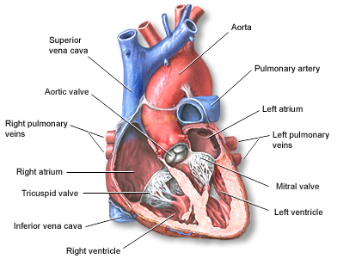
Figure 1: The human heart.

As the aortic valve becomes more narrow, the left ventricle has to increase pressure to pump blood out through the valve. To do this extra work, the muscles in the ventricle walls become thicker, which can lead to chest pain. As the pressure continues to rise, blood may back up into the lungs. Severe forms of aortic stenosis prevent enough blood from reaching the brain and the rest of the body. Aortic stenosis may be present from birth (congenital), but usually it develops later in life (is acquired). Children with aortic stenosis may have other congenital conditions. In adults, aortic stenosis usually occurs due to calcium deposits that narrow the valve. This is called calcific aortic stenosis, and it generally affects older people. The other common cause is rheumatic fever, a condition that may develop after strep throat or scarlet fever. Valve problems do not develop for 5 - 10 years or longer after rheumatic fever occurs. Rheumatic fever is increasingly rare in the United States. Calcification of the valve happens sooner in patients who are born with abnormal aortic or bicuspid valves. In rare cases, calcification can also occur more quickly in patients who have received radiation treatment to the chest. Aortic stenosis is not very common. It occurs more often in men than in women.
Transcatheter aortic valve implantation (TAVI) is a recently developed surgical technique to treat symptomatic aortic valve stenosis in elderly and high-risk patients. Compared to the standard aortic valve replacement surgery, the TAVI limits the surgical access to either a small minithoracotomy (transapical TAVI) or femoral approach (transfemoral TAVI) causing minimal tissue trauma. Independently of the TAVI approach it can be performed on the beating heart without cardiopulmonary bypass support. Recovery time may be reduced and the patient can eventually return to normal activity more quickly. More than 70,000 transcatheter valve implantations have been performed worldwide [1].
The TAVI is done via a retrograde (transfemoral, transaxillary) or antegrade (transapical) approach [2]. The main advantage of the transapical TAVI technique is the direct access to the aortic valve which eliminates the need for a large peripheral vascular access in patients with peripheral vascular disease, small tortuous vasculature, a history of major vascular complications, or previous vascular interventions [2]. In transapical TAVI, a stented valve bioprosthesis that is temporarily crimped upon a balloon catheter, is inserted through the apex into the aortic root via a left anterolateral minithoracotomy. For that the apex of the left ventricle is punctured with a needle, and after balloon valvuloplasty the aortic valve prosthesis (AVP) is positioned within the stenotic aortic valve using guide wire techniques. After reaching the correct position, the stented AVP is deployed by an inflatable balloon to reach its final diameter, thus fixing the prosthesis to the aortic annulus (Fig. 3a).
The Edwards SAPIENTM prosthesis (Edwards Lifesciences Inc, Irvine, CA, USA) is the most commonly used prosthesis for TAVI in several European countries and the only one approved for transapical approach so far [3]. Thus the Edwards SAPIENTM prosthesis has been used in this study. It consists of three bovine pericardial cusps mounted into a stainless-steel balloon-expandable stent (Fig. 3b).

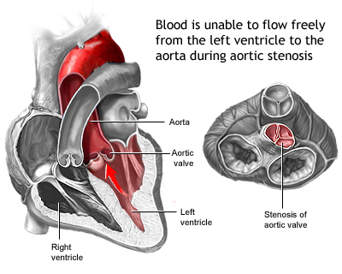
Figure 2: Stenosis of aortic valve.

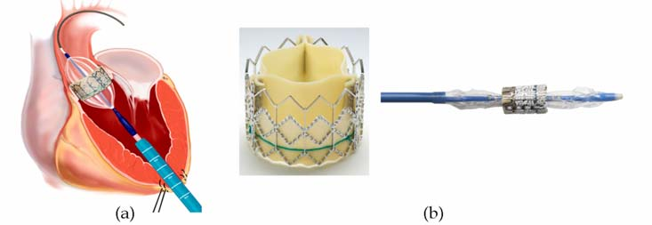
Figure 3: Transcathete aortic valve implantation. (a) Schematic view of the transapical approach. (b) Edwards SPAIENTM prosthesis and the balloon-based delivery system.

Medical imaging technology, including computed tomography (CT), X-ray fluoroscopy, magnet resonance imaging (MRI), and echocardiography, is needed to provide accurate information on the stenotic valve and to choose the appropriate prosthetic valve size for TAVI procedures [4][5]. Live two-dimensional (2D) X-ray fluoroscopy guidance is mostly used during the intervention, in order to determine proper valve positioning and the plane of alignment of the aortic valve cusps with supplemental echocardiography confirmation.
At the begin of the surgical procedure, the physician uses the interventional C-arm imaging system to reconstruct a 3D CT image of the aortic root under a short episode of rapid ventricular pacing (RVP) from acquired rotational 2D image sequences by applying 75 ml diluted contrast agent of 200º over 5 seconds [6]. In the presence of contrast agent, different fluoroscopic projections are used to visualize the aortic root and the aortic annulus in a perpendicular view (Fig. 4a) .

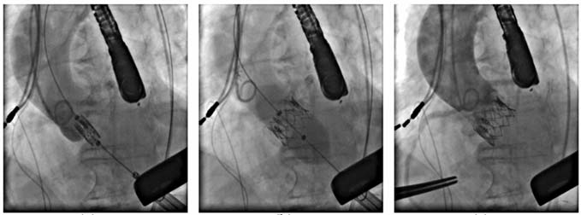
(a) (b) (c)
Figure 4: 2D Fluoroscopy guidance during the transapical TAVI. (a) Valve positioning. (b) Valve implantation. (c) Final assessment after valve implantation.

The annular plane is sometimes visible depending on the amount of annular calcification, but often only indirect clues are provided by the position of a pigtail catheter. The pigtail catheter should be placed at the bottom of a coronary sinus as follow [6]. The following valve adjustment in the aortic annulus requires additional contrast injections and radiation exposure. When valve positioning is considered correct, the balloon-expandable prosthesis is released to replace the diseased valve under RVP as shown in Fig. 4b. After the implantation, the assessment of implanted AVP is also done using fluoroscopy guidance (Fig. 4c).
Exact valve placement is crucial during the intervention, because complications can arise from a misplaced valve, which are difficult to manage and requires different bailout strategies. These complications have been reported [7] such as high-degree atrioventricular (AV) block (10-30%), paravalvular leak (4-35%), coronary ostia occlusion (0.5-1%), aortic dissection (0-4%), cardiac tamponade (1-9%). A malposition of the prosthesis rarely occurs, however, 5.3% incidence (9/170) patients was reported [8]. The 30-day mortality of the TAVI in Europe is 5-10% [3]. Also, the contrast of fluoroscopic images is generally limited to minimize the radiation exposure for the patient and the physician. The contrast agent is injected to visualize the aortic root, valve annulus, and coronary ostia in few seconds. The amount of contrast injections must be minimized to avoid renal insufficiencies in high-risk elderly patients.

Related work
Only few previous studies deal with image-guided planning and intraoperative support of the TAVI procedure. Gessat et al., 2009 and Karar et al., 2009, 2010 have previously proposed a guidance system including a planning system [9] and tracking the AVP in fluoroscopic image sequences [10][11]. Siemens has prototypically equipped the interventional C-arm with a system for automatic segmentation and overlay of aortic root volume and landmarks on 2D fluoroscopic images, but without motion correction [12]. Robotic systems have been developed for the TAVI using intraoperative MRI guidance [13][14]. Real-time 3D transesophageal (TEE) is recently presented for guiding the TAVI [15]. Mohamed Esmail Karar et al. Present a system that integrates a 3D aortic mesh model and landmarks form intraoperative C-arm CT images with tracking the prosthesis in live fluoroscopic images [6], but the failure of template-based tracking algorithm of of pigtail catheter may occur in the images with illumination changes and contrast injections. The displacement error of the pigtail catheter remains high (The maximum errors are less than 5.0 mm only for one to three images per sequence).

Objective
In order to overcome the current difficulties associated with the TAVI under 2D fluoroscopy guidance, we present a new approach that integrates the methods of Kalal et al. [35] and Joint Tracking of Features [54] to track the aortic valve plane in live fluoroscopic images.

Contribution
The developed 2D fluoroscopy guidance method accuracy was determined by the tracking accuracy of both the pigtail catheter and the annular calcification or any instrumental and calcification in the aortic root that have the same movement with the aortic valve plane. Automatic detection of contrast agent in a fluoroscopic image is used to initialize the synchronized contour model and plane tracking with aortic root motion in interventional image sequences. The template image of the pigtail catheter and/or the calcifications are manually defined on the first image of sequence. A region of interest (ROI) of the image is defined to reduce the processing time and increase the algorithm robustness. In practice, the size of the ROI is 3 times the size of the template image and is constant for all images of each sequence. We implement our approach in C++ and evaluate it on existing recorded test data. We give a performance comparison to existing methods and analyze whether our approach is suitable for the TAVI procedure.

Organization
This report is organized as follows. Chapter 2 give us the current state of the art of object tracking. In Chapter 3, the valve tracking method is described. In Section 3.1.1, the tracking method based on the estimation of optical flow is presented. In Section 3.1.2, the cascaded approach to object detection is explained. Section 3.1.3 deals with the question of how to fuse the results of the tracker and describes what happens during the learning step. Section 3.2 give the picture of how to use the pigtail catheter/calcification tracked positions to determine the aortic valve plane in 2D fluoroscopy image sequences. Chapter 4 shows experimental results on test data as well as a comparison to other tracking methods. Chapter 5 gives a conclusion and final remarks.

State of the art of object tracking

Object tracking is an important task within the field of computer vision. The proliferation of high-powered computers, the availability of high quality and inexpensive video cameras, and the increasing need for automated video analysis has generated a great deal of interest in object tracking algorithms. There are three key steps in video analysis: detection of interesting moving objects, tracking of such objects from frame to frame, and analysis of object tracks to recognize their behavior.
In its simplest form, tracking can be defined as the problem of estimating the trajectory of an object in the image plane as it moves around a scene. In other words, a tracker assigns consistent labels to the tracked objects in different frames of a video. Additionally, depending on the tracking domain, a tracker can also provide object-centric information, such as orientation, area, or shape of an object. Tracking objects can be complex due to:
- Loss of information caused by projection of the 3D world on a 2D image,
- Noise in images,
- Complex object motion,
- Nonrigid or articulated nature of objects,
- Partial and full object occlusions,
- Complex object shapes,
- Scene illumination changes, and
- Real-time processing requirements.
One can simplify tracking by imposing constraints on the motion and/or appearance of objects. For example, almost all tracking algorithms assume that the object motion is smooth with no abrupt changes. One can further constrain the object motion to be of constant velocity or constant acceleration based on a priori information. Prior knowledge about the number and the size of objects, or the object appearance and shape, can also be used to simplify the problem.
In this work we focus on semi-automated single-target tracking. The problem of single-target tracking is defined as follows [28]. Given a sequence of images I₁ ...I_{n}, estimate the state x_{k} of the target for each frame I_{k}. Object tracking methods encode the state x_{k} as centroids, bounding boxes, bounding ellipses, chains of points or shape [28]. For example, in Fig. 5, a bounding box is shown around an object of interest. In this case, the parameters of x_{k} consist of the upper left corner of the rectangle (x,y) and its width and height. Maggio and Cavallaro [28] group approaches based on the amount of user interaction that is required to identify the objects of interest. Manual tracking requires the interaction with the user in every frame. Automated tracking methods use a priori information in order to initialize the tracking process automatically. In semi-automated tracking, user input is required in order to initialize the tracking process.
According to Maggio and Cavallaro [28], the main challenge in object tracking is clutter. Clutter is the phenomenon when features expected from the object of interest are difficult to discriminate against features extracted from other objects in the scene. In Fig. 6 an example for clutter is shown. In this image, several objects are present that are similar in shape to the object of interest. Another challenge is introduced by appearance variations of the target itself. Intrinsic appearance variability includes pose variation and shape deformation, whereas extrinsic appearance variability includes illumination change [29]. Approaches that maintain a template of the object of interest typically face the template update problem that relates to the question of how to update an existing template so that it remains a representative model [30]. If the original template is never changed, it will eventually no longer be an accurate representation of the model. When the template is adapted to every change in appearance, errors will accumulate and the template will steadily drift away from the object. This problem is closely related to the stability-plasticity dilemma, which relates to the trade-off between the stability required to retain information and the plasticity required for new learning [32]. This dilemma is faced by all learning systems [40]. Objects undergo occlusions when covered by other object or when they leave the field of view of the camera. In order to handle such cases, a mechanism is necessary that re-detects the object in- dependently of its last position in the image [39]. Requirements on the execution time pose another difficulty. [39].

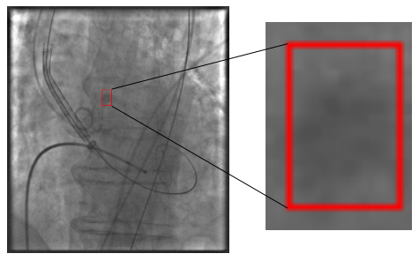
Figure 5: The state of an object encoded in a bounding box. The enlarged patch constrained by the bounding box is displayed on the right.

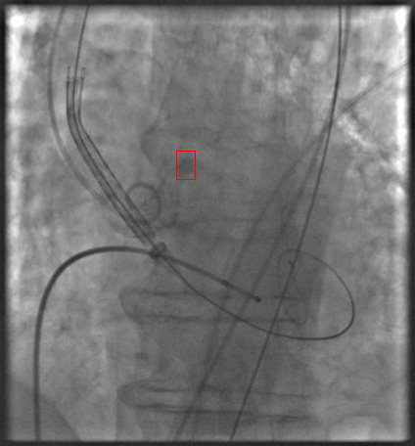
Figure 6: The main challenge in object tracking is to the distinguish the object of interest (red) from clutter in the background (green).

Lepetit et al. [36] identify two paradigms in object tracking. Recursive tracking methods estimate the current state x_{t} of an object by applying a transformation on the previous state x_{t−1} based on measurements z₁ . . . z_{t} taken in the respective images. The recursive estimation of a state depends on the state of the object in the previous frame and is susceptible to error accumulation [36]. For instance, Lucas and Kanade [37] propose a method for estimating sparse optic flow within a window around a pixel. The optic flow is fit into a transformation model that is used to predict the new position of the object. Stanley T. Birchfield et al. propose the Joint Tracking of Features [54] for tracking the object of interest in consecutive frames, in which features are tracked jointly . Comaniciu et al. [17] propose a tracker based on mean shift. The transformation of the object state is obtained by finding the maximum of a similarity function based on color histograms. In contrast, Tracking-by-detection methods estimate the object state solely by measurements taken in the current image. This principle remedies the effect of error accumulation. However, the object detectors have to be trained beforehand. Özuysal et al. [39] generate synthetic views of an object by applying affine warping techniques to a single template and train an object detector on the warped images. The object detector is based on pairwise pixel comparison and is implemented efficiently. Object detection is then performed in every frame in order to track the object. We use an online variant of this method as a part of an object detection cascade.
In-between these paradigms, adaptive tracking-by-detection methods have been developed that update an object detector online. Avidan [16] integrates a support vector machine classifier into an optic-flow-based tracker. Instead of minimizing an intensity difference function between successive frames, he maximises the classifier score. The support vector machine is trained beforehand and unable to adapt. Collins et al. [18] were the first to treat tracking as a binary classification problem, the two classes being the object of interest and background. They employ automatic feature selection in order to switch to the most discriminative color space from a set of different color spaces. They employ self-learning in order to acquire new training examples. In self-learning, a supervised method is retrained using its own predictions as additional labeled points. This setting is prone to drift [19]. Javed et al. [20] employ co-training in order to label incoming data and use it to improve a detector trained in an offline manner. It has been argued that in object tracking the underlying assumption of co-training that two conditionally independent views of the same data are available is violated, since in object tracking training examples are sampled from the same modality [34]. Ross et al. [29] incrementally learn a low-dimensional subspace representation and adapt this representation to changes in the appearance of the target. Adam et al. [21] propose an approach called FragTrack that uses a static part-based appearance model based on integral histograms. Avidan [22] uses self-learning for boosting in order to update an ensemble classifier. Grabner et al. [23] employ a semi-supervised approach and enforces a prior on the first patch, while treating the incoming images as unlabeled data. However, if the prior is too strong, then the object is likely not to be found again. If it is too weak, then it does not discriminate against clutter. Babenko et al. [24] apply Multiple Instance Learning (MIL) to object tracking. In multiple instance learning, overlapping examples of the target are put into a labeled bag and passed on to the learner, which is therefore allowed more flexibility in finding a decision boundary. Stalder et al. [25] split the tasks of detection, recognition and tracking into three separate classifiers and achieve robustness to occlusions. Santner et al. [26] propose PROST, a cascade of a non-adaptive template model, an optical-flow-based tracker and an online random forest. The random forest is updated only if its ouput overlaps with the output of one of the two other trackers. Hare et al. [27] generalize from the binary classification problem to structured output prediction. In their method called Struck they directly estimate the expected state transformations instead of predicting class labels.
Kalal et al. [34] propose a method called TLD (Tracking-Learning-Detection) that uses patches found on the trajectory of an optic-flow-based tracker in order to train an object detector. Updates are performed only if the discovered patch is similar to the initial patch. What separates this method from the adaptive tracking-by-detection methods is that the output of the object detector itself is used only to reinitialize the optic-flow-based tracker in case of failure but is never used in order to update the classifier itself. Kalal et al. achieve superior results as well as higher frame rates compared to adaptive tracking-by-detection methods.

Valve Tracking Method

Calcifications and Pigtail Catheter Tracking
We use the approach of Kalal et al. [35] and Joint Tracking of Features [54] for recursive tracking. This approach is based on estimating optical flow using the method of Lucas and Kanade [38]. For object detection, we follow [33] and maintain templates that are normalized in brightness and size. We keep separate templates for positive examples of the object and for negative examples found in the background. These templates form the basis of an object detector that is run independently of the tracker. New templates are acquired using P/N-learning as proposed in [34]. If the detector finds a location in an image exhibiting a high similarity to the templates, the tracker is re-initialized on this location. Since the comparison of templates is computationally expensive, we employ a cascaded approach to object detection. In [34] a random fern classifier [41] based on 2-bit- binary patterns and a fixed single template is used. Our object detection cascade consists of a foreground detector, a variance filter, a random fern classifier based on features proposed in [37] and the template matching method. Fig. 7 depicts the work-flow of our approach. The initialization leads to a learning step. Next, the recursive tracker and the detector are run in parallel and their results are fused into a single final result. If this result passes a validation stage, learning is performed. Then the process repeats.

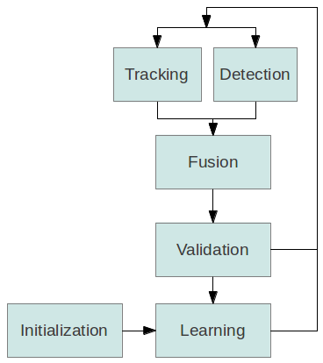
Figure 7: The tracking process is initialized by manually selecting the object of interest. No further user interaction is required.

Tracking
In this part we describe a recursive method for object tracking. In this method, no a priori information is required about the object except for its location in the previous frame, which means that an external initialization is required. In our approach, the initialization is accomplished by manual intervention in the first frame and by the results of an object detection mechanism in consecutive frames.
We follow the approach of Kalal et al. [35] and Joint Tracking of Features [54] for recursive tracking. We explain this method according to Fig. 8. First, an equally spaced set of points is constructed in the bounding box in frame t, which is shown in the left image. Next, the optical flow is estimated for each of these points by employing the method of Lucas and Kanade [38] and Joint Tracking of Features [54]. This method works most reliably if the point is located on corners and is unable to track points on homogeneous regions. We use information from the Joint Lucas-Kanade method as well as two different error measures based on normalized cross correlation and forward-backward error in order to filter out tracked points that are likely to be erroneous. In the right image the remaining points are shown. If the median of all forward-backward error measures is above a certain threshold, we stop recursive tracking entirely, since we interpret this event as an indication for drift. Finally, the remaining points are used in order to estimate the position of the new bounding box in the second frame by employing a transformation model based on changes in translation and scale. In the right image, the bounding box from the previous frame was transformed according to the displacement vectors from the remaining points.

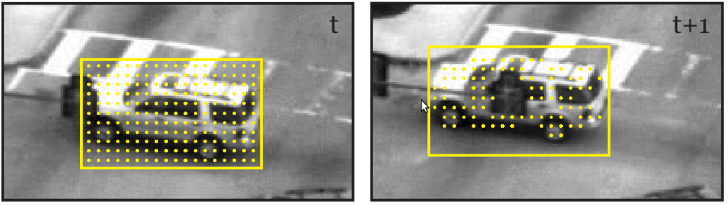
Figure 8: The principle of the recursive tracking method consists of tracking points using an estimation of the optical flow, retaining only correctly tracked points and estimating the transformation of the bounding box. Images are from [35].

Estimation of Optical Flow
As explained by Bruhn et al. [48], differential methods for both dense optical flow as well as sparse feature tracking are based on the assumption that the intensity values of the projection of scene points do not change over time and is expressed as

(1)

where I(x, y, t) is the intensity of pixel X = (x, y)^{T} in frame t, and U = (u, v)^{T} is the displacement of the pixel between consecutive frames t and t + 1 .
Eq. (1) states that a pixel at the two-dimensional location (X) in an image t might change its location in the second image t+1 but retains its brightness value. In the following, the vector U will be referred to as the displacement vector. The second assumption is referred to [52] as temporal persistence. It states that the displacement vector is small. For small displacements, a linearized Taylor series expansion yields the well-known optic flow constraint equation

(2)

where the subscripts denote partial derivatives. The well- known aperture problem arises because this single equation is insufficient to recover the two unknowns u and v.
The Lucas-Kanade [53] approach to overcoming the aperture problem assumes that the unknown displacement u of a pixel is constant within some neighborhood. As a result, the displacement can be computed by minimizing

(3)

where K_{ρ} ∗ (·) denotes convolution with an integration window of size ρ. Differentiating with respect to u and v, and setting the partial derivatives to zero, yields the linear system

(4)

which is solved iteratively to minimize E_{LK}.
Alternatively, the Horn-Schunck [52] approach regularizes the underconstrained optic flow constraint equation by imposing a global smoothness term. While Lucas-Kanade finds the displacement of a small window around a single pixel, Horn-Schunck computes the global displacement functions u(x, y) and v(x, y) by minimizing

(5)

where λ is the regularization parameter and Ω is the domain of the image. The minimum of this functional is found by solving the corresponding Euler-Lagrange equations, leading to

(6)

Where and are the Laplacian of u and v respectively. Solving this equation for u and v and using the approximation that , where is the average of the values of u among the neighbors of the pixel, and h is a constant scale factor, we get

(7)

Thus, the sparse linear system can be solved using the Jacobi method with iterations for pixel (i, j)^{T} of the form

(8)

(9)

Where

(10)

Faster convergence is obtained by performing computations in place (Gauss-Seidel) and using successive overrelaxation (SOR).

Joint Tracking of Features
Sparse features have traditionally been tracked from frame to frame independently of one another. In this part, we describe a framework in which features are tracked jointly. Combining ideas from Lucas-Kanade and Horn-Schunck, the estimated motion of a feature is influenced by the estimated motion of neighboring features. The approach also handles the problem of tracking edges in a unified way by estimating motion perpendicular to the edge, using the motion of neighboring features to resolve the aperture problem. The combination of the Lucas-Kanade and Horn-Schunck approaches in Eqs. (3) and (5) is to be minimized

(11)

where N is the number of feature points, and the data and smoothness terms are given by

(12)

(13)

In these equations, the energy of feature i is determined by how well its displacement (u_{i} , v_{i})^{T} matches the local image data, as well as how far the displacement deviates from the expected displacement . Note that in our approach, the expected displacement is computed from the average of the neighboring displacements.

The result of this implementation is shown in Fig. 9.

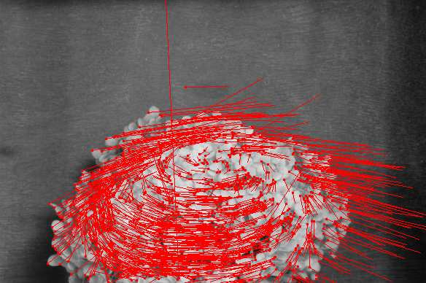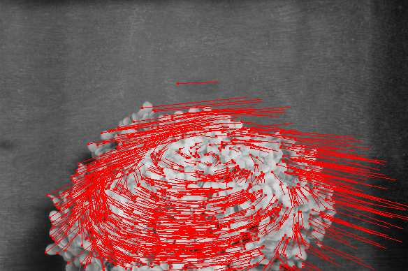
Figure 9: Results of standard Lucas-Kanade (left) and joint Lucas-Kanade (right) on image pairs from three sequences. Red dots indicate tracked feature points, and red lines show the displacements (scaled for display). The latter algorithm exhibits fewer erroneous displacements in regions of repetitive texture. Image are from [54].

Error Measurements
Kalal et al. [35] propose the forward-backward error measure. This error measure is illustrated conceptually in Fig. 10. In the left image, the point 1 is tracked correctly to its corresponding position in the right image. The point 2, however, ends up at a wrong location as an occlusion occurs. The proposed error measure is based on the idea that the tracking of points must be reversible. Point 1 is tracked back to its original location. In contrast, point 2 is tracked back to a different location. The proposed error measure is defined as the Euclidean distance

(14)

In Eq. (14), p'' is

(15)

meaning that the Lucas-Kanade method is applied twice on p.
In [35] the forward-backward error measure is used in conjunction with another measure
based on the similarity of the patch surrounding p and the patch surrounding the tracking result p . The similarity of these two patches P1 and P2 is compared using the Normalized Correlation Coefficient (NCC) of two image patches P1 and P2 that is defined as

(16)

In Eq. (16) where μ1 , μ2 , σ1 and σ2 are the means and standard deviations of P1 and P2. The normalized correlation coefficient is invariant against uniform brightness variations [51].

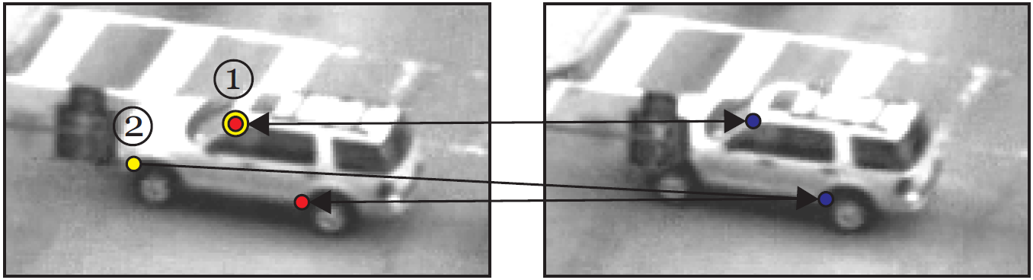
Figure 10: The idea of the forward-backward error measure lies in the observation that certain points cannot be re-tracked to their original location. Images are from [35].

Transformation Model
Following the approach of Kalal et al. [35], we calculate the median of all forward-backward errors med_{FB} and the median med_{NCC} of all similarity measures and keep only those points exhibiting a forward-backward error less than med_{FB} and a similarity measure larger than med_{NCC}.
Furthermore, if med_{FB} is larger than a predefined threshold θ_{FB} , we do not give any results as we interpret this case as an unreliable tracking result. The remaining points are used to calculate the transformation of the bounding box. For this, the pairwise distances between all points are calculated before and after tracking and the relative increase is interpreted as the change in scale.
The translation in x-direction is computed using the median of the horizontal translations of all points. The translation in y-direction is calculated analogously. An algorithmic version of the proposed tracker is given in Alg. 1. We use a grid of size 10×10, a window size W = 10 and a threshold θ_{FB} = 10 for all of our experiments.

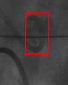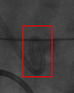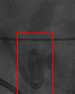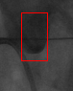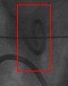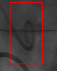
1 6 18 36 66 77
Figure 11: The tracking is robust to partial occlusions. But it accuracy decreases over time.

Algorithm 1 Tracking
Input: B_{I}, I, J
p₁ . . . p_{n} ← generatePoints(B_{I})
for all p_{i} do
p'_{i} ← JLK(p_{i})
p''_{i} ← JLK(p'_{i})
ε_{i} ← |p_{i} − p''_{i}|
η_{i} ← NCC(W(p_{i}),W(p'_{i}))
end for
medNCC ← median(η₁ . . . η_{n})
medFB ← median(ε₁ . . . ε_{n})
if medFB > θ_{FB} then
B_{J} = Ø
else
C ← {(pi , p'i) | p'_{i} ≠ Ø, ε_{i} ≤ medFB, η_{i} ≥ medncc}
B_{J} ← transform(B_{I},C)
end if

Detection
In this part we discuss the method that we employ for object detection. Object detection enables us to re-initialise the recursive tracker that itself does not maintain an object model and is therefore unable to recover from failure. While the recursive tracker depends on the location of the object in the previous frame, the object detection mechanism presented here employs an exhaustive search in order to find the object. Since several thousands of subwindows are evaluated for each input image, most of the time of our overall approach is spent for object detection.

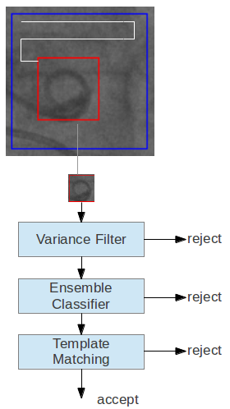
Figure 12: In sliding-window-based approaches for object detection, subwindows are tested independently. We employ a cascaded approach in order to reduce computing time.

Our object detector is based on a sliding-window approach [31], which is illustrated in Fig. 12. The image at the top is presented to the object detector, which then evaluates a classification function at certain predefined subwindows within each input image. Depending on the size of the initial object, we typically employ 50,000 to 200,000 subwindows for an image of (512 × 512) resolution. Each subwindow is tested independently whether it contains the object of interest. Only if a subwindow is accepted by one stage in the cascade, the next stage is evaluated. Cascaded object detectors aim at rejecting as many non-relevant subwindows with a minimal amount of computation [50]. The three stages that we use for image classification are shown below the input image. In the first stage all subwindows are rejected that exhibit a variance lower than a certain threshold. The second stage comprises an ensemble classifier based on random ferns [41]. The thirst stage consists of a template matching method that is based on the normalised correlation coefficient as a similarity measure. We handle overlapping accepted subwindows by employing a non-maximal suppression strategy.

Sliding-Window Approach
In sliding-window-based approaches for object detection, subimages of an input image are tested whether they contain the object of interest [42]. Potentially, every possible subwindow in an input image might contain the object of interest. However, in a (512 × 512) resolution image there are already 23,507,020,800 possible subwindows and the number of possible subwindows grows as n⁴ for images of size n × n (see App. A.1 for a proof). We restrict the search space to a subspace R by employing the following constraints. First, we assume that the object of interest retains its aspect ratio and scale. Furthermore, we introduce margins dx and dy between two adjacent subwindows and set d_{x} and d_{y} to be 1/10 of the values of the original bounding box. We also consider subwindows with a minimum area of 25 pixels only. The size of the set of all subwindows R constrained in this manner is then

(17)

In Eq. (17) w and h denote the size of the initial bounding box and n and m the width and height of the image. A derivation for this formula is given in App. A.1. For an initial bounding box of size w = 80 and h = 60 the number of subwindows in a (512 × 512) resolution image is 146,190. Since each subwindow is tested independently, we employ as many threads as cores are available on the system in order to test the subwindows.

Variance Filter
The variance of an image patch is a measure for uniformity. In Fig. 13 many sample subwindows are shown, marked in white and green, that are evaluated in uniform background regions. One of these subwindows contain patches that exhibit a variance lower than the patch of the object selected for tracking, which is contained in the green rectangle. In this section we describe a mechanism that calculates the variance of a patch in a subwindow using integral images and that rejects all patches exhibiting a variance lower than a threshold σ_{min}². Such a variance filter is able to rapidly reject uniform background regions but unable to distinguish between different well-structured objects. For instance, six white bounding box in Fig. 13 will be accepted as well.

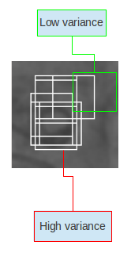
Figure 13: Uniform background regions are identified by setting a variance threshold.

We use an efficient mechanism in order to compute the variance that is shown in [31]. In order to simplify the following explanation, image patches defined by the bounding box B are considered as a one-dimensional vector of pixels and its elements are addressed using the notation x_{i} for the i^{th} pixel. For images, the variance σ² is defined as

(18)

where n is the number of pixels in the image and μ is

(19)

An alternative representation of this formula is

(20)

In order to calculate σ² using Eq. (20) for an image patch of size n, n memory lookups are needed. By taking advantage of the fact that two overlapping image patches partially share the same pixel values, we will now show a way to calculate σ² for an image patch that uses only 8 memory lookups after transforming the input image I into two integral images. An integral image I' is of the same size as I and contains at location (x, y) the sum of all pixel values between the points (1, 1) and (x, y). This can be formulated as

(21)

An integral image is computable in a single pass over the image by using the fact that I'(x, y) can be decomposed into

(22)

In Eq. (22) I (x, y) = 0 for x = 0 or y = 0. By using the integral image representation, the computation of the sum of pixels up to a specific point no longer depends on the number of pixels in the patch. In Fig. 14, the sum of the pixel values within the rectangle ABCD is obtained the following way. First, the sum of all pixels between (0,0) and the point D is computed. Next, the pixels in the area between (0,0) and B are subtracted as well as the pixels in the area between and (0,0) and C. The area between (0,0) and A must be added again, since it is subtracted twice. Using this observation, a formula for computing the sum of pixels within a bounding box B consisting of the parameters (x, y, w, h) is given by

(23)

And use the notation

(24)

as a shorthand for Eq. (23). We use Eq. (24) in order to calculate μ in Eq. (20). In order to calculate also the first term of the right-hand side of this equation using integral images, we modify Eq. (21) to use the squared value of I(x, y). We get

(25)

In analogy to Eq. (24) we write

(26)

By combining Eq. (19), Eq. (20), Eq. (24) and Eq. (26), we get

(27)

For σ_{min}² , we use half of the variance value found in the initial patch.

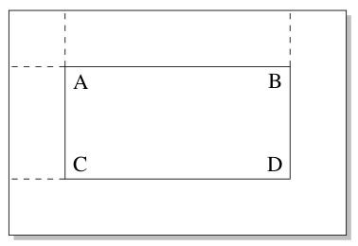
Figure 14: The sum of the pixel values within the rectangle ABCD is calculable by summing up
the pixels up to D, subtracting the pixels up to both B and C and adding the pixels up to A. The
computation is achieved using four look-ups when done on integral images.

Ensemble Classifier
In the second stage of the detection cascade we employ an ensemble classification method presented in [41] that is known as random fern classification. This classifier bases its decision on the comparison of the intensity values of several pixels. For each tested subwindow, a probability P_{pos} is calculated. If this probability is smaller than 0.5 the subwindow is rejected. This method of classification is slower than the variance filter, but still is very fast compared to classification methods using SIFT features, as it was experimentally evaluated in [41].

We use features that are proposed in [37]. Fig. 15 depicts the process of feature calculation. In this figure, a sample image to be classified is shown. In each of the four boxes below this image, a black and a white dot are shown. Each of these dots refers to a pixel in the original image. The positions of these dots are drawn out of a uniform distribution once at startup and remain constant. For each of these boxes it is now tested whether in the original image the pixel at the position of the white dot is brighter than the pixel at the position of the black dot. Mathematically, we express this as

(28)

Where d_{i,1} and d_{i,2} are the two random locations . Note that this comparison is invariant against constant brightness variations. The result of each of these comparisons is now interpreted as a binary digit and all of these values are concatenated into a binary number. In Fig. 15 the resulting binary number is 1101. When written in decimal form, this translates to 13, as it is shown in the box below the binary digit. The i_{th} feature determines the value of the i_{th} bit of a number. A feature group of size S, such as the one shown in Fig. 15 is referred to as a fern in [41]. The feature value obtained is used to retrieve the probability P(y = 1 | F), where y = 1 refers to the event that the subwindow has a positive class label. These probabilities will be discussed in section 3.1.3.

With only one fern, it is necessary to use a large number of features to achieve satisfactory results [41]. However, the amount of training data needed to estimate the P(y = 1 | F_{k}) increases with each additional feature. This problem is known as curse of dimensionality [43]. Amit and Geman [44] encounter the same problem when using randomised decision trees for character recognition and alleviate it by not using one large tree, but several smaller trees. They then average their output. This finding was adopted in [41] and leads to the classifier depicted in Fig. 16. Below the image to be classified, there are three ferns, each consisting of a different set of feature positions and each yielding a different value for P(y = 1 | F_{k}). In the bottom rectangle, the average of these values P_{pos} is shown. P_{pos} is expressed as

(29)

Where M refers to the number of ferns used.
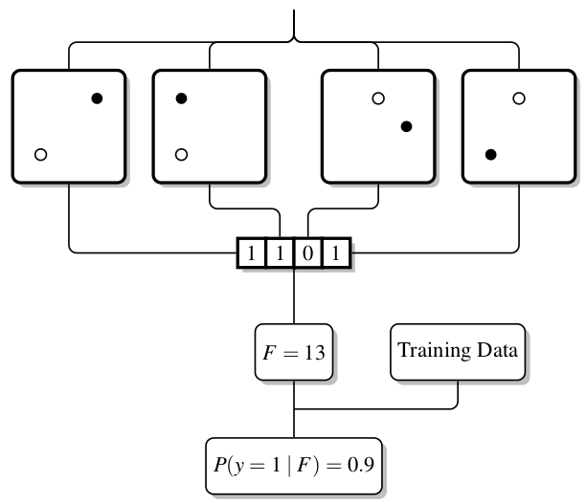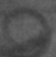
Figure 15: Feature Calculation for a single fern. The intensity values of the i^{th} pixel pair determine the i^{th} bit of the feature value. This feature value is then used to retrieve the posterior probability
P(y = 1 | F_{k}).

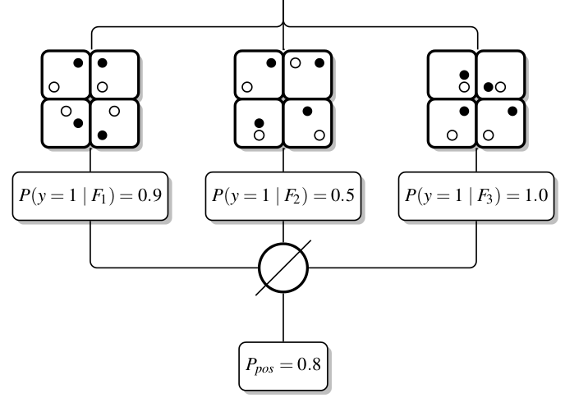
Figure 16: Ensemble classification using three random ferns. The posteriors P(y = 1 | F_{k}) of each individual fern are averaged to produce a final confidence value P_{pos}.

Template Matching
In the third stage of the detector cascade we employ a template matching method. This stage is even more restrictive than the ensemble classification method described in the previous section, since the comparison is performed on a pixel-by-pixel level. We resize all patches to 15 × 15 pixels. For comparing two patches P₁ and P₂ , we employ the Normalized Correlation Coefficient (NCC)

(30)

Where μ₁ , μ₂ , σ₁ and σ₂ are the means and standard deviations of P₁ and P₂. This distance measure is also known as the Pearson coefficient. When interpreted geometrically, it denotes the cosine of the angle between the two normalized vectors. NCC yields values between −1 and 1, with values closer to 1 when the two patches are similar. We use the following formula in order to define a distance between two patches that yields values between 0 and 1.

(31)

We maintain templates for both the positive and negative class. We refer to the positive class as P⁺ and to the negative class as P⁻. The templates are learned online, as it will be described in Section 3.1.3. In Fig. 17 positive and negative examples of the pigtail are shown that were learned on the sequence . Given an image patch P that is of unknown class label, we calculate both the distances to the positive class

(32)

And the distance to the negative class

(33)

The distance to the nearest positive instance according to Eq. (32) is d + = 0.1 and the distance to the nearest negative instance according to Eq (33) is d − = 0.4. We fuse these distances into a single value using the formula

(34)
Eq. (34) expresses the confidence whether the patch belongs to the positive class. A subwindow is accepted if p⁺ is greater than a threshold θ⁺. A confidence value above this threshold indicates that the patch belongs to the positive class. We use a value of θ⁺ = 0.65 for all of our experiments.

Positive examples

Negative examples

Figure 17: Positive and negative patches acquired for the template matching method during a run on a sequence from the dataset.

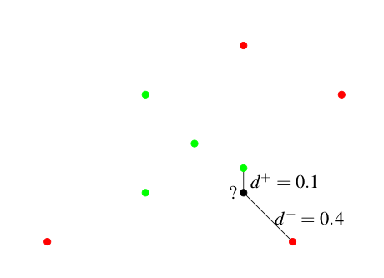
Figure 18: An unknown patch, labeled with a question mark, and the distance d + to the positive class and the distance d − to the negative class. The distance is based on the normalized correlation coefficient. The actual space in which the distance measurement takes place has 15 × 15 dimensions.

Non-maximal Suppression
An object detection mechanism ideally identifies positive subwindows with a confidence value of 1 and negative subwindows with a confidence of 0, but in practice the output consists of hills and valleys characterizing intermediate belief in the fitness of a given location. In Fig. 19 this situation is illustrated. In this figure, several detections with high confidence occur around the true detection marked in white. Blaschko [45] also states that considering only the subwindow yielding the highest confidence is problematic because this leads to other local maxima being ignored. Instead it is desirable to employ non-maximal suppression strategies that identify relevant local maxima.

For non-maximal suppression, we use the method described in [31] that clusters detections based on their spatial overlap. For measuring the overlap between two bounding boxes, we use the formula from the PASCAL challenge [46]

(35)

This measure is bounded between 0 and 1. We now use the hierarchical clustering algorithm described in [47] that works as follows. First we calculate the pairwise overlap between all confident bounding boxes. We then start at one bounding box and look for the nearest bounding box. If this distance is lower than a certain cutoff threshold, we put them into the same cluster and furthermore, if one of the bounding already was in a cluster, we merge these clusters. If the overlap is larger than the cutoff threshold, we put them into different clusters. We then proceed to the next bounding box. We use a cutoff of 0.5 for all of our experiments.

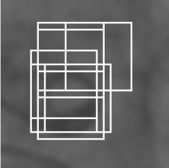
Figure 19: Overlapping subwindows with high confidence .

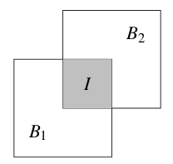
Figure 20: We define an overlap measure between two bounding boxes B1 and B2 to be the area of their conjunction I divided by the area of their disjunction B1 + B2 − I

In Alg. 2 an algorithm for implementing the detection cascade is given. In Line 1 the set Dt that contains confident detection is initialised. In Lines 2-3 the required preprocessing for the variance filter is shown. Lines 4-15 contain the actual cascade. In Line 10 the subwindow is added to the set of confident detections if it has passed all stages of the cascade. In Line 16 the non-maximal suppression method is applied.

Algorithm 2 Detection Cascade
1: D_{t} ← Ø
2: I' ← integralImage(I);
3: I'' ← integralImage(I²);
4: for all B ∈ R do
5: if isInside(B, F); then
6: if calcVariance(I'(B), I''(B)) > σ_{min}² then
7: if classifyPatch(I(B)) > 0.5 then
8: P ← resize(I(B), 15, 15)
9: if matchTemplate(I(B)) > θ⁺ then
10: D_{t} ← D_{t}UB
11: end if
12: end if
13: end if
14: end if
15: end for
16: D_{t} ← cluster(D_{t})

Learning
When processing an image, both the recursive tracker and the object detector are run in parallel. In this section we deal with the question of how to combine the output of both methods into a single final result. We then show what happens during the learning step and when it is performed. The background model and the threshold for the variance filter are not adapted during processing . In learning, we enforce two P/N-learning constraints [34]. The first constraint requires that all patches in the vicinity of the final result must be classified positively by the object detector. The second constraint requires that all other patches must be classified negatively by the object detector.

Fusion and Validity
In Alg. 3 our algorithm for fusing the result of the recursive tracker R_{t} and the confident detections D_{t} into a final result B_{t} is given. The decision is based on the number of detections, on their confidence values p_{Dt}⁺ and on the confidence of the tracking result p_{Rt}⁺. The latter is obtained by running the template matching method on the tracking result. If the detector yields exactly one result with a confidence higher than the result from the recursive tracker, then the response of the detector is assigned to the final result (Line 5 and 15). This corresponds to a re-initialisation of the recursive tracker. If the recursive tracker produced a result and is not re-initialised by the detector, either because there is more than one detection or there is exactly one detection that is less confident than the tracker, the result of the recursive tracker is assigned to the final result (Line 7). In all other cases the final result remains empty (Line 1), which suggests that the object is not visible in the current frame.

Algorithm 3 Hypothesis Fusion and Validity.
Input: R_{t},D_{t}
Output: B_{t}
1: B_{t} ← Ø
2: valid(B_{t}) ← false
3: if R_{t} ≠ Ø then
4: if |D_{t}| = 1 ∧ p_{Dt}⁺ > p_{Rt}⁺ then
5: B_{t} ← D_{t}
6: else
7: B_{t} ← R_{t}
8: if p_{Rt}⁺ > θ⁺ then
9: valid(B_{t}) ← true
10: else if valid(B_{t−1}) ∧ p_{Rt}⁺ > θ⁻ then
11: valid(B_{t}) ← true
12: end if
13: end if
14: else if |D_{t}| = 1 then
15: B_{t} ← D_{t}
16: end if

We use the predicate valid(B_{t}) to express a high degree of confidence that the final result B_{t} is correct. Only if the final result is valid the learning step described in the next section is performed. As it is stated in Alg. 1 the final result is valid under the following two circumstances, both of which assume that the tracker was not re-initialised by the detector. The final result is valid if the recursive tracker produced a result with a confidence value being larger than θ⁺ (Line 9). The final result is also valid if the previous result was valid and the recursive tracker produced a result with a confidence larger than θ⁻ (Line 11). In all other cases, the final result is not valid. The first bounding box is always valid. The threshold θ⁺ indicates that a result belongs to the positive class. The threshold θ⁻ indicates that a result belongs to the negative class and is fixed at θ⁻ = 0.5 for all of our experiments.

P/N-Learning
The P/N-Learning is a semi-supervised learning method . This method shows how so-called structural constraints can extract training data from unlabeled data for binary classification. In P/N-learning, there are two types of constraints: A P-constraint identifies false negative outputs and adds them as positive training examples. An N-constraint does the opposite. As it is depicted in Fig. 21, X_{u} refers to the unlabeled data available. This data is first classified by an existing classifier that assigns labels Y_{u} to X_{u}. Then, the structural constraints, according to some criterion, identify misclassified examples X_{c} with new labels Y_{c}. These examples are then added to the training set and training is performed, which results in an update of the classification function.
The P-Constraint requires that all patches that are highly overlapping with the final result must be classified as positive examples. The N-Constraint requires that all patches that are not overlapping with the valid final result must be classified as negative examples. We consider a bounding box B highly overlapping with B_{t} if it exhibits an overlap of at least 60%. B is considered not to be overlapping with B_{t} if the overlap is smaller than 20%. For measuring overlap, we employ the metric already described in Sec. 3.1.2.5.

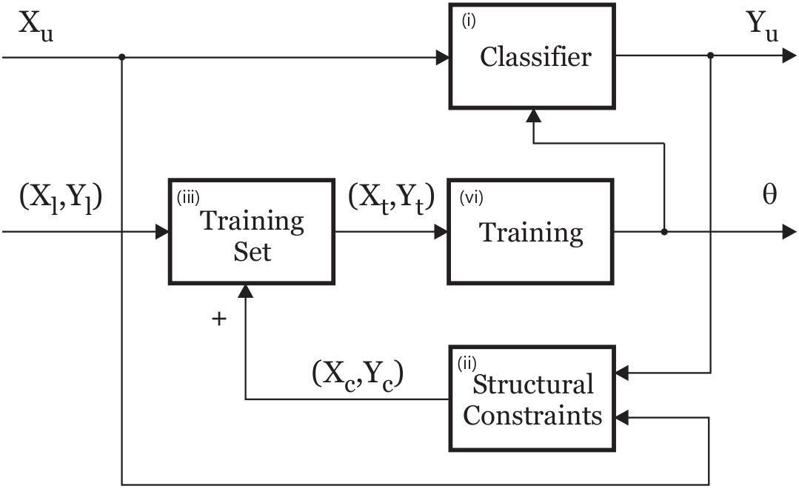
Figure 21: P/N Constraints. Image is from [34].

A complete algorithmic description of the constraints is given in Alg. 4. For the ensemble classifier, we have not yet explained how the posterior values are calculated for each fern. Recall that P(y = 1|F_{k}) is the probability whether a patch is positive given the features F_{k} . We define the posterior to be

(36)

In Eq. (36) p_{Fk} is the number of times the P-constraint was applied to this combination of features and n_{Fk} is the number of times the N-constraints was applied.

In Fig. 22 it is illustrated when positive templates are added. At point A, tracking starts with a high confidence and a valid result. Learning is performed, but no positive examples are added, because the confidence is above θ⁺. The confidence then drops below θ⁺ (Point B) but remains above θ⁻. According to Alg. 3 this means that the final result is still valid. Exactly in this case positive patches are added, which leads to an increased confidence. At Point C, the confidence drops below θ⁻, which leads to the final result not being valid anymore. In Point D, confidence is at the same level as in Point B, but no learning is performed since the final result is not valid.

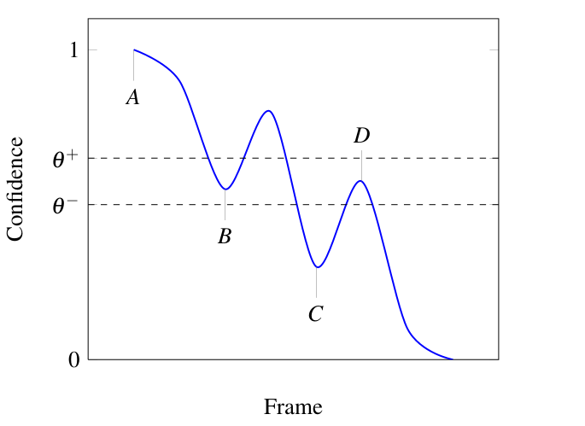
Figure 22: Positive examples are added only when the confidence value drops from a high value (Frame A) to a value between θ⁺ and θ⁻ (Frame B). In Frame D no learning is performed, since the confidence rises from a low value in Frame C. This measure ensures that the number of templates is kept small.

Algorithm 4 P/N-constraints
Input: I, Bt
1: for all B ∈ R do
2: if overlap(B, Bt ) > 0.6 and classifyPatch(I(B)) < 0.5 then
3: for k = 1 . . . M do
4: F ← calcFernFeatures(I(B), k)
5: p_{Fk}[F] ← p_{Fk}[F] + 1
6: end for
7: else if overlap(B,B_{t}) < 0.2 and classifyPatch(I(B)) > 0.5 then
8: for k = 1 . . . M do
9: F ← calcFernFeatures(I(B), k)
10: n_{Fk}[F] ← n_{Fk}[F] + 1
11: end for
12: if p_{Bt}⁺ > θ⁻ then
13: P⁻ ← P⁻ ∪ I(B)
14: end if
15: end if
16: end for
17: if p_{Bt}⁺ < θ⁺ then
18: P⁺ ← P⁺ ∪ I(B_{t})
19: end if

Main Loop
All components that are used in our approach are described. In Alg. 5 the main loop of our implementation is given. When the initial patch is selected, a learning step is performed (Line 1). For each image in the sequence, the tracker and the detector are run (Line 3 and 4), their result is fused (Line 5) and if the final result is considered valid then the learning step is performed (Line 7). The final result is then printed (Line 9) and the next image is processed.

Algorithm 5 Main loop
Input: I₁ . . . I_{n} , B₁
1: learn(I₁ , B₁)
2: for t = 2 . . . n do
3: R_{t} ← track(I_{t−1}, I_{t}, B_{t−1})
4: D_{t} ← detect(I_{t})
5: B_{t} ← fuse(R_{t} , D_{t})
6: if valid(B_{t}) then
7: learn(I_{t} , B_{t})
8: end if
9: print(B_{t})
10: end for

Approximating Aortic Valve Plane Motion
Automatic detection of contrast agent in a fluoroscopic image is used to initialize the synchronized contour and valve plane model tracking with aortic root motion in interventional image sequences. Real-time tracking of the aortic valve plane is performed by calculating the updated displacement of pigtail catheter / calcifications between two frames such that the difference between the matching locations of template in one frame and the corresponding template position in the other frame defines the 2D displacement of the pigtail catheter / calcifications. Fig. 23 shows the overlay of aortic contour model and valve plane onto a fluoroscopic image of sequence with updating via pigtail catheter tracking.

Figure 23: Overlay of aortic contour model and valve plane onto a fluoroscopic image of sequence with updating via pigtail catheter tracking.

Results

In this chapter, our approach is evaluated on sequences that have been recorded at CIT, Hospital Pontchaillou-CHU, Rennes. We employ the standard metrics recall and precision for assessing performance of the pigtail catheter and calcification tracking. For this evaluation, a C++ implementation was created, where the calculation of the optical flow, the calculation of the normalised correlation coefficient as well as low- level image operations are implemented as function calls to the OpenCV library. All experiments were conducted on an Intel Core 2 Duo CPU T7300 processor running at 2.0 Ghz, 1,5 GB RAM under Ubuntu 11.10. The captured fluoroscopic images are 512x512 pixels.
This chapter is organised as follows. Sec. 4.1 explains the evaluation protocol. In Sec. 4.2, the video sequences that are used in our experiments are described. In Sec. 4.3, the parameters for the ensemble classifier are evaluated empirically. In Sec. 4.4, qualitative and quantitative analysis of the pigtail catheter and calcifications tracking are shown on three video sequences. Sec. 4.5 describes qualitative and quantitative results of the approximating aortic valve plane motion. In Sec. 4.6 quantitative results for performance and execution time are obtained for our approach and the state-of-the-art methods.

Evaluation Protocol

Recall and Precision
In order to compare the output of an algorithm to ground truth values we use the overlap measure from Eq. (35). In [55] it is shown that this measure equally penalizes translations in both directions and scale changes. A result is considered true positive if the overlap is larger than a threshold ω (Case a). A result is counted as false negative when the algorithm yields no result for a frame even though there is an entry in the ground truth database (Case b). The opposite case is a false positive (Case c). If the overlap is lower than the threshold ω, then this is counted both a false negative and a false positive (Case d). If for a frame neither an algorithmic output nor an entry in the ground truth database exists then this case is considered a true negative (Case e).
After processing a video sequence, all occurrences of True Positives (TP), False Positives (FP), True Negatives (TN) and False Negatives (FN) are counted. Based on these values we calculate two performance metrics. Recall is defined as

(37)

Eq. (37) measures the fraction of positive examples that are correctly labeled. Precision is defined as

(38)

Eq. (38) measures the fraction of examples classified as positive that are truly positive.
In a classification task, a precision score of 1.0 for a class C means that every item labeled as belonging to class C does indeed belong to class C (but says nothing about the number of items from class C that were not labeled correctly) whereas a recall of 1.0 means that every item from class C was labeled as belonging to class C (but says nothing about how many other items were incorrectly also labeled as belonging to class C).
Often, there is an inverse relationship between precision and recall, where it is possible to increase one at the cost of reducing the other. For example, an information retrieval system (such as a search engine) can often increase its recall by retrieving more documents, at the cost of increasing number of irrelevant documents retrieved (decreasing precision). Similarly, a classification system for deciding whether or not, say, a fruit is an orange, can achieve high precision by only classifying fruits with the exact right shape and color as oranges, but at the cost of low recall due to the number of false negatives from oranges that did not quite match the specification.
In our application, both of high recall and high precision are required.

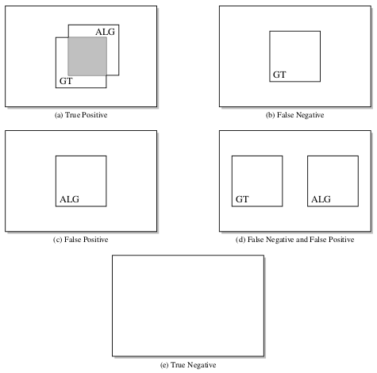
Figure 24: Five possible cases when comparing algorithmic results to ground truth values.

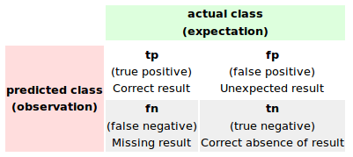
Figure 25: The terms true positives, true negatives, false positives, and false negatives.

Displacement error
In each image of all tested datasets, the tracking accuracy was assessed by computing the absolute displacement errors between the automatically and manually located pigtail’s template, calcification's template and the start point, end point of the aortic valve plane p₁ and p₂. For each image i of the sequence, the automatic localization target point (x_{i}^{A},y_{i}^{A}) and manual localization target point (x_{i}^{M},y_{i}^{M}) are used to compute the displacement error d_{i}. The absolute mean error d_{mean} ± standard deviation (SD) and maximum error d_{max} are also computed over n images of the sequence as

(39)

(40)

(41)

Sequences
In this section we describe the sequences that we use for evaluation, all of which are accompanied by manually annotated ground truth data. Experiments were retrospectively performed on six patient datasets from clinical routine of the TAVI. Each patient dataset include a fluoroscopic image sequence and the related aortic contour model with valve plane. The fluoroscopic sequences include 60-150 images per sequence with 512 × 512 pixels. The pixel size was approximately 0.2 mm.
Sequence | Frames | Contrast Agent | Pigtail | Calcifications
a. BEAU | 78 | Yes | Yes | No
b. BER | 56 | Yes | Yes | No
c. JAN | 59 | Yes | Yes | Yes
d. TAVI 1 | 195 | Yes | Yes | Yes
e. LEF | 80 | Yes | Yes | Yes
f. LECO | 74 | Yes | Yes | Yes

Table 1: Six patient datasets from clinical routine of the TAVI.
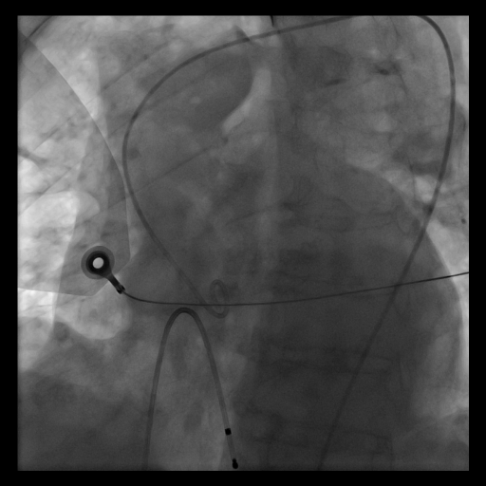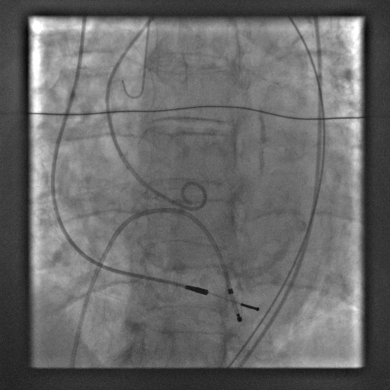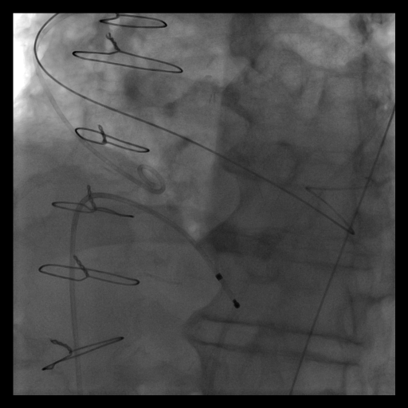
(a) BEAU (b) BER (c) JAN
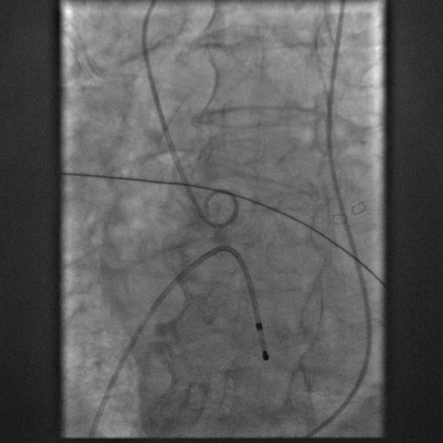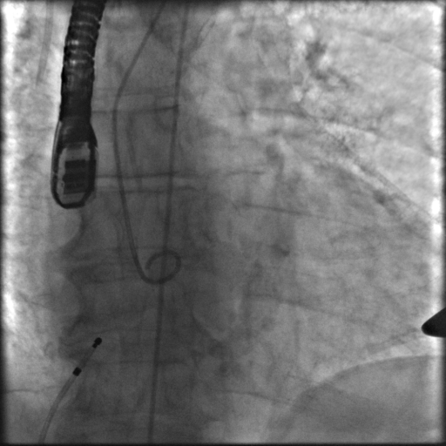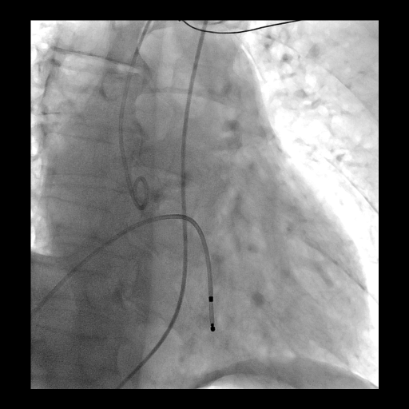
(d) TAVI 1 (e) LEF (f) LECO
Figure 26: The data set used for analysing the importance of the overlap measure and for comparing to existing approaches.

Parameter Selection for Ensemble Classifier
In this experiment we analyse the effects of varying the parameters for the ensemble classifier on the sequence BEAU. The two parameters in question are the number of features in a group (S) and the total number of groups (M). Since S is the number of features that are assumed to be correlated, for large values of S the curse of dimensionality arises, meaning that the amount of training data increases with S. On the other hand, low values of S ignore correlation in the data . Another aspect for choosing S is the amount of memory required. For S = 24, at least 16,777,216 entries for the posterior values have to be stored for every fern. For this experiment, we set M = 50 and let S vary from 1 to 24. In Fig. 28, S is plotted against the achieved recall. The recall first increases linearly with S and reaches its maximum at S = 13. For higher values of S, less recall is achieved.

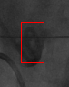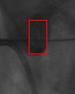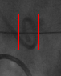
Figure 27: Sample frames of BEAU with illumination changes of the object of interest.

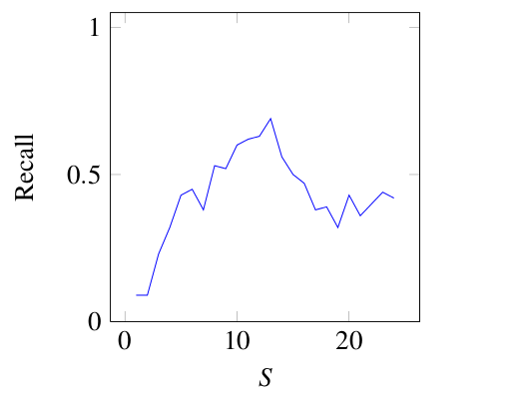
Figure 28: Varying the size S of the feature groups when M = 50 .

Since the time spent on testing each sliding window depends linearly on M, this means that M should be small when low execution time is desired. Fig. 29 shows how the recall is affected by M. For this experiment, we set S = 13. The results show that recall increases up to M = 30 and does not change afterwards.

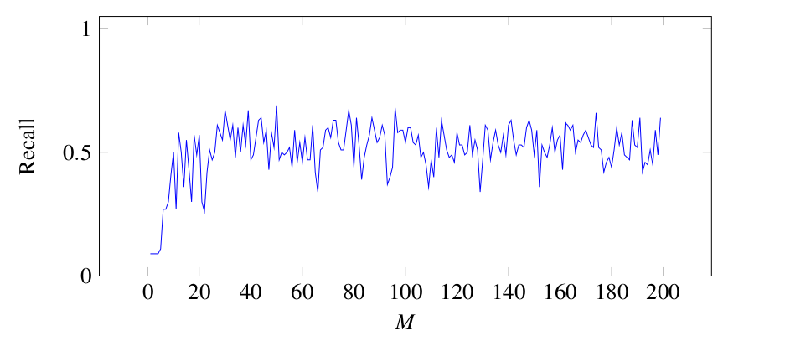
Figure 29: Varying the number of ferns M when S = 13.

Discussion
This experiment shows that the parameters of the ensemble classifier influence recall. We get best results for S = 13 and M > 30. For the rest of the experiments in this chapter, we set S = 13 and M = 10, as a compromise between recall, speed and memory consumption.

Calcifications and Pigtail Catheter Tracking Results

Qualitative Results
In this section, qualitative results for the sequences BEAU and LECO are given. In all of the presented images, a blue box presents the region of interest (ROI), a red bounding box denotes a result with its confidence being larger than 0.5. The tracked calcification results for LECO is presented in Fig. 30. In the top left image, the calcification initially selected for tracking is shown. The calcification just moves inside the ROI (blue box), there is no occlusion in this sequence. As the size of calcification is smaller than the pigtail catheter and there are many similar objects (clutters) around. The tracking task is not easy, especially when there is the present of contrast agent (frames 26 ... 72). In frame 72, the calcification disappears, a failure of the tracking is detected and very fast after that, the detector correctly reinitializes the target as soon as it reappears (frame 74). Many learnings (12 times) are …....
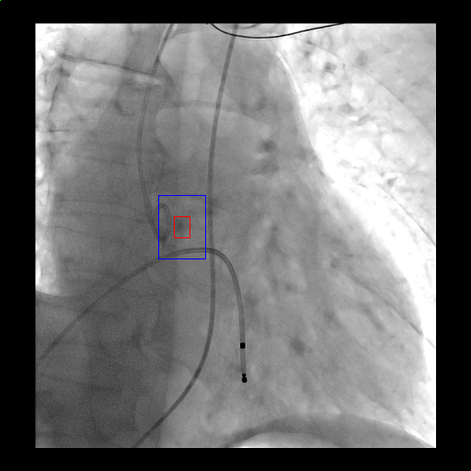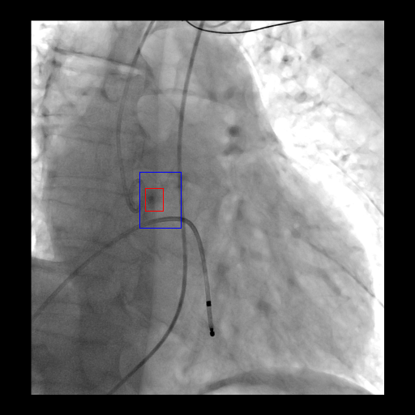
1 9
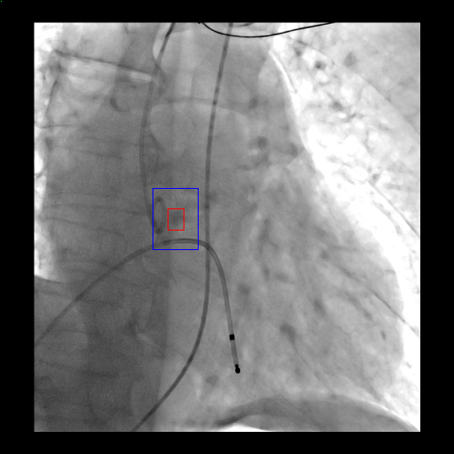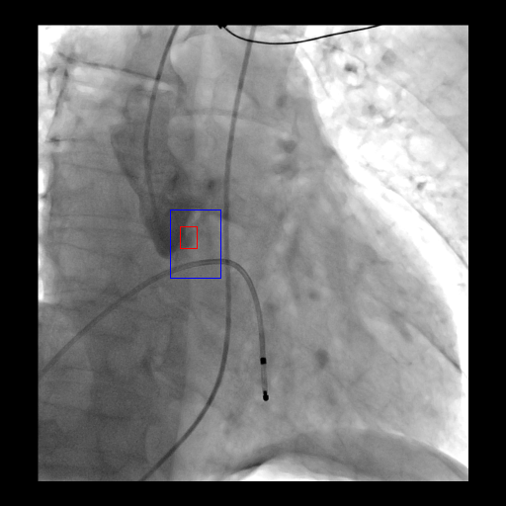
18 26
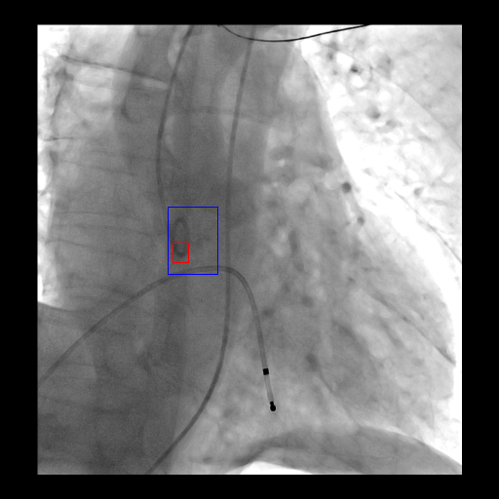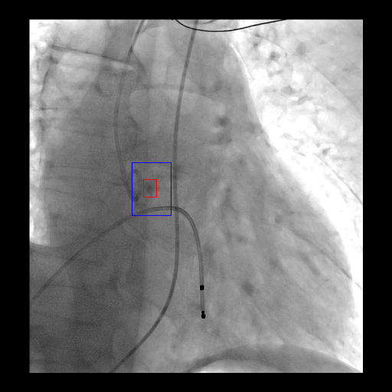
72 74
Figure 30: Qualitative results for the sequence LECO.
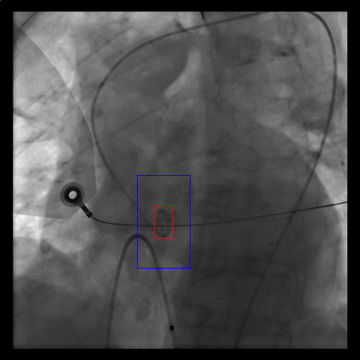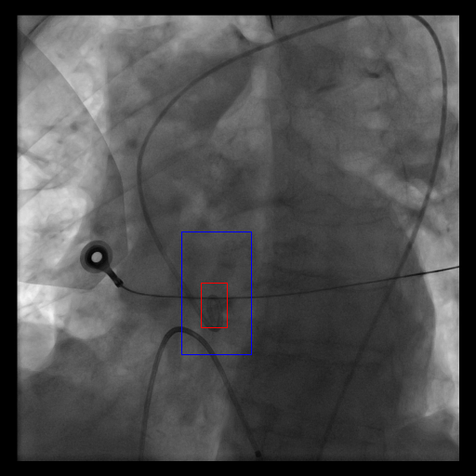
1 5
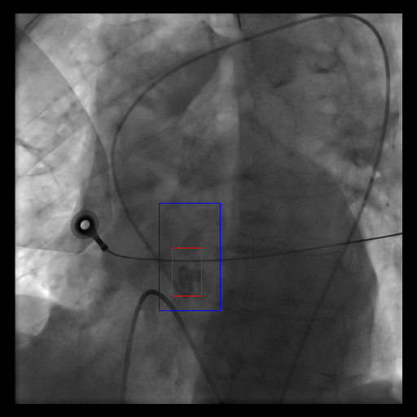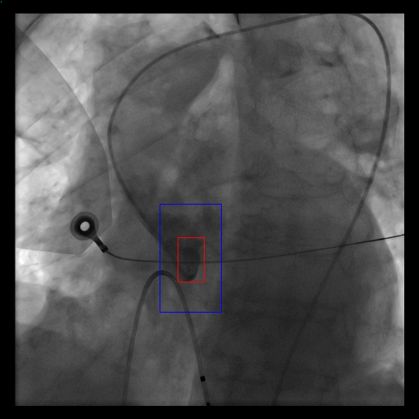
15 31
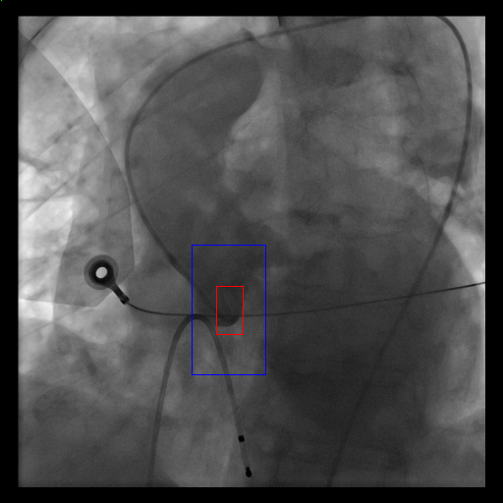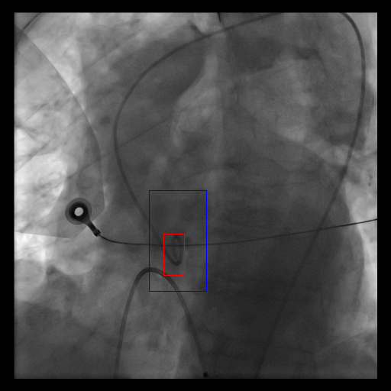
50 77
Figure 31: Qualitative results for the sequence BEAU.
performed to maintain the change of illumination from the contrast agent. The calcification is tracked correctly until the end of the sequence.
We show the tracked pigtail results for BEAU in Fig. 31. In the top left image, the pigtail catheter initially selected for tracking is shown. The challenge here is the partial occlusion of the pigtail catheter because of other surgical instruments. The pigtail moves from the top to the bottom and gets occluded by another surgical instrument in different positions (frames 1 … 5), in frame 15, the pigtail moves below the instrument. Several learnings (5 times) are performed in order to maintain this change of template of the pigtail. In other side, the injections of the contrast agent will cause the illumination changes of our object of interest (frames 31 … 50). In frame 31 we can't see clearly our object of interest. The pigtail catheter however, is detected and tracked correctly.
Discussion
The experiments discussed in this section demonstrate that our method is able to learn the appearance of objects online and to re-detect the objects of interest after occlusions, even it disappears in some frames. On LECO, the calcification is re-detected after the disappearing. In both the first and the second experiment there aren't frames where the object of interest is not detected even though it is visible.

Quantitative analysis
In this section our approach is evaluated quantitatively with comparison between the curve from the detector and the manual curve. The red curve presents the automatic curve obtained in the end of the sequence, the manual curve is shown in blue. The more two curves are similar, the better the quality of our approach is. For this evaluation the dataset from the previous section is used , excluding the images with high dose contrast injections (3-20 images per each sequence).
Fig. 32 denotes the tracked results of the calcification from the sequence LECO again the manual results. In Fig. 32a, the projection on X-axis of the barycenter of our object is presented, Fig. 32b shows the projection on Y-axis. The displacement error is described in Fig. 33. The maximum displacement error is 22.63 pixels (~4.5mm), the absolute mean errors is 4.08 pixels (~0.816mm). The high errors from frames 26-27 caused by the present of contrast agent injections, the learning step is performed in order to reinitialize the tracker in frame 28.
Fig. 34 denotes the tracked results of the pigtail catheter from the sequence BEAU again the manual results. In Fig. 34a, the projection on X-axis of the barycenter of our object is presented, Fig. 34b shows the projection on Y-axis. The displacement error is described in Fig. 35. The maximum displacement error is 19.5 pixels (~3.9mm), the absolute mean errors is 7.19 pixels (~1.438mm). The high errors from frames 15 to 30 are explained by the present of contrast agent injections.
Discussion
Fig. 36 And 37 shows the displacement errors of the tracked calcification and pigtail catheter for six sequences. Seq. TAVI 1 and Seq. LECO present the highest maximum displacement errors 3.9 mm and 4.5 mm respectively. However, all tested fluoroscopic images showed that the maximum and mean displacement errors of the pigtail tracking were less than 4.5 mm for one to three images per each sequence only and less than 1.5 mm respectively. These error values remain within the clinical accepted range.

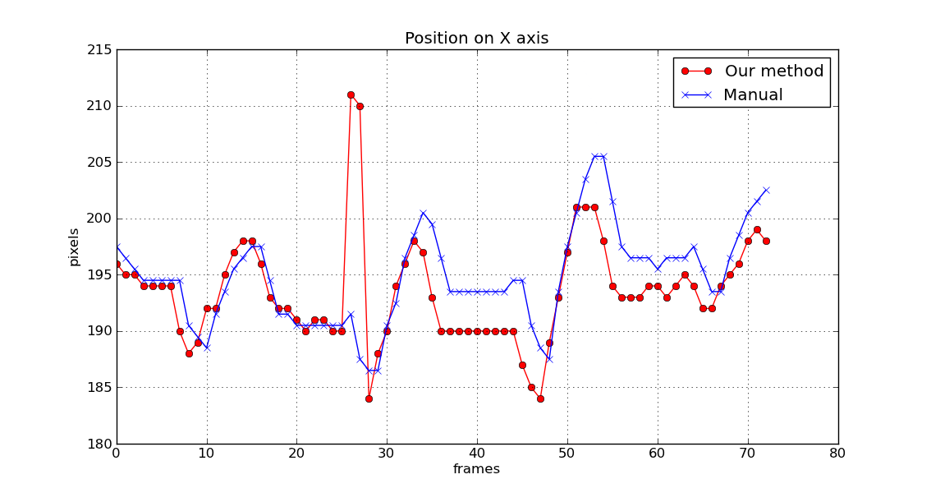
(a)

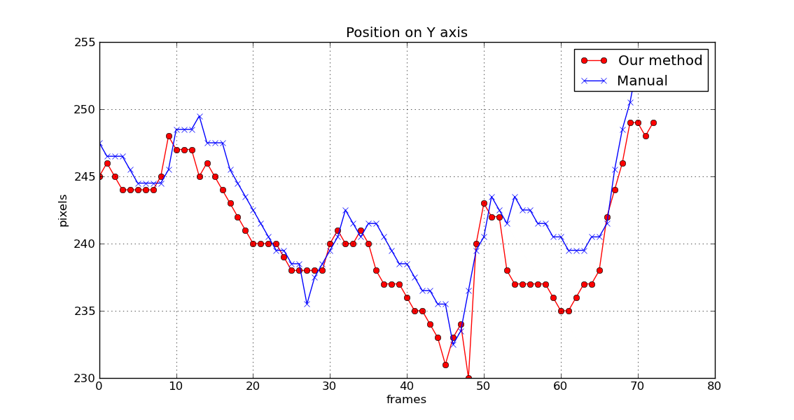
(b)
Figure 32: Projection of the calcification barycenter on X-axis and Y-axis, compare to the manual curves for LECO.

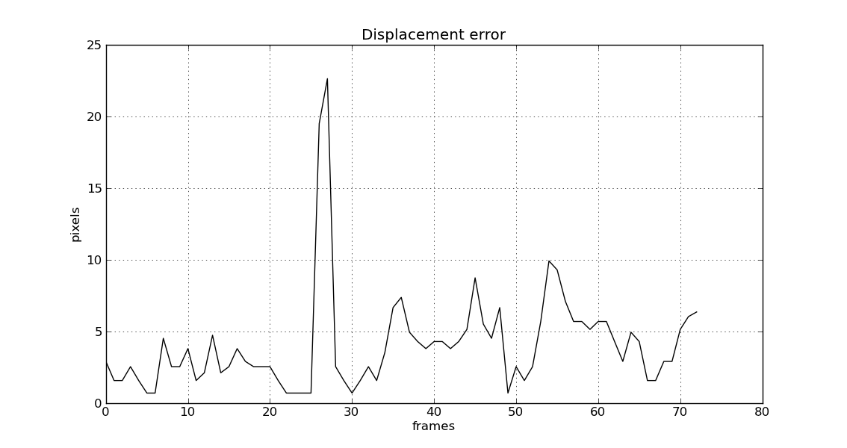
Figure 33: Displacement errors of the tracked pigtail catheter for LECO.

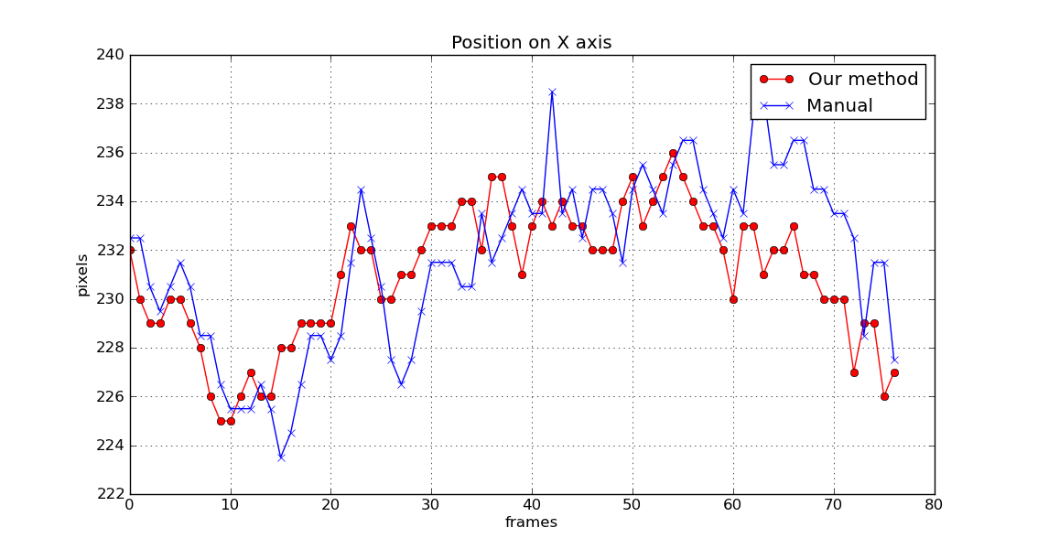
(a)

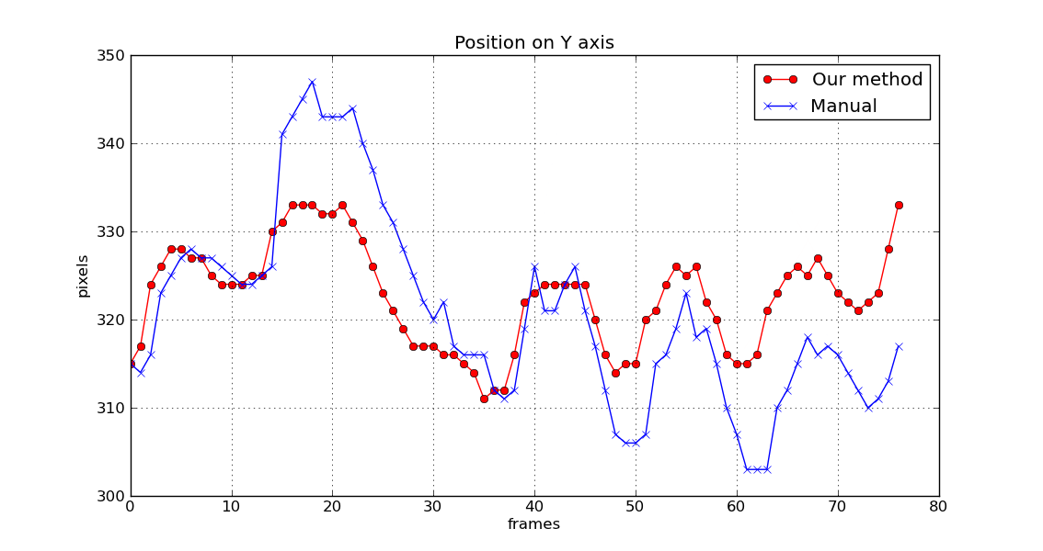
(b)
Figure 34: Projection of the pigtail barycenter on X-axis and Y-axis, compare to the manual curves for BEAU.

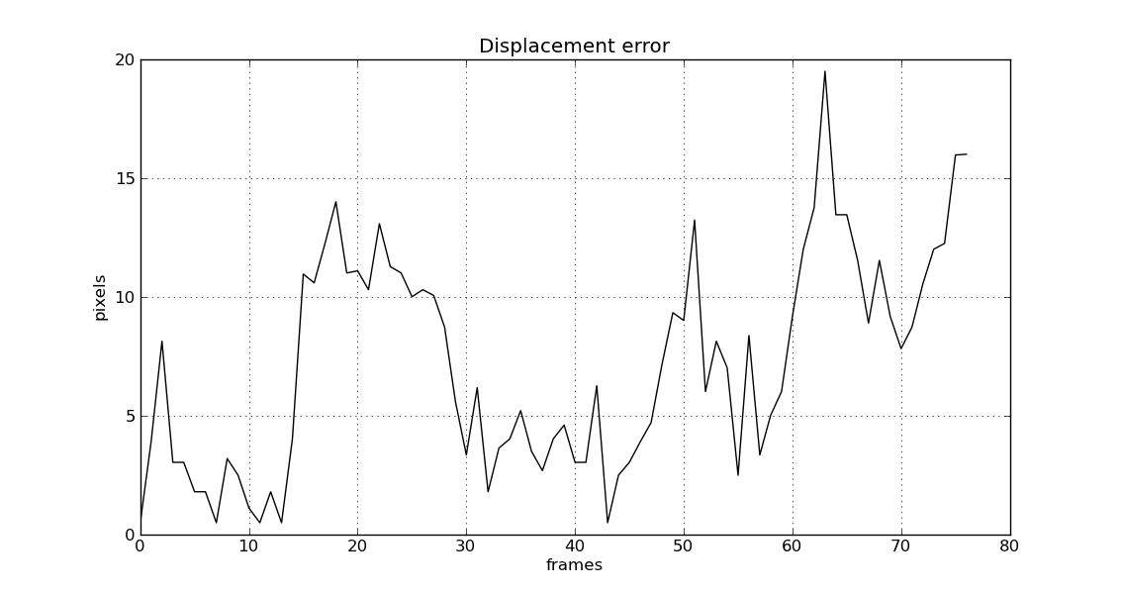
Figure 35: Displacement errors of the tracked pigtail catheter for BEAU.

Seq. | Frames | Cont-rast agent | Occlusion | Pigtail size (hxw) | Pigtail variance | Calci. size (hxw) | Calci. variance | Detect. Rate  pig./cacl. | recall  pig./cacl. | precision  pig./cacl.
a. BEAU | 78 | Yes | Yes | 25x44 | 29.1809 | x | x | 1.00/Na | 0.987/Na | 0.987/Na
b. BER | 56 | Yes | No | 37x41 | 49.4909 | x | x | 1.00/Na | 1.000/Na | 1.000/Na
c. JAN | 59 | Yes | Yes | 38x42 | 99.264 | 16x19 | 69.5764 | 0.68/1.00 | 0.683/0.717 | 1.000/0.717
d. TAVI1 | 195 | Yes | No | 43x46 | 137.537 | 19x29 | 45.604 | 1.00/1.00 | 0.995/0.897 | 0.995/0.897
e. LEF | 80 | Yes | Yes | 44x43 | 35.7984 | 31x25 | 53.7665 | 0.75/1.00 | 0.525/1.000 | 0.700/1.000
f. LECO | 74 | Yes | No | 26x47 | 71.6055 | 15x18 | 47.6129 | 1.00/1.00 | 0.986/0.945 | 0.986/0.945

Table 2: Performance analysis of our approach for six Seq. BEAU, LECO, BER, JAN, , LEF, LECO. All sequences have the detection rate greater than 70%, the recall/precision evaluations of the tracked pigtail catheter are higher than the evaluations of the tracked calcification.

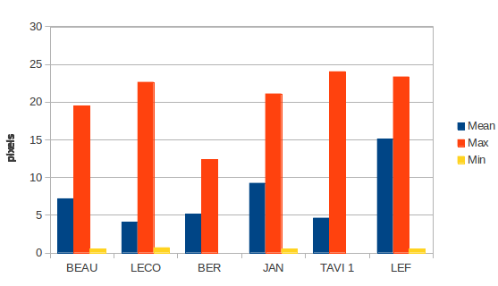
Figure 36: Displacement errors of the tracked pigtail catheter for six sequences.

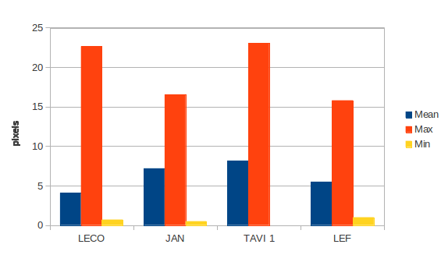
Figure 37: Displacement errors of the tracked calcification for four sequences.

Detailed performance analysis of our approach is performed on all six sequences from Fig. 26. The performance is measured using detection rate, recall and precision. Table 2 (5th-8th columns) shows the size and the variance of pigtail catheter and calcification respectively. The minimum size of the tracked pigtail catheter in all sequences is 25x44 pixels (seq. BEAU), the minimum size of the tracked calcification is 15x18 pixels (seq. LECO). Table 2 (9^{th-}11th columns) shows the resulting scores of the tracker-detector. This tracker-detector has high detection rate, recall and precision for most of the sequences with exception of sequence JAN and LEF. In sequence JAN, there is a significant background clutter and objects similar to the target and partial occlusion. Recall of the method is low for the sequences which have the size of the tracked object less than 15x15 pixels. The majority of sequences have the detection rate, recall and precision from 70% to 100%, which shows that the pigtail catheter and the calcification are enable to be tracked correctly over frames.

Approximating Aortic Valve Plane Motion Results
The initialization step for defining a template image of pigtail catheter, template image of the calcification, importing the aortic valve plane varied between three to five minutes. The maximum total computation time for fluoroscopic image processing algorithms was approximately 100 milliseconds per frame.
Fig. 39 shows an example of updating of visualized aortic valve plane based on tracked aortic pigtail catheter and/or calcifications. The tracked calcification is in the red box. The aortic valve plane is presented by the green line.
The comparison of displacement errors of the aortic valve plane between the tracked calcification and pigtail catheter for four sequences is presented in Fig. 38. The maximum displacement errors of both tracked pigtail catheter and calcification are less than 25 pixels (~5mm) for all sequences. The absolute mean errors are less than 10 pixels (~2mm). For the sequences LECO, JAN, LEF, the displacement error of the valve plane with tracking of calcification is less than the displacement error of the valve plane with tracking of pigtail catheter. In fact, the aortic calcifications have the rigid link to the valve plane, the tracked results performed on calcifications are better.

Figure 38: Comparison of displacement errors of the aortic valve plane between the tracked calcification and pigtail catheter for four sequences.

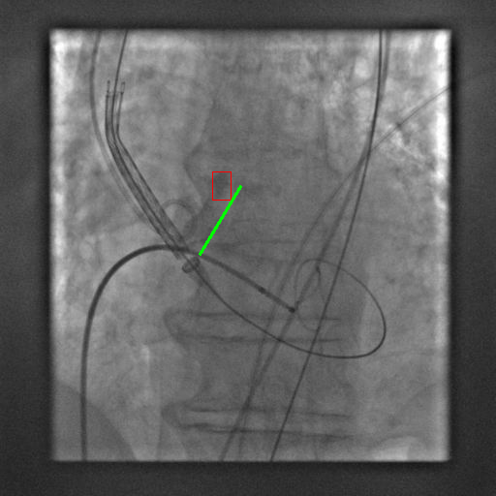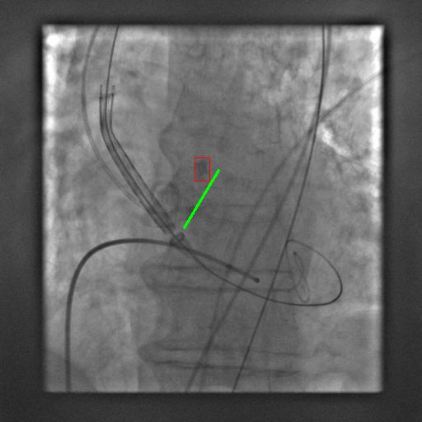
1 18
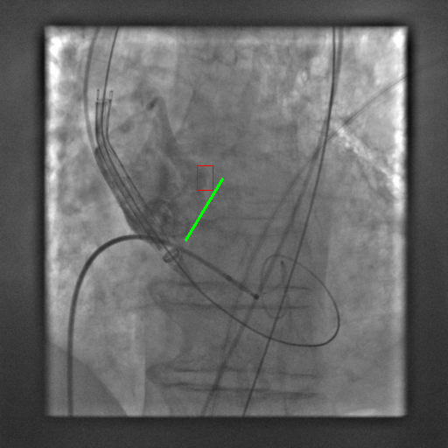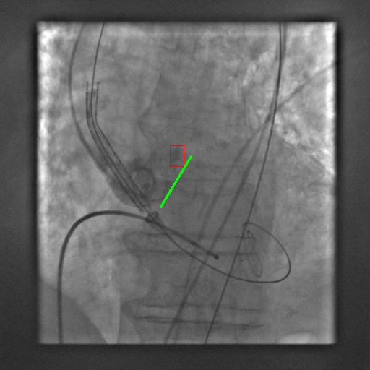
49 60
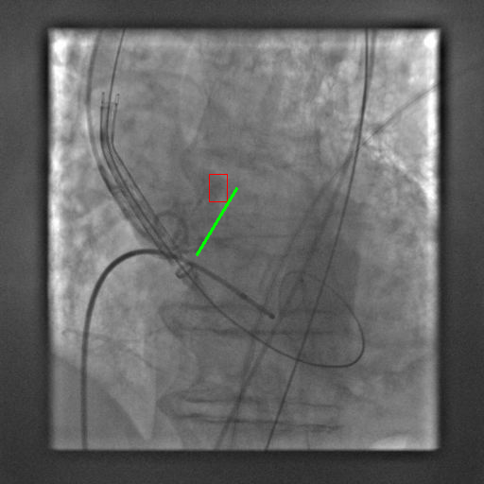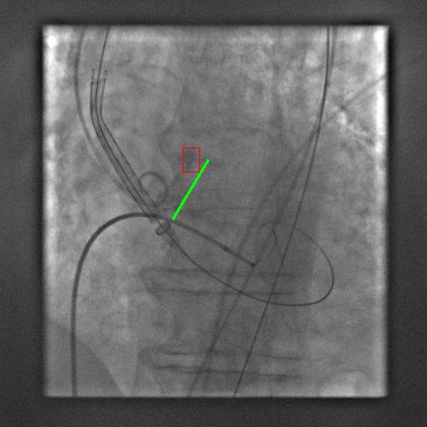
120 175
Figure 39: Examples of the developed method results. Updating of visualized aortic valve plane based on tracked aortic pigtail catheter and/or calcifications.

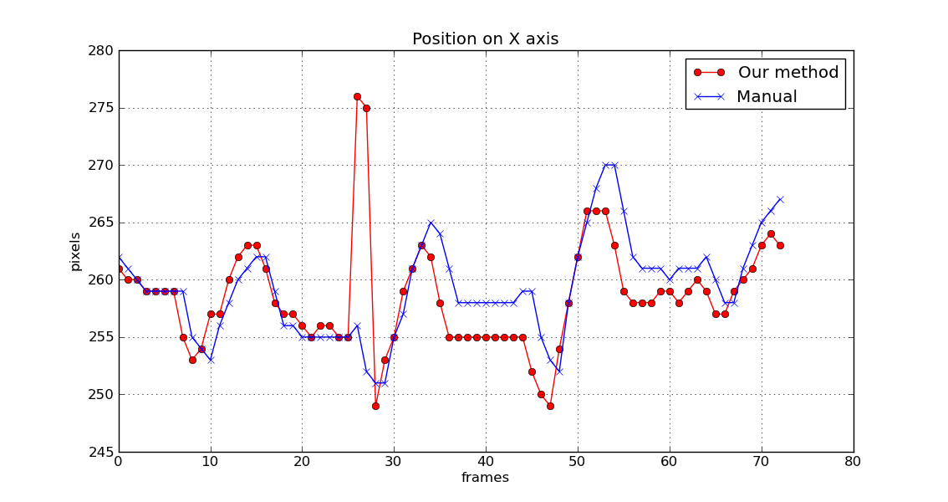
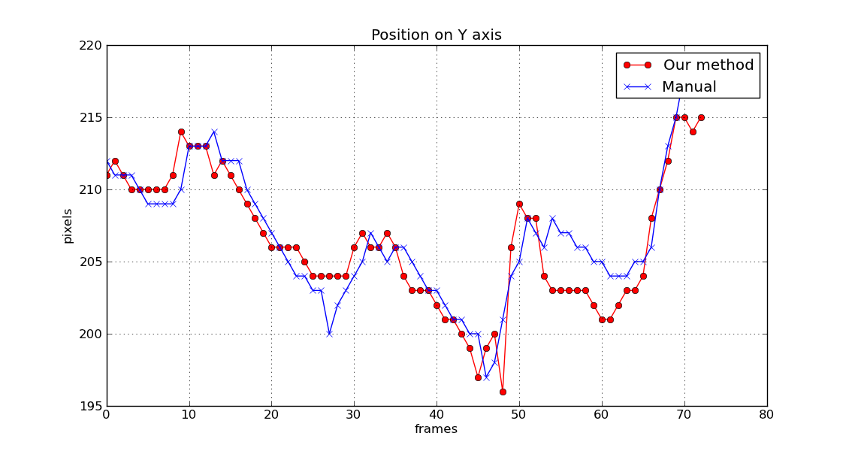
Figure 40: Projection of the start point of the valve plane on X-axis and Y-axis with the tracked calcification, compare to the manual curves for LECO.

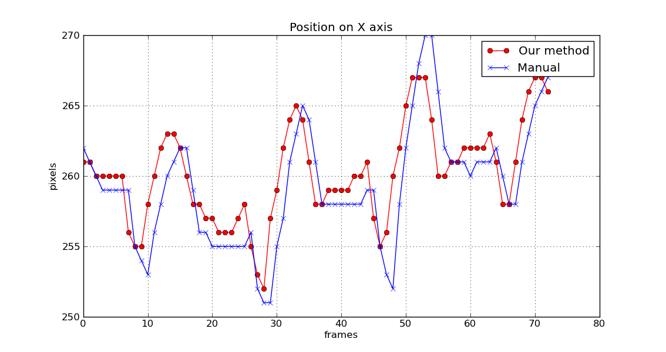
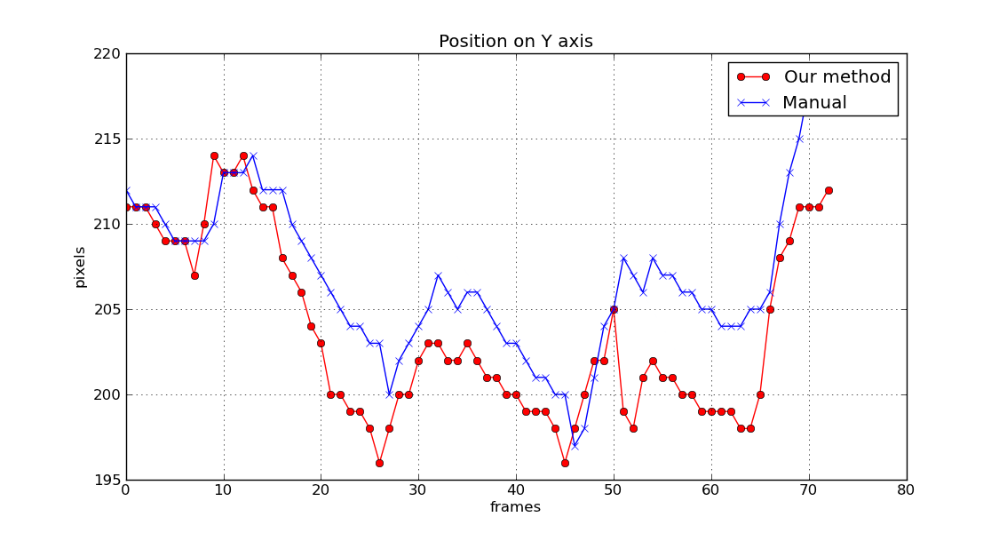
Figure 41: Projection of the start point of the valve plane on X-axis and Y-axis with the tracked pigtail catheter, compare to the manual curves for LECO.

Comparison to State-of-the-Art Methods
In this section, our approach is compared to four others tracking approach with respect by precision and execution time. Fig. 42 denotes the comparison to the state-of-the-art methods for seq. BEAU.

X-axis
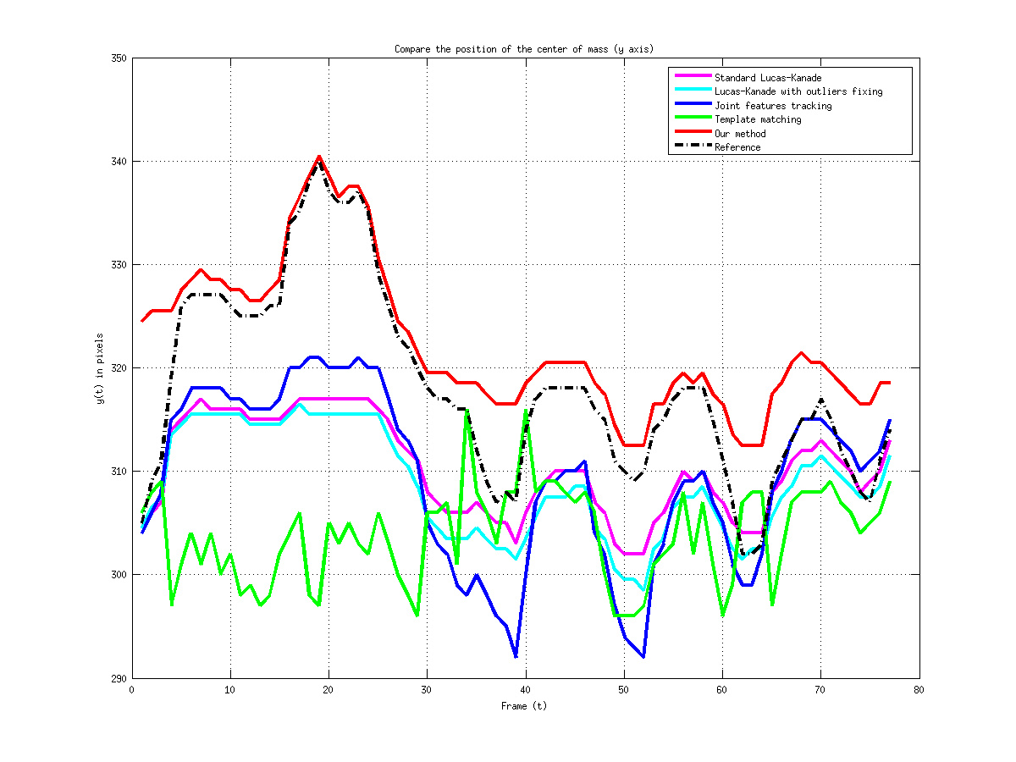
Y-Axis
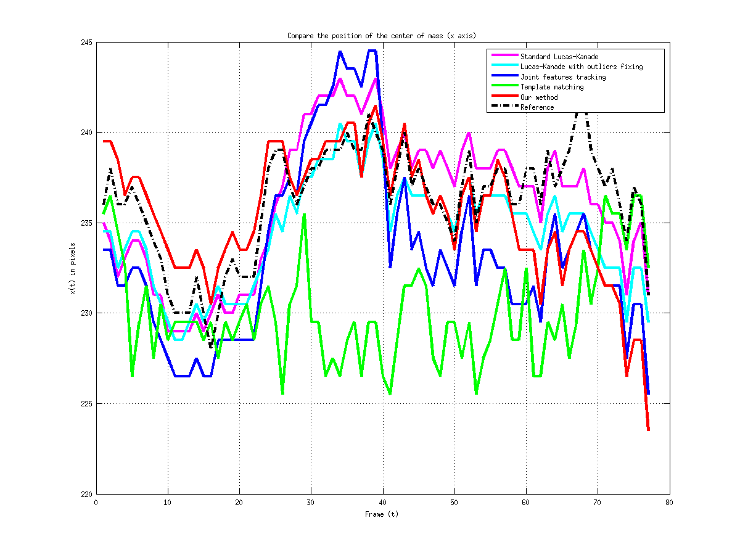
Figure 42: Precision comparison to the state-of-the-art methods. The first row in a cell denotes the projection of the barycenter of the tracked pigtail catheter on X-axis, the second row presents the projection on Y-Axis.

We also present a comparison of the time needed for execution for the selected algorithms. For this evaluation, each algorithm was run 5 times on the sequence BEAU and the average was calculated. The results are presented in Table 3. In the second column the average time in seconds needed to process one frame in sequence as a whole is given. In the third column, the number of frames in the sequence divided by the processing time is given.

Methods | Time (ms) | Frames / s
Standard Lucas Kanade | 11,54 | 86,66
Joint Lucas Kanade | 12,75 | 78,43
Template Matching | 2,03 | 429,61
Our (single-threaded) | 64.97 | 15,39

Table 3: Speed comparison on BEAU.

Discussion
Our algorithm achieves the highest precision on the sequence compare to others state-of-the-art methods. The execution time of Template Matching is good, but performs worse on sequences with occlusions and contrast agent. Our single-threaded implementation takes most computing time. This is caused by the use of random ferns over 2-bit-binary patterns, the addition of a variance filter in the detection cascade and the implementation in C++.

Conclusions

We presented an implementation of a novel approach to robust object tracking based on the Tracking-Learning-Detection paradigm. We made the following contributions: We reproduced the results of Kalal et al. and showed that the use of joint features tracking based improve the result of the tracker. In sequences containing occlusions, approaches based on Tracking-Learning-Detection perform adaptive tracking-by-detection methods.
One problem that was encountered during the experiments is that the object detector is unable to discriminate against objects that exhibit a similar appearance. This problem is partially caused by the fact that the comparison of templates is performed on images of reduced size. One solution to this problem might be to increase the resolution of the template images, but this will introduce the curse of dimensionality. As a compromise, one could employ image pyramids for the templates and perform the comparison using a coarse-to-fine strategy. For the computing time, the solution is a GPU implementation, we expect a further reduction of computing time by a factor of 4.
Currently, our approach gives information about the location of the object of interest only, but not about its orientation. Information about the orientation of objects could be retrieved by employing an affine transformation model for the Lucas-Kanade tracker.
For the application, we demonstrated that a robust approach to track successfully the calcifications and the pigtail catheter with or without contrast agent injection and the occlusions by others surgical instruments. In summary, our image-guided TAVI assistance system has been developed to assist the positioning of the aortic valve plane under live 2D fluoroscopy guidance. To allow continuous visualization of diseased valve plane without further contrast injections, the projected 2D aortic root contour and valve plane are overlaid and updated onto fluoroscopic images according to the aortic root motion via tracking the calcifications and/or the pigtail catheter. The developed fluoroscopy-guided TAVI assistance image processing aims to guide the physician to accurately define the exact position of the AVP. Only a minimal user-interaction is required for initializing the image processing algorithms.

Bibliography

[1] | Valle-Fernández, R. d., Martinez, C. A. & Ruiz, C. E. (2010). Transcatheter Aortic Valve Implantation. Cardiology Clinics, Vol.28, No.1, (February 2010), pp. 155-168, ISSN 0733-8651.

[2] | Singh, I. M., Shishehbor, M. H., Christofferson, R. D., Tuzcu, E. M. & Kapadia, S. R. (2008). Percutaneous Treatment of Aortic Valve Stenosis. Cleveland Clinic journal of medicine, Vol.75, No.11, (November 2008), pp. 805-812, DOI 10.3949/ccjm.75.11.805 .

[3] | Thomas, M., Schymik, G., Walther, T., Himbert, D., Lefevre, T., Treede, H., Eggebrecht, H., Rubino, P., Michev, I., Lange, R., Anderson, W. N. & Wendler, O. (2010). Thirty- Day Results of the SAPIEN Aortic Bioprosthesis European Outcome (SOURCE) Registry: A European Registry of Transcatheter Aortic Valve Implantation Using the Edwards SAPIEN Valve Circulation, Vol. 122, No.1, ( July 2010), pp. 62-69, DOI 10.1161/circulationaha.109.907402 .

[4] | Kaleschke, G., Seifarth, H., Kerckhoff, G., Reinecke, H. & Baumgartner, H. (2010). Imaging Decision-Making for Transfemoral or Transapical Approach of Transcatheter Aortic Valve Implantation. EuroIntervention : journal of EuroPCR in collaboration with the Working Group on Interventional Cardiology of the European Society of Cardiology, Vo. 6, Suppl. G, (June 2010), pp. G20-27, ISSN 1774-024X.

[5] | Van de Veire, N. (2010). Imaging to Guide Transcatheter Aortic Valve Implantation. Journal of Echocardiography, Vol. 8, No.1, (March 2010), pp. 1-6, ISSN 1349-0222.

[6] | Mohamed Esmail Karar, David Holzhey, Matthias John, Ardawan Rastan, Friedrich-Wilhelm Mohr, and Oliver Burgert (2011). Image-Guided Transcatheter Aortic Valve Implantation Assistance System.

[7] | Yan, T. D., Cao, C., Martens-Nielsen, J., Padang, R., Ng, M., Vallely, M. P. & Bannon, P. G. (2010). Transcatheter Aortic Valve Implantation for High-Risk Patients with Severe Aortic Stenosis: A Systematic Review. The Journal of thoracic and cardiovascular surgery, Vol.139, No.6, ( Junary 2010)pp. 1519-28, ISSN 0022-5223.

[8] | Al Ali, A. M., Altwegg, L., Horlick, E. M., Feindel, C., Thompson, C. R., Cheung, A., Carere, R. G., Humphries, K., Ye, J., Masson, J. B. & Webb, J. G. (2008). Prevention and Management of Transcatheter Balloon-Expandable Aortic Valve Malposition. Catheter Cardiovasc Interv, Vol.72, No.4, (October 2008), pp. 573-578, DOI 10.1002/ccd.21667.

[9] | Gessat, M., Merk, D. R., Falk, V., Walther, T., Jacobs, S., Nottling, A. & Burgert, O. (2009). A Planning System for Transapical Aortic Valve Implantation. Proceedings of SPIE Medical Imaging 2009: Visualization, Image-Guided Procedures, and Modeling, Vol.7261, pp. 72611E, DOI 10.1117/12.810270, Orlando, Florida, USA, February 8, 2009.

[10] | Karar, M. E., Gessat, M., Walther, T., Falk, V. & Burgert, O. (2009). Towards A New Image Guidance System for Assisting Transapical Minimally Invasive Aortic Valve Implantation. Conf Proc IEEE Eng Med Biol Soc 2009, pp. 3645-3648, Minneapolis, Minnesota, USA, Septemper 3-6, 2009, ISSN 1557-170X.

[11] | Karar, M. E., Merk, D. R., Chalopin, C., Walther, T., Falk, V. & Burgert, O. (2010). Aortic Valve Prosthesis Tracking for Transapical Aortic Valve Implantation. Int J Comput Assist Radiol Surg. (September 2010), pp. 1-8, ISSN 1861-6410.

[12] | John, M., Liao, R., Zheng, Y., Nottling, A., Boese, J., Kirschstein, U., Kempfert, J. & Walther, T. (2010). System to Guide Transcatheter Aortic Valve Implantations Based on Interventional C-arm CT Imaging. Med Image Comput Comput Assist Interv, Vol. 13, No. Pt 1, (2010), pp. 375-382, DOI 10.1007/978-3-642-15705-9_46.

[13] | Li, M., Kapoor, A., Mazilu, D. & Horvath, K. A. (2011). Pneumatic Actuated Robotic Assistant System for Aortic Valve Replacement Under MRI Guidance. Biomedical Engineering, IEEE Transactions on, Vol. 58, No. 2, ( January 2011), pp. 443-451, ISSN 0018-9294.

[14] | Li, M., Mazilu, D. & Horvath, K. (2008). Robotic System for Transapical Aortic Valve Replacement with MRI Guidance. Medical Image Computing and Computer- Assisted Intervention. Vol. 5242, (2008), pp. 476-484, DOI: 10.1007/978-3-540- 85990-1_57.

[15] | Siegel, R., Luo, H. & Biner, S. (2011). Transcatheter Valve Repair/Implantation. The International Journal of Cardiovascular Imaging (formerly Cardiac Imaging), pp. 1-13, ISSN 1569-5794.

[16] | S. Avidan. Support vector tracking. IEEE Transactions on Pattern Analysis and Machine Intelligence, 26(8):1064–1072, 2004.

[17] | D. Comaniciu, V. Ramesh, and P. Meer. Real-time tracking of non-rigid objects using mean shift. In IEEE Conference on Computer Vision and Pattern Recognition, volume 2, pages 142–149 vol.2. IEEE, 2000.

[18] | R. T. Collins, Y. Liu, and M. Leordeanu. Online selection of discriminative tracking features. IEEE Transactions on Pattern Analysis and Machine Intelligence, 27(10):1631– 1643, 2005.

[19] | O. Chapelle, B. Schölkopf, and A. Zien, editors. Semi-Supervised Learning. The MIT Press, Sept. 2006.

[20] | O. Javed, S. Ali, and Mubarak Shah. Online detection and classification of moving objects using progressively improving detectors. In 2005 IEEE Computer Society Conference on Computer Vision and Pattern Recognition (CVPR’05), volume 1, pages 696–701. IEEE, 2005.

[21] | A. Adam, E. Rivlin, and I. Shimshoni. Robust fragments-based tracking using the integral histogram. In 2006 IEEE Computer Society Conference on Computer Vision and Pattern Recognition - Volume 1 (CVPR’06), volume 1, pages 798–805. IEEE, July 2006.

[22] | S. Avidan. Ensemble tracking. IEEE Transactions on Pattern Analysis and Machine Intelligence, 29(2):261–271, Feb. 2007.

[23] | H. Grabner, C. Leistner, and H. Bischof. Semi-supervised On-Line boosting for robust tracking. In D. Forsyth, P. Torr, and A. Zisserman, editors, Proceedings of the 10th European Conference on Computer Vision, volume 5302, pages 234–247, Berlin, Heidelberg, 2008. Springer Berlin Heidelberg.

[24] | B. Babenko, Ming-Hsuan Yang, and S. Belongie. Visual tracking with online multiple instance learning. In 2009 IEEE Computer Society Conference on Computer Vision and Pattern Recognition Workshops (CVPR Workshops), pages 983–990. IEEE, June 2009.

[25] | S. Stalder, H. Grabner, and L. van Gool. Beyond semi-supervised tracking: Tracking should be as simple as detection, but not simpler than recognition. In IEEE International Conference on Computer Vision Workshops, pages 1409–1416. IEEE, 2009.

[26] | J. Santner, C. Leistner, A. Saffari, T. Pock, and H. Bischof. PROST: Parallel robust online simple tracking. In IEEE Conference on Computer Vision and Pattern Recognition, pages 723–730. IEEE, June 2010.

[27] | S. Hare, A. Saffari, and P. H. S. Torr. Struck: Structured output tracking with kernels. In IEEE International Conference on Computer Vision, pages 263–270. IEEE, Nov. 2011.

[28] | E. Maggio and A. Cavallaro. Video Tracking: Theory and Practice. Wiley, 2011.

[29] | D. Ross, J. Lim, R.-S. Lin, and M.-H. Yang. Incremental learning for robust visual tracking. International Journal of Computer Vision, 77(1):125–141, May 2008.

[30] | L. Matthews, T. Ishikawa, and S. Baker. The template update problem. IEEE Transactions on Pattern Analysis and Machine Intelligence, 26(6):810–815, 2004.

[31] | P. Viola and M. Jones. Rapid object detection using a boosted cascade of simple features. In 2001 IEEE Computer Society Conference on Computer Vision and Pattern Recognition. CVPR 2001, volume 1, pages I–511–I–518, Los Alamitos, CA, USA, Apr. 2001. IEEE Comput. Soc.

[32] | S. Grossberg. Competitive learning: From interactive activation to adaptive resonance. Cognitive Science, 11(1):23–63, Jan. 1987.

[33] | Z. Kalal, J. Matas, and K. Mikolajczyk. Online learning of robust object detectors during unstable tracking. In Proceedings of the IEEE On-line Learning for Computer Vision Workshop, pages 1417–1424, 2009.

[34] | Z. Kalal, J. Matas, and K. Mikolajczyk. P-N learning: Bootstrapping binary classifiers by structural constraints. In 2010 IEEE Conference on Computer Vision and Pattern Recognition (CVPR), pages 49–56. IEEE, June 2010.

[35] | Z. Kalal, K. Mikolajczyk, and J. Matas. Forward-Backward Error: Automatic Detection of Tracking Failures. In International Conference on Pattern Recognition, pages 23–26, 2010.

[36] | V. Lepetit and P. Fua. Monocular model-based 3D tracking of rigid objects. Found. Trends. Comput. Graph. Vis., 1(1):1–89, 2005.

[37] | V. Lepetit, P. Lagger, and P. Fua. Randomized trees for Real-Time keypoint recognition. In IEEE Computer Society Conference on Computer Vision and Pattern Recognition, volume 2, pages 775–781, Los Alamitos, CA, USA, 2005. IEEE Computer Society.

[38] | B. D. Lucas and T. Kanade. An iterative image registration technique with an applica-tion to stereo vision. In Proceedings of the International Joint Conference on Artificial Intelligence, pages 674–679, 1981.

[39] | A. Yilmaz, O. Javed, and M. Shah. Object tracking: A survey. ACM Computing Surveys, 38(4), Dec. 2006.

[40] | W. C. Abraham and A. Robins. Memory retention–the synaptic stability versus plasticity dilemma. Trends in neurosciences, 28(2):73–78, Feb. 2005.

[41] | M. Ozuysal, P. Fua, and V. Lepetit. Fast keypoint recognition in ten lines of code. In IEEE Conference on Computer Vision and Pattern Recognition, Los Alamitos, CA, USA, June 2007. IEEE.

[42] | C. H. Lampert, M. B. Blaschko, and T. Hofmann. Beyond sliding windows: Object localization by efficient subwindow search. In IEEE Conference on Computer Vision and Pattern Recognition, pages 1–8, 2008.

[43] | T. M. Mitchell. Machine Learning. McGraw-Hill Science/Engineering/Math, 1 edition, Mar. 1997.

[44] | Y. Amit and D. Geman. Shape quantization and recognition with randomized trees. Neural Computation, 9(7):1545–1588, Oct. 1997.

[45] | M. B. Blaschko. Branch and Bound Strategies for Non-maximal Suppression in Object Detection, volume 6819 of Lecture Notes in Computer Science, chapter 28, pages 385– 398. Springer Berlin Heidelberg, Berlin, Heidelberg, 2011.

[46] | M. Everingham, L. Van Gool, C. Williams, J. Winn, and A. Zisserman. The pascal visual object classes (VOC) challenge. International Journal of Computer Vision, 88(2):303–338, June 2010.

[47] | F. Murtagh. A survey of recent advances in hierarchical clustering algorithms. The Computer Journal, 26(4):354–359, Nov. 1983.

[48] | A. Bruhn, J. Weickert, and C. Schnorr. Lucas/Kanade meets Horn/Schunck: Combining local and global optic flow methods. International Journal of Computer Vision, 61(3):211– 231, 2005.

[49] | B. K. P. Horn and B. G. Schunck. Determining optical flow. Artificial Intelligence, 17(185):185–203, 1981.

[50] | H. Schneiderman. Feature-centric evaluation for efficient cascaded object detection. In IEEE Computer Society Conference on Computer Vision and Pattern Recognition, volume 2. IEEE, June 2004.

[51] | J. P. Lewis. Fast normalized cross-correlation. In Vision Interface, pages 120–123. Canadian Image Processing and Pattern Recognition Society, 1995.

[52] | B. K. P. Horn and B. G. Schunck. Determining optical flow. Artificial Intelligence, 17(185):185–203, 1981.

[53] | B. D. Lucas and T. Kanade. An iterative image registration technique with an application to stereo vision. In Proceedings of the 7th International Joint Conference on Artificial Intelligence, pages 674–679, 1981.

[54] | Stanley T. Birchfield and Shrinivas J. Pundlik . Joint Tracking of Features and Edges . IEEE Conference on Computer Vision and Pattern Recognition (CVPR) Anchorage, Alaska, June 2008 .

[55] | B. Hemery, H. Laurent, and C. Rosenberger. Comparative study of metrics for evaluation of object localisation by bounding boxes. In International Conference on Image and Graphics, pages 459–464. IEEE, Aug. 2007.

Open Computer Vision : http://opencv.willowgarage.com/wiki/
Ubuntu : http://www.ubuntu.com/ubuntu
Calcifications : Yes or No means that we use the calcifications for the tracking or not.

