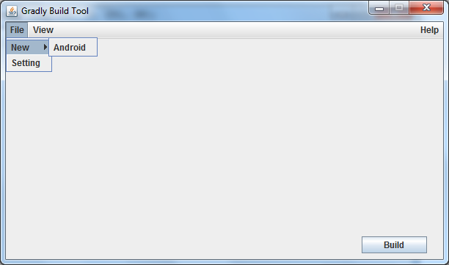

Figure 1. Android build tool Menu File UI.

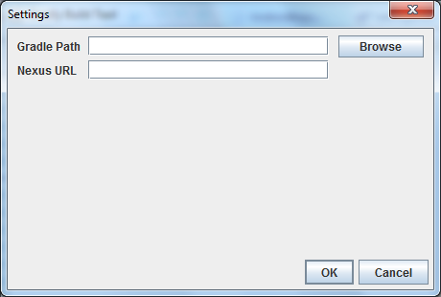

Figure 2. Settings UI.

Includes:

* Gradle Path: Path to Gradle’s directory on local.
* Nexus URL: url to repository on Nexus server.

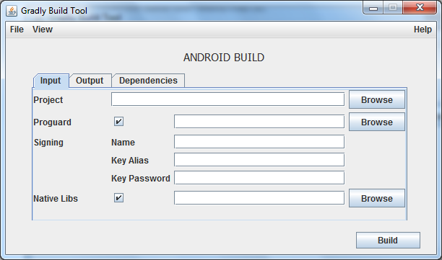

Figure 3. Android build tool Input tab UI.

Includes:

* Project: Path to root directory of project need to build.
* Proguard: checked if project need proguard and path to proguard file.
* Signing section: Sign apk file.
* Native Libs: cheked if project need native lib and path to “armeabi” directory.

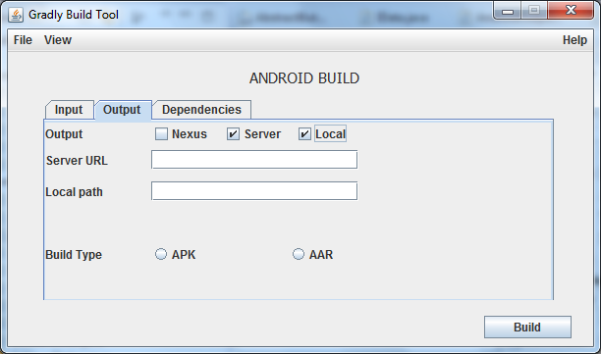

Figure 4. Android build tool Output tab UI.

Includes:

* Output: Nexus – deploys come out file to Nexus server.

Server – deploys come out file to own server.

Local – deploys come out file to local.

* Server URL: url points to destination of result file on server.
* Local path: url points to destination of result file on local.
* Build Type: type of come out file (apk – android application or aar – android library).

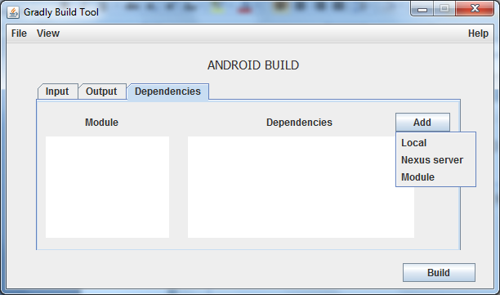

Figure 5. Android build tool Dependencies tab UI.

Includes:

* Module section: consist of module(s) in project.
* Dependencies section: list of dependencies (if needed) for each module to build/run (defined by user).
* Dependencies Add button: 3 sources to declare dependencies (jar file from Local, artifact form Nexus server or another project (module) in that project).

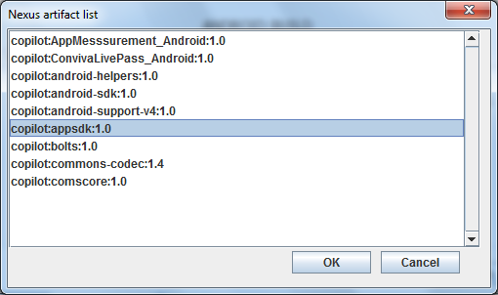

Figure 6. Nexus artifact dependencies chooser dialog.