Fancy Title

Author A1Author B1Author C1,2

1Institut A; 2Institut B

**Address for correspondence**: XX;XX;XX

# Abstract

**Background:Methods:Results:Discussion:Keywords:** ;

# Introduction

Many Studens struggle to find an adequte format for their thesis. Ironically the advent of “modern” WYSIWYG programms seems to make it harder. The

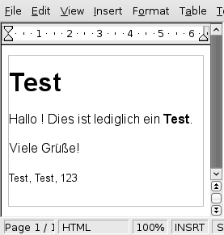

Example of an WYSIWYG editor

This is a test Introduction # Methods ## Participants ## Methods ## Analysis

# Results

## Participants

# Discussion

## Limitations

## Conclusions

(Hirschfeld, Bien, de Vries, Lüttmann, & Schwall, 2010) says. And again (Hirschfeld et al., 2010).

# References

Hirschfeld, G., Bien, H., de Vries, M., Lüttmann, H., & Schwall, J. (2010). Open-source software to conduct online rating studies. *Behavior Research Methods*, *42*(2), 542–546. doi:10.3758/BRM.42.2.542