MET CS 555 Assignment 2 – 20 points
SUBMISSION REQUIREMENTS: Please submit a single document (word or PDF) for submission. Your submission should contain a summary of your results (and answers to questions asked on the homework) as well as your R code used to generate your results (please append your R code to the end of your submission).
An experiment was conducted to determine the effect of children participating in a given meal preparation on calorie intake for that meal. Data are recorded below. Save the data to a format that can be read into R. Read the data in for analysis. Use R to calculate the quantities and generate the visual summaries requested below. You will lose points if you are not utilizing R.
(1) Summarize the data by whether children participated in the meal preparation or not. Use an appropriately labelled table to show the results. Also include a graphical presentation that shows the distribution of calories for participants vs. non-participants. Describe the shape of each distribution and comment on the similarity (or lack thereof) between the distributions in each group. (2 points)

 | Min | 1st Quartile | Median | Mean | Third Quartile | Max.
participants | 211.0 | 298.4 | 424.9 | 410.1 | 456.3 | 635.2
non_partipants | 139.7 | 296.4 | 374.7 | 374.1 | 445.6 | 688.8

The distribution for participants would resemble a normal distribution if the bucket from 200 to 300 were the same as 600 to 700 bucket. For non-participants, the distribution is left skewed. There are not many similarities between these two distributions.
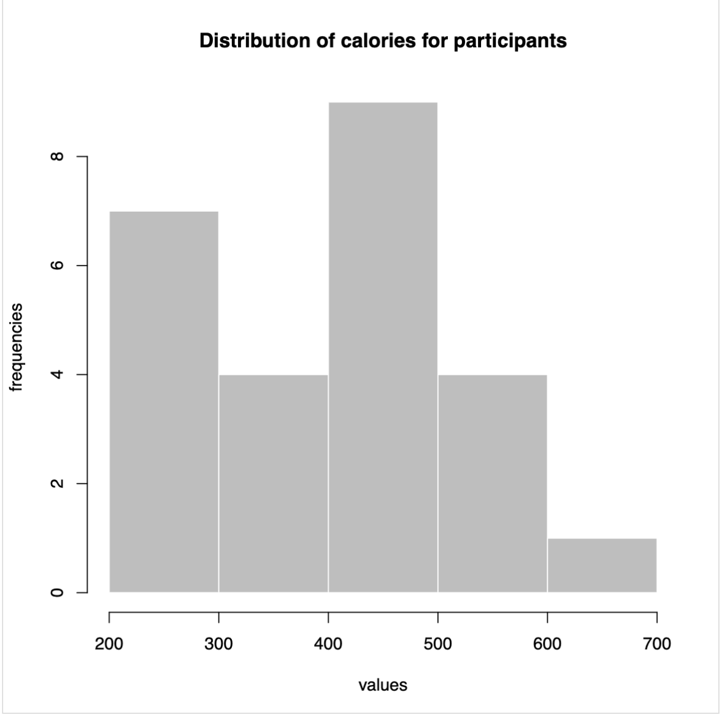
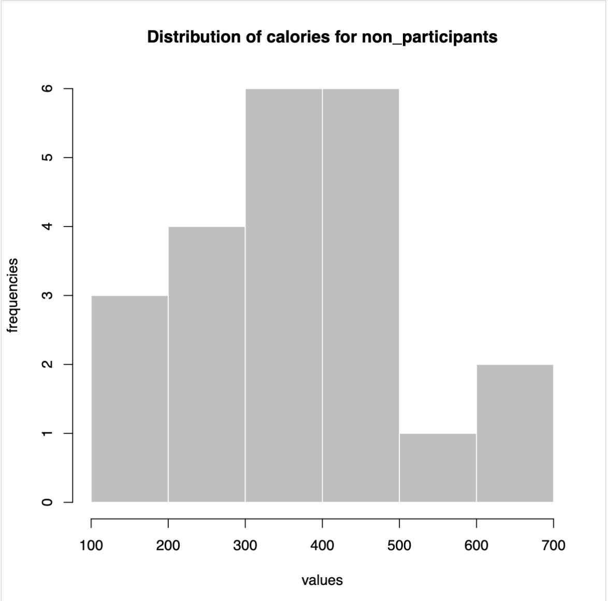
(2) Does the mean calorie consumption for those who participated in the meal preparation differ from 425? Formally test at the alpha = 0.05 level using the 5 steps outlined in the module. (6 points)
Step 1 Specify the hypotheses and alpha level
H0 : The population mean is 425
H1 : The population mean is different from 425
alpha = 0.05

Step 2 select test statistic
Since the sample size is less than 30, we use t-statistic
Step 3 select the decision rule.
If the absolute value of t-static is greater than or equal to critical value, the null hypothesis will be rejected.
Step 4 compute the test statistic and critical value
t_static =( 410.1 - 425)/(121.51/sqrt(25) )= -0.61
(t_statistic can also be obtained from t.test(participants,mu = 425)from my r code.)
critical value = qt(0.975,24)= 2.06
Step 5 conclusion
Since 2.06 is greater than 1.96, we reject the null hypothesis.
(3) Calculate a 90% confidence interval for the mean calorie intake for participants in the meal preparation. Interpret the confidence interval. (4 points)
critical value = qt(0.95,24) = 1.71
lower_boundary= 410.1 - 1.71* 121.51/5 = 368.54
upper_boundary = 410.1 + 1.71* 121.51/5 = 451.66
Alternatively, t.test(participants,conf.level = 0.9)in my r code returns the same result.

Interpretation: there is a 90% probability that the population mean will fall into the confidence interval.

(4) Formally test whether or not participants consumed more calories than non-participants at the alpha = 0.05 level using the 5 steps outlined in the module. (6 points )

Step 1
H0: the mean of participants’ consumption is equal to the mean of non-participants population.
H1: the mean of participants’ consumption is greater than the mean of non-participants population.
alpha level = 0.05

Step 2
Since it is a two sample problem,we choose t-statistic

Step 3
If the absolute test statistic is greater than the critical value, we’ll reject

Step 4
t_statistic = (410.1 - 374.1) / sqrt((121.51^2/25)+(133.14^2/22)) = 0.96
critical value = qt(0.95,42.901) = 1.68
alternatively, t_statistic can be calculated by

t.test(
x = participants,
y = non_participants,
alternative = "greater",
conf.level = 0.95)

Step 5
Since 0.96 < 1.72, fail to reject the null hypothesis.

(5) Are the assumptions of the test used in (4) met? How do you know? (2 points)

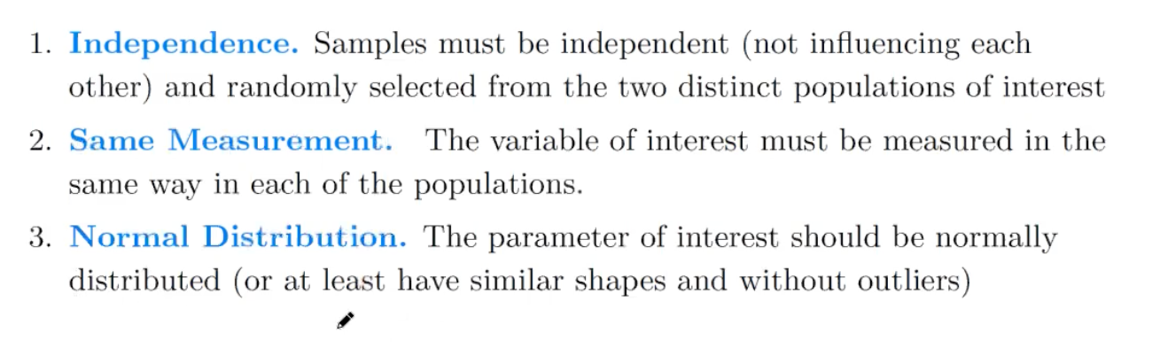
Independence:
Not sure if members in a sample influence each other or not.
Random selection is also not specified in the question.
Same Measurement:
Yes, both use calories as the measurement unit.
Normal distribution:
not sure about this.

qt(0.95,21)

cat(qt(0.975,24))

df <- read.csv("calories.csv")

participants <- df$participants
non_participants <- df$non_participants
non_participants <- na.omit(non_participants)

t.test(
x = participants,
y = non_participants,
alternative = "greater",
conf.level = 0.95)

cat(sd(participants),"\n")
cat(sd(non_participants))

# to test the null hypothesis of mean = 425
t.test(participants,mu = 425)
# to test the sample mean with a confidence level of 90%.
t.test(participants,conf.level = 0.9)

qt(0.95,4)

qt(0.95,42.901)

pnorm(0.95)
qt(0.95,24)

cat(sd(participants))
cat(sd(non_participants))

summary(participants)
summary(non_participants)

hist(
participants,
breaks = 50,
main = "Distribution of calories for participants",
xlab = "values",
ylab = "frequencies",
col = "gray",
border = "white"
)

hist(
non_participants,
breaks = 50,
main = "Distribution of calories for non_participants",
xlab = "values",
ylab = "frequencies",
col = "gray",
border = "white"
)

Data Set for Assignment 2
Calorie Intake for participants
230.16
210.99
288.73
590.28
582.59
635.21
249.86
441.66
572.43
357.78
396.79
298.38
282.99
368.51
388.59
256.32
408.82
424.94
477.96
428.74
432.52
428.27
596.79
456.30
446.38
Calorie intake for non-participants
614.61
503.46
425.22
688.77
184.00
299.73
350.65
394.94
261.55
295.28
139.69
462.78
179.59
301.75
436.58
371.39
469.02
378.09
287.31
448.55
332.64
403.98

