Epsilon Nutrition App

Software Design Specification

Description of Project

Team Epsilon:
Tim Jose
Conrad Escandon
Kamaljot Saini
Scottie Prom
Temuujin Batulzii

Term:
Summer ‘19
CS-401_01SP_1

Last Update: 07/22/2019

Table of Contents

Table of Contents 2
Revision History 6
References: 7
1. Introduction 7
1.1 Purpose 7
1.2 Scope 7
1.3 Aim 7
1.4 Intended Audience 7
1.5 Definitions and Acronyms 8
1.6 System Overview 8
2. Design Considerations 9
2.1 Assumptions and Dependencies 9
2.2 General Constraints 9
2.3 Goals and Guidelines 9
2.4 Development Methods 9
3. Architectural Strategies 10
3.1 Product Development 10
3.2 Hardware & Software Interface Paradigms 10
3.3 Future plans for extending the application 10
4. System Architecture 12
4.1 Subsystem Architecture 13
4.1.1 Welcome Screen Activity 13
4.1.2 Home Screen Activity 13
4.1.3 Profile Activity 13
4.1.4 Nutrition Activity 13
4.1.5 Recipes Activity 14
4.1.6 Add Recipe Activity 14
4.1.7 Calculator Activity 15
4.1.8 Diary Activity 15
4.1.9 Food Query Activity 15
4.1.10 Food Nutrition Facts Activity 15
4.1.11 Sidebar Interface 15
4.2 Use Cases 15
4.2.1 Profile Creation Use Case 15
4.2.2 Record Meal Use Case 16
4.2.3 Create Recipe Use Case 16
4.2.4.1 Calculate BMI Use Case 17
4.2.4.2 Calculate BMR Use Case 18
4.2.4.3 Calculate TDEE Use Case 18
4.2.5 Submit Diary Entry Use Case 19
4.2.6 Side Navigation Bar Use Case 19
5. Policies and Tactics 20
5.1 Coding Conventions 20
6. Detailed System Design 20
6.1 Welcome Screen Section 20
6.1.1 onCreate(); 20
6.1.1.0 Structure & Location 20
6.1.1.1 Definition 20
6.1.1.2 Responsibility 20
6.1.1.3 Constraints 21
6.1.1.4 Composition 21
6.1.1.5 Uses & Interactions 21
6.1.1.6 Resources 21
6.1.1.7 Processing 21
6.1.1.8 Interface/Exports 21
6.1.2 calculation() 22
6.1.2.0 Structure & Location 22
6.1.2.1 Definition 22
6.1.2.2 Responsibility 22
6.1.2.3 Constraints 22
6.1.2.4 Composition 22
6.1.2.5 Uses & Interactions 22
6.1.2.6 Resources 22
6.1.2.7 Processing 22
6.1.2.8 Interface/Exports 22
6.2 Recipes Section 23
6.2.1 loadRecipes() 23
6.2.1.1 Definition 23
6.2.1.2 Responsibilities 23
6.2.1.3 Constraints 23
6.2.1.4 Composition 23
6.2.1.5 Uses / Interactions 23
6.2.1.6 Resources 23
6.2.1.7 Processing 23
6.2.1.8 Interface/ Exports 24
6.2.2.1 Definition 24
6.2.2.2 Responsibilities 24
6.2.2.3 Constraints 24
6.2.2.4 Composition 24
6.2.2.5 Uses/ Interactions 24
6.2.2.6 Resources 25
6.2.2.7 Processing 25
6.2.2.8 Interface/ Exports 25
6.2.3 writeToFile(FILE_NAME, input_recipe) 25
6.2.3.1 Definition 25
6.2.3.2 Responsibilities 25
6.2.3.3 Constraints 25
6.2.3.4 Composition 25
6.2.3.5 Uses/ Interactions 26
6.2.3.6 Resource 26
6.2.3.7 Processing 26
6.2.3.8 Interface/Exports 26
6.3 Diary 27
6.3.1 27
6.3.1.1 Definition 27
6.3.1.2 Responsibilities 27
6.3.1.3 Constraints 27
6.3.1.4 Composition 27
6.3.1.5 Uses/ Interactions 27
6.3.1.6 Resources 27
6.3.1.7 Processing 27
6.3.1.8 Interface/ Exports 27
6.4 BMI Calculator 28
6.4.1 Definition 28
6.4.2 Responsibilities 28
6.4.3 Constraints 28
6.4.5 Composition 28
6.4.5 Uses/ Interactions 28
6.4.6 Resources 28
6.4.7 Processing 28
6.4.8 Interface/ Exports 28
6.5 BMR Calculator 29
6.5.1 Definition 29
6.5.2 Responsibilities 29
6.5.3 Constraints 29
6.5.4 Composition 29
6.5.5 Uses/ Interactions 29
6.5.6 Resources 29
6.5.7 Processing 29
6.5.8 Interface/ Exports 30
6.6 TDEE Calculator 30
6.6.1 Definition 30
6.6.2 Responsibilities 30
6.6.3 Constraints 30
6.6.4 Composition 30
6.6.5 Uses/ Interactions 30
6.6.6 Resource 30
6.6.7 Processing 30
6.6.8 Interface/ Exports 31
6.7 Sidebar Navigation 31
6.7.1 Definition 31
6.7.2 Responsibilities 31
6.7.3 Constraints 31
6.7.4 Composition 31
6.7.5 Uses/ Interactions 31
6.7.6 Resource 31
6.7.7 Processing 32
6.7.8 Interface/ Exports 32
7. Glossary 32

Revision History

Name | Date | Description
Conrad Escandon | 07/12/2019 | SDS Format, Ch.1
Conrad Escandon | 07/14/2019 | Additions to Ch.2
Tim Jose | 7/21/2019 | Some formatting and additions
Tim Jose | 7/22/2019 | System Architecture Diagram, Use cases
Kamaljot Saini | 07/22/2019 | Made revisions to section 1.6
Scottie Prom | 07/22/2019 | Revised 4.1.7, BMI, BMR, TDEE Use Cases
Kamaljot Saini | 07/22/2019 | Revised and added specific details of IDE in section 3.1
Kamaljot Saini | 07/22/2019 | Revised section 4.1.5 “Recipes Activity”
Kamaljot Saini | 07/23/2019 | Authored detailed system design for “Recipes System” section 6.2
Kamaljot Saini | 07/23/2019 | Added screenshots for sections 4.1.5(Recipes Activity) & 4.1.6 (Add Recipe Activity)
Scottie Prom | 7/23/2019 | Added Detailed System Design 6.4 , 6.5 , 6.6
Conrad Escandon | 7/23/2019 | Added Detailed System Design 6.3
Scottie Prom | 7/23/2019 | Added Detailed System Design 6.7 , UseCase6
Temuujin Batulzii | 7/23/2019 | Added Detailed System Design 6.1, 6.2
Temuujin Batulzii | 7/23/2019 | Revision

References:

1. Introduction

1.1 Purpose
This Software Design Specification (SDS) provides an overview of the proposed Epsilon Nutrition Application project design. It will encompass in detail the basic outline of our project and represent a basis for the development process. This will also allow critical analysis of the logical and functional aspects of the design before any commitment is made to implementation. The Epsilon Nutritional project is a tool designed as a prototype to demonstrate assistance in achieving nutritional goals based on user input and in collaboration with related API’s.

1.2 Scope
The scope of the design document is to illustrate the functionality of the Epsilon Nutritional Application. This prototype nutritional tool is a mobile app tool. It will use the Nutritionix API in relation to a user interaction scenario. The design document will also show interactions between the mobile application, between different inputs applied by the user who is the main actor in the design.

1.3 Aim
The design description defined in this document serves multiple purposes:
- To describe the functional structure, data and algorithms to be implemented.
- To identify required system resources.
- To assist in producing test cases.
- To aid in visual representation of interactions.

1.4 Intended Audience
The Software Design Description is written for knowledgeable software professionals and designers. Thus the User will not be within the intended audience for this document, which is:
- Project Managers
- Auditors and Reviewers
- Programmers

It is recommended that the User refer to the Software Requirements Specification document.

1.5 Definitions and Acronyms
For a complete list of the definitions and acronyms used in the remainder of this document, refer to the Glossary.

1.6 System Overview
This section is to provide a general description of the software system including its functionality and matters related to the overall system and its design. Refer to Section 6 for specific descriptions.

Module | Description
Splash Screen | An initial screen while the user profile is loaded.
Sidebar | A navigation tool continuously accessible for quick access to separate modules, not limited to: home, settings, calculator.
Progress | Provides a line graph of progress made based on stored user data within a chosen timeline: month, week, year.
Calculator | Provides an assessment of health based on user input in conjunction with the API.
Nutrition | A design for the user to have access for inputting nutritional values of consumed foods.
Diary | A design for the user to have access to inputting generalized information.
Recipes | Allows the user to save and display their personal recipes.

2. Design Considerations

2.1 Assumptions and Dependencies
Epsilon Nutrition will require an Android device running version 4.0 or greater. The application assumes that the device will be connected to the internet in order to make database queries to the Nutritionix API. The application also assumes that Nutritionix API is always up and running. Inaccurate data may be provided in the case the API is not working. The program will be developed in Android Studio V.3. Accuracy of provided data to the user is dependent on the honest entry of their requested weight, height, age, gender, and activity level. Honest entry of calorie and nutrient consumption is also necessary for accurate goal tracking.

2.2 General Constraints
User will be required to be running a minimum OS of Android 4.0 or greater. Refer to SRS v.01 Section 3.2. Internet connectivity is highly recommended for a continuous interaction with API’s, however manual entry of data is possible without internet access. Epsilon Nutrition will not implement a crash report, therefore not needing a collection of crash reports. All data from the app is stored locally on the user’s phone. If the database file is lost or corrupted the user will not be able to recover their data. The Nutritionix API limits the application to 500 calls per 24 hours.

2.3 Goals and Guidelines
The application stores all data onto a local database file for ease of use and access without the necessity of internet access. This allows the application to be used even without internet access. Being almost entirely text-based, the app aims to be extremely low on memory-consumption. Despite requiring heavy manual user entry the app shall provide a simplified user-interface to provide an easy and intuitive user experience.

2.4 Development Methods
Epsilon Nutrition will follow the “Big Bang” development methodology. The application will be designed with a modular approach to allow for developers to integrate their code fluidly. Being primarily in Java, the majority of the provided classes will use an object-oriented style of programming.

3. Architectural Strategies

3.1 Product Development
The application will be developed in Android Studio version 3.4.2(reference exact details below). Database queries in the backend will be made to the Nutritionix API.

Android Studio 3.4.2
Build #AI-183.6156.11.34.5692245, built on June 27, 2019
JRE: 1.8.0_152-release-1343-b01 amd64
JVM: OpenJDK 64-Bit Server VM by JetBrains s.r.o

3.2 Hardware & Software Interface Paradigms
- Android OS
- Minimum tested: 4.0
- Maximum tested: 9.0
- 3rd Party Components
  - Nutritionix API: Provides a database of common and brand-name foods
  - Gradle: Build program used by Android Studio
  - Volley: Library dependency to make HTTP requests

3.3 Future plans for extending the application
- Barcode Scanner
- Prettier UI
- More internet functionality
  - Cloud storage for database backup
  - User-submitted recipes
  - Add friends
  - Share progress on social media (Twitter, Facebook, etc)
- Fitness-related functionality
  - Calories burned
  - Exercise routines
- Image uploading
  - Progress pictures
  - Recipes
- Social Media Implementation
  - Allow user to upload progress on Twitter and Facebook
- Recipes Section
  - Also connect to Nutritionx API to record more detailed nutritional information of user-input recipes

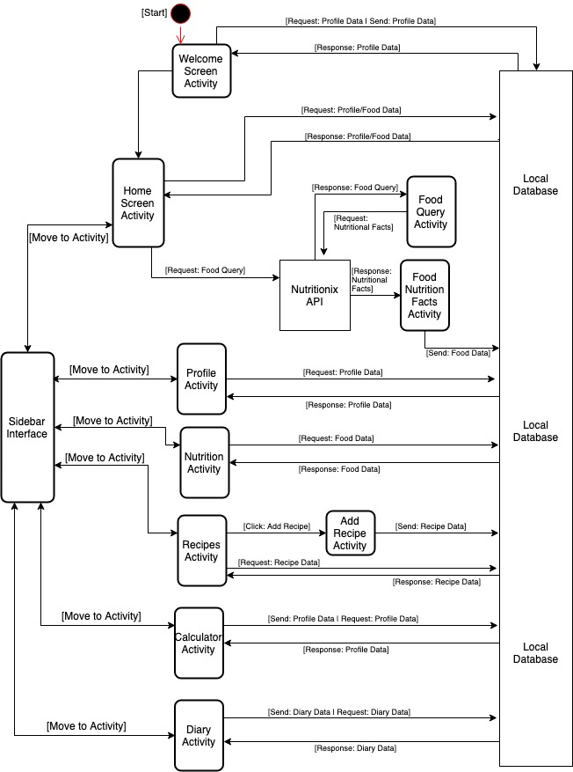
4. System Architecture

4.1 Subsystem Architecture

4.1.1 Welcome Screen Activity
Upon entering the application the Welcome Screen Activity requests for profile data from the local database. If profile data is not found, it prompts the user to enter their profile data:
- Name
- Birthdate
- Height
- Weight
- Gender
- Activity Level
Upon submission, the profile data is sent to the database and the activity proceeds to the Home Screen Activity. If the initial db request responds with profile data, the Welcome Screen skips to the Home Screen immediately.

4.1.2 Home Screen Activity
Where the user can view how many calories they have consumed and how many they have remaining. A consumed food can be added by making a query from the search bar. Recorded foods can also be removed from this screen. The Home Screen Activity requests and receives the user’s profile and food data from the database.

4.1.3 Profile Activity
The user can view and update their profile data initially entered during the Welcome Screen at the Profile page.

4.1.4 Nutrition Activity
The food data from consumed meals that are stored in the database are aggregated at the Nutrition Activity to display total calories, macros, and other nutrients consumed (E.G. sodium, cholesterol, etc).

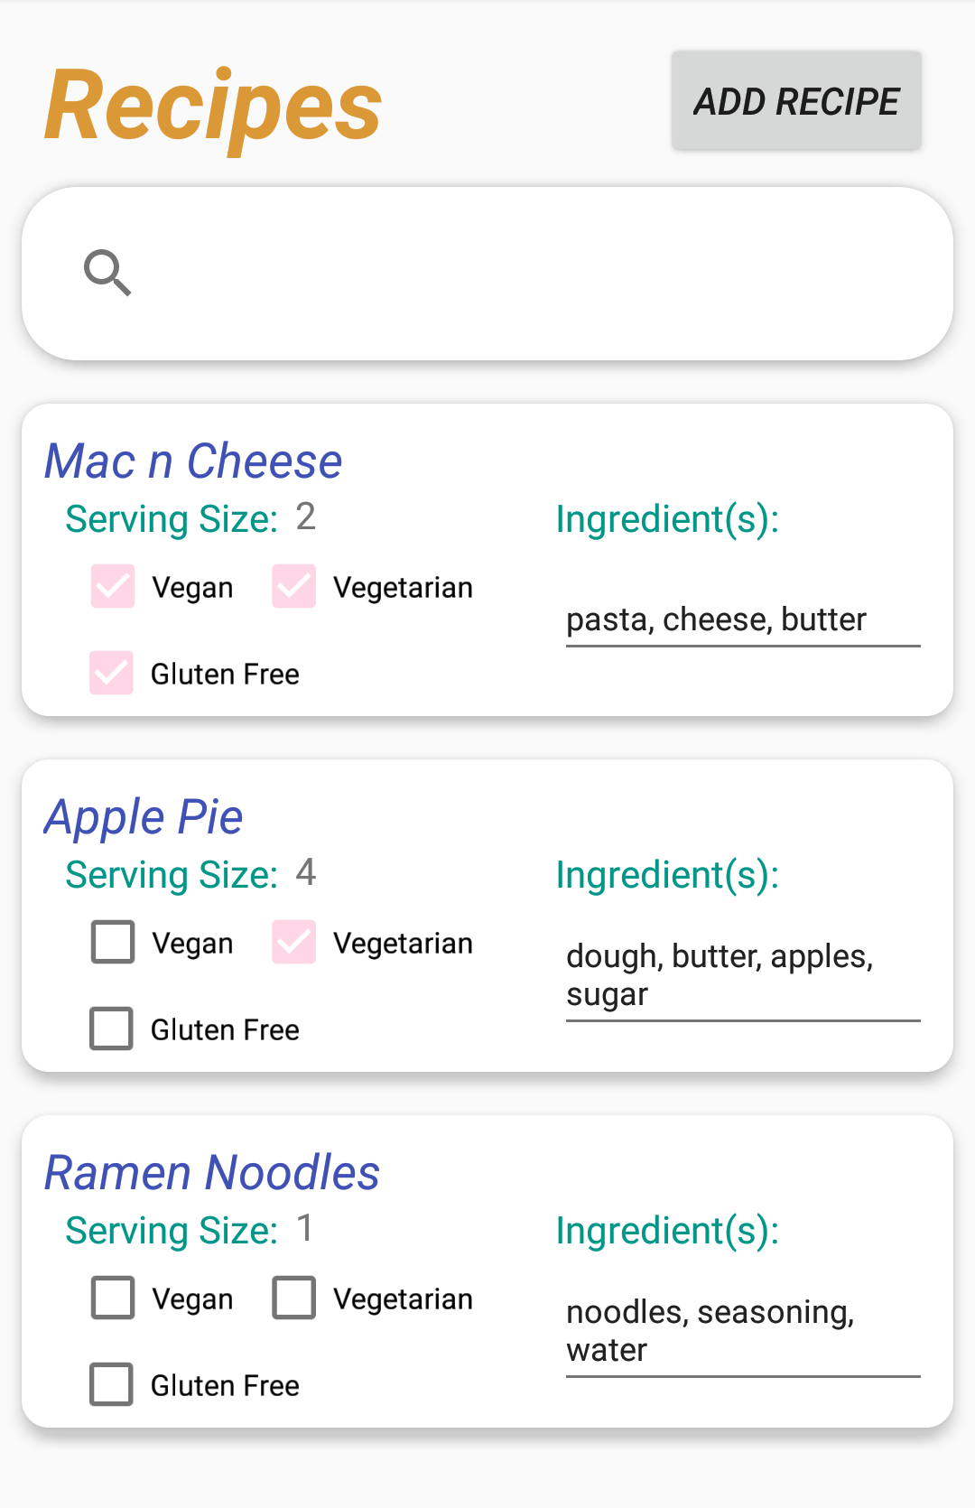
4.1.5 Recipes Activity
The main screen for recipes retrieves data from a text-file database, stores the recipes into “Recipes” objects, and finally places them into both a List and HashMap data structure respectively. The List is then connected to a recyclerView to display all the recipes within the database to the user. Additionally, the user may submit custom recipes for meals not found in the Nutritionix API database using the “Add Recipe” button which leads to the “Add Recipe” Activity.

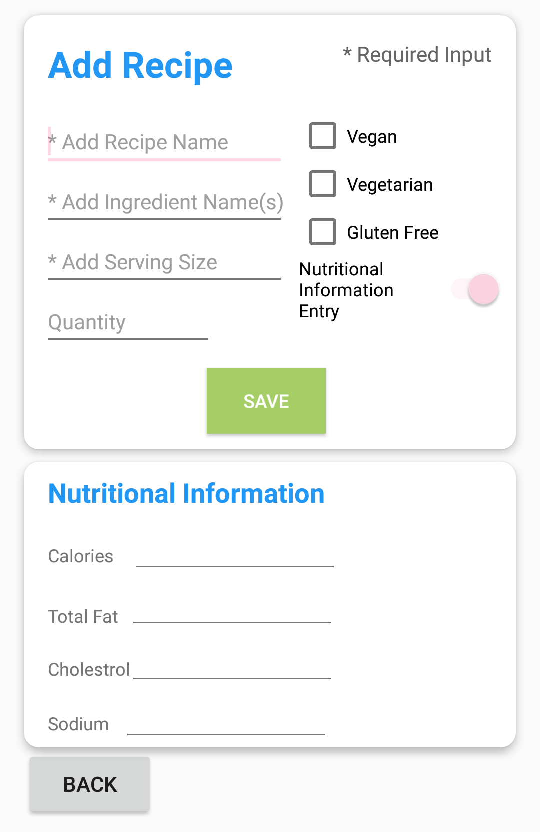
4.1.6 Add Recipe Activity
Prompts user for recipe name, ingredients, serving size, quantity and offers options to mark the recipe as vegan, vegetarian, or gluten free. Upon click the “save” button, recipe data is sent to the local database to be stored.

4.1.7 Calculator Activity
The user has an option to select either a BMI, TDEE, or BMR Calculator. Once the user gets their calculation from one of the calculators, they are able to go back and select another calculator to use.

4.1.8 Diary Activity
Displays all diary entries provided by the user. Features a button for the user to submit additional diary entries.

4.1.9 Food Query Activity
When a search is submitted from the Home Screen, a GET request is sent to the Nutritionix API. The Food Query Activity displays a list of results pertaining to the search string. Each of the displayed results are clickable which leads to the Food Nutrition Facts Activity.

4.1.10 Food Nutrition Facts Activity
When a query result is selected from the Food Query Activity, a POST request is sent to the Nutritionix API. Once a response is received, the Food Nutrition Facts Activity displays a list of calories and all common nutrients (macros, sodium, etc) for the selected food item. This activity features a button to add a food item to the local database for meals consumed for the day. This data contributes to calories and nutrients consumed.

4.1.11 Sidebar Interface
The sidebar interface is accessible from any page within the app via the 3-bar button featured at the top left of the app. This allows the user to quickly and easily navigate to any of the main features of the application via two simple clicks.

4.2 Use Cases

4.2.1 Profile Creation Use Case
Id | UC-01
Title | Profile Creation
Description | User enters personal data to create a profile
Precondition | User has never opened the app before
Postcondition | User profile is created
Priority | High
Detailed Description | 1 | User opens app
 | 2 | App prompts for name, age, birthdate, weight, height, gender, and activity level
 | 3 | User submits data
 | 4 | User BMI, BMR, and TDEE are calculated
 | 5 | User data is written to database and profile is created

4.2.2 Record Meal Use Case
Id | UC-02
Title | Record a Meal Consumed
Description | User records a meal consumed for the day to track calorie and nutrient consumption
Precondition | - User finds and selects a food via the search bar  - User manually enters an item  - User selects a premade recipe
Postcondition | User meal consumption is record
Priority | High
Detailed Description | 1 | User selects a food item via search bar, manual entry, or recipe
 | 2 | Application adds all supplied calories and nutrients to daily total
 | 3 | Application stores selected food into database
 | 4 | User is taken back to homepage with selected food now showing

4.2.3 Create Recipe Use Case
Id | UC-03
Title | Create a Recipe
Description | User creates a personal recipe for a meal that may not be found via the main screen search bar
Precondition | User visits the Recipe Creation page via the sidebar
Postcondition | A new recipe is created
Priority | Medium
Detailed Description | 1 | User clicks “Add Recipe”
 | 2 | Application prompts for recipe name, ingredients, serving size, quantity, is vegan, is vegetarian, is gluten free
 | 3 | User submits data
 | 4 | Recipe data is written to database
 | 5 | User is returned to recipe page with new recipe showing

4.2.4.1 Calculate BMI Use Case
Id | UC-04
Title | BMI Calculator
Description | User enters a person’s information to calculate BMI.
Precondition | User visits the Calculator page via the sidebar and clicks on the “BMI Calculator” option.
Postcondition | BMI calculation number is shown based off the user’s input.
Priority | Medium
Detailed Description | 1 | App prompts for height and weight
 | 2 | User submits data
 | 3 | BMI result is calculated.
 | 4 | Calculated BMI is shown on screen.
 | 5 | User has an option to go back to the “Calculator Screen” to calculate their TDEE/BMR.

4.2.4.2 Calculate BMR Use Case
Id | UC-04
Title | BMR Calculator
Description | User enters a person’s information to calculate BMR.
Precondition | User visits the Calculator page via the sidebar and clicks on the “BMR Calculator” option.
Postcondition | BMR calculation number is shown based off the user’s input.
Priority | Medium
Detailed Description | 1 | App prompts for height, weight, age, and gender.
 | 2 | User submits data
 | 3 | BMR result is calculated.
 | 4 | Calculated BMR is shown on screen.
 | 5 | User has an option to go back to the “Calculator Screen” to calculate their TDEE/BMI.

4.2.4.3 Calculate TDEE Use Case
Id | UC-04
Title | TDEE Calculator
Description | User enters a person’s information to calculate TDEE.
Precondition | User visits the Calculator page via the sidebar and clicks on the “TDEE Calculator” option.
Postcondition | TDEE calculation number is shown based off the user’s input.
Priority | Medium
Detailed Description | 1 | App prompts for height, weight, activity level, gender, and age.
 | 2 | User submits data
 | 3 | TDEE result is calculated.
 | 4 | Calculated TDEE is shown on screen.
 | 5 | User has an option to go back to the “Calculator Screen” to calculate their BMI/BMR.

4.2.5 Submit Diary Entry Use Case
Id | UC-05
Title | Diary Entry
Description | User enters diary entries about whatever they’d like
Precondition | User visits diary page
Postcondition | A diary post is stored in the database
Priority | Low
Detailed Description | 1 | User clicks button to add a diary entry
 | 2 | User writes entry and submits
 | 3 | System stores the data in the database
 | 4 | User is taken back to diary page where their diary entry is now displayed by date

4.2.6 Side Navigation Bar Use Case
Id | UC-06
Title | Side Navigation Bar
Description | The skeleton of the application that allows the user to select different options of the Nutrition App.
Precondition | The application needs to be able to launch.
Postcondition | User will have access and be able to navigate throughout all of the application’s features.
Priority | High
Detailed Description | 1 | User clicks the triple bar on the top left corner of the screen.
 | 2 | Side bar appears on the screen with options the user can choose from.
 | 3 | If the user clicks on one of the selected menu items, the screen will go to the selected menu.
 | 4 | If the user clicks out of the side bar, the side bar will close and the page the user was last on, will be where the user is currently on.

5. Policies and Tactics

5.1 Coding Conventions
All members will be developing the application in Android Studio. Standard Java coding conventions will be used. Class names must start with a capital letter, constants must be in all uppercase letters, and variables must be written using the camelCase convention. Xml ids will use the underscore_case convention with all lowercase letters.

6. Detailed System Design

6.1 Welcome Screen Section

6.1.1 onCreate();

6.1.1.0 Structure & Location
Method within the class “WelcomeScreen”

6.1.1.1 Definition
Android built-in method which creates activity when the program runs initially.

6.1.1.2 Responsibility
- To initialize variables for input values
- To receive user inputs from UI and converted them to String
- To send different class those converted Strings when the user clicks on “Next” button

6.1.1.3 Constraints
The method will wait for the user to click on “Next” button to be completely executed . In order for the method to run, there must not be existing user profile data in text file. If there is existing user profile, the method will not be executed.

6.1.1.4 Composition
- EditText variables which have reference for the values which are entered by the user.
- Button variable which contains reference of the button on the screen.
- String, int, double variables that are used to save entered values by the user.
- Built-in function setOnClickListener() that implements logic when the user clicks on the “Next” button.
- Built-in Intent class object that is used to start a new action. In this case, it passes entered values to different class which also means the application goes to different screen during run-time.

6.1.1.5 Uses & Interactions
When the app runs initially, this method will run if there is no existing user profile data in text file. This method will call different method called calculation() for calculation of BMI, TDEE, BMR. calculation() method will return calculated data within onCreate() method which will send different class those data.

6.1.1.6 Resources
N/A

6.1.1.7 Processing
The method will receive Bundle object as its parameter and use its method setContentView() to set layout for the application user interface. Then, EditText variables initialized with reference id of text fields from the UI screen. When the user enters values on those text fields, EditText variables will hold those values which are stored to string, int, double variables. Within the method, then Intent object is created to be used for sending these string, int, double values to different class. Intent object is passed to startactivity() built-in method to open new screen on the app.The new screen will use those sent values

6.1.1.8 Interface/Exports
N/A

6.1.2 calculation()

6.1.2.0 Structure & Location
Method within the class “WelcomeScreen”

6.1.2.1 Definition
The method which calculates the BMI, BMR, TDEE

6.1.2.2 Responsibility
The method will receive int, double values for “Height”,”Weight”, “Age” as parameter and does arithmetic calculations and will return an int or double depending on parameter.

6.1.2.3 Constraints
- The method must receive values for parameter
- The method must be called in onCreate() method and return appropriate values=

6.1.2.4 Composition
- Variables that will be used for arithmetic calculation
- It contains arithmetic formula for BMI, BMR, TDEE

6.1.2.5 Uses & Interactions
Calculates BMI, BMR, TDEE

6.1.2.6 Resources
It will receive Int and double values within the onCreate() method.

6.1.2.7 Processing
onCreate() method will call this method bypassing int, double values to the parameter. The method do the arithmetic calculation and simply returns int or double values based on its overloading.

6.1.2.8 Interface/Exports
N/A

6.2 Recipes Section

6.2.1 loadRecipes()
Author (Kamal) Side Note: Load recipes is indirectly used to implement the search functionality of the recipes system. https://youtu.be/sJ-Z9G0SDhc This video was referenced to help learn and build the live search functionality of the “Recipes” system.

6.2.1.0 Structure & Location
method within class “RecipesHomepage”

6.2.1.1 Definition
This method is purpose built to load recipes from a text file database into “Recipes” objects and store them both into a List and Hashmap data structure.

6.2.1.2 Responsibilities
- Deserialize stored recipe data in text file
- Store the reconstructed recipes objects into List and HashMap data structure

6.2.1.3 Constraints
The file must exist for this method to perform as intended; otherwise, an “FileNotFound” exception will be thrown. Additionally, if the recipes database has a lot of data entries, the Android system must have enough physical random access memory to store the data in List and HashMap data structures while the application is running.

6.2.1.4 Composition
- If it has dependencies, then you would write them here, but loadRecipes is a standalone method that just needs a filename

6.2.1.5 Uses / Interactions
The file name from which this method will de-serialize data is needed. This method is called in the “onCreate” method of “RecipesHomepage” class.

6.2.1.6 Resources
This method directly interacts with a text file database.

6.2.1.7 Processing
Requirement for Processing:
Data in the text file database must be stored as such:
Name of Recipe/Name of Ingredient(s)/Number of Servings/Quantity of
Ingredients/vegan_Flag/vegetarian_Flag/glutenFreeFlag/
The next entry should start on a new line.

Before any processing, the method creates all its necessary variables which will be used to store data in temporarily from the text file database. In addition, a “FileInputStream” object is created for use with reading in the data itself. The majority of the method is written within a try-catch block to be able to throw and catch exceptions. The file is read in line by line and each line is temporarily stored in a “charArray.” The method then cycles through the charArray storing each entity of recipe name, ingredient name, etc. into its respective string variable. These string variables are later parsed and put into a “Recipes” object. Finally, the “Recipes” object is stored into a List and HashMap data structure.

6.2.1.8 Interface/ Exports
This method is indirectly responsible for exporting a List structure into a recyclerViewer adapter so that it can display all the recipes on the main Recipes page.

6.2.2 saveButton() method

6.2.2.1 Definition
This method is invoked when the user clicks on the “SAVE” button in the “Add Recipe” section. Its sole purpose is to store relevant user-input recipe information into a “Recipes” object and output it into a text-file database.

6.2.2.2 Responsibilities
Takes user input from the “Add Recipe” section, ensures the user-input recipe meets the required criteria for saving to text-file database, stores it in a “Recipes” object, and finally it outputs the “Recipes” object into the text file.

6.2.2.3 Constraints
This method will work as intended if and only if it is provided, as a bare minimum, the inputs of recipe name, recipe ingredient(s), and serving size. The method will throw exceptions if the user tries to save a recipe without these three main components. Additionally, the Android device must have enough storage space to contain the text-file database.

6.2.2.4 Composition
N/A

6.2.2.5 Uses/ Interactions
This method directly interacts with the “writeToFile”(reference section 6.2.3) method.

6.2.2.6 Resources
Recipes are stored in a text-file database.

6.2.2.7 Processing
editText object is used to extract user-input information from the “Add Recipe” section. Also, checkBox objects are used to extract the boolean/isChecked values from user input. Each text entry is stored into its own temporary string used for processing and parsing the input data in preparation for storing it into a “Recipes” object. The method checks to see if the user has entered the required components in order to save file. If the user fails to input the required components recipe name, recipe ingredient(s), and serving size; the method will throw appropriate exceptions to alert the user it’s not possible to save without those 3 required inputs. After storing the user-input into a “Recipes” object, the method invokes an external method “writeToFile()” to finally write the “Recipes” object into a text-file database.

6.2.2.8 Interface/ Exports
Exports a “Recipes” object into the “writeToFile()” method in order to ultimately write the “Recipes” object to the text-file database.

6.2.3 writeToFile(FILE_NAME, input_recipe)

6.2.3.1 Definition
This method is invoked by the “saveButton()”(reference section 6.2.2.x above) method. It simply accepts “Recipes” as objects and stores them into a text-file database.

6.2.3.2 Responsibilities
This methods purpose is to attempt to successfully write “Recipes” objects into a text-file database.

6.2.3.3 Constraints
Before execution of this method the following pre-conditions must be met: text-file database must exist, uncorrupted “Recipes” object must be available to pass into the method.
Additionally, there must be enough storage space on the Android device to successfully write a “Recipes” object to file.

6.2.3.4 Composition
N/A

6.2.3.5 Uses/ Interactions
As stated earlier, this method directly interacts with the “saveButton()” method. Also, a side effect of this method is being able to display the recipes on the homepage of the recipes system.

6.2.3.6 Resource
To work as intended, it is vital for this method to successfully meet the pre-conditions of having an existing text-file and a “Recipes” object. Additionally, there must be enough storage space in the Android device for the recipe to successfully save into the text-file database.

6.2.3.7 Processing
The method is given a text-file database name and a “Recipes” object as input. From there, it simply uses the custom built “toString()” method within the “Recipes” class to properly format and output the “Recipes” object data into the text-file database. Reference section 6.2.1.7 above to see an example of how the “Recipes” object data should be formatted within the text-file database.

6.2.3.8 Interface/Exports
N/A

6.3 Diary

6.3.1

6.3.1.1 Definition
The diary component provides the user with an option to save text data.

6.3.1.2 Responsibilities
The purpose of this component is to allow the user to document data that the user may find important to their goals. The data is generally catalogued by date and more personally by providing a title to the data entry.

6.3.1.3 Constraints
Access to saving data to file is needed for storing and retrieving data. Component is restricted to interacting with text data; component does not support image data.

6.3.1.4 Composition
The component is composed of interdependent entities. A single entity is used for composition of the diary component and the other entities are used as a collection container of the entries that all share a common catalogue method.

6.3.1.5 Uses/ Interactions
The dairy component interacts with the navigation bar to either initiate or exit the diary component.

6.3.1.6 Resources
None.

6.3.1.7 Processing
User is presented a default category to use in storing text data. User is allowed to create a new category to store text data by interacting with a button indicating a request for a new catalogue title. User category choice will determine where the entry is to be catalogued.
User will be presented with a new screen to create an entry and save to file.

6.3.1.8 Interface/ Exports
Data retrieved is presented using list view type in a recyclerview interface. Entries will have a dedicated output screen to interact with.
Data request are transferred between entities using a parcelable interface. The parcelable interface will allow for the flattening of data to transfer between entities in the event of an inclusion of new data types.

6.4 BMI Calculator

6.4.1 Definition
The BMI Calculator will calculate the user’s body max index based off their height and weight.

6.4.2 Responsibilities
The purpose of this component is to give the user an accurate BMI calculation that they can use as a reference to see if they are at risk for health related problems such as diabetes, heart disease, and cancer.

6.4.3 Constraints
A constraint would be that the user would only be allowed to enter imperial measurement numbers instead of number from the metric system.

6.4.5 Composition
In this class, there are two main functions. There is the back function that allows the user to go back the Calculator option screen as well the calculate function that will give the user a BMI number.

6.4.5 Uses/ Interactions
The BMI Calculator interacts with the Main Calculator page, which interacts with the Navigation Bar Menu.

6.4.6 Resources
The BMI Calculator does not affect any other component on this app and is its own separate entity.

6.4.7 Processing
Once the application has the user’s input of height and weight, it will do the mathematical equation of 730 x (User’s Inputted Weight in pounds) / (User’s inputted height squared, in inches). In the result that one of the mandatory inputs is missing, the app would not calculate unless there both inputs are filled out.

6.4.8 Interface/ Exports
N/A

6.5 BMR Calculator

6.5.1 Definition
The BMR Calculator will calculate the user’s basal metabolic rate based off their height, weight, age, and gender.

6.5.2 Responsibilities
The purpose of this component is to give the user an accurate BMR calculation that will tell them how much their body burns in calories while at rest. They can use that number to try to and go on a caloric deficit based off their BMR number that would help them lose weight if needed.

6.5.3 Constraints
A constraint would be that the user would only be allowed to enter imperial measurement numbers instead of number from the metric system.

6.5.4 Composition
In this class, there are three main functions. There is the back function that allows the user to go back the Calculator option screen, a function that calculates the user’s BMR if they were a female, and a function that calculates the user’s BMR if they were male.

6.5.5 Uses/ Interactions
The BMR Calculator interacts with the Main Calculator page, which interacts with the Navigation Bar Menu.

6.5.6 Resources
The BMR Calculator does not affect any component on this app and is its own separate entity.

6.5.7 Processing
Once the application has the user’s input of height, weight, age, the user will have an option to select if they want to calculate the BMR for a male or female. The BMR calculation will be based off the original Harris-Benedict equation. For Males, the equation is ((6.24 x weight in pounds) + (12.7 x height in inches) – (6.755 x age) + 66.47). For Females, the equation is ((4.35 x weight in pounds) + (4.7x height in inches) – (4.7 x age) + 655.1).

6.5.8 Interface/ Exports

6.6 TDEE Calculator

6.6.1 Definition
The TDEE Calculator will calculate the user’s Total Daily Energy Expenditure based off their height, weight, age, and gender, and activity level.

6.6.2 Responsibilities
The purpose of this component is to give the user an accurate TDEE calculation that will tell them how much their body burns in calories while based on their level of activity. They can use that number to try to and go on a caloric deficit based off their TDEE number that would help them lose weight if needed, or how many more calories they need to consume to gain weight.

6.6.3 Constraints
A constraint would be that the user would only be allowed to enter imperial measurement numbers instead of numbers from the metric system.

6.6.4 Composition
In this class, there are three main functions. There is the back function that allows the user to go back the Calculator option screen, a function that calculates the user’s TDEE if they were a female, and a function that calculates the user’s TDEE if they were male. This class also contains radio buttons has values stored, that would be in the calculation of their TDEE.

6.6.5 Uses/ Interactions
The TDEE Calculator interacts with the Main Calculator page, which interacts with the Navigation Bar Menu.

6.6.6 Resource
The TDEE Calculator does not affect any component on this app and is its own separate entity.

6.6.7 Processing
Once the application has the user’s input of height, weight, age, the user will have an option to select if they want to calculate the TDEE for a male or female. The TDEE calculation will be based off the original Harris-Benedict BMR’ equation multiplied by a value based off their level of activity. For Males, the equation is ((6.24 x weight in pounds) + (12.7 x height in inches) – (6.755 x age) + 66.47). For Females, the equation is ((4.35 x weight in pounds) + (4.7x height in inches) – (4.7 x age) + 655.1). There are 4 radio buttons with the choices of none, light, moderate, and heavy. “None” has a value of 1.2, “light” has a value of 1.375, “moderate” has a value of 1.55, and “heavy” has a value of 1.725. Once you have the BMR, the app will multiply that value based on the selected radio button, and thus the TDEE for the user will be calculated.

6.6.8 Interface/ Exports
N/A

6.7 Sidebar Navigation

6.7.1 Definition
The Sidebar Navigation is the main user interface that allows for the user to navigate throughout the different features of the application.

6.7.2 Responsibilities
The responsibilities of the sidebar navigation is for the user to access the different features of the application by selecting the triple bar button on the top left of the app. For any page that the user is on, they would be able to navigate out of that page onto another page of their choosing.

6.7.3 Constraints
N/A

6.7.4 Composition
To be able to call different classes throughout the application, the classes that are accessible in the navigation menu are extended as Fragments. “.inflate” is used to show the navigation menu when the triple bar is clicked. A switch statement is used to navigate the six selectable classes.

6.7.5 Uses/ Interactions
The Sidebar Navigation Menu interacts with the six classes by calling to those classes.

6.7.6 Resource
The resources that are affected by the Navigation Bar would be the six classes that are in the option menu. The Navigation Bar would not interfere with the subclasses that would be possible nested in some of the other classes. For example, when navigating to the “Calculator” option, there are three calculators to choose from in that page. The Navigation Bar would not be able to directly access of the three calculators.

6.7.7 Processing
In the MainActivity Class, there is a switch statement that calls the six different classes that is accessible from the side bar. The classes that are being called extend a fragment. Once the .java class is called, it will inflate the selected XML file on the user screen.

6.7.8 Interface/ Exports
N/A

7. Glossary
Account: An official and verified user associated with the application.

Android: An operating system designed for smartphones and tablets designed by Google.

Android Studio: The official IDE for Android application development.

API: A set of routines, calls, and tools for building software. Generally, specifies how software components interact.

App: see Application.

Application: Software designed to perform a task for a user.

Barcode: A machine-readable arrangement of numbers and vertical lines printed on a package.

BMI: Body Mass Index. A measure of body fat based on weight and height.

BMR: Basal Metabolic Rate. The number of calories needed for the body to function at rest.

Developer: Someone who develops code.

Facebook: A social media platform that allows registered users to post statuses, pictures, videos, that would allow them to connect with friends and family.

Integrated Development Environment (IDE): A software application that has a source code editor, build tools, and debugger that is used by programmers.

Interface​ ​​-​ ​​A​ ​device​ ​or​ ​program​ ​enabling​ ​a​ ​user​ ​to​ ​communicate​ ​with​ ​a​ device..

Macro: Short for “Macronutrients” which makes up protein, carbohydrates, and fat.

Project Manager: Someone who manages the schedule, budget, and development of a software project.

Response​ ​​-​ ​A​ ​reaction​ ​to​ ​a​ ​stimulus.

Software Requirement Specification: A description of the software to be developed.

Stimulus​ ​​-​ ​An​ ​event​ ​that​ ​causes​ ​a​ ​response.

TDEE: Total Daily Energy Expenditure. The average number of calories burned per day.

Tester: Someone who debugs a program.

Text File: The method of app data management.

Twitter: Social Media Platform that allows registered users to post statuses or “tweets” in 140 characters or less.

User: Entity interacting with the software.

Verifiable: a registered user found in a system of data management.

